S3 part:

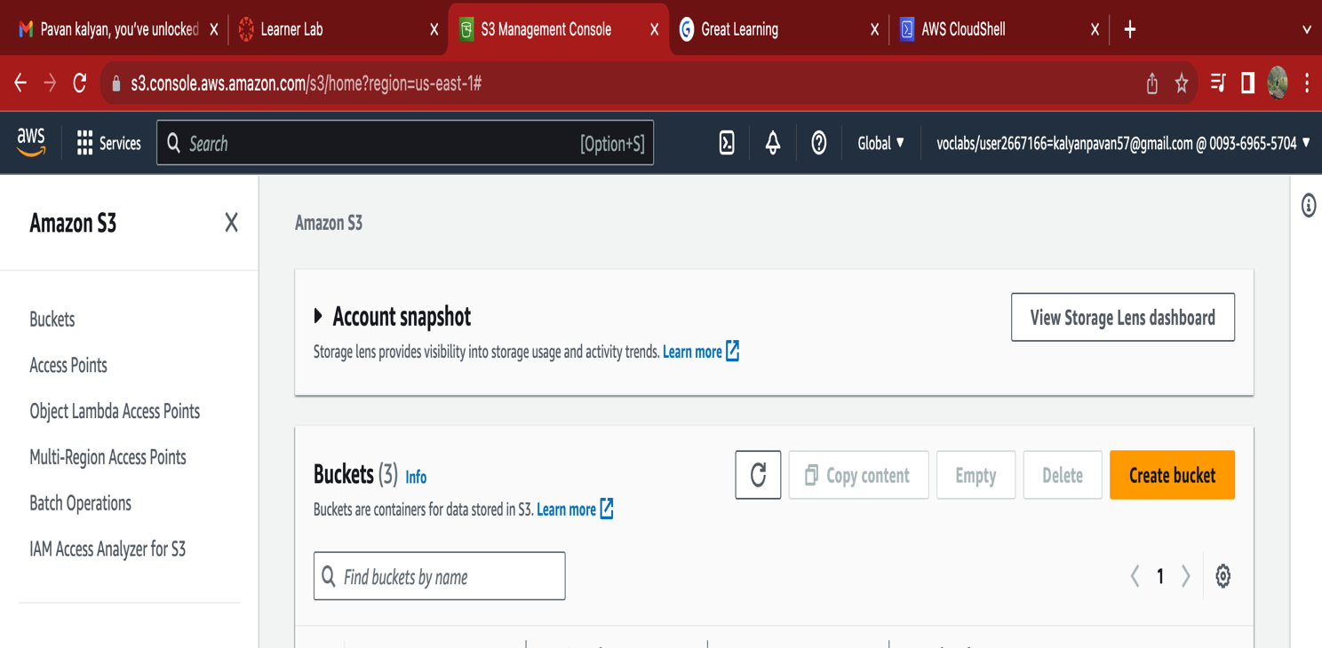

Use CLI to upload files and list them and delete file

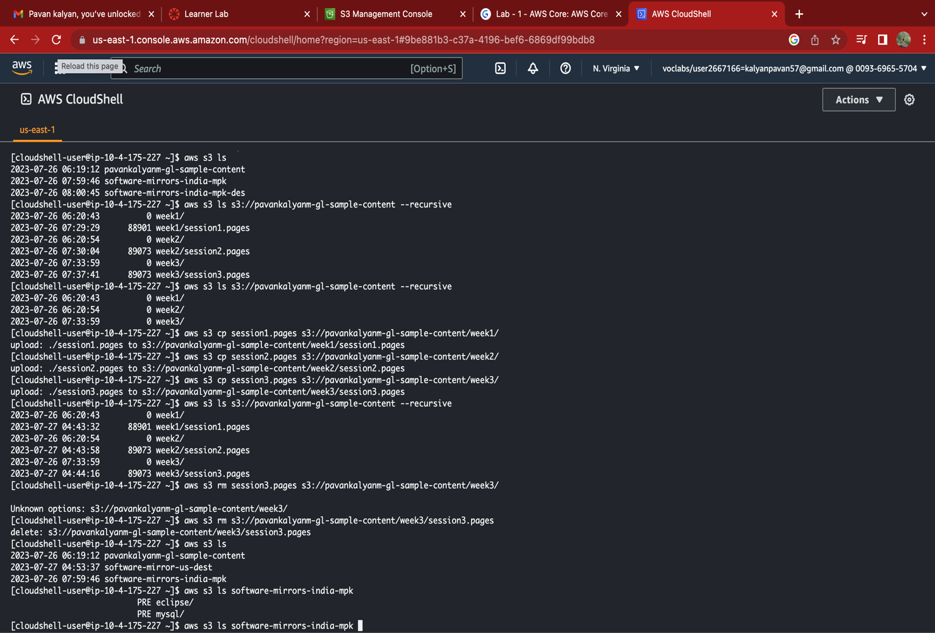

**Enable version.**

**Cross region Replication**:

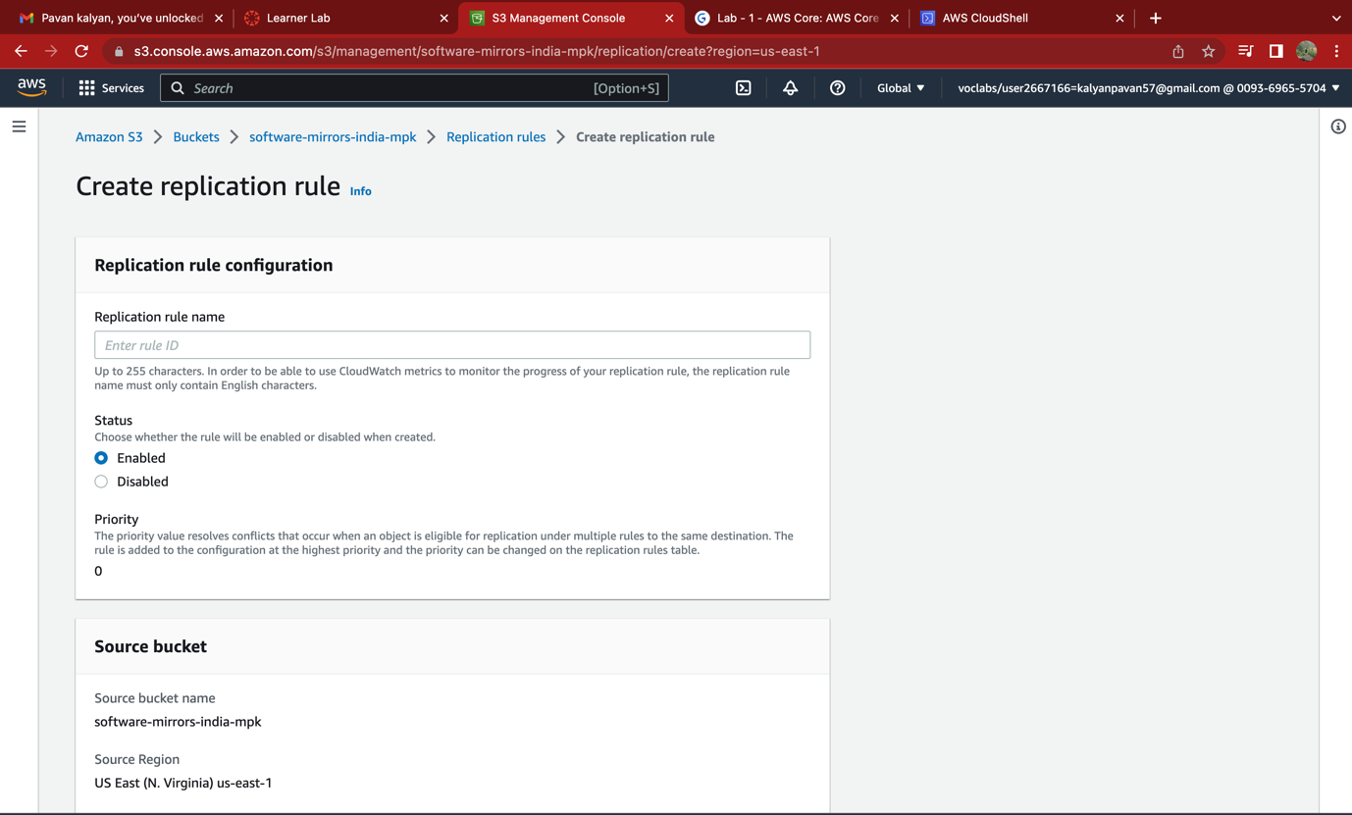

**New file which was uploaded in source bucket got replicated to destination bucket:**

EC2 part:

**Detach Volume:**

**Snapshot:**

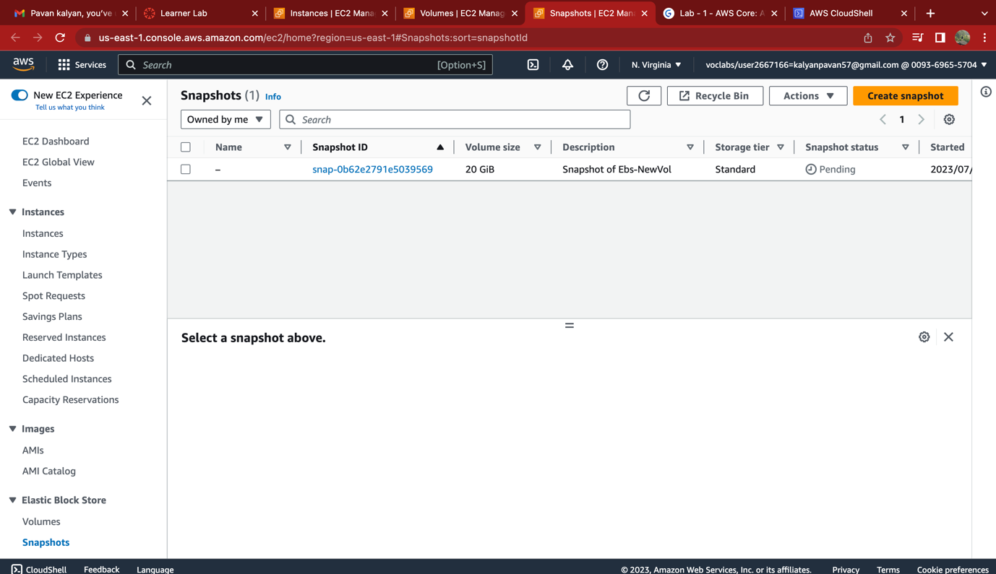

**Create new volume with snapshot and attach to EC2:**

