## horizontal line



EC2 Instance Start & Stop Using CloudWatch Rule as a target using SSMAutomations

**─**

Prepared by: Singaravelan.P

Reviewed by:

Accepted By:

# Table of contents

**Table of contents** **1**

**Overview** **2**

EC2 Stop & Start 2

**Goals** **2**

**Step 1: Create an IAM Role for EC2 Instance SSM Full Access** **3**

**Step 2: Attach a IAM Role for EC2 Instance** 4

**Step 3: Install the SSM Agent in your EC2 Instances** 4

**Step 4: Create a IAM role for AutomationAssumeRole for Cloudwatch target SSMAutomation** 5

**Step 5: Create a Cloudwatch rule for EC2 instance Start** 7

# 

# 

# 

# 

# 

# Overview

## EC2 Start & Stop:

This scenario is Start & Stop an EC2 instance in Specific time for each server using SSM Automation with Cloudwatch rule.

# Goals

1. Create a IAM role(SSM_Full) for EC2 instance role policy is SSM Full Access
2. Attach a SSM_Full role to Specified EC2 Instance
3. Install a SSM Agent in All EC2 instance
4. Create a IAM role for AutomationAssumeRole for Cloudwatch target SSMAutomation
5. Create a Cloudwatch rule for EC2 instance stop
6. Create a Cloudwatch rule for EC2 instance start

## 

## Step1: Create an IAM Role for EC2 Instance SSM Full Access:

Go to IAM Console create a Role for EC2 with SSM Full Access.

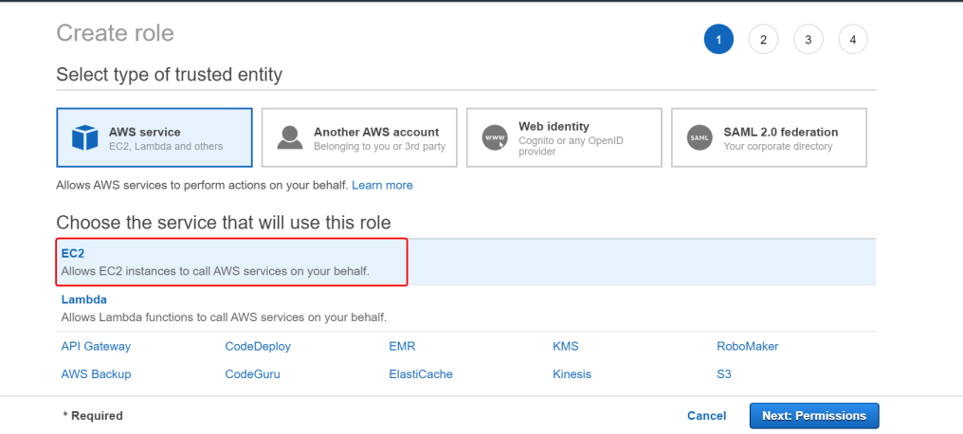

Attach permissions policies

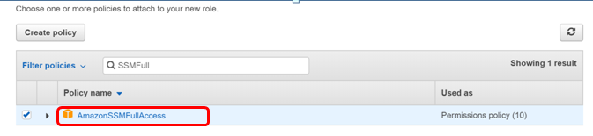

Provide a Role name & review to create

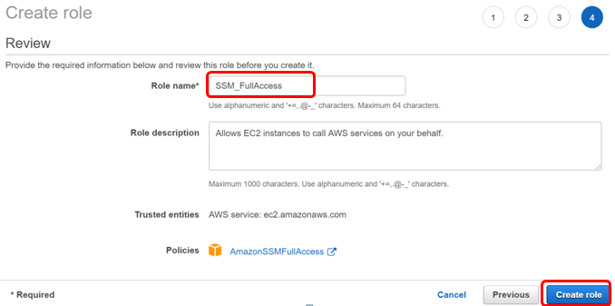

## 

## Step2: Attach a IAM Role for EC2 Instance

Go to Ec2 -> Choose a Instance -> Action-> Instance Setting-> Attach/Replace IAM role

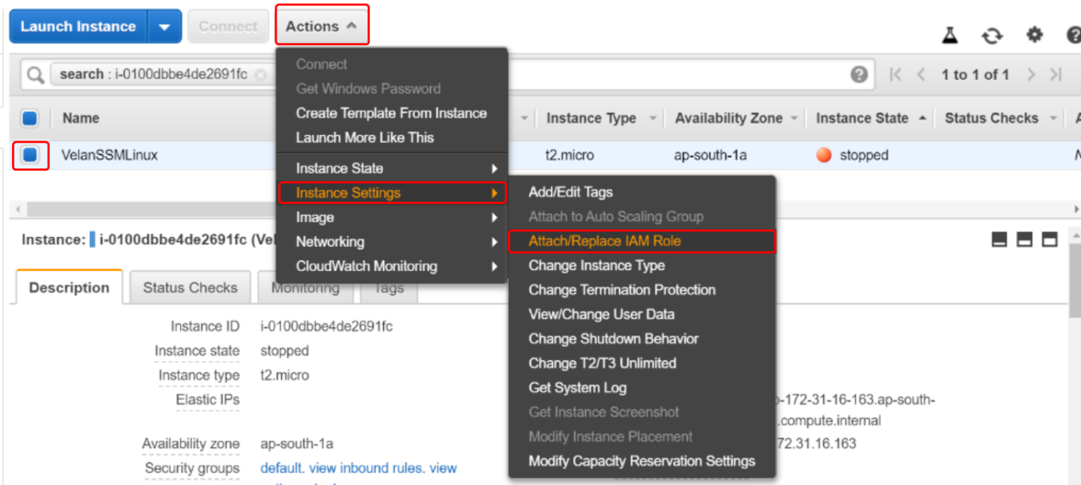

Then choose your SSM Role name & Apply.

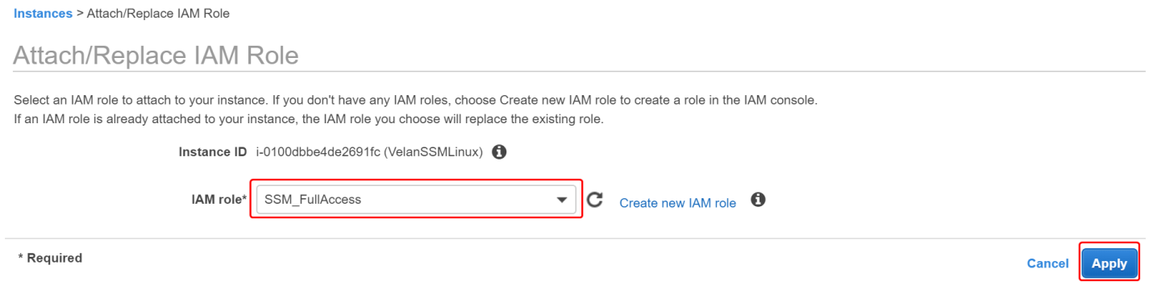

## Step3: Install the SSM Agent in your EC2 Instances

Refer the below link to install the agent.

<https://docs.aws.amazon.com/systems-manager/latest/userguide/sysman-manual-agent-install.html>

After installation check the ssm gent service is running & enable

Note : Latest AMI it will come by default in SSM.

## 

## Step4: Create a IAM role for AutomationAssumeRole for Cloudwatch target SSMAutomation

Go to IAM Console create a Role ( [SSMAutomationRole](https://console.aws.amazon.com/iam/home?region=ap-south-1#/roles/SSMAutomationRole)) for EC2 with AmazonSSMAutomationRole

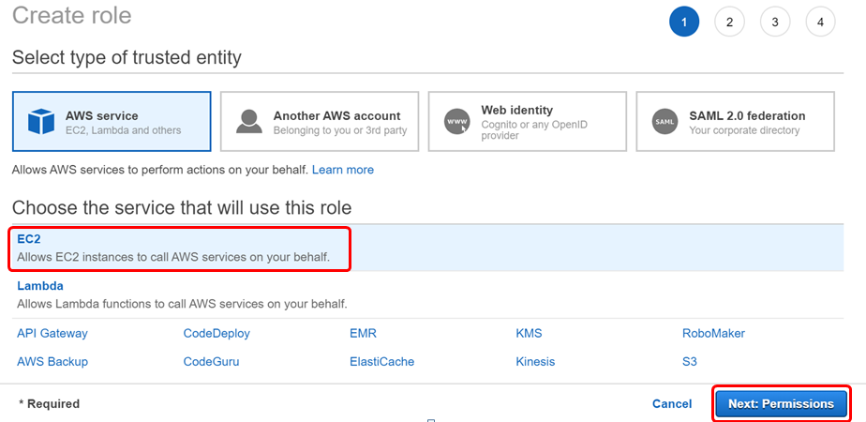

Attach permissions policies (AmazonSSMAutomationRole)

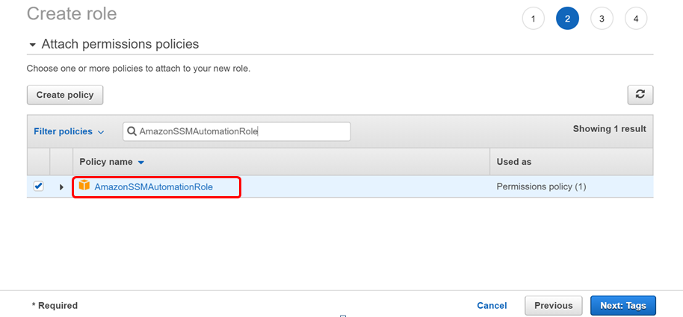

Provide a role name & review to create

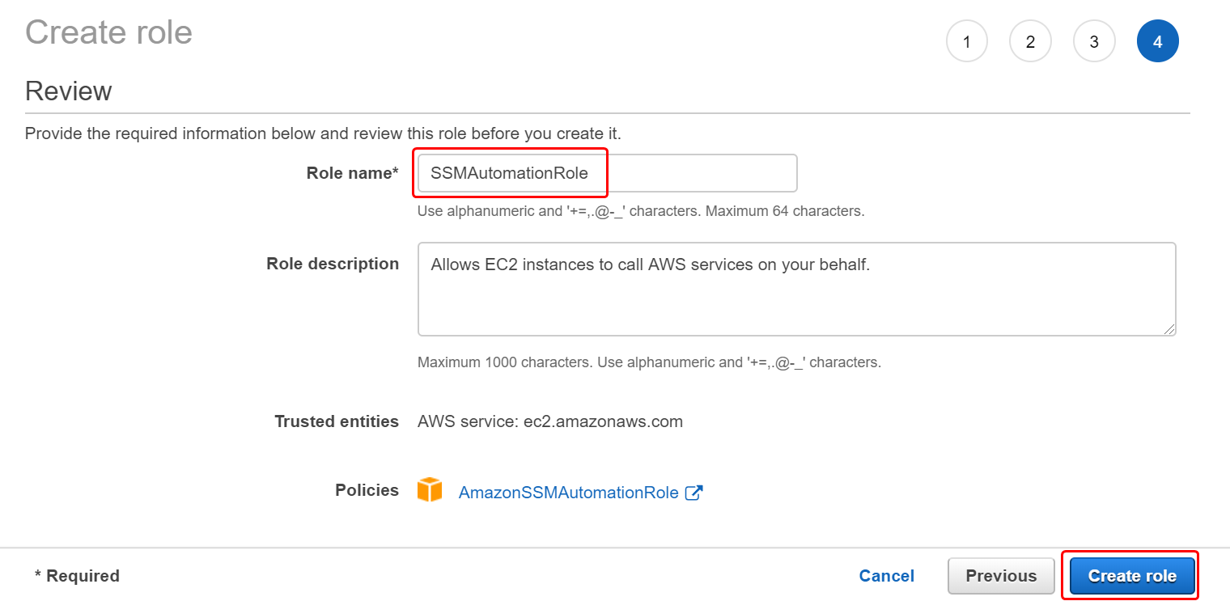

Go to the role (SSMAutomationRole) & click the Trust relationships to edit following

## 

"Service": [

"ec2.amazonaws.com",

"ssm.amazonaws.com"

]

## Step5: Create a Cloudwatch rule for EC2 instance Stop

Go to Cloudwatch -> Events -> rules -> Create rule

Click a Schedule with Cron expression and provide a time to Stop

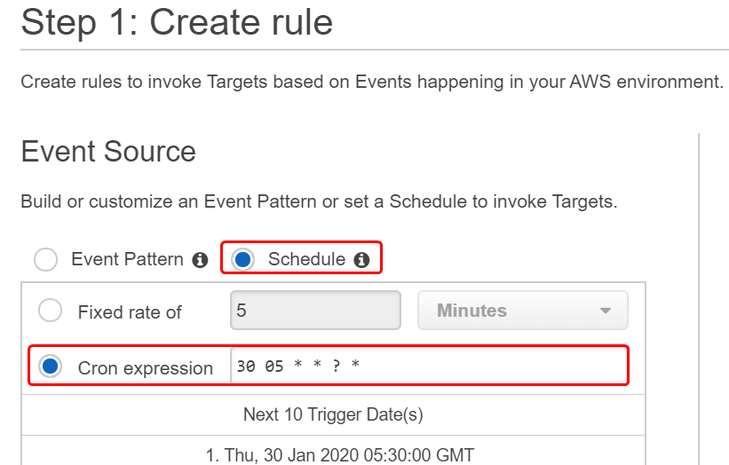

In the Same Page Click the target -> add target -> SSM Automation

Collect an SSMAutomationRole ARN

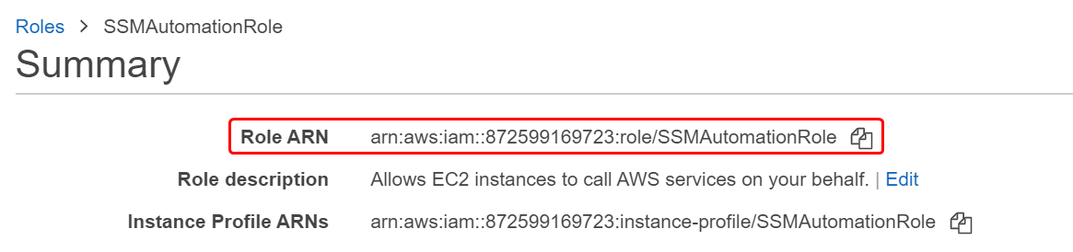

Then choose your document for AWS-StopEC2Instance and Instanced Role ARN.

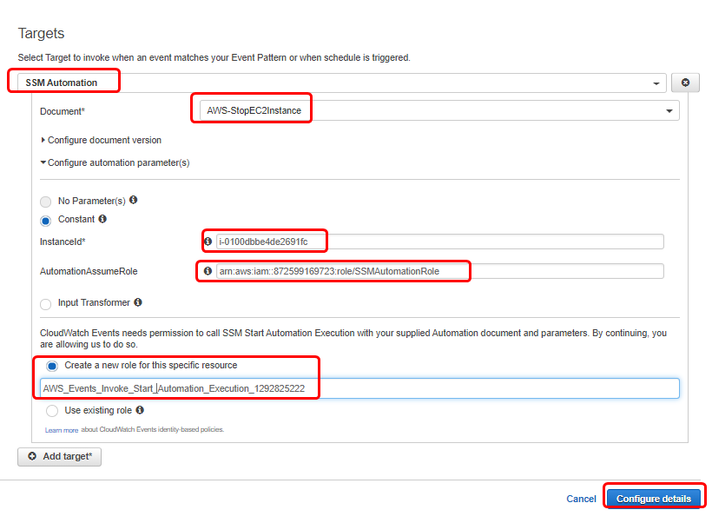

Click to Configure & provide a Role name with Description, Then Click to Create rule

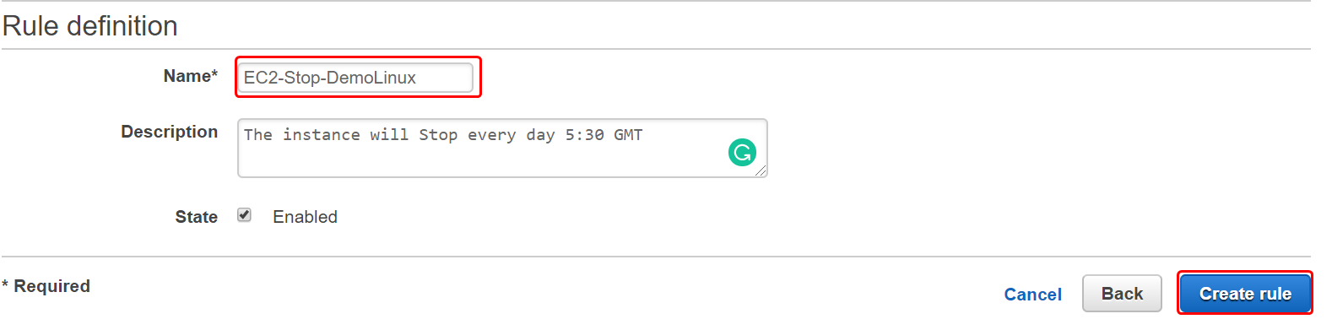

Rule is Created Successfully.



## Step5: Create a Cloudwatch rule for EC2 instance Start

Go to Cloudwatch -> Events -> rules -> Create rule

Click a Schedule with Cron expression and provide a time to Start

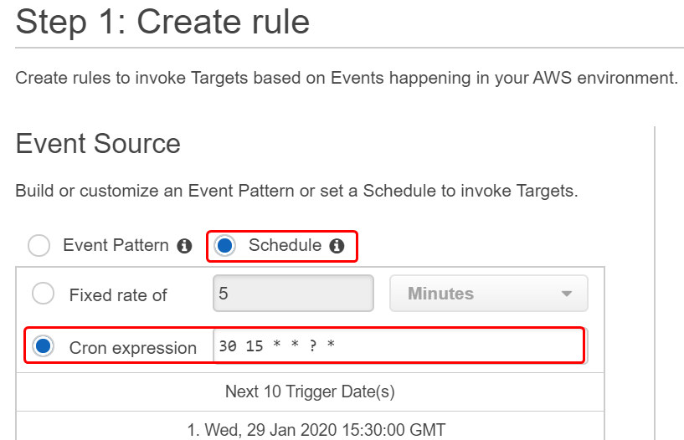

In the Same Page Click the target -> add target -> SSM Automation

Collect an SSMAutomationRole ARN



Then choose your document for AWS-StartEC2Instance and Instanced Role ARN.

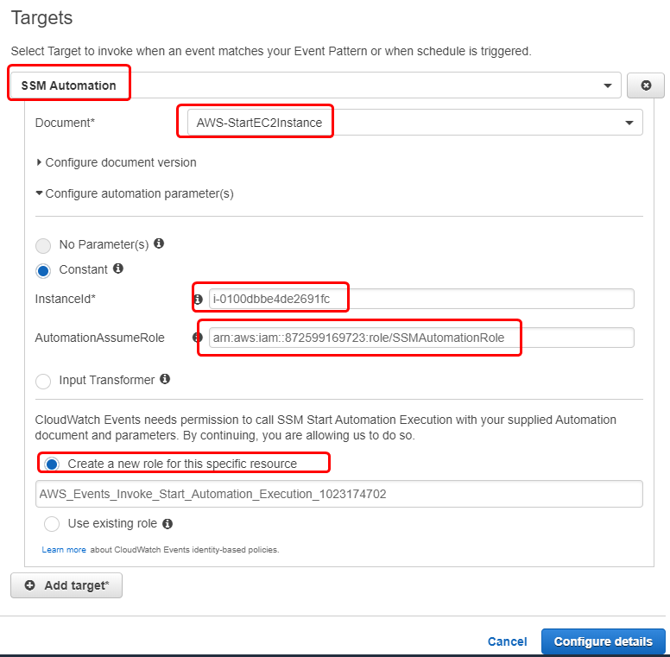

Click to Configure & provide a Role name with Description, Then Click to Create rule

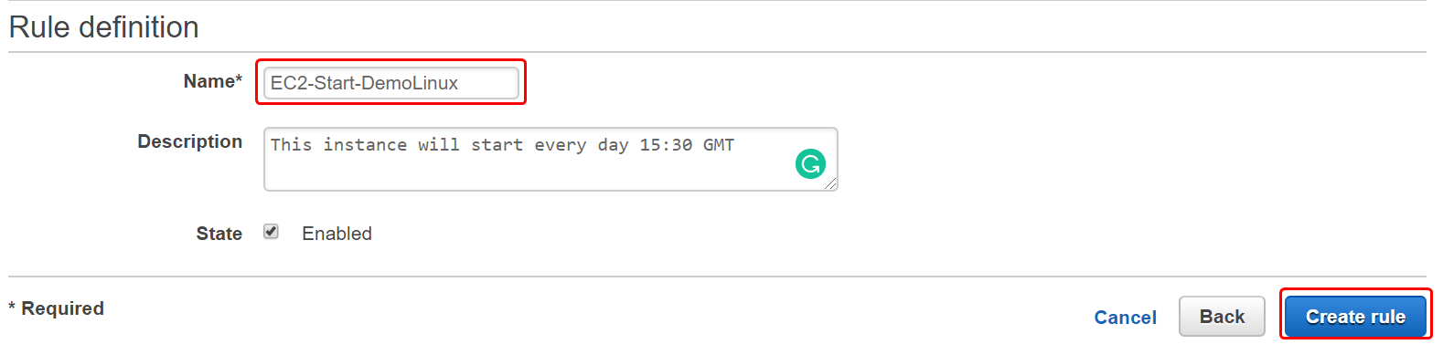

Rule is Created Successfully.

