**Carbon Black Installation Steps :**

**Ref :** <https://help.redcanary.com/get-started-with-red-canary/configure-and-deploy-edr-sensors/installing-the-carbon-black-response-sensor-on-linux>

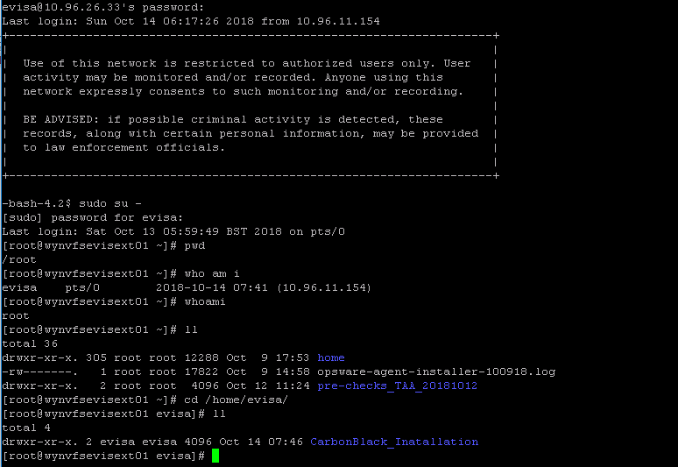

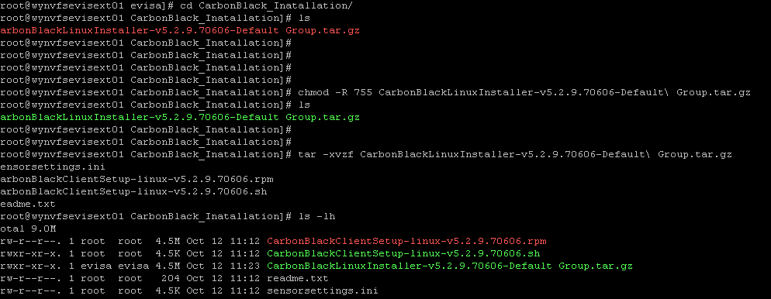

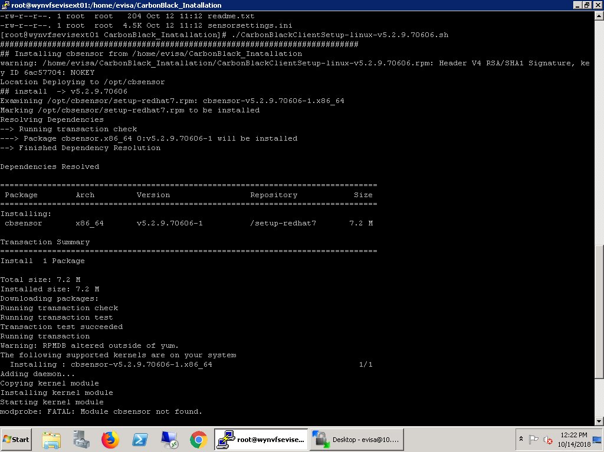

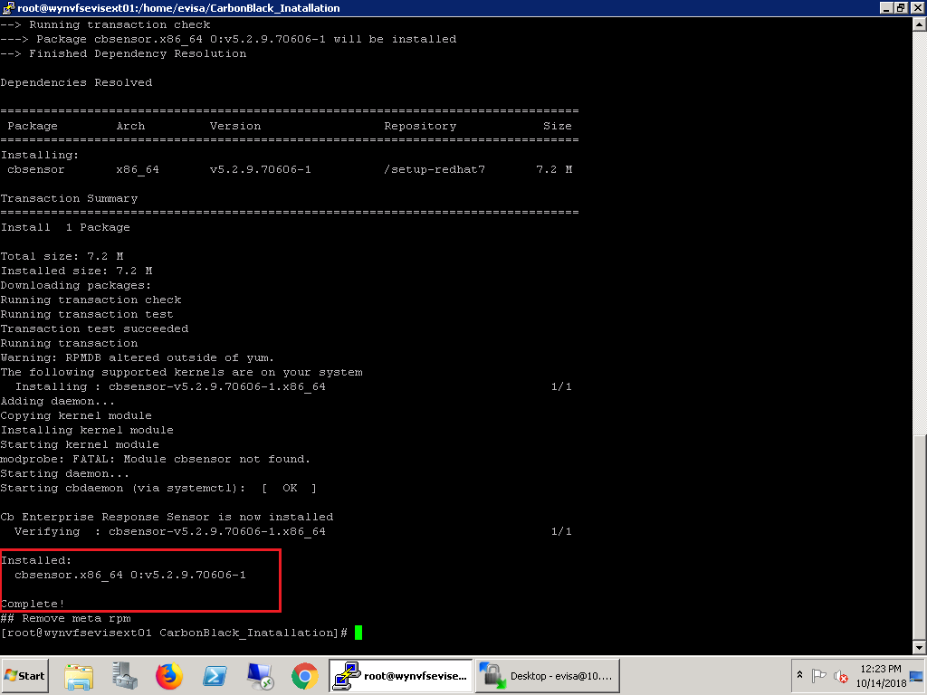

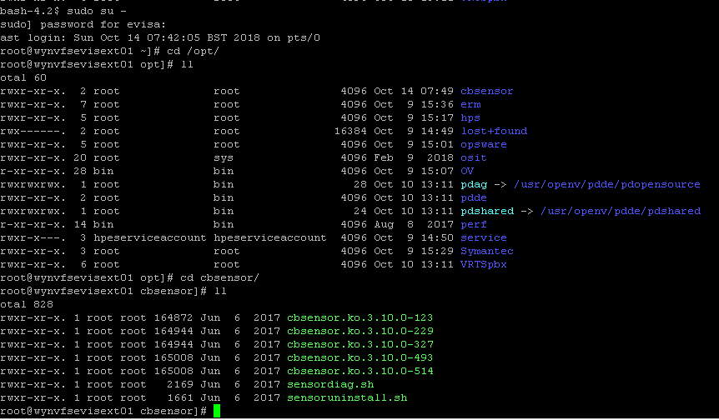

**Command to check CarbonBlack service status :**

#systemctl status cbdaemon