What Is Amazon CloudFront?

***Amazon CloudFront is a web service that speeds up distribution of your static and dynamic web content, such as .html, .css, .js, and image files, to your users. CloudFront delivers your content through a worldwide network of data centers called edge locations. When a user requests content that you're serving with CloudFront, the user is routed to the edge location that provides the lowest latency (time delay), so that content is delivered with the best possible performance***.

* If the content is already in the edge location with the lowest latency, CloudFront delivers it immediately.
* If the content is not in that edge location, CloudFront retrieves it from an origin that you've defined—such as an Amazon S3 bucket, a MediaPackage channel, or an HTTP server (for example, a web server) that you have identified as the source for the definitive version of your content.

# What is CDN?

A CDN is a content Delivery network which uses a network of all geographically dispersed severs edge locations to cache copies of content close to all users, lower latency when they download or stream objects.

# Why we need to use one?

* Large Distribution of caching servers
* Routes users to view the best location
* Caches appropriate content at the Edge
* Accelerates dynamic content
* Provides scalability and Performance of Application

# Now let’s see how to Host a Static Site on AWS, using S3 and CloudFront

Create a s3 bucket in the AWS Console

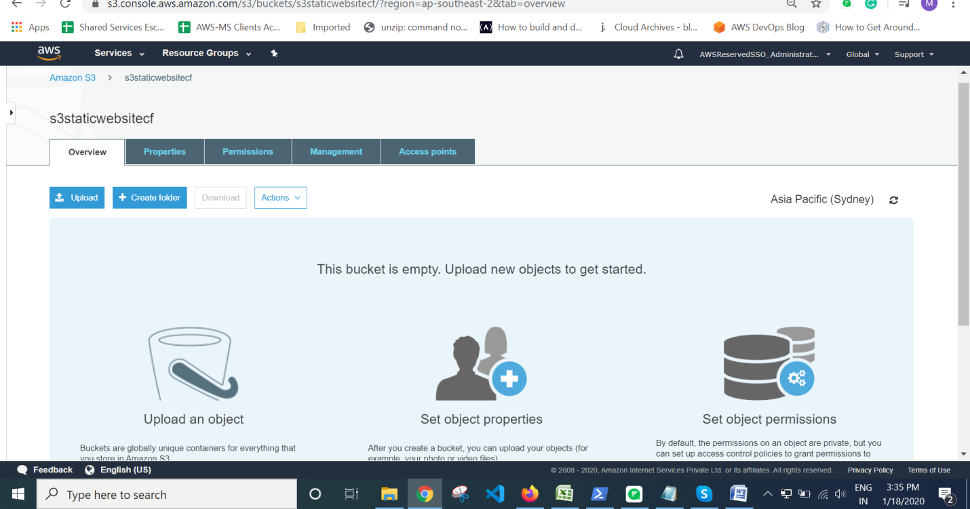

And upload your html code inside your s3 bucket

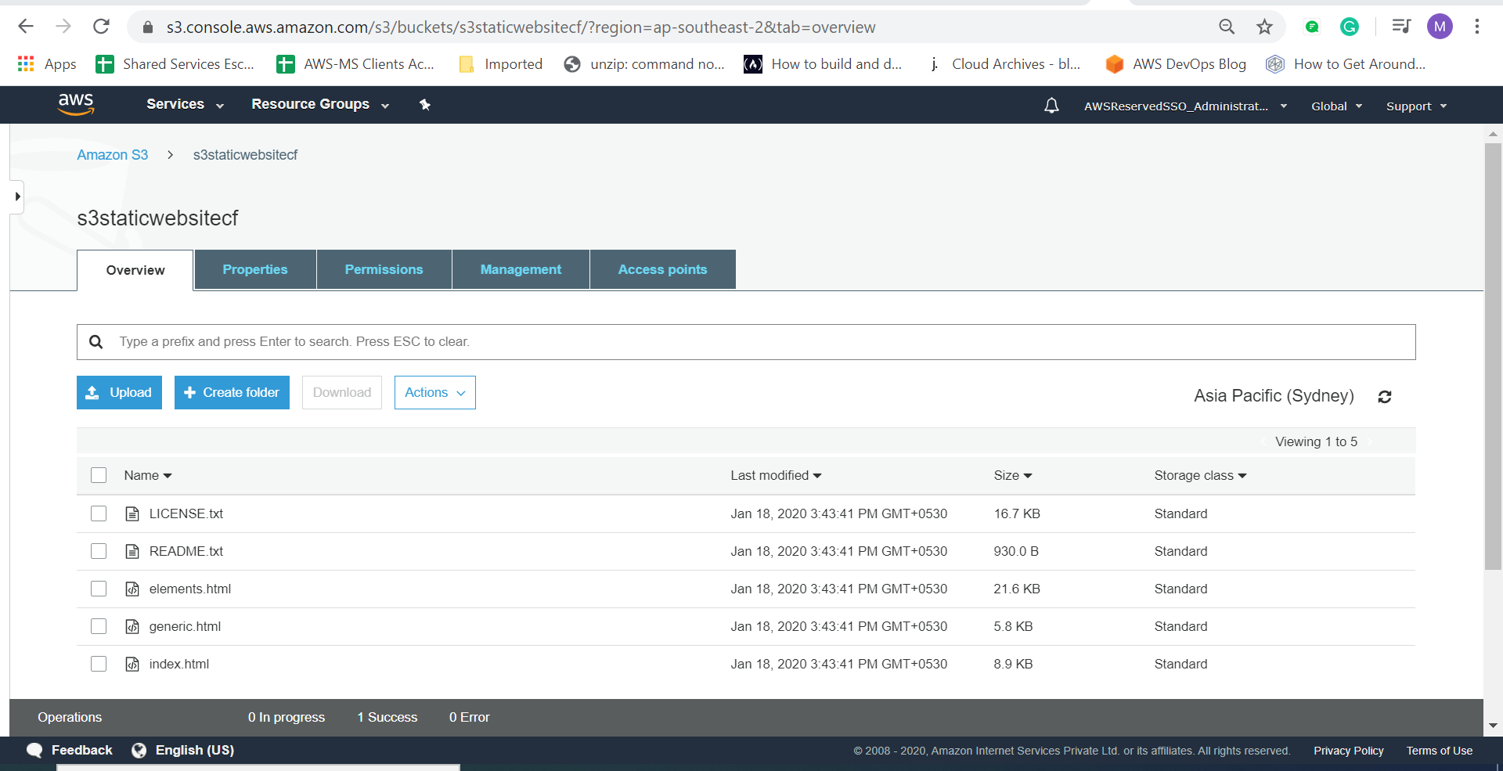

Now go to s3 bucket properties enable static website hosting

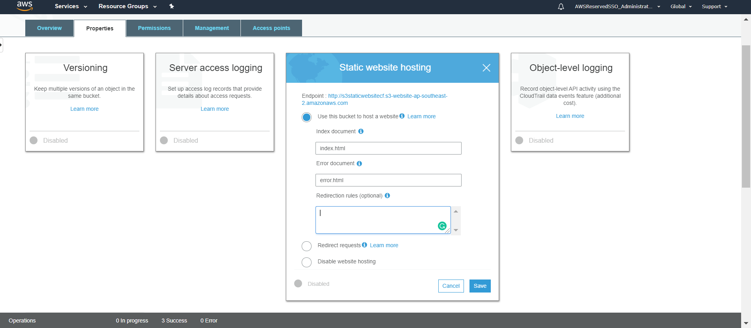

Click save

Now copy the end point URL which is mentioned above screenshot and paste the URL in your respective browser so that you can view your static website content through browser

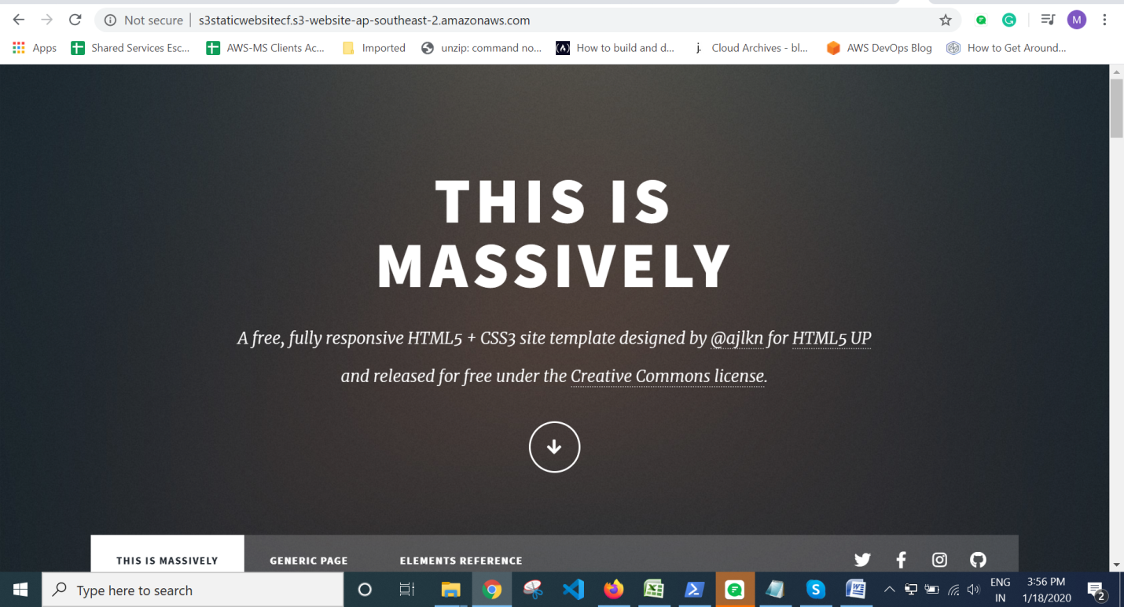

# Now going forward we are gone setup a CloudFront Distirbution

Now go to Cloud Front service in AWS Console

And Click on Create Distribution as show on the screenshot below

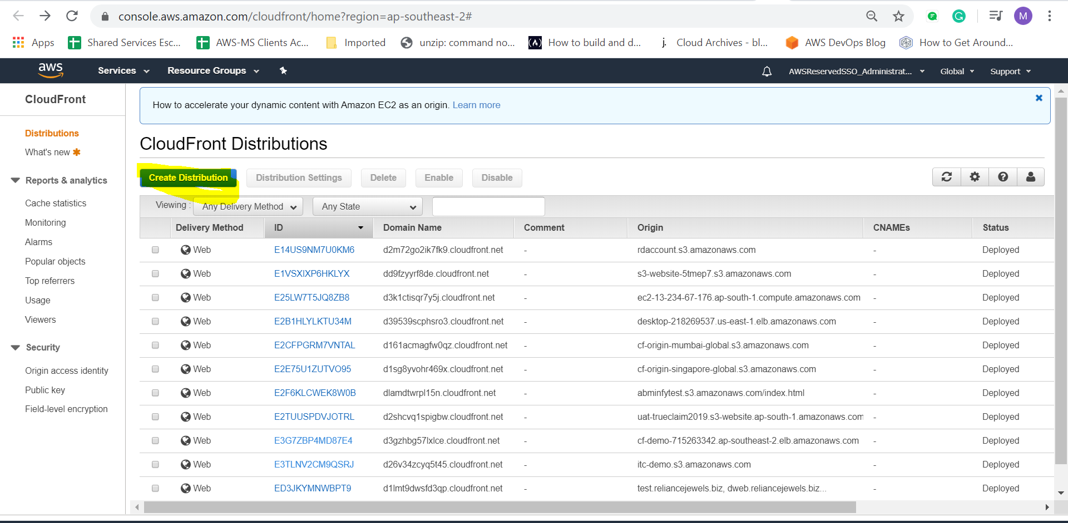

Since we are hosting our website in s3 we need to select a Web delivery method for our content

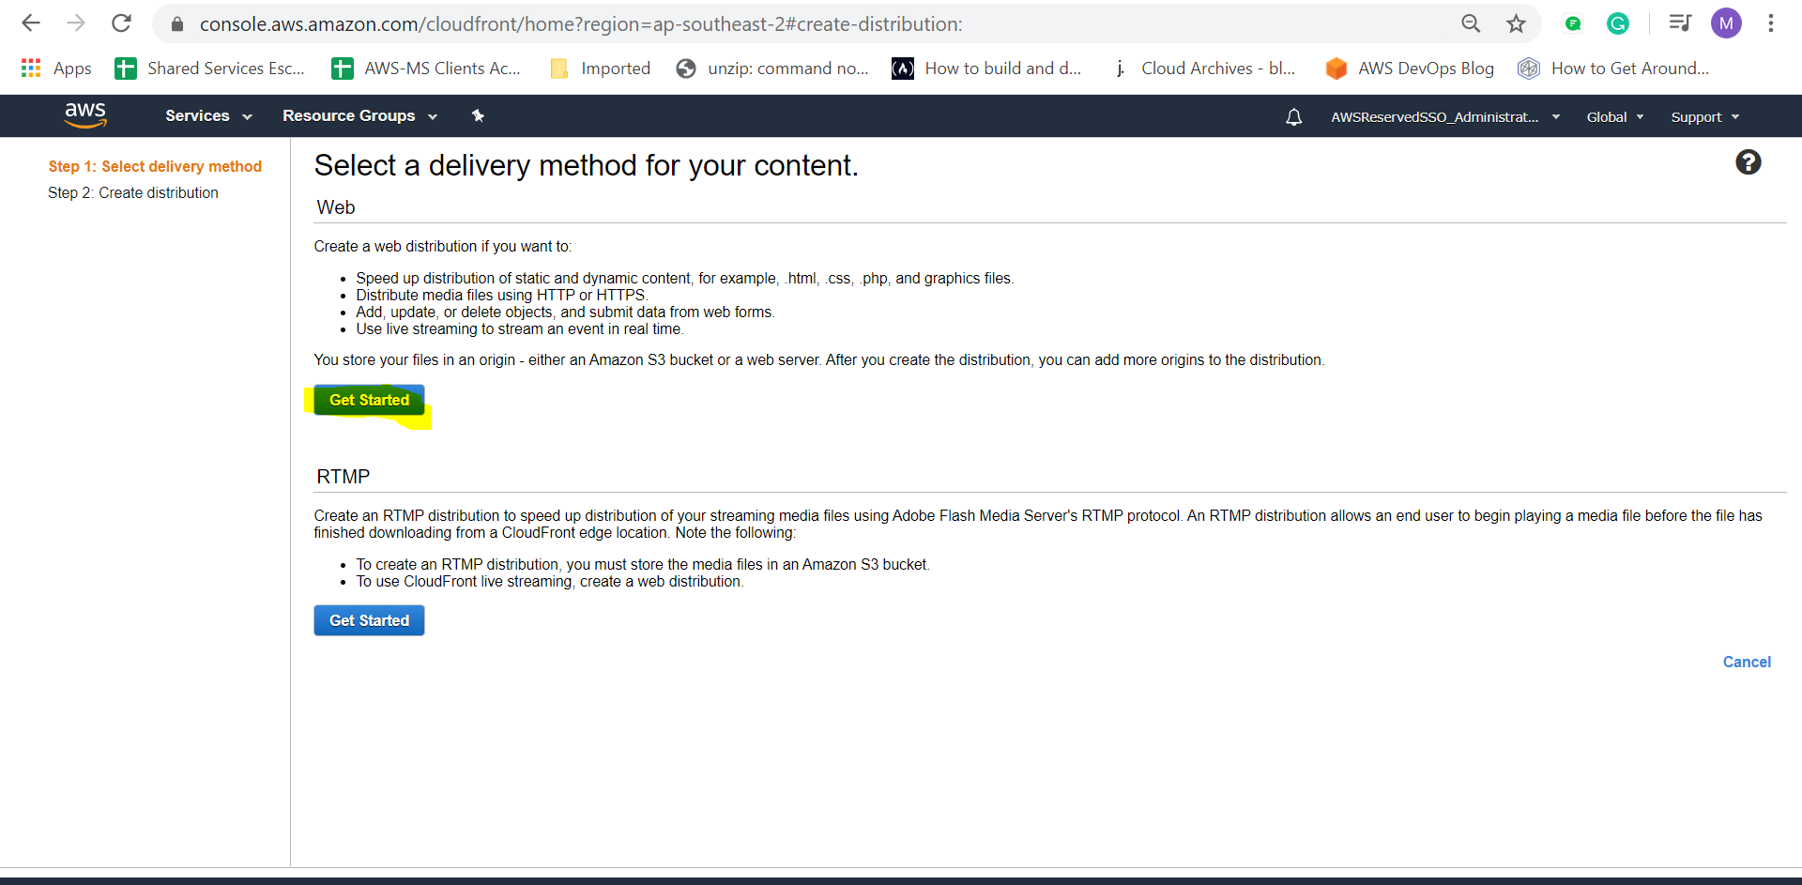

Now we need to select an origin domain name so going forward and selecting our s3 domain name here by default s3 creates a domain name when we enable static web hosting content.

Select your s3 bucket name in origin domain name box

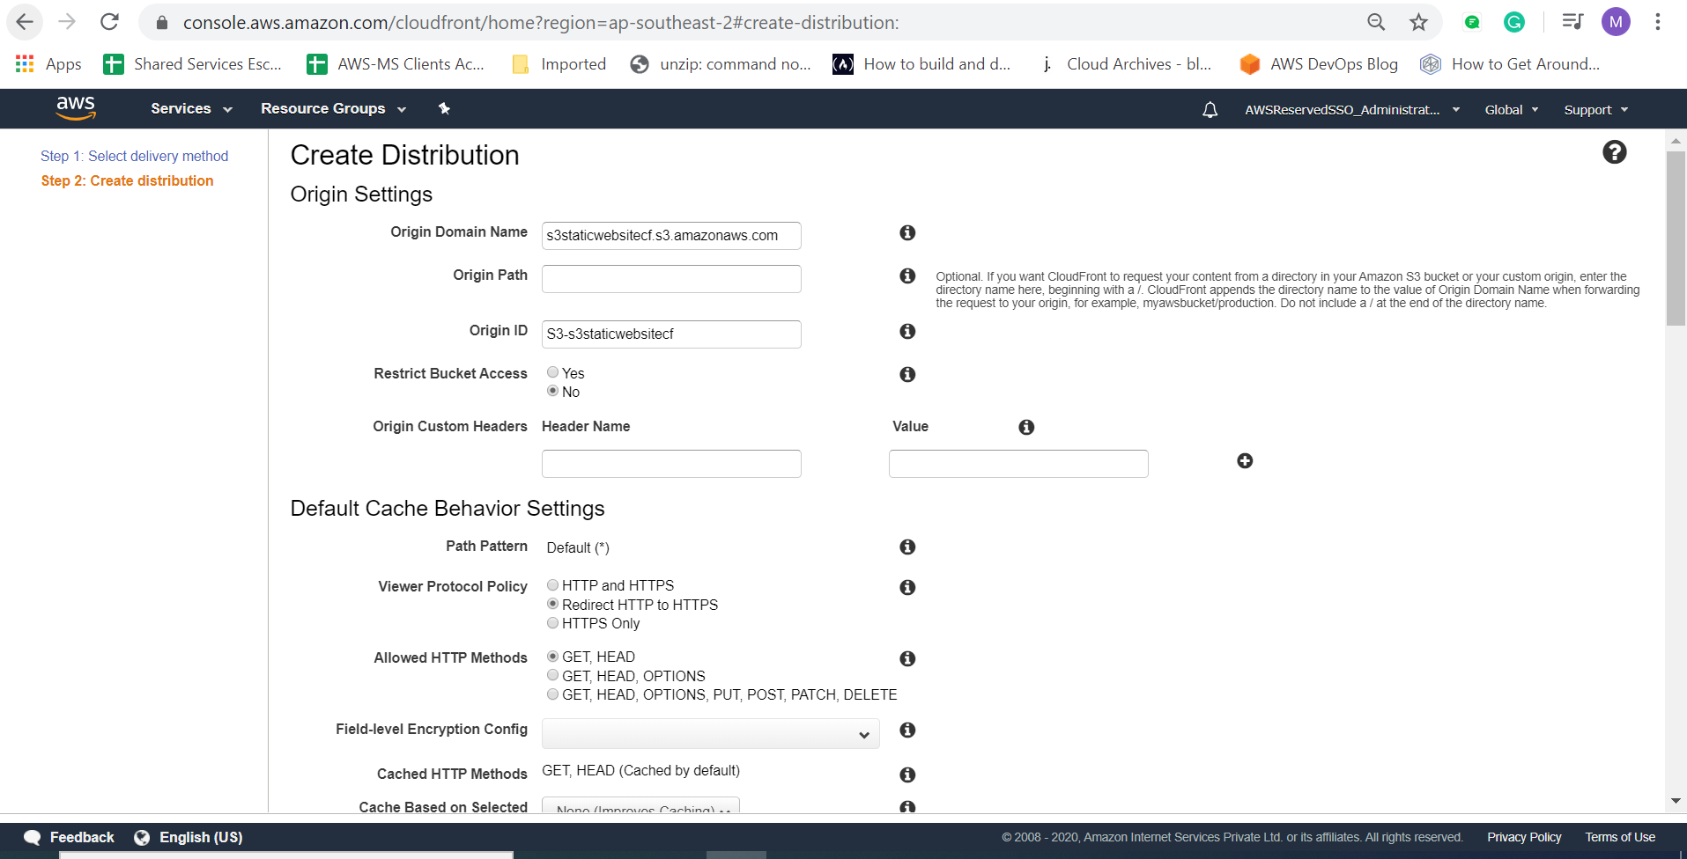

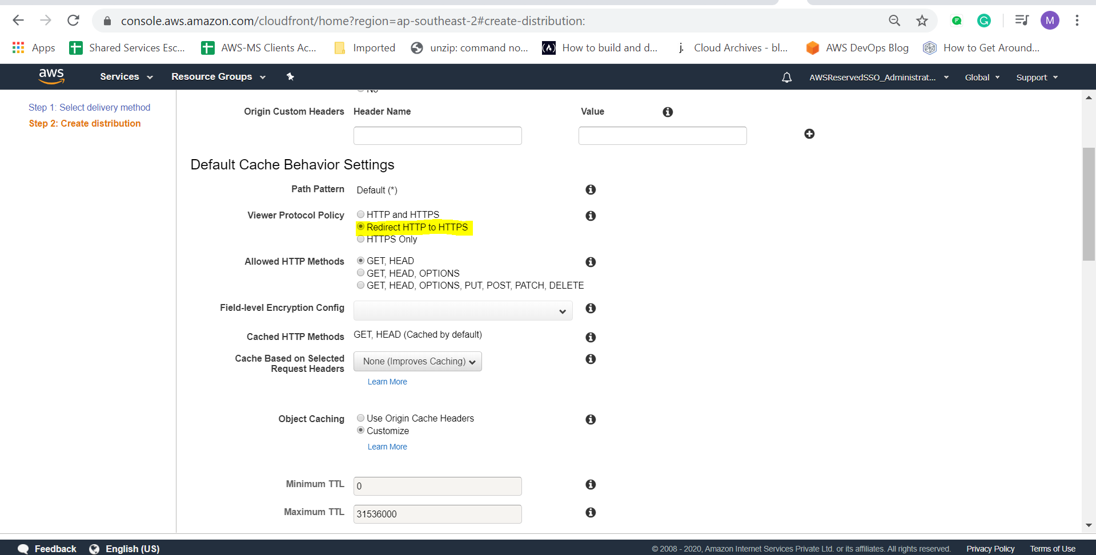

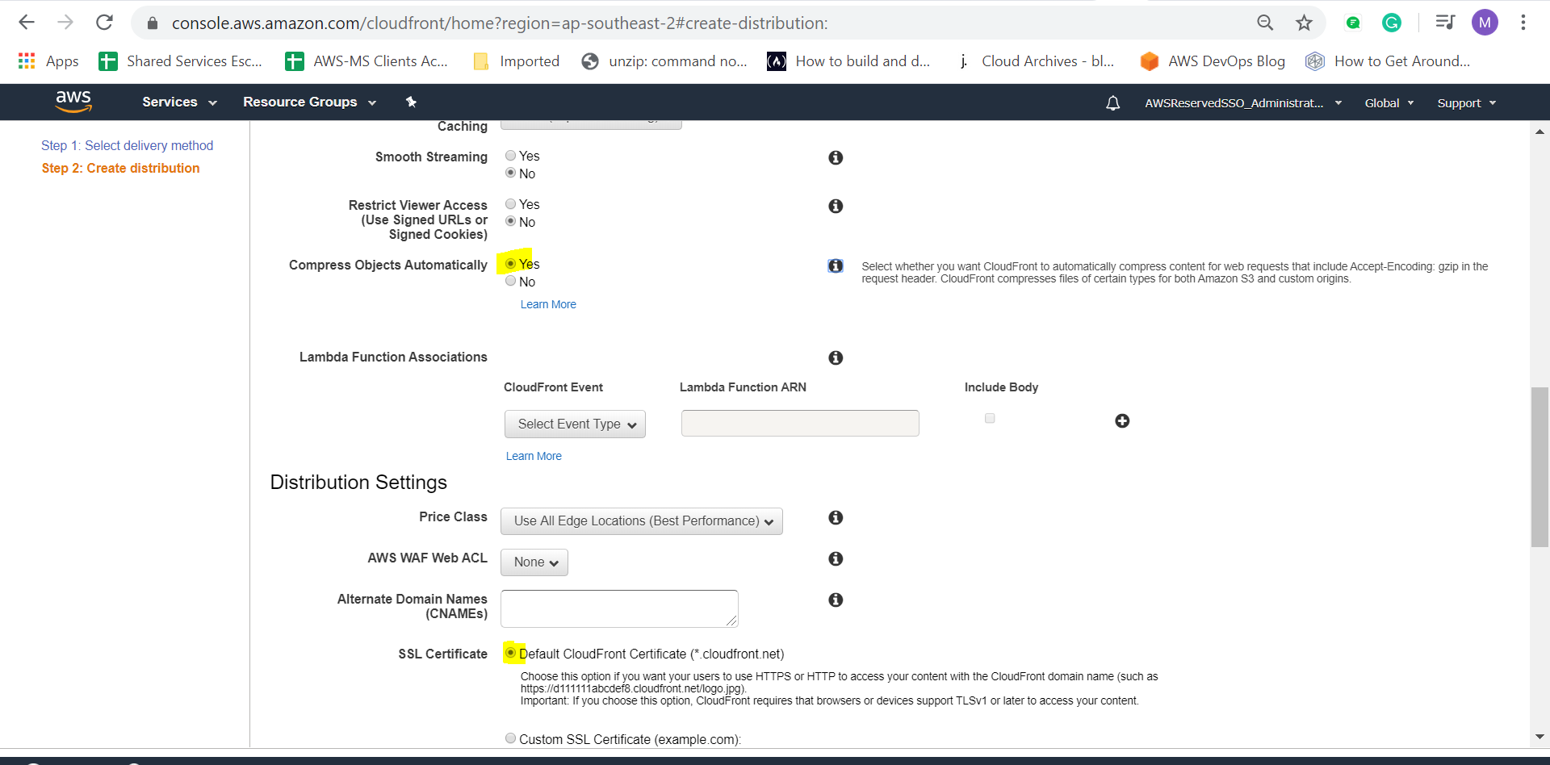

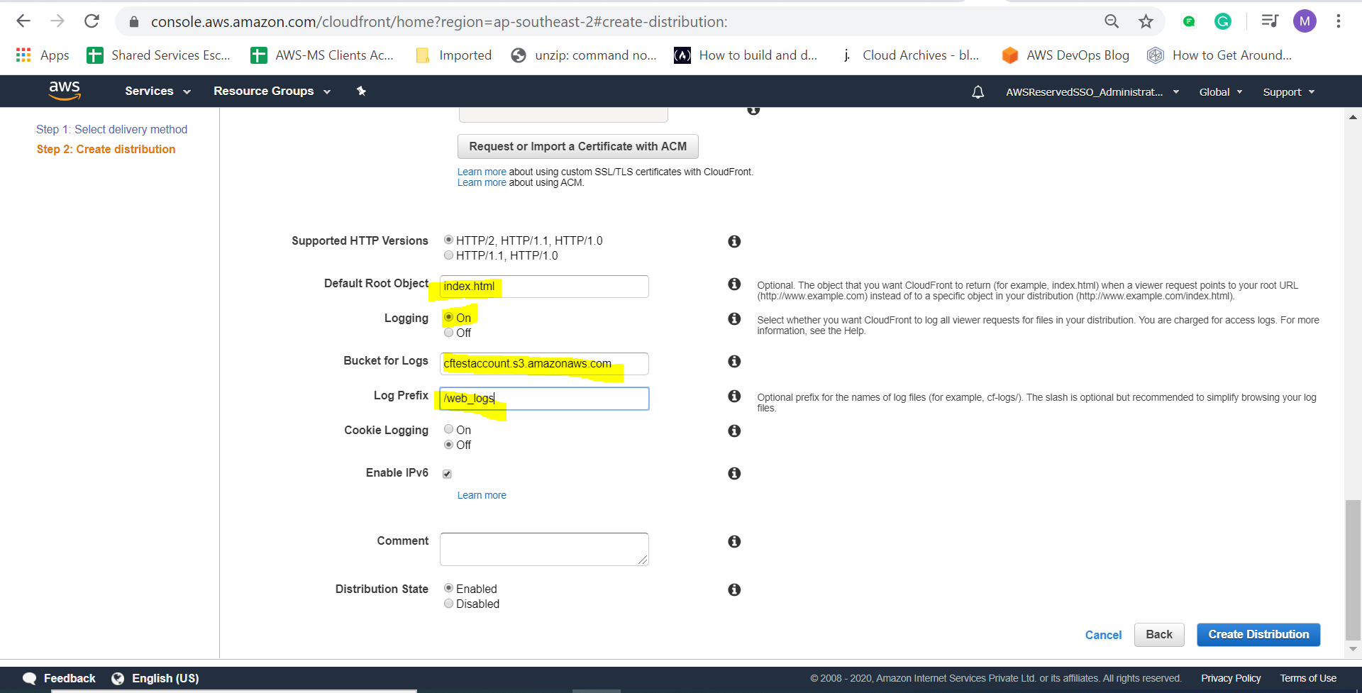

Now click on create distribution

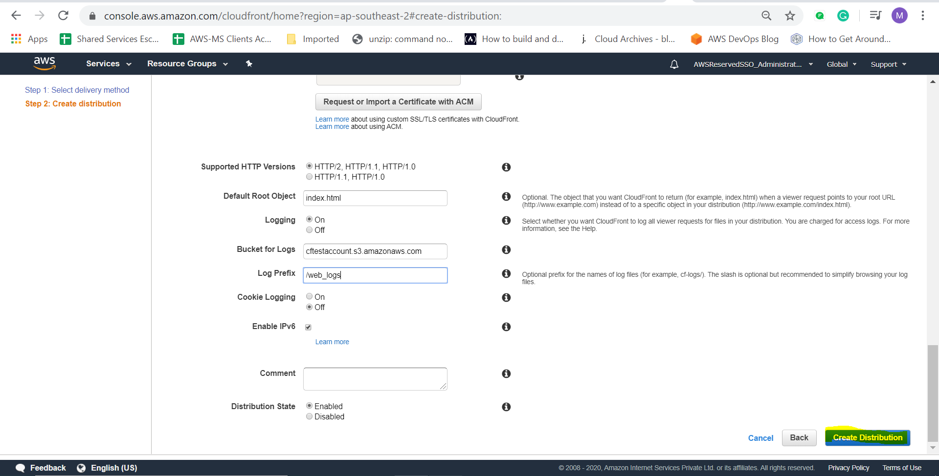

Now the CF is in progess it takes at aleast 20 min to update the cache to all the edge location.

Wait till it is completely deployed

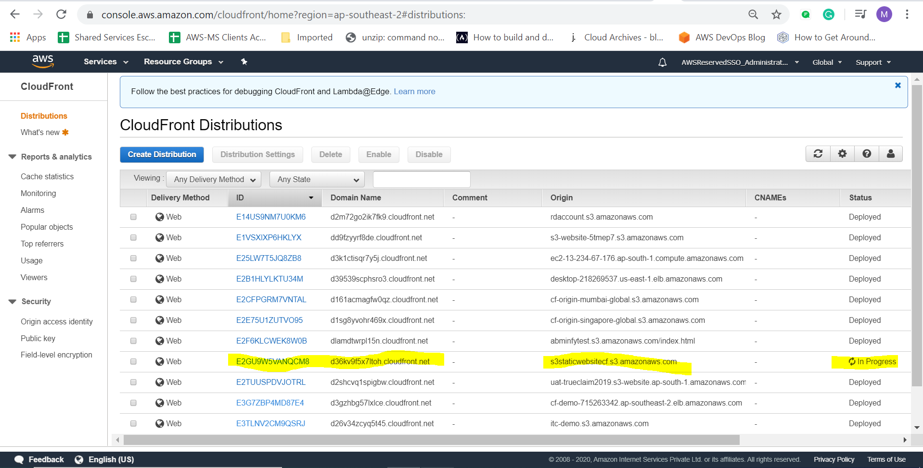

Now we are going to setup custom error page in CF

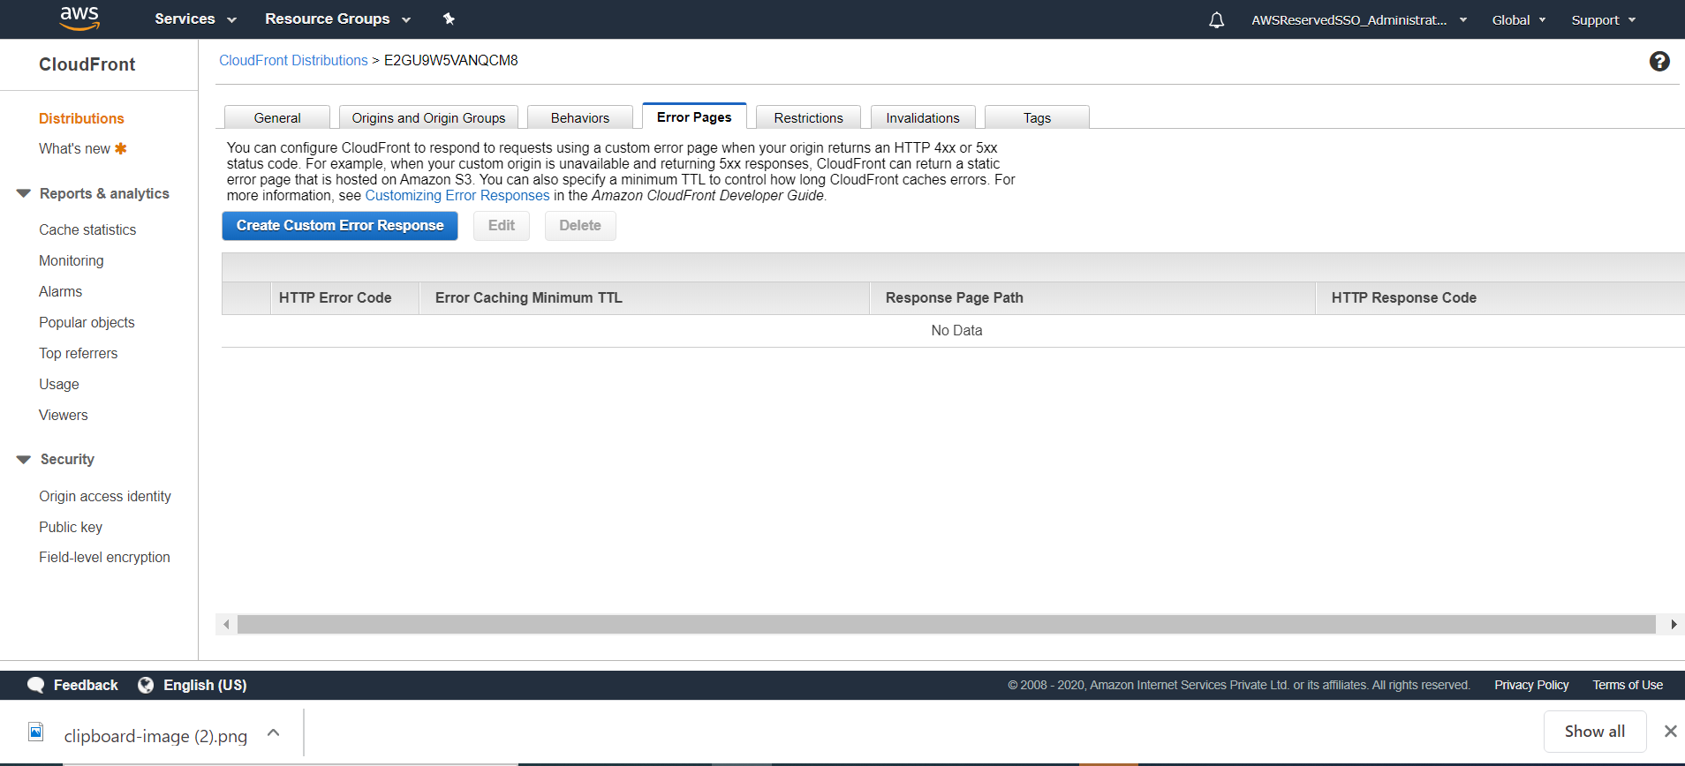

Now create the custom error page as mentioned below and give the path of the error.html and click create

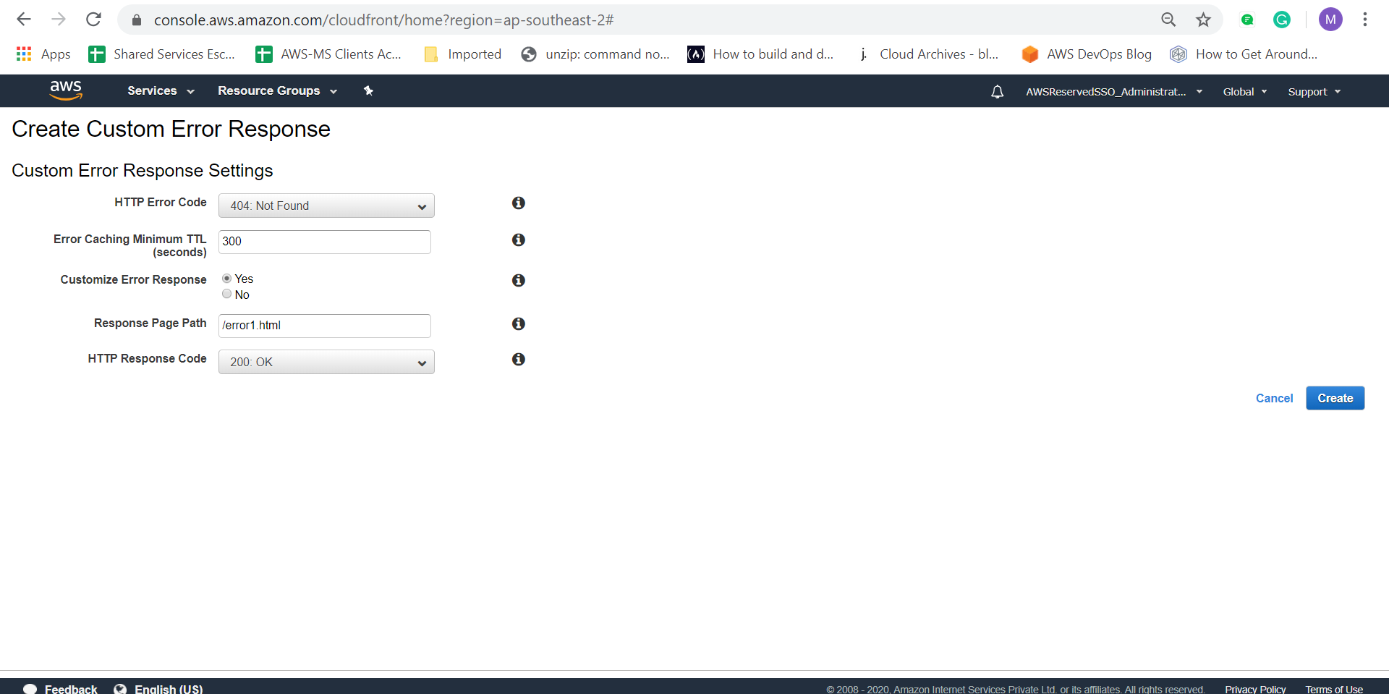

Create same as for 403 response

And as usual it takes 15 min to 20 min to deploy

Now hit the CF domain with the wrong URL

See the below screenshot

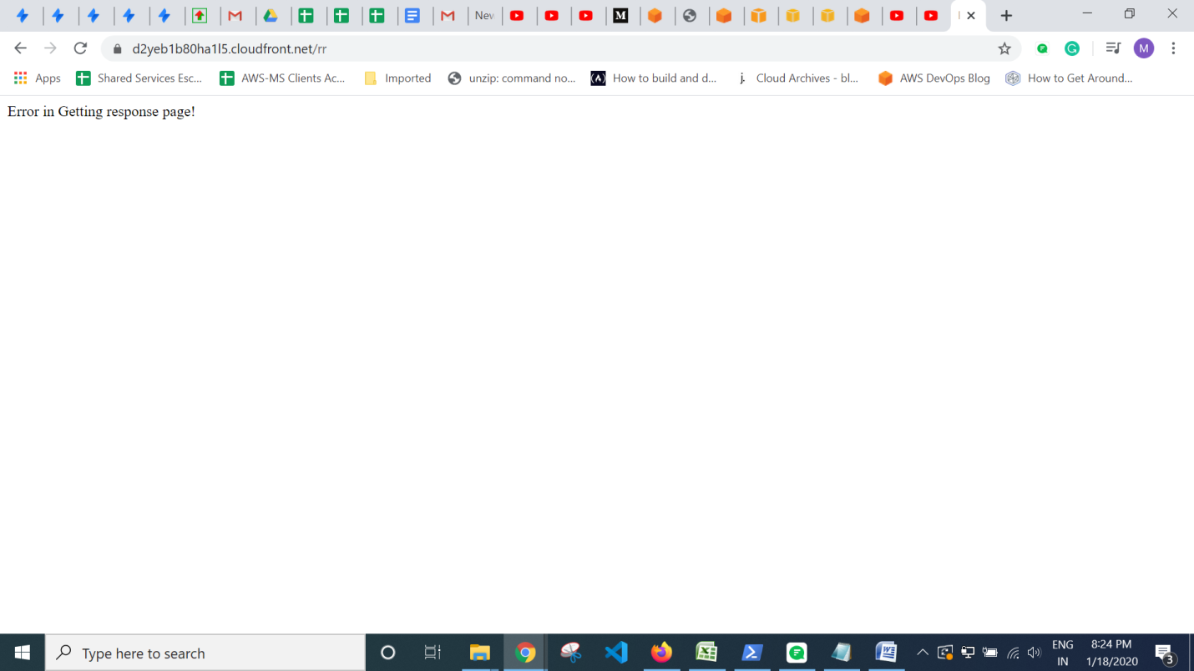

Now you can see the custom made response error in the browser

T