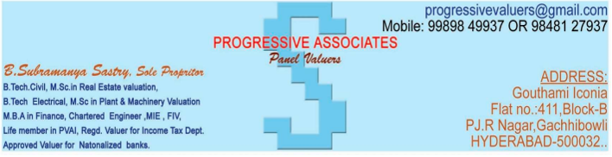

I | GENERAL
1 | Purpose for which the valuation is made | Purchase Loan.
2 | Date of inspection | System date (dd-mmm-yyyy)
 | Date of valuation | System date (dd-mmm-yyyy)
3 | List of documents produced for perusal | 1). Copy of Agreement of sale in favour of  {Searchable key words from uploaded document (AOS.PDF/AOS.docx): "In favour of" or "AND" or "Vendee" or "By and Between" or "SECOND PART". }
2). Copy of Building Permission Plan from
{Searchable key words from uploaded document (PERMISSION.PDF/ PERMISSION .docx): " Permission Number " or "PERMIT No" or "PERMIT NUMBER" or " Building Permission Number "}
3). Copy of Sale deed/DAGPA document No {Searchable key words from uploaded document
(AOS.PDF/ AOS .docx): }
4). Copy of Work Order in favour of
{Searchable key words from uploaded document (WO.PDF/WO.docx): "PLACED ON" or "AND" }
5). Copy of RERA
{Searchable key words from uploaded document (RERA.PDF): "Rera Registration Number" or "RERA" }
 |  | 6). Free holder
4 | Name of the Owner(s) | {Searchable key words from uploaded document (AOS.PDF/AOS.docx): "Vendee" or "By and Between" or "SECOND PART" or "OWNERS/LANDOWNERS/EXECUTANTS” }
 | Name of the purchaser (s) and his / their address (es) with Phone no. (details of share of each owner in case of joint ownership) | {Searchable key words from uploaded document (AOS.PDF/AOS.docx): "In favour of" or "AND" or "Vendee" or "By and Between" or "SECOND PART". }
5 | Brief description of the property (Including leasehold / freehold etc.) | {Searchable key words from uploaded document (AOS.PDF/AOS.docx): "Schedule of the property"}
6 | Prohibited Properties Details
7 | Legal Opinion
8 | Mortgage Details
 | FTL and Buffer Zone Details
9 | Location of property
 | Plot No. / Survey No.
 | Door No / House No
 | T.S. No. / Village
 | Ward / Taluka
 | Mandal / District
 | Date of issue and validity of layout of approved map / plan
 | Approved map / plan issuing authority
 | Whether genuineness or authenticity of approved map / Plan is Verified | Yes, Verified
 | Any other comments by our empanelled values on Authentic of approved plan | Title flow to be Verified with the legal opinion.
10. | Postal address of the property
11. | City / Town | City
 | Residential Area | Residential Area
 | Commercial Area | No
 | Industrial Area | No
12. | Classification of the area
 | High / Middle / Poor | Middle
 | Urban / Semi Urban / Rural | Urban
13 | Coming under Municipality limits / Village Panchayat/ Corporation
14. | Whether covered under any State / Central Govt. enactments (e.g. Urban Land Ceiling Act) or notified under agency area / scheduled area / cantonment area | No
15. | Boundaries of the Flat | As Per Deed | As Per Actuals
 | North | OPEN TO SKY | OPEN TO SKY
 | South | OPEN TO SKY | OPEN TO SKY
 | East | CORRIDOR & LIFT AND FLAT NO. 302 | CORRIDOR & LIFT AND FLAT NO. 302
 | West | OPEN TO SKY | OPEN TO SKY

