Anchor tag :

With the anchor tag we can redirect the user from current webpage to a different webpage. By specifying the path of the webpage using “href” attribute. href attribute is a mandatory attribute where its value should be provided while declaring anchor tag.

Syntax:

<a href = “ [www.google.com](http://www.google.com) “> click here </a>

Here click here will be provided with some default color, and if you click on it and visit the page the color changes . however we change the color using css class.

By default click here will be underlined , if you want to change it use text-decoration property in css class.

You can give the local path of the user custom webpages( created by user) to href . and while clicking on it the local webpages gets opened on the same page. If we want to open in the new tab we have to use target attribute in the anchor tag.

Syntax:

<a href = “ [www.google.com](http://www.google.com) “ target = “_blank” > click here </a>

Here if “ _blank” value is used in the target attribute our link we opened in the new tab. If “_self” value is given our link will be opened on the same page. By default it is set is “_self”.

Image tag :

It is used to display the image on the webpage. Image tag is a empty tag it contains attributes only , closing tags are not allowed in html image element.

Here the mandatory attribute is src attribute where the location of the image should be given

Syntax:

<img src="good_morning.jpg" alt="Good Morning Friends"/>

We can give gif in place of image also.

Attributes of img tag.

alt attribute : the alt attribute defines the alternate text for an image , if it cant be displayed.

Syntax:

< img src="image.jpg" alt=" Alt Text" >

Width , height are the attributes to set the height and width of the image . they can be given in the css class.

Title attribute :

Title attribute is used to define some extra information about the element. The value of the title attribute will be visible when you mouse over an element.

Syntax:

<p title="I'm a tooltip"> This is a Tooltip </p>

Title attribute can be added to all the elements.

// check text-whitespace , div tag further.

Whenever we are trying to give the path either for image or for the link , we can specify the path in 2 different ways.

1. Absolute path
2. Relative path

Absolute File Paths

Absolute file paths specify the complete location of a file in a system, starting from the root directory. They include the full directory path, ensuring precise file identification regardless of the current directory location.

Syntax

<img src="https://media.geeksforgeeks.org/wp-content/uploads/geek.png" alt="My Image">

Relative path :

A relative file path in HTML refers to the location of a file relative to the current web page’s location.

Syntax :

<img src="/images/geeks.jpg" alt="My Image">

Note : web address can be given relative path , it should be given only in absolute path.

To move one location backward use “../”

DOM ( document object model ) :

The dom structure indicates the tree structure representation of our webpage

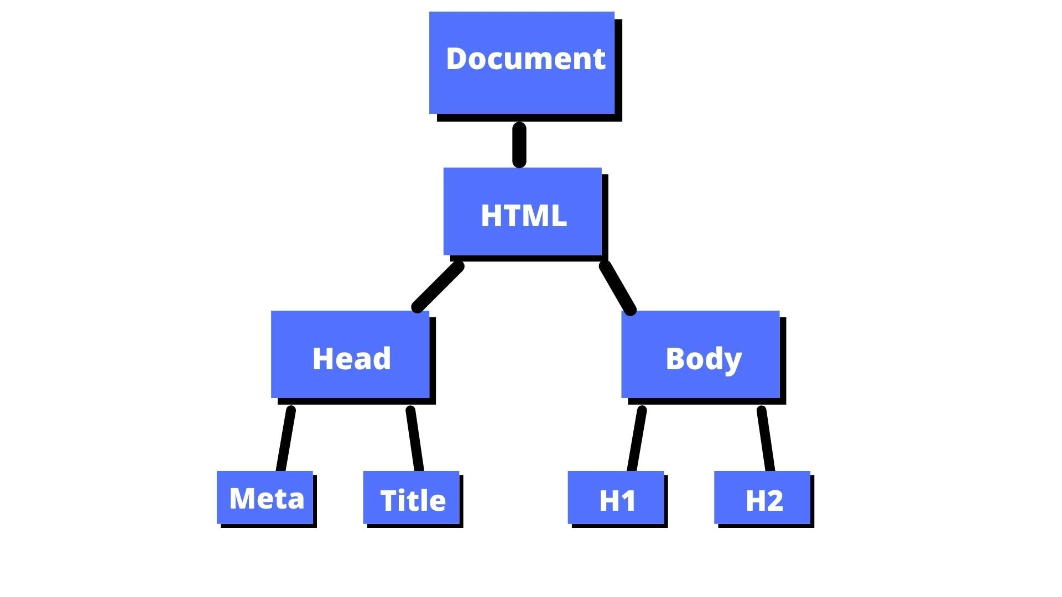

Dom element : Any html element which is part of the complete dom structure is called dom element.

