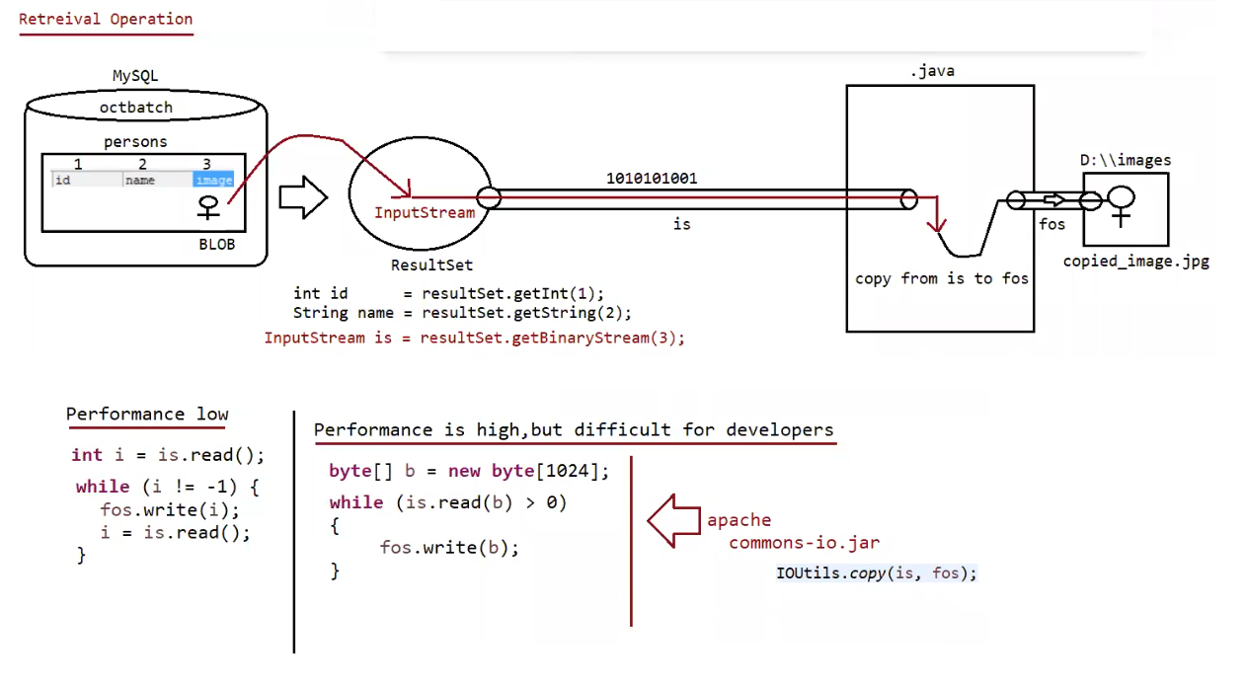

Steps to Retrieve BLOB type from Database

=========================================================

1. Prepare ResultSet object with BLOB type

ResultSet rs = st.executeQuery("select * from persons");

2. Read Normal data from ResultSet

String name=rs.getString(1);

3. Get InputStream to read binary data from ResultSet

InputStream is = rs.getBinaryStream(2);

4. Prepare target resource to hold BLOB data by using FileOutputStream

FileOutputStream fos = new FOS("katrina_new.jpg");

5. Read Binary Data from InputStream and write that Binary data to output Stream.

int i=is.read();

while(i !=- 1){

fos.write(i);

s.read();

}

(or)

byte[] b= new byte[2048];

while(is.read(b) > 0){

fos.write(b);

}

Eg: Jdbc_Image_Retrival

// go through the code

Eg: Jdbc_Image_Retrival_Apache_Lib

// go through the code

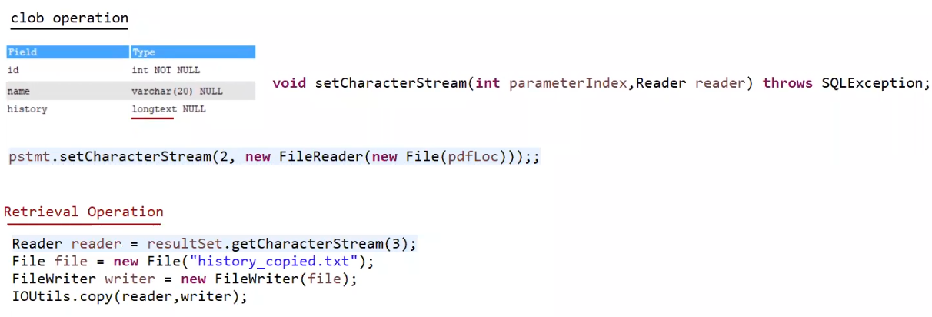

Eg: Jdbc_Pdf_Insertion_To_Database

// go through the code

Eg: Jdbc_Pdf_Retrival_From_Database

// go through the code

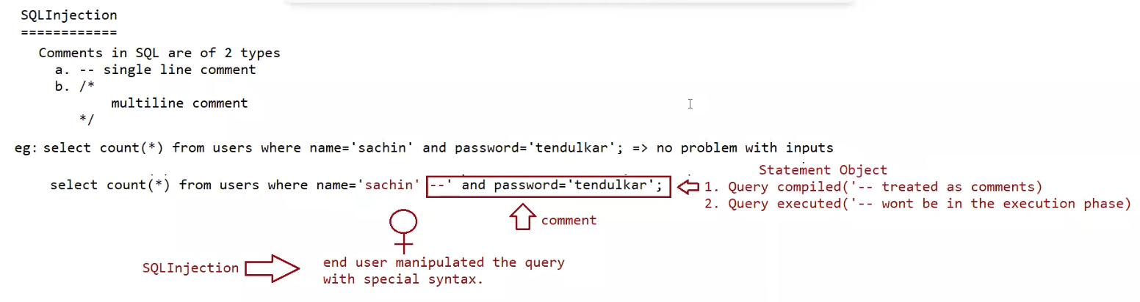

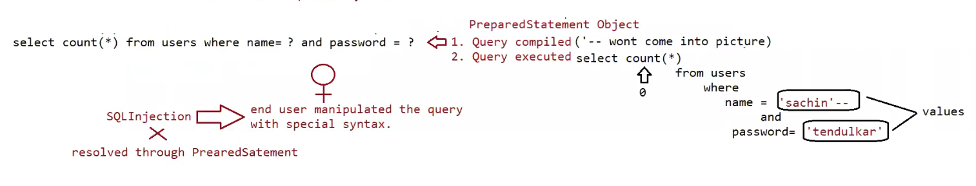

Eg: Sql_Injection_Statement_Approach

// go through the code

Eg: Sql_Injection_PreparedStatement_Approach

//go through the code