Heap Memory (Step-by-Step Creation)
Step 1️⃣: Outer array is created
• Java creates one array of size 3
• This array stores references to 2D arrays
👉 Think like this:
Outer array = list of addresses

Step 2️⃣: Middle arrays are created
• Each reference points to a 2D array of size 4
• These arrays store references to 1D arrays

Step 3️⃣: Inner arrays are created
• Each reference points to a 1D array of size 3
• These arrays store actual integer values

Heap Memory Looks Like This:
arr (stack)
↓
Heap:
Level 1 → 3 references (2D arrays)
Level 2 → each has 4 references (1D arrays)
Level 3 → each has 3 int values

📌 Important Points to Lock in Memory
✔️ Every level is a separate array object
✔️ Java does not store 3D arrays as one block
✔️ All arrays are stored in heap memory
✔️ Only the reference is stored in stack

4️⃣ Example Usage (Understand Indexing Clearly)
arr[0][1][2] = 85;
How Java reads this:
1️⃣ arr[0]
→ select the 2D array at index 0
2️⃣ arr[0][1]
→ select the 1D array at index 1
3️⃣ arr[0][1][2]
→ select position 2 and store 85
In very simple words:
• Level-1 group = 0
• Level-2 group = 1
• Value position = 2
• Stored value = 85

5️⃣ When Should We Use a 3D Array?
🧠 CORE IDEA
👉 Use a 3D array when data has three levels of grouping.
Examples:
• Country → State → City
• College → Class → Student
• Company → Department → Employee
• Book → Chapter → Page

⚠️ Small but Very Important Clarification (Mistake Fix)
❌ Wrong thinking
A 3D array is a cube in memory
✅ Correct thinking
A 3D array is an array of arrays of arrays
That is why Java allows uneven sizes:
int[][][] arr = new int[3][][];
arr[0] = new int[2][];
arr[1] = new int[4][];
arr[2] = new int[1][];
Each level:
✔️ Is created separately
✔️ Can have different length

🧠 One-Line Gold Summary (Memorize This)
👉 A 3D array in Java is an array that stores references to 2D arrays, which store references to 1D arrays, so each level is a separate object in heap memory.

Memory representation of 3d – array
int[][][] arr = new int[3][4][3]
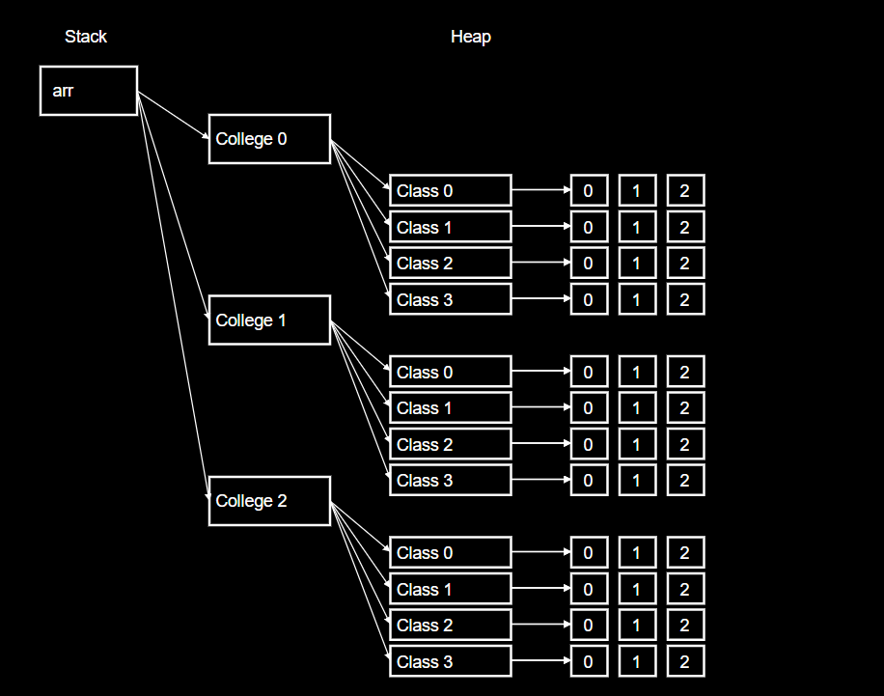

📘 Two-Dimensional Jagged Array (Jagged 2D Array)

🧠 CORE POINT (Memorize This – MOST IMPORTANT)
👉 A jagged 2D array is accessed using two indexes, but each inner array can have a different length.
This single line is the heart of jagged arrays.

🔍 Explain the Core Point (Slow & Clear)
What does “different length inner arrays” mean?
• A jagged array is still a 2D array
• The first level does not store values
• The first level stores references to inner arrays
• Each inner array is created independently
• Because they are independent, their sizes can differ
📌 That is why the structure looks uneven (jagged).

🧩 How Indexing Works (Step-by-Step Thinking)
Example:
int[][] arr = new int[3][];

Step 1️⃣: First index
arr[1]
• This does not give a value
• It gives one inner array
So:
👉 First index → selects which inner array

Step 2️⃣: Second index
arr[1][1]
• Now we go inside that selected inner array
• This gives the actual value
So:
👉 Second index → selects the value inside the inner array

🔑 Why it is called “Jagged”
• Inner arrays are not forced to be equal in size
• Each inner array is created separately
• Their lengths may differ
📌 Unequal inner arrays = Jagged array

🧠 One-Line Memory Hook (Very Strong)
👉 First index chooses the inner array, second index chooses the value — inner array sizes can differ.
If you remember this line, you will never forget jagged arrays.

❌ What NOT to Remember (Avoid Confusion)
❌ Rows
❌ Columns
❌ Tables
❌ Matrices
These ideas hide the real concept.

✅ Final Perfect Definition (Exam + Interview Safe)
👉 A jagged 2D array in Java is a 2D array where each element of the outer array points to an inner array that can have a different length.

2️⃣ Syntax (Core Idea First)
🧠 CORE IDEA
👉 First create the outer array, then create each inner array separately.

Declaration
int[][] arr = new int[3][];
• Outer array size = 3
• Inner array sizes are not decided yet

Creating Inner Arrays
arr[0] = new int[5];
arr[1] = new int[3];
arr[2] = new int[6];
📌 Each inner array:
• Is created independently
• Can have any length

3️⃣ How Jagged Array Is Stored in Memory
🧠 CORE IDEA
👉 A jagged array is an array that stores references to independent inner arrays.

Stack Memory
• Stack stores only the reference variable arr
• arr points to heap
arr → heap

Heap Memory (Step-by-Step)
Step 1️⃣: Outer array
• One array of size 3
• Stores 3 references

Step 2️⃣: Inner arrays
• Reference 0 → inner array of size 5
• Reference 1 → inner array of size 3
• Reference 2 → inner array of size 6
Heap structure:
ref → [ ] [ ] [ ] [ ] [ ]
ref → [ ] [ ] [ ]
ref → [ ] [ ] [ ] [ ] [ ] [ ]
✔️ Each inner array is a separate object
✔️ Sizes are unequal

📌 Important Points to Lock in Memory
✔️ Jagged array is still 2D
✔️ Inner arrays are independent objects
✔️ Java does not force same length
✔️ Saves memory for uneven data

4️⃣ Example Usage (Understand Indexing Clearly)
arr[1][1] = 25;
How Java reads this:
1️⃣ arr[1]
→ select the inner array at index 1
2️⃣ arr[1][1]
→ select index 1 inside that inner array
3️⃣ = 25
→ store value 25

In very simple words:
• First index = which inner array
• Second index = which value
• Stored value = 25

5️⃣ When Should We Use Jagged Arrays?
🧠 CORE IDEA
👉 Use jagged arrays when each group has different amount of data.
Examples:
• Groups with uneven counts
• Variable-length data sets
• Hierarchical data with uneven depth

🧠 One-Line Gold Summary (Memorize This)
👉 A jagged 2D array is a 2D array where each inner array is created separately and can have a different length.
