Eg: Array_3D_Jagged_Eg2
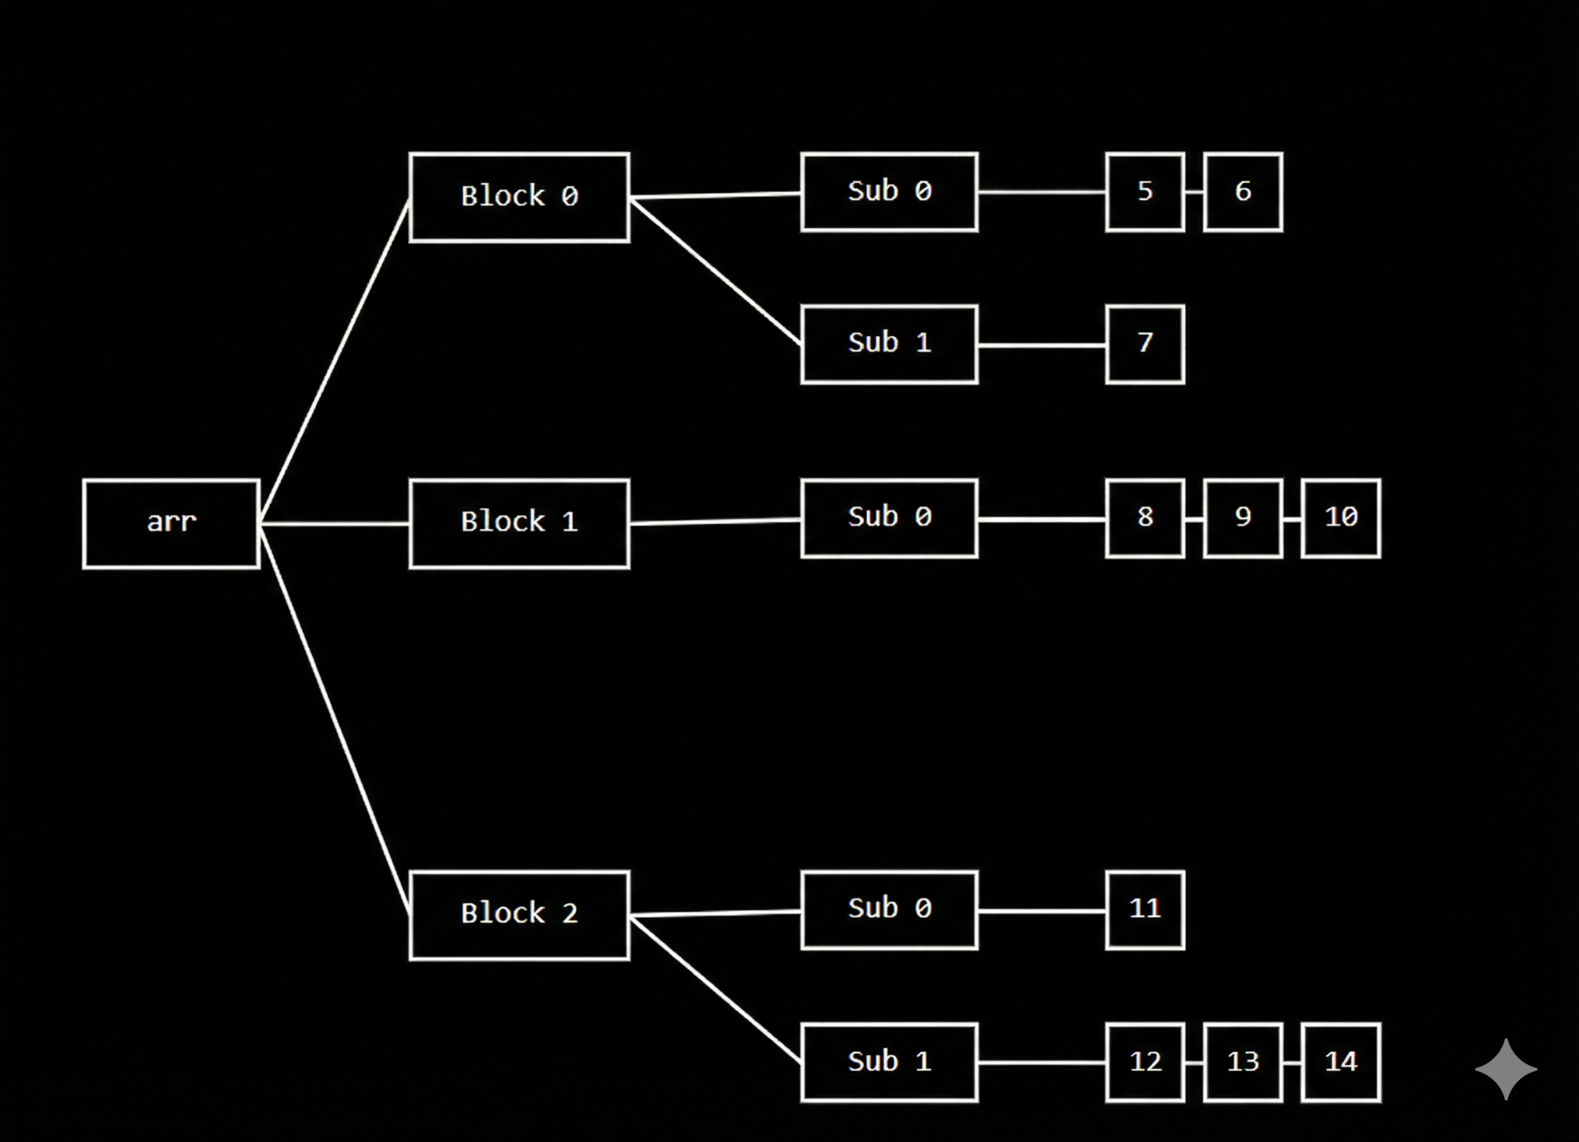

🔹 Given 3D Jagged Array (Target Structure)
We want the loops to finally create this exact structure:
int[][][] arr = {
{ {5, 6}, {7} },
{ {8, 9, 10} },
{ {11}, {12, 13, 14} }
};

🔹 Meaning of This Structure
First dimension (outer) size = 3
arr[0] → 2 inner arrays
arr[1] → 1 inner array
arr[2] → 2 inner arrays
Inner sizes:
arr[0][0] → 2 elements
arr[0][1] → 1 element

arr[1][0] → 3 elements

arr[2][0] → 1 element
arr[2][1] → 3 elements

🔹 Loops Under Discussion
// Create the outermost array
int[][][] arr = new int[colleges][][];

// Step 2: Take the number of classes for each college
for (int i = 0; i < colleges; i++) {
int classes = sc.nextInt();
arr[i] = new int[classes][];
}

// Step 3: Take the number of students for each class
for (int i = 0; i < arr.length; i++) {
for (int j = 0; j < arr[i].length; j++) {
int students = sc.nextInt();
arr[i][j] = new int[students];
}
}
So:
colleges = 3

🔸 Initial State (Before Loops)
arr → [ null , null , null ]
Memory now:
arr →
[
null,
null,
null
]

🔁 OUTER LOOP : Iteration – 0
int i = 0 ; i (0) < 3 → true
classes = 2
(because arr[0] has 2 inner arrays)
arr[0] = new int[2][]
Memory now:
arr →
[
[ null , null ],
null,
null
]

inner loop : iteration – 0
j = 0 ; j (0) < 2 → true
students = 2
(because arr[0][0] has 2 elements)
arr[0][0] = {5, 6}
Memory now:
arr →
[
[
[ 5 , 6 ],
null
],
null,
null
]

inner loop : iteration – 1
j = 1 ; j (1) < 2 → true
students = 1
(because arr[0][1] has 1 element)
arr[0][1] = {7}
Memory now:
arr →
[
[
[ 5 , 6 ],
[ 7 ]
],
null,
null
]

inner loop : iteration – 2
j = 2 ; j (2) < 2 → false
➡️ inner loop condition failed
➡️ control comes to outer loop

🔁 OUTER LOOP : Iteration – 1
int i = 1 ; i (1) < 3 → true
classes = 1
(because arr[1] has 1 inner array)
arr[1] = new int[1][]
Memory now:
arr →
[
[
[ 5 , 6 ],
[ 7 ]
],
[ null ],
null
]

inner loop : iteration – 0
j = 0 ; j (0) < 1 → true
students = 3
(because arr[1][0] has 3 elements)
arr[1][0] = {8, 9, 10}
Memory now:
arr →
[
[
[ 5 , 6 ],
[ 7 ]
],
[
[ 8 , 9 , 10 ]
],
null
]

inner loop : iteration – 1
j = 1 ; j (1) < 1 → false
➡️ inner loop condition failed
➡️ control comes to outer loop

🔁 OUTER LOOP : Iteration – 2
int i = 2 ; i (2) < 3 → true
classes = 2
(because arr[2] has 2 inner arrays)
arr[2] = new int[2][]
Memory now:
arr →
[
[
[ 5 , 6 ],
[ 7 ]
],
[
[ 8 , 9 , 10 ]
],
[ null , null ]
]

inner loop : iteration – 0
j = 0 ; j (0) < 2 → true
students = 1
(because arr[2][0] has 1 element)
arr[2][0] = {11}
Memory now:
arr →
[
[
[ 5 , 6 ],
[ 7 ]
],
[
[ 8 , 9 , 10 ]
],
[
[ 11 ],
null
]
]

inner loop : iteration – 1
j = 1 ; j (1) < 2 → true
students = 3
(because arr[2][1] has 3 elements)
arr[2][1] = {12, 13, 14}
Memory now:
arr →
[
[
[ 5 , 6 ],
[ 7 ]
],
[
[ 8 , 9 , 10 ]
],
[
[ 11 ],
[ 12 , 13 , 14 ]
]
]

inner loop : iteration – 2
j = 2 ; j (2) < 2 → false
➡️ inner loop condition failed
➡️ control comes to outer loop

🔁 OUTER LOOP : Iteration – 3
int i = 3 ; i (3) < 3 → false
➡️ outer loop condition failed
➡️ outer loop ends

✅ FINAL MEMORY STATE (WITH ACTUAL VALUES)
arr →
[
[ [5,6], [7] ],
[ [8,9,10] ],
[ [11], [12,13,14] ]
]

📌 Important Note (Very Important for Understanding)
In the above explanation, the numbers shown inside the array are only for understanding and visualization purpose.
Up to these two for loops, we are NOT storing actual values from the user.
These loops are used only to create the 3-dimensional jagged structure
(first level, second level, and third level arrays).
The real values will be stored later using another separate set of for loops.

🧠 One-Line Core Truth (Interview Friendly)
First set of loops creates the jagged array structure; a separate set of loops is required to store actual values.

🔹 Loops Under Discussion (Value Insertion)
// Step 4: Enter marks for each student
for (int i = 0; i < arr.length; i++) { // colleges
for (int j = 0; j < arr[i].length; j++) { // classes
for (int k = 0; k < arr[i][j].length; k++) { // students
System.out.println(
"Enter marks for College " + i +
", Class " + j +
", Student " + k + ": ");
arr[i][j][k] = sc.nextInt();
}
}
}

🔸 Initial State (Before Value Insertion Loops)
Structure already exists, but values are not yet stored.
Memory now:
arr →
[
[ [ _ , _ ], [ _ ] ],
[ [ _ , _ , _ ] ],
[ [ _ ], [ _ , _ , _ ] ]
]
(_ means empty / not assigned yet)

🔁 1️⃣ OUTERMOST LOOP

Step 1
i = 0 ; i (0) < 3 → true
➡️ control goes to middle loop

🔁 2️⃣ MIDDLE LOOP (for i = 0)

Step 2
j = 0 ; j (0) < 2 → true
➡️ control goes to inner loop

🔁 3️⃣ INNER LOOP (for i = 0, j = 0)

Step 3
k = 0 ; k (0) < 2 → true
arr[0][0][0] = 5
Memory now:
arr →
[
[ [ 5 , _ ], [ _ ] ],
[ [ _ , _ , _ ] ],
[ [ _ ], [ _ , _ , _ ] ]
]

Step 4
k = 1 ; k (1) < 2 → true
arr[0][0][1] = 6
Memory now:
arr →
[
[ [ 5 , 6 ], [ _ ] ],
[ [ _ , _ , _ ] ],
[ [ _ ], [ _ , _ , _ ] ]
]

Step 5
k = 2 ; k (2) < 2 → false
➡️ inner loop ends
➡️ control goes to middle loop

🔁 2️⃣ MIDDLE LOOP (for i = 0)

Step 6
j = 1 ; j (1) < 2 → true
➡️ control goes to inner loop

🔁 3️⃣ INNER LOOP (for i = 0, j = 1)

Step 7
k = 0 ; k (0) < 1 → true
arr[0][1][0] = 7
Memory now:
arr →
[
[ [ 5 , 6 ], [ 7 ] ],
[ [ _ , _ , _ ] ],
[ [ _ ], [ _ , _ , _ ] ]
]

Step 8
k = 1 ; k (1) < 1 → false
➡️ inner loop ends
➡️ control goes to middle loop

Step 9
j = 2 ; j (2) < 2 → false
➡️ middle loop ends
➡️ control goes to outer loop

🔁 1️⃣ OUTERMOST LOOP

Step 10
i = 1 ; i (1) < 3 → true
➡️ control goes to middle loop

🔁 2️⃣ MIDDLE LOOP (for i = 1)

Step 11
j = 0 ; j (0) < 1 → true
➡️ control goes to inner loop

🔁 3️⃣ INNER LOOP (for i = 1, j = 0)

Step 12
k = 0 ; k (0) < 3 → true
arr[1][0][0] = 8

Step 13
k = 1 ; k (1) < 3 → true
arr[1][0][1] = 9

Step 14
k = 2 ; k (2) < 3 → true
arr[1][0][2] = 10
Memory now:
arr →
[
[ [ 5 , 6 ], [ 7 ] ],
[ [ 8 , 9 , 10 ] ],
[ [ _ ], [ _ , _ , _ ] ]
]

Step 15
k = 3 ; k (3) < 3 → false
➡️ inner loop ends
➡️ control goes to middle loop

Step 16
j = 1 ; j (1) < 1 → false
➡️ middle loop ends
➡️ control goes to outer loop

🔁 1️⃣ OUTERMOST LOOP

Step 17
i = 2 ; i (2) < 3 → true
➡️ control goes to middle loop

🔁 2️⃣ MIDDLE LOOP (for i = 2)

Step 18
j = 0 ; j (0) < 2 → true
➡️ control goes to inner loop

🔁 3️⃣ INNER LOOP (for i = 2, j = 0)

Step 19
k = 0 ; k (0) < 1 → true
arr[2][0][0] = 11
Memory now:
arr →
[
[ [ 5 , 6 ], [ 7 ] ],
[ [ 8 , 9 , 10 ] ],
[ [ 11 ], [ _ , _ , _ ] ]
]

Step 20
k = 1 ; k (1) < 1 → false
➡️ inner loop ends
➡️ control goes to middle loop

🔁 2️⃣ MIDDLE LOOP (for i = 2)

Step 21
j = 1 ; j (1) < 2 → true
➡️ control goes to inner loop

🔁 3️⃣ INNER LOOP (for i = 2, j = 1)
arr[2][1][0] = 12
arr[2][1][1] = 13
arr[2][1][2] = 14
Memory now:
arr →
[
[ [ 5 , 6 ], [ 7 ] ],
[ [ 8 , 9 , 10 ] ],
[ [ 11 ], [ 12 , 13 , 14 ] ]
]

Step 22
j = 2 ; j (2) < 2 → false
➡️ middle loop ends
➡️ control goes to outer loop

🔁 OUTERMOST LOOP

Step 23
i = 3 ; i (3) < 3 → false
➡️ outermost loop ends

✅ FINAL MEMORY STATE (After Value Insertion)
arr →
[
[ [5,6], [7] ],
[ [8,9,10] ],
[ [11], [12,13,14] ]
]

