📘 Core Concept: Arrays in Java (Primitive vs Reference)

🔹 1️⃣ Arrays Are Homogeneous (Most Important Point)
An array in Java can store only ONE type of data.
That one type can be:
- a primitive type (int, char, double, boolean, etc.)
- OR a reference type (objects of a class, interface, array, etc.)
👉 But never mixed.

🔹 2️⃣ What “Homogeneous” Really Means
If an array is declared as:
int[] arr;
Then:
- Every element must be an int
- You cannot store:
  - double
  - String
  - Object
  - any other type
Java enforces this at compile time.

🔹 3️⃣ Arrays of Primitive Types (Value Storage)

Example:
int[] arr = new int[5];

What happens internally:
- arr stores 5 integer values
- Each element directly holds a number
- Default value = 0
arr[0] = 10;
arr[1] = 20;

Core idea:
Primitive array stores actual values, not references.

🔹 4️⃣ Arrays of Objects (Reference Storage)

Example:
Student[] students = new Student[3];

Important internal truth:
- This array does NOT store Student objects
- It stores references to Student objects
Initially:
students → [ null , null , null ]
When you write:
students[0] = new Student("Pavan", 21);
What happens:
- A Student object is created in heap
- Its reference is stored in students[0]

🔹 5️⃣ Why Object Arrays Are Still Homogeneous
Even though objects have many fields:
String name;
int age;
The array type is still:
Student[]
So:
- Every element must be Student
- You cannot store:
  - Employee
  - String
  - Object (without casting)
  - Any other class
👉 Homogeneous means same reference type, not same data inside.

🔹 6️⃣ Primitive Array vs Object Array (Key Difference)
Aspect | Primitive Array | Object Array
What is stored | Actual values | References
Default value | 0 / false / '\0' | null
Memory | Continuous values | References → objects
Example | int[] | Student[]

🔹 7️⃣ Very Important Interview Line ⭐
Arrays in Java are homogeneous. They can store either primitives or references, but all elements must be of the same declared type.

🧠 Final Core Concept in One Sentence
A Java array is a fixed-size, homogeneous data structure that stores either primitive values directly or references to objects of the same type.

Eg: Array_Object_Type
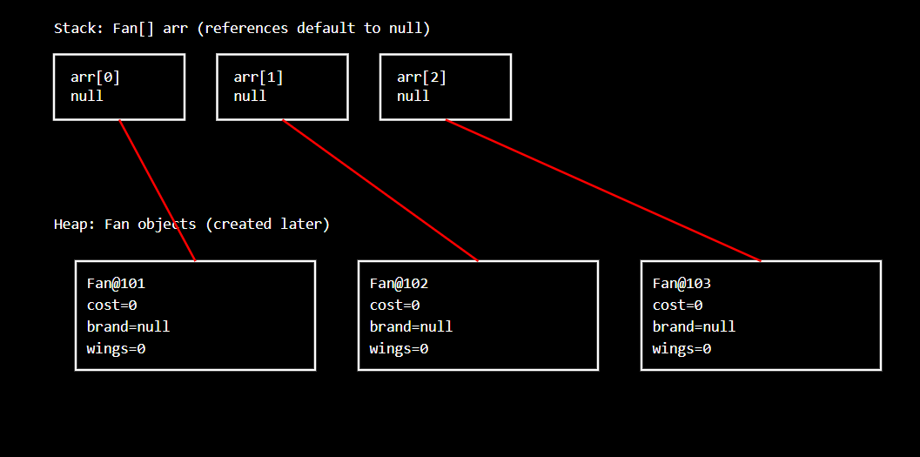

🔹 1️⃣ Arrays of Primitive Types
“If an array stores primitives, their default values are based on the data type.”
✔️ Correct
Examples:
int[] a = new int[3]; // [0, 0, 0]
double[] b = new double[2]; // [0.0, 0.0]
char[] c = new char[2]; // ['\u0000', '\u0000']
boolean[] d = new boolean[2]; // [false, false]
👉 Primitive arrays store actual values, so JVM assigns type-specific default values.

🔹 2️⃣ Arrays of Object (Reference) Types
“If an array stores object type, default value will be null for all types.”
✔️ Correct
Example:
Fan[] fans = new Fan[3];
Initial state:
fans → [ null , null , null ]
👉 Because:
- The array stores references
- No object is created yet
- Default value for any reference type = null
This applies to:
- Class objects
- Interface references
- Arrays of arrays
- Wrapper classes (Integer, Double, etc.)
- String

⚠️ Small Precision Point (Important)
The correct technical wording is:
The default value of a reference type is always null.
Not “object type” strictly — but reference type.
(Your meaning is correct; this is just terminology accuracy.)

🧠 Final Interview-Perfect Statement ⭐
In Java, arrays of primitive types are initialized with type-specific default values, while arrays of reference types are initialized with null references.

📘 Arrays and Contiguous Memory — Corrected Core Concept

1️⃣ What does contiguous memory REALLY mean?
Think of RAM as a long row of numbered seats 🎭.
When Java creates an array, it needs:
- one continuous block of memory
- all array elements must be placed next to each other
👉 This is what contiguous memory means.
⚠️ Important correction:
- This idea applies to the array itself
- NOT necessarily to the objects referenced by the array

2️⃣ Primitive Array (Fully Contiguous Data)

Example
int[] arr = new int[3];

What really happens
- Each int takes 4 bytes
- Total memory needed = 3 × 4 = 12 bytes
- JVM asks memory manager:
“Give me 12 bytes in one continuous block”
If memory manager finds:
[xxxx][xxxx][xxxx] ← continuous
➡️ Array is created
If memory looks like:
[xxxx] [ ] [xxxx] [ ] [xxxx]
➡️ Array cannot be created
✔️ Primitive array stores actual values contiguously

3️⃣ Reference Array (Contiguous references, NOT objects)

Example
Fan[] arr = new Fan[3];

❗ Important correction here
What is stored contiguously?
✅ Only the references (addresses)
❌ NOT the Fan objects

Memory reality
arr → [ ref , ref , ref ] ← contiguous
Later:
arr[0] = new Fan();
- new Fan() creates an object somewhere in heap
- That location does NOT need to be contiguous
- The array only stores the address
👉 Objects can be anywhere in heap memory
✔️ This is where your earlier explanation needed correction

4️⃣ Why does Java REQUIRE contiguous memory for arrays?

(Deep but Simple Explanation)

🔹 Core Idea (Before Example)
An array is designed for direct access, not searching.
That means:
Java must reach arr[i] immediately, without checking other elements.
This is only possible if array elements are stored next to each other in memory.

🔹 Think of Memory as Numbered Houses 🏠
Assume:
- Each int takes 4 bytes
- Array base address starts at 1000
int[] arr = new int[5];

Memory layout (contiguous):
Index | Address
arr[0] | 1000
arr[1] | 1004
arr[2] | 1008
arr[3] | 1012
arr[4] | 1016

🔹 How CPU Accesses arr[3]
CPU does one calculation:
address = baseAddress + (index × elementSize)
address = 1000 + (3 × 4)
address = 1012
➡️ CPU jumps directly to address 1012
✔️ No loop
✔️ No searching
✔️ No checking previous elements
⚡ This is O(1) constant-time access

🔹 What if elements were NOT contiguous? ❌
Imagine this (scattered memory):
Index | Address
arr[0] | 1000
arr[1] | 2500
arr[2] | 1800
arr[3] | 9999
Now try to access:
arr[3]

Problem:
- CPU cannot calculate address
- Formula no longer works
- JVM must:
  - store a separate address table
  - look up where index 3 is stored
This becomes:
Search → lookup → then access
❌ Slower
❌ More memory
❌ Complex
👉 Array loses its main advantage

🔹 Why Java DOES NOT allow this for arrays
Java says:
“If I cannot calculate the address directly, it is not an array.”
So Java enforces:
- Fixed size
- Contiguous storage
- Same element size
That guarantees:
- Fast access
- Simple memory math
- Predictable performance

🔹 Real-World Analogy 🚗

Contiguous (Array)
- Parking slots numbered in order
- Want slot 7?
- Directly go to slot 7

Non-contiguous (Linked list)
- Cars parked randomly
- To find 7th car:
  - Start from first
  - Move one by one
➡️ Much slower

🔑 Why LinkedList Exists Then?
LinkedList trades:
- ❌ Fast random access
- ✅ Easy insertion/deletion
Arrays trade:
- ❌ Fixed size
- ✅ Fast random access

✅ Final One-Line Truth (Interview Gold ⭐)
Arrays use contiguous memory so the JVM can compute element addresses directly, giving constant-time random access without searching.

