Eg: Strings_Method_Eg15
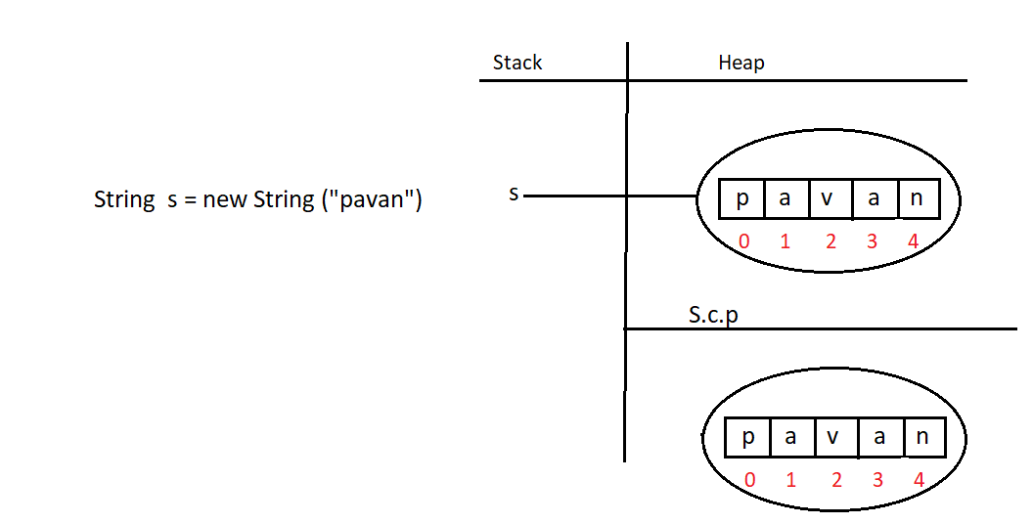

Eg: String_Eg16
// go through the code

Eg: String_Eg17
// go through the code

Eg: String_Eg18
// go through the program

Eg: String_Eg19

🔒 First: What does immutable really mean?
Immutable does NOT mean:
“You cannot read part of the string”
Immutable means:
“You cannot CHANGE the existing String object”
👉 Reading / copying characters is allowed
👉 Modifying existing characters is NOT allowed

🔍 Your code again (important part)
String s = "powerstarpavankalyan";
System.out.println(s.substring(9));

🧠 How substring() works internally

Step-by-step (very important)
- Java looks at the original String
"powerstarpavankalyan"
- It does NOT change this string
- It reads characters starting from index 9
- It creates a NEW String object
- Copies only required characters into the new String
- Returns the reference of the new String
📌 Original String remains unchanged

🧪 Memory picture (easy)
String Constant Pool / Heap:

"powerstarpavankalyan" ← s (UNCHANGED)

"pavankalyan" ← new String from substring(9)

"pavan" ← new String from substring(9,14)

❓ “How only specific characters are taken if immutable?”
👉 Because substring() does NOT edit the original String
It only:
- Reads characters
- Copies selected characters
- Creates a new String
This is allowed in immutable objects.

Example:
Think of a photocopy machine 📄
- Original book = original String
- Photocopy few pages = substring
- Book is untouched

🔑 Important rule (INTERVIEW GOLD)
Immutability prevents modification,
not reading or copying data.

🔁 Proof that original String is unchanged
String s = "powerstarpavankalyan";
s.substring(9);
System.out.println(s);
Output:
powerstarpavankalyan
✔ Original String is intact

🆚 Why this is safe
Because:
- No existing object is modified
- New object is created every time
- Thread-safe
- Secure (important for passwords, URLs, DB keys)

📝 One-line perfect comment you can write in code
// substring() does not modify the original String;
// it creates and returns a NEW String by copying selected characters

Eg: String_Eg20

🔒 Strings are IMMUTABLE
In Java, String is immutable, which means:
Once a String object is created, its content can never be changed.
So this code 👇
String s = "Hallo";
s.replace('a', 'e');
❌ does NOT change "Hallo".

🔁 Then how does replace() work?
replace() does NOT modify the original string.
Instead, it does this internally 👇
- Reads the original string "Hallo"
- Creates a NEW String object
- Puts modified characters into the new String → "Hello"
- Returns the new String reference
📌 Original String stays the same in memory.

🔍 Step-by-step memory explanation
String s = "Hallo";
System.out.println(s.replace('a','e'));

What happens in memory:
String Constant Pool:
"Hallo" ← s (unchanged)
"Hello" ← new String created by replace()
- "Hallo" is still "Hallo"
- "Hello" is a new String
- We directly printed the returned new String
- Since we didn’t store it, it can be garbage collected later

🧪 Proof that original String is unchanged
String s = "Hallo";
s.replace('a','e');
System.out.println(s); // Output: Hallo
Why?
👉 Because s still points to "Hallo".

✅ To actually use the replaced value
You must collect the returned reference:
String s = "Hallo";
s = s.replace('a','e');
System.out.println(s); // Output: Hello
Now:
- Old "Hallo" becomes unused
- s points to "Hello"

🧠 Key Interview Line (VERY IMPORTANT)
String methods never change the original String.
They always return a new String.

🔄 Comparison with StringBuilder
Feature | String | StringBuilder
Mutable | ❌ No | ✅ Yes
replace changes same object | ❌ | ✅
Thread-safe | ✅ | ❌

Eg: String_Eg21

🔑 Key Points to Remember
- Strings are immutable
- toUpperCase() and toLowerCase() do not modify the original String
- A new String object is created and returned
- If returned value is not stored, it may be garbage collected

Eg: String_Eg22
// go through the code

Eg: String_Eg23
// go through the program

Eg: String_Eg24
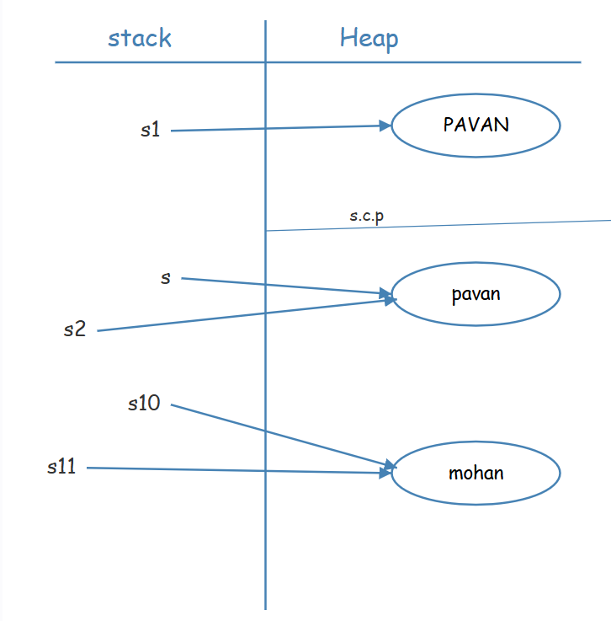
In an expression like s.toLowerCase(), runtime String methods operate on the String object referenced by s, which is called the receiver object.
The JVM examines only this receiver object to perform the operation.
If the method determines that the operation does not change the content of the receiver object, the JVM returns the same object reference.
The returned reference may point to an object in the String Constant Pool or in the Heap, and this depends entirely on where the receiver object is located.
The JVM does not explicitly search the Heap or the String Constant Pool to find another String object with the same content, and it does not switch the reference to SCP.
If the operation changes the content, a new String object is compulsorily created in the Heap and the reference to this new object is returned.

Eg: String_Operation_On_Same_Object
// go through the code

Eg: String_Eg25
✅ Core Points: toString() and Object Printing
🔹 1. Printing an object
- When an object is passed to System.out.println(),
- Java automatically calls the toString() method on that object.

🔹 2. Default toString() (Object class)
- If a class does not override toString(),
- The Object class toString() is used.
- It returns:
- ClassName@HexadecimalHashCode
- Example:
- Student@5acf9800

🔹 3. String class behavior
- String class overrides toString().
- String.toString() returns the actual string content.
- So:
- System.out.println(s);
- System.out.println(s.toString());
both print the same text.

🔹 4. Explicit vs implicit toString()
- System.out.println(obj) → implicit call to obj.toString()
- System.out.println(obj.toString()) → explicit call
- Both give the same output.

🔹 5. Why String behaves differently
- String is designed to represent text.
- So it overrides toString() to return readable data.
- User-defined classes must override toString() to get meaningful output.

Eg: String_Eg26
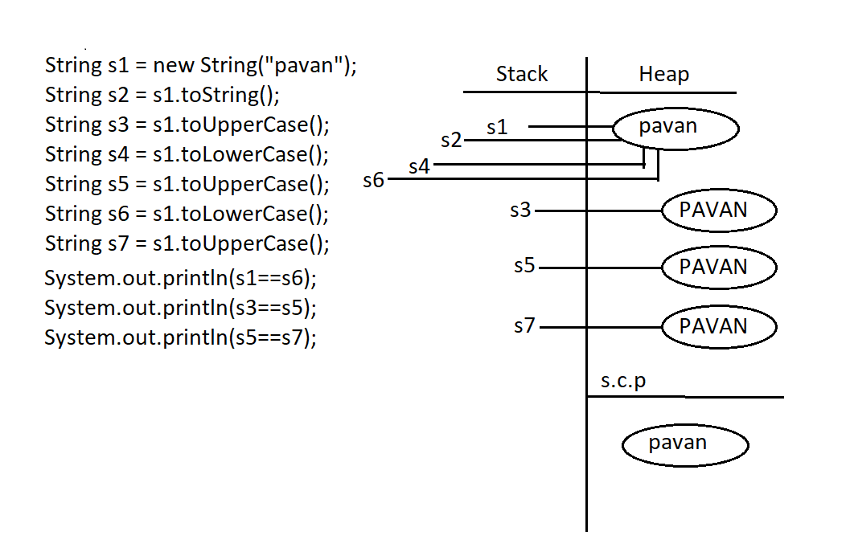

Eg: String_Eg27
// go through the code

✅ Final vs Immutability (Corrected Notes)
• The final modifier is applicable to variables, whereas immutability is applicable to objects.
• If a reference variable is declared as final, it means the reference cannot be reassigned to another object.
It does NOT mean that the object itself cannot be modified.
• Declaring a reference variable as final does not make the object immutable.
• final and immutability are two completely different concepts.

✅ Correct Examples (Concept Clarity)
final StringBuffer sb = new StringBuffer("Hello");
sb.append(" World"); // allowed (object is mutable)
// sb = new StringBuffer("New"); ❌ not allowed (reference is final)
✔ Reference is final
✔ Object is still mutable

✅ Mutability of Common Classes (CORRECTED)
• StringBuilder and StringBuffer are mutable by default.
• StringBuilder and StringBuffer have almost the same methods.
The main difference is:
- StringBuilder → not thread-safe
- StringBuffer → thread-safe (synchronized)

• Wrapper classes (Byte, Short, Integer, Long, Float, Double, Character, Boolean) are immutable, not mutable.
Example:
Integer i = 10;
i = i + 5; // creates a new Integer object
✔ Wrapper objects cannot be changed once created
✔ New object is created for new value

🏁 FINAL CORRECT SUMMARY (BEST FOR NOTES)
- final → restricts reference reassignment
- Immutability → restricts object modification
- final ≠ immutability
- StringBuilder, StringBuffer → mutable
- Wrapper classes → immutable
- StringBuilder and StringBuffer share same methods, differ in thread safety

⭐ ONE-LINE REMEMBER RULE
final protects the reference, immutability protects the object.

✅ Constructors of StringBuffer (Corrected)
StringBuffer s = new StringBuffer();
• Creates an empty StringBuffer object
• Default initial capacity is 16 characters
• Initial length is 0

✅ Capacity Growth (Correct Behavior)
• When the current capacity is not sufficient, StringBuffer automatically increases its internal capacity
• No new StringBuffer object is created
• The same object reference is retained

✅ Capacity Increase Formula
New capacity = (current capacity + 1) * 2
(or equivalently)
New capacity = current capacity * 2 + 2

⭐ Final Remember Point
StringBuffer expands internally; only capacity changes, not the object.

Eg: StringBuffer_Constructor_Eg28
// go through the program

Eg: StringBuffer_Constructor_Eg29
// go through the code

Eg: StringBuffer_Constructor_Eg30
// go through the code

Eg: String_Eg31
// go through the program

Eg: String_Eg32
// go through the program

Eg:String_Eg33
🔑 Core Concept in This Example
❓ What is the real problem being tested?
This example tests how equals() behaves differently for String and StringBuffer.

🧠 Key Rule 1: String.equals()
- String overrides equals()
- It compares content (characters), not memory address
Example:
"Hello".equals("Hello") // true

🧠 Key Rule 2: StringBuffer.equals()
- StringBuffer does NOT override equals()
- It inherits equals() from Object
- Object.equals() compares references, not content
So:
new StringBuffer("Hello").equals(new StringBuffer("Hello")) // false

🧠 Key Rule 3: Why toString() is used
- StringBuffer.toString() converts buffer content into a String
- Once converted, String.equals() can compare content
So:
s.toString().equals(s1)
means:
Compare the text inside StringBuffer with the text inside String

🧠 Applying These Rules to Your Code
StringBuffer s = new StringBuffer("Hello");
String s1 = "Hello";
First check:
s.toString().equals(s1.toString())
- Both become "Hello"
- String.equals() compares content
- Content matches
- ✅ TRUE → prints "Match = -1"
Second check:
s.equals(s1)
- StringBuffer.equals() compares references
- Different objects (StringBuffer vs String)
- ❌ FALSE

⭐ FINAL CORE IDEA (MOST IMPORTANT)
String.equals() compares content,
StringBuffer.equals() compares reference.
To compare content, convert StringBuffer to String.

Eg: String_Eg34
// go through the code

