**ABSTRACT**

Face (facial) recognition is the identification of humans by the unique characteristics of their Faces. Face recognition technology is the least intrusive and fastest bio-metric technology. It works with the most obvious individual identifier the human face. With increasing security needs and with advancement in technology extracting information has become much simpler. This project aims on building an application based on face recognition using different algorithms and comparing the results. The basic purpose being to identify the face and retrieving information stored in database. It involves two main steps. First to identify the distinguishing factors in image n storing them and Second step to compare it with the existing images and returning the data related to that image. The various algorithms used for face detection are PCA Algorithm and Gray Scale Algorithm.

Keywords : Face Recognition, PCA Algorithm, Gray Scale Algorithm, Eigenfaces.

**TABLE OF CONTENTS**

1. INTRODUCTION 7
2. PROBLEMS AND OBJECTIVE 9

OBJECTIVES: 9

1. METHODOLOGY 10
2. PROPOSED ALGORITHM 11
3. FACE RECOGNITION 12
   1. FACE RECOGNITION USING GEOMETRICAL FEATURES 12

5.2. FACE RECOGNITION USING TEMPLATE MATCHING 13

1. CONCLUSION 14
2. REFERENCES 15

# INTRODUCTION

Biometrics is used in the process of authentication of a person by verifying or identifying that a user requesting a network resource is who he, she, or it claims to be, and vice versa. It uses the property that a human trait associated with a person itself like structure of data with the incoming data we can verify the identity of a particular person [1]. There are many types of biometric system like detection and recognition, iris recognition etc., these traits are used for human identification in surveillance system, criminal identification, face details etc. By comparing the existing fingerprint recognition.

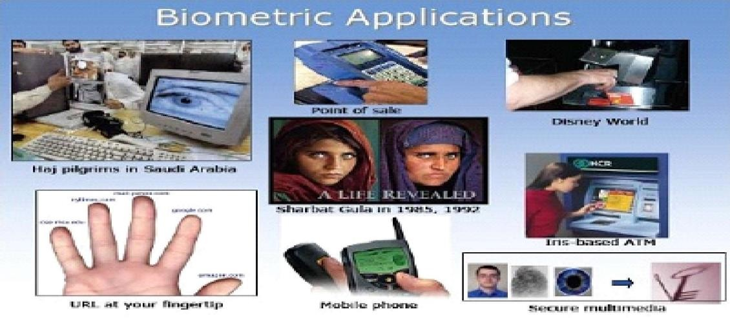

Human beings have recognition capabilities that are unparalleled in the modern computing era. These are mainly due to the high degree of interconnectivity, adaptive nature, learning skills and generalization capabilities of the nervous system. The human brain has numerous highly interconnected biological neurons which, on some specific tasks, can output form super computers. A child can accurately identify a face, but for a computer it is a cum-bersome task. Therefore, the main idea is to engineer a system which can emulate what a child can do. Advancements in computing capability over the past few decades have en- abled comparable recognition capabilities from such engineered systems quite successfully. Early face recognition algorithms used simple geometric models, but recently the recognition process has now matured into a science of sophisticated mathematical representations and matching processes. Major advancements and initiatives have propelled face recognition technology into the spotlight. Face recognition technology can be used in wide range of applications.

Computers that detect and recognize faces could be applied to a wide variety of practical applications including criminal identification etc. Face detection and recognition is used in many places now a days, verifying websites hosting images and social networking sites. Face recognition and detection can be achieved using technologies related to computer science. Features extracted from a face are processed and compared with similarly processed faces present in the database. If a face is recognized it is known or the system may show a similar face existing in database else it is unknown. In surveillance system if a unknown face appears more than one time then it is stored in database for further recognition. These steps are very useful in criminal identification. In general, face recognition techniques can be divided into two groups based on the face representation they use appearance-based, which uses holistic texture features and is applied to either whole-face or specific face image and feature- based, which uses geometric facial features (mouth, eyebrows, cheeks etc), and geo- metric relationships between them.

# PROBLEMS AND OBJECTIVE

The problem of face recognition can be stated as follows: Face Recognition human facial features like the mouth, nose and eyes in a full-frontal face image. We will be adapting a multi-step process in order to achieve the goal. To detect the face region, we will be using asking color segmentation method. Morphological techniques will be adapted to fill the holes that would be created after the segmentation process. From the skeletonization process, a skeleton of the face will be obtained from which face contour points could be extracted. Facial features can be located in the interior of the face contour. We will use several different facial-images to test our method.

## OBJECTIVES:

1. Trying to find a face within a large database of faces. In this approach the system returns a possible list of faces from the database. The most useful applications contain crowd surveillance, video content indexing, personal identification (example: drivers license),

mug shots matching, etc.

1. Real time face recognition: Here, face recognition is used to identify a person on the spot and grant access to a building or a compound, thus avoiding security hassles. In this case the face is compared against a multiple training samples of a person.

# METHODOLOGY

The previous sections illustrate different techniques and methods of face detection and recog- nition. Each category of method performs well in certain criteria and also has drawbacks as well. Systems with robustness and certain level of accuracy are still far away. Keeping in view case study the following architecture is proposed for the detection and recognition system.

As discussed earlier that the robust system catering the needs of real world situation is a challenging task. The images will be scanned by scanner and stored into database. Again the image will be scanned and stored into the database. Now two images of the same candidate will be stored into the database. The first step is to select desired images from the database then for comparisons them the next step is to detect faces from each image. The next step is to recognize that images as of the same candidate or not.

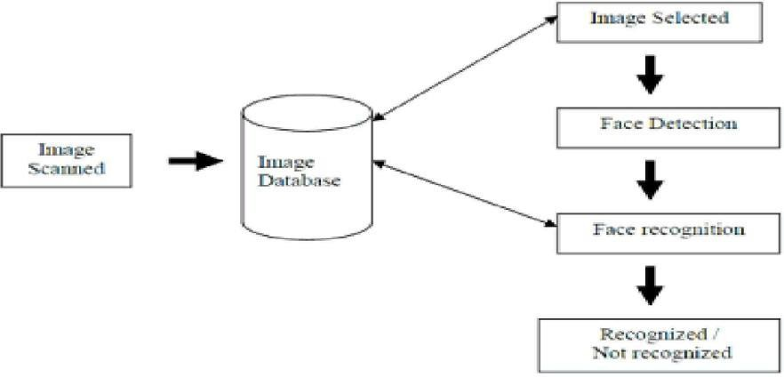

# PROPOSED ALGORITHM

1. Set image resolution parameter 4 (*imres*)
2. Set PCA dimensionality parameter (*PCADIM* )
3. Read training images
4. Form training data matrix (*Mtraindata* )
5. Form training class labels matrix (*Mtrainlabels* )
6. Calculate PCA transformation matrix (tmatrix)
7. Calculate feature vectors of all training images using tmatrix
8. Store training feature vectors in a matrix
9. Read test faces
10. For each test face do
11. Calculate the feature vector of a test face using t matrix
12. Compute the distances between test feature vector and all training vectors
13. Store the distances together with the training class labels
14. Initialize error count to zero.
15. For each test face do
16. Using the distance data, determine the person ID of the most similar training vector
17. If the found ID is not equal to the ID of the test image increment error count
18. Output the correct recognition accuracy :(1 - (error count/ total test image count))*100

# 5. FACE RECOGNITION

Over the last few decades many techniques have been proposed for face recognition. Many of the techniques proposed during the early stages of computer vision cannot be considered successful, but almost all of the recent approaches to the face recognition problem have been creditable. According to the research by Brunelli and Poggio (1993) all approaches to human face recognition can be divided into two strategies:

* 1. Geometrical features and
  2. Template matching.

**5.1 FACE RECOGNITION USING GEOMETRICAL FEATURES**

This technique involves computation of a set of geometrical features such as nose width and length, mouth position and chin shape, etc. from the picture of the face we want to recognize. This set of features is then matched with the features of known individuals. A suitable metric such as Euclidean distance (finding the closest vector) can be used to find the closest match. Most pioneering work in face recognition was done using geometric features (Kanade, 1973), although Craw et al. (1987) did relatively recent work in this area .The advantage of using geometrical features as a basis for face recognition is that recognition is possible even at very low resolutions and with noisy images (images with many disorderly pixel intensities). Although the face cannot be viewed in detail its overall geometrical configuration can be extracted for face recognition. The technique's main disadvantage is that automated extraction of the facial geometrical features is very hard. Automated geometrical Department of ECE Page 35 feature extraction based recognition is also very sensitive to the scaling and rotation of a face in the image plane (Brunelli and Poggio, 1993). This is apparent when we examine Kanade's(1973) results where he reported a recognition rate of between 45-75 % with a database of only 20 people. However if these features are extracted manually as in Goldstein et al. (1971), and Kaya and Kobayashi (1972) satisfactory results may be obtained.

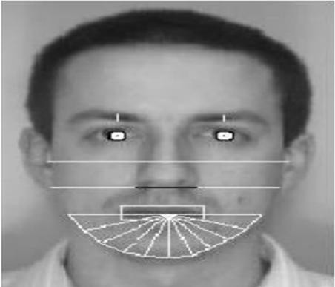

**5.2. FACE RECOGNITION USING TEMPLATE MATCHING**

This is similar the template matching technique used in face detection, except here we are not trying to classify an image as a 'face' or 'non-face' but are trying to recognize a face. Whole face, eyes, nose and mouth regions which could be used in a template matching strategy. The basis of the template matching strategy is to extract whole facial regions (matrix of pixels) and compare these with the stored images of known individuals. Once again Euclidean distance can be used to find the closest match. The simple technique of comparing grey-scale intensity values for face recognition was used by Baron (1981). However there are far more sophisticated methods of template matching for face recognition. These involve extensive preprocessing and transformation of the extracted grey-level intensity values. For example, Turk and Pentland (1991a) used Principal Component Analysis, sometimes known as the eigenfaces approach, to pre-process the gray-levels and Wiskott et al. (1997) used Elastic Graphs encoded using Gabor filters to pre-process the extracted regions. An investigation of geometrical features versus template matching for face recognition by Brunelli and Poggio (1993) came to the conclusion that although a feature based strategy may offer higher recognition speed and smaller memory requirements, template based techniques offer superior recognition accuracy.

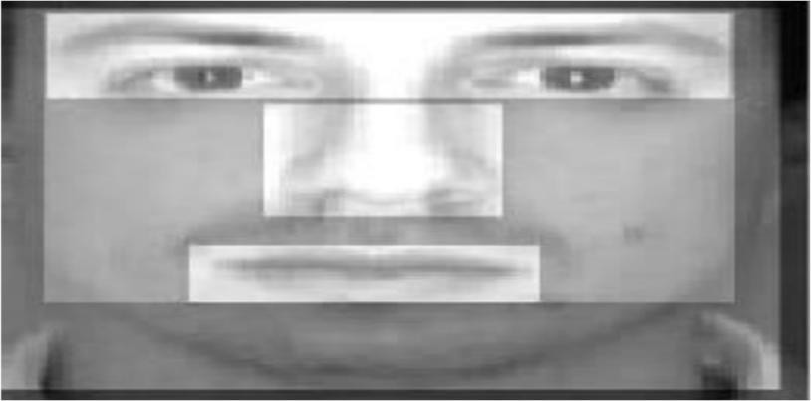

# CONCLUSION

Face recognition systems are useful in law enforcement and justice solutions by staying one step ahead of the world’s ever-advancing criminals. This includes acclaimed CABS- computerized arrest and booking system and the child base protection which is a software solution for global law enforcement agencies to help protect and recover missing and sexually exploited children, particularly as it relates to child pornography. It is also useful in Homeland defense which includes everything from preventing terrorists from boarding aircraft, to protecting critical infrastructure from attack or tampering (e.g. dams, bridges, water reservoirs, energy plants, etc.), to the identification of known terrorists. It is also applicable in airport and other transportation terminal security. Face recognition software, can enhance the effectiveness of immigration and customs personnel. The financial services industry revolves around the concept of security. Face recognition software, can improve the security of the financial services industry, saving the institution time and money both through a reduction of fraud case and the administration expenses of dealing with forgotten passwords. Furthermore, biometric-based access control units can safeguard vaults, teller areas, and safety deposit boxes to protect against theft. The use of biometrics can also ensure that confidential information remains confidential while deterring identity theft, particularly as it relates to ATM terminals and card-not-present e-commerce transactions. It allows capturing, archiving, and retrieving identifying characteristics as tattoos, marks, or scars. It can also analyze scenes from either streaming or archived video , ”looking” for out- of-the-ordinary occurrences, the presence of certain vehicles, specific faces, etc. This is beneficial and can save significant time and money to those individuals who spend hours, days, or weeks monitoring video streams (i.e. examining a bank’s security in a criminal investigation).

# REFERENCES

1. Face Recognition by Independent Component Analysis Marian Stewart Bartlett, Member, IEEE, Javier R. Movellan, Member, IEEE, and Terrence J. Sejnowski, Fellow,IEEE.
2. Eigenspace-Based Face Recognition: A Comparative Study of Different Approaches Javier Ruiz-del-Solar, Member, IEEE, and Pablo Navarrete, Student Member, IEEE
3. Face Recognition by Extending Elastic Bunch Graph Matching with Particle Swarm Optimization
4. Discriminant Analysis of Principal Components for Face Recognition.
5. [www.wikipedia.com](http://www.wikipedia.com/)