**3.10 Table Specification**

1. Super Admin:

| **Field** | **Type** | **Constraints** |
| --- | --- | --- |
| id | int(11) | P.K. |
| name | varchar(30) |  |
| contact | bigint(12) |  |
| address | varchar(50) |  |
| username | varchar(50) |  |
| superAdmin_password | varchar(50) |  |
| flag | int(11) |  |

1. Agency

| **Field** | **Type** | **Constraints** |
| --- | --- | --- |
| ag_id | int(11) | P.K. |
| ag_name | varchar(50) |  |
| mobile_no | bigint(12) |  |
| contact_person | varchar(50) |  |
| address | varchar(100) |  |
| username | varchar(200) |  |
| agency_password | varchar(200) |  |
| flag | int(11) |  |

1. Client:

| **Field** | **Type** | **Constraints** |
| --- | --- | --- |
| client_id | int(11) | P.K. |
| ag_id | int(11) | F.K. |
| c_name | varchar(50) |  |
| c_address | varchar(100) |  |
| c_mobile | bigint(20) |  |
| client_username | varchar(30) |  |
| client_password | varchar(30) |  |
| flag | int(11) |  |

1. Delivery Boy:

| **Field** | **Type** | **Constraints** |
| --- | --- | --- |
| deb_id | int(11) | P.K |
| ag_id | int(11) | F.K. |
| deb_name | varchar(30) |  |
| deb_contact | bigint(20) |  |
| deb_address | varchar(50) |  |
| deb_username | varchar(30) |  |
| deb_password | varchar(30) |  |
| flag | int(11) |  |

1. Order Master:

| **Field** | **Type** | **Constraints** |
| --- | --- | --- |
| order_id | int(11) | P.K |
| client_id | int(11) | F.K. |
| jar_type | varchar(100) |  |
| order_type | varchar(100) |  |
| date_from | varchar(100) |  |
| till | varchar(100) |  |
| price | varchar(30) |  |
| place | varchar(1000) |  |
| quantity | int(11) |  |
| ag_id | int(11) | F.K. |
| Flag | varchar(100) |  |

1. Delivery:

| **Field** | **Type** | **Constraints** |
| --- | --- | --- |
| delivery_id | int(11) | P.K. |
| client_id | int(11) | F.K. |
| order_id | int(11) | F.K. |
| delivery_date | varchar(100) |  |
| d_time | varchar(30) |  |
| send_jar_qty | int(11) |  |
| received_jar_qty | int(11) |  |
| ag_id | int(11) | F.K. |
| delivery_flag | int(11) |  |

1. bill:

| **Field** | **Type** | **Constraints** |
| --- | --- | --- |
| bill_id | int(11) | P.K. |
| client_id | int(11) | F.K. |
| order_id | int(11) | F.K. |
| bill_date | varchar(100) |  |
| pay_from_month | varchar(20) |  |
| pay_to_month | varchar(20) |  |
| no_of_jar | int(11) |  |
| rate | float |  |
| total | float |  |
| discount | float |  |
| net_total | float |  |
| ag_id | int(11) |  |

1. Order Serve:

| **Field** | **Type** | **Constraints** |
| --- | --- | --- |
| order_id | int(11) | P.K. |
| type | varchar(10) |  |
| no_of_days_in_week | int(11) |  |

1. Payment :

| **Field** | **Type** | **Constraints** |
| --- | --- | --- |
| payment_id | int(11) | No |
| client_id | int(11) | No |
| payment_date | varchar(20) | No |
| paid | int(11) | No |
| payment_type | varchar(30) | No |
| ref_no | bigint(20) | No |
| name_of_bank | varchar(100) | No |
| ag_id | int(11) | No |

**User Interface Screens:**

Super Admin Login:

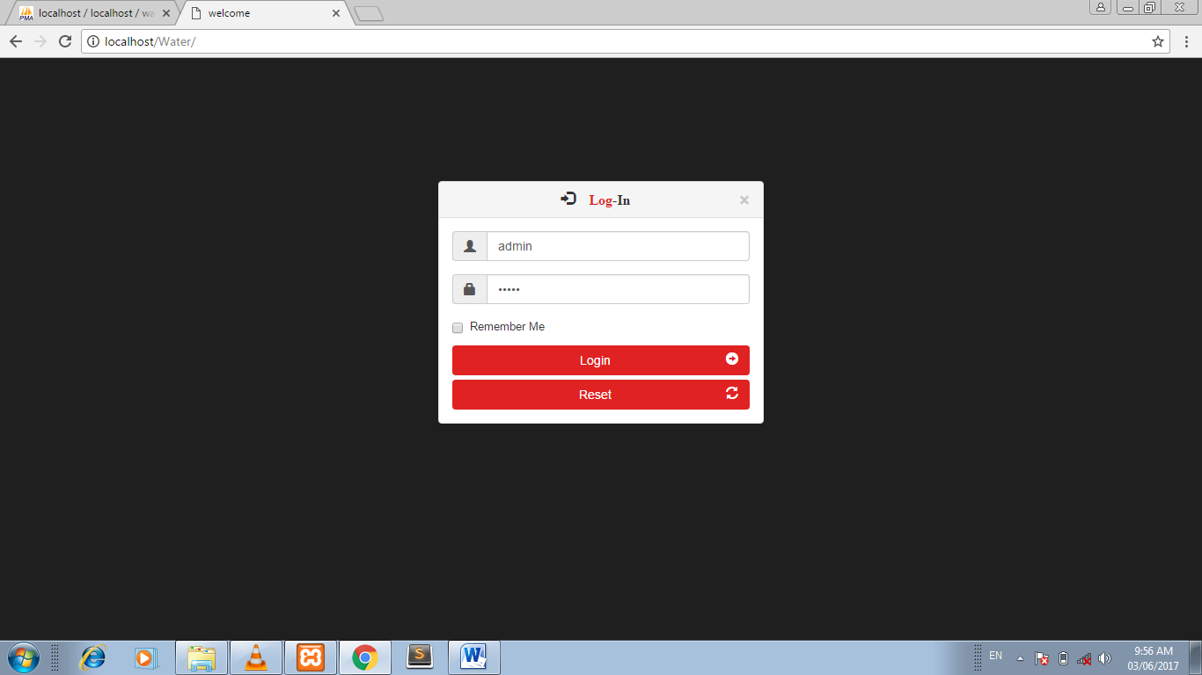

Admin Dashboard :

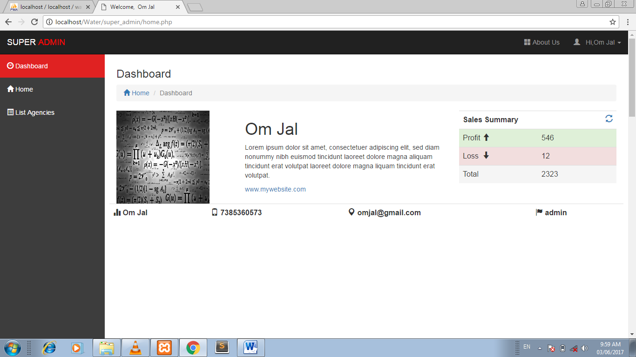

Maintain Agency :

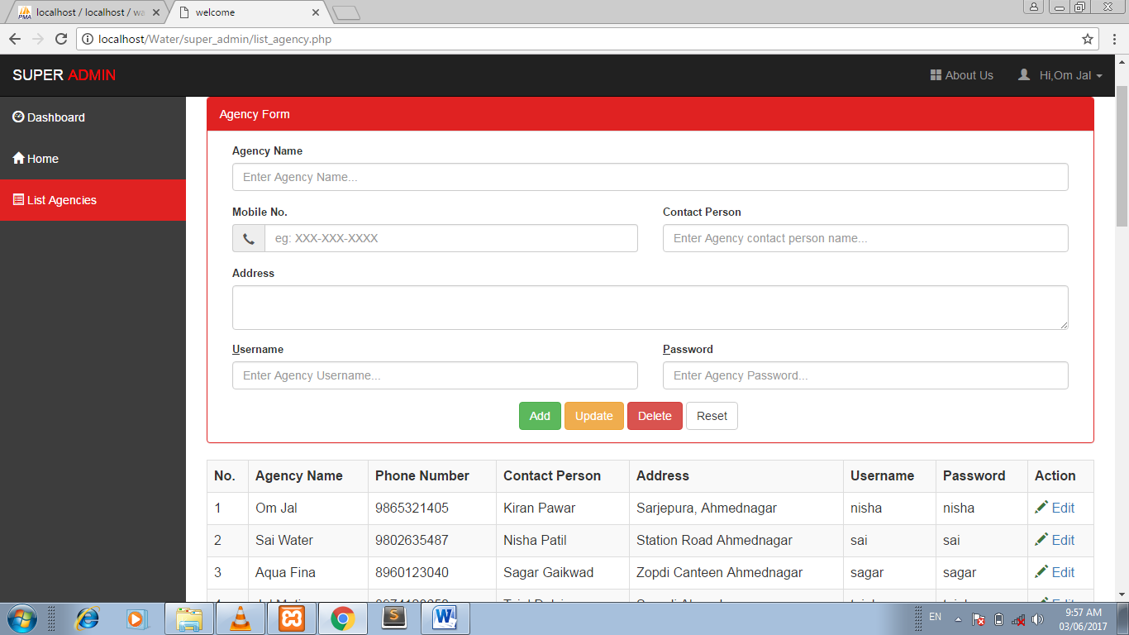

Agency AdminLogin :

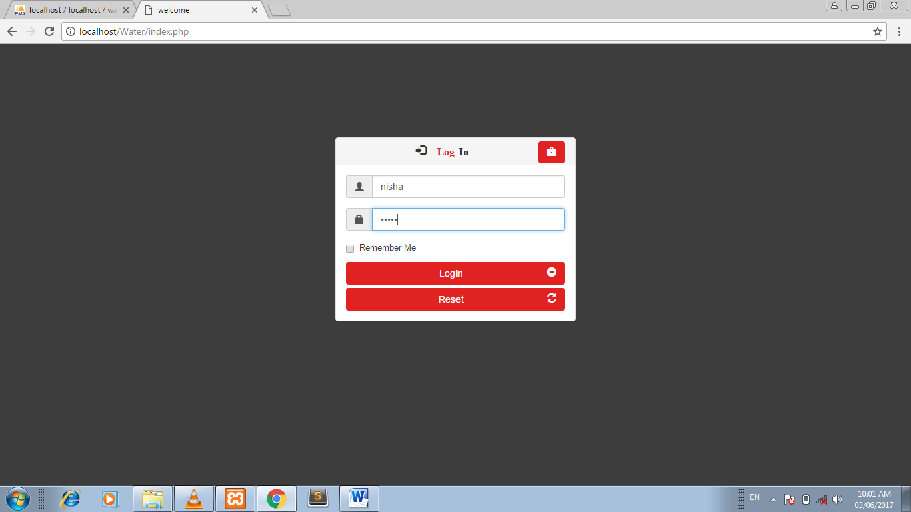

Agency Admin Dashboard:

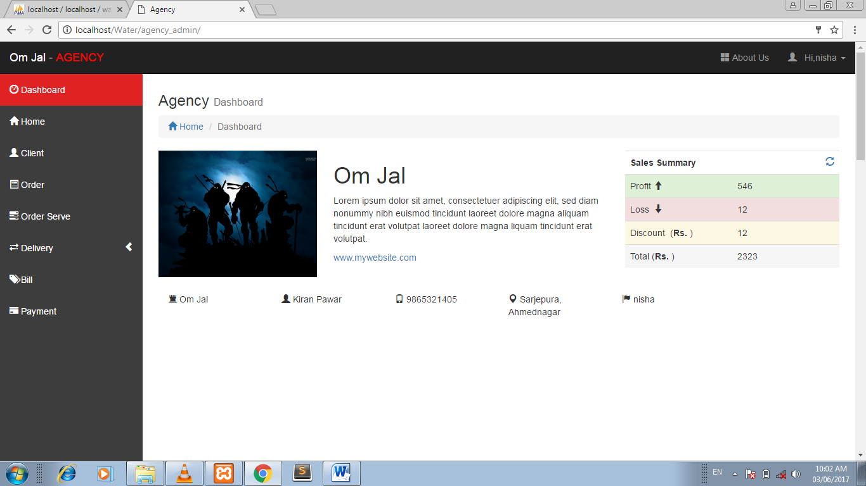

Maintain Client :

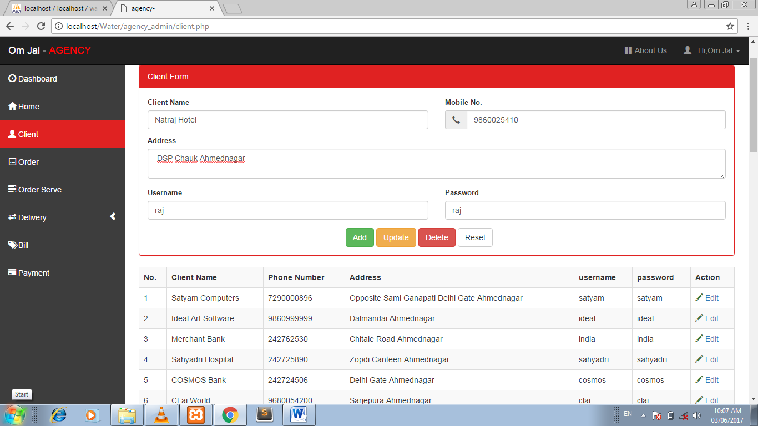

Maintain Order :

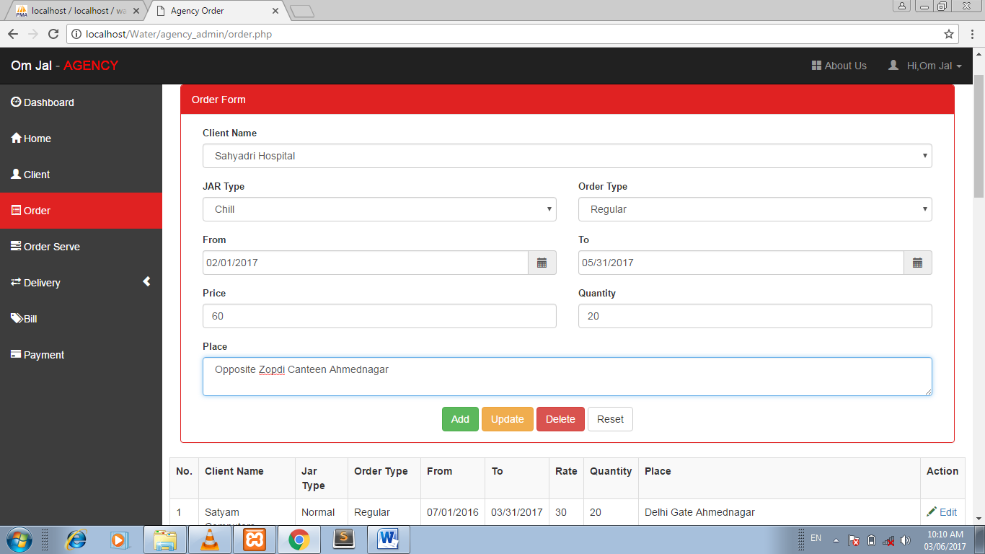

Delivery Form :

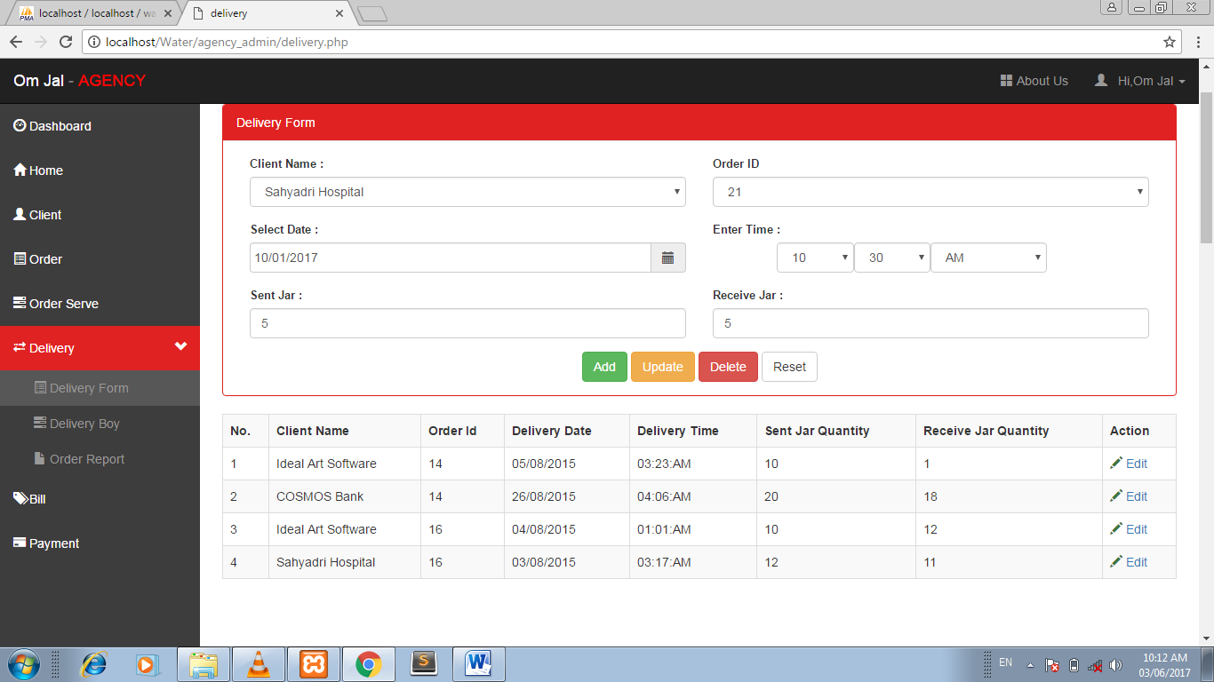

Maintain Delivery Boy :

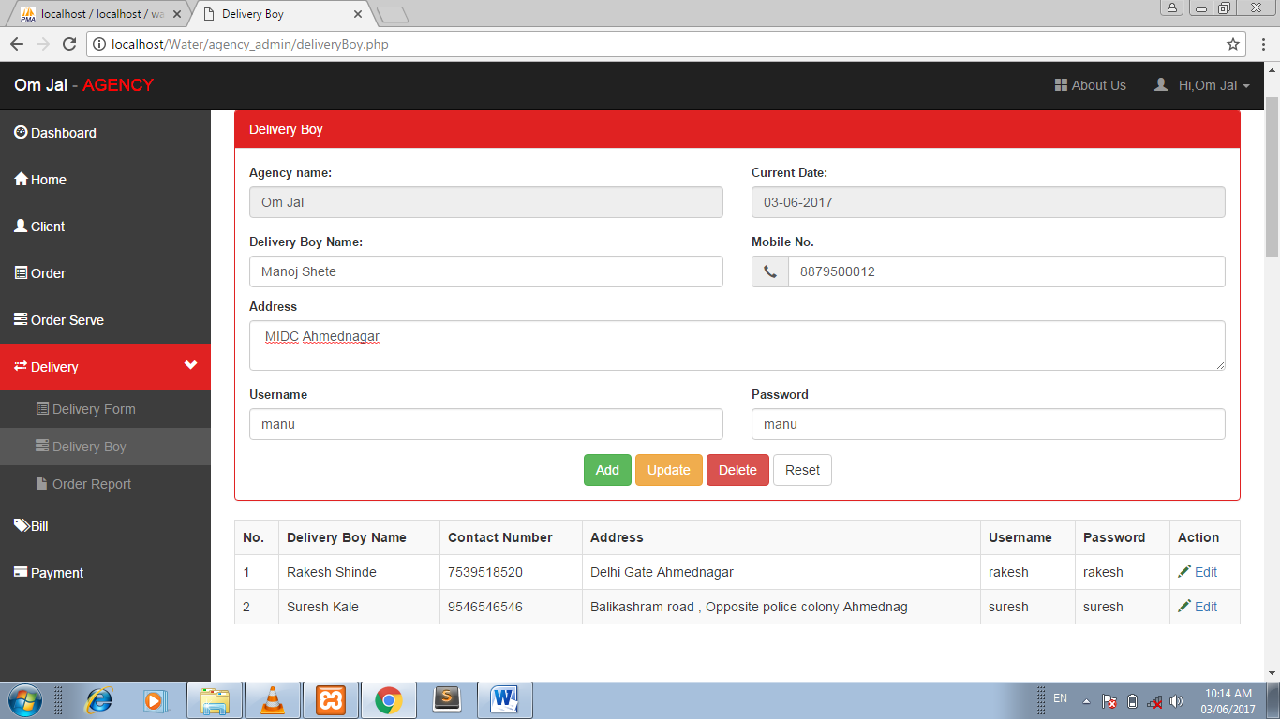

Manage Bill :

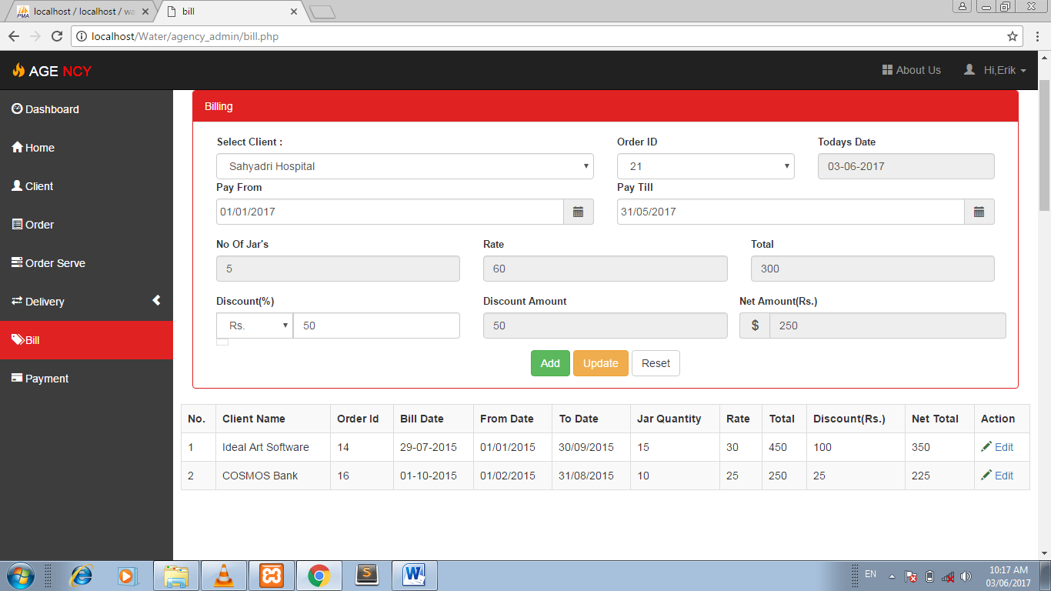

Payment Details

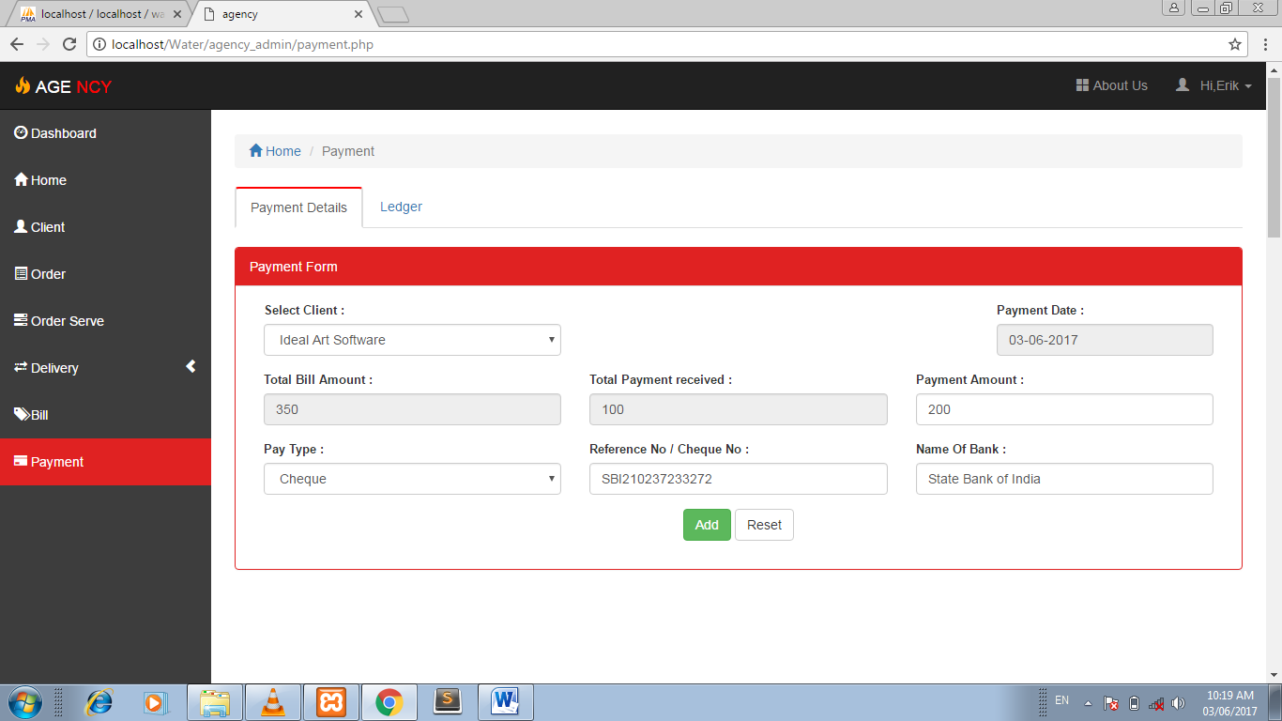

Delivery Boy Login :

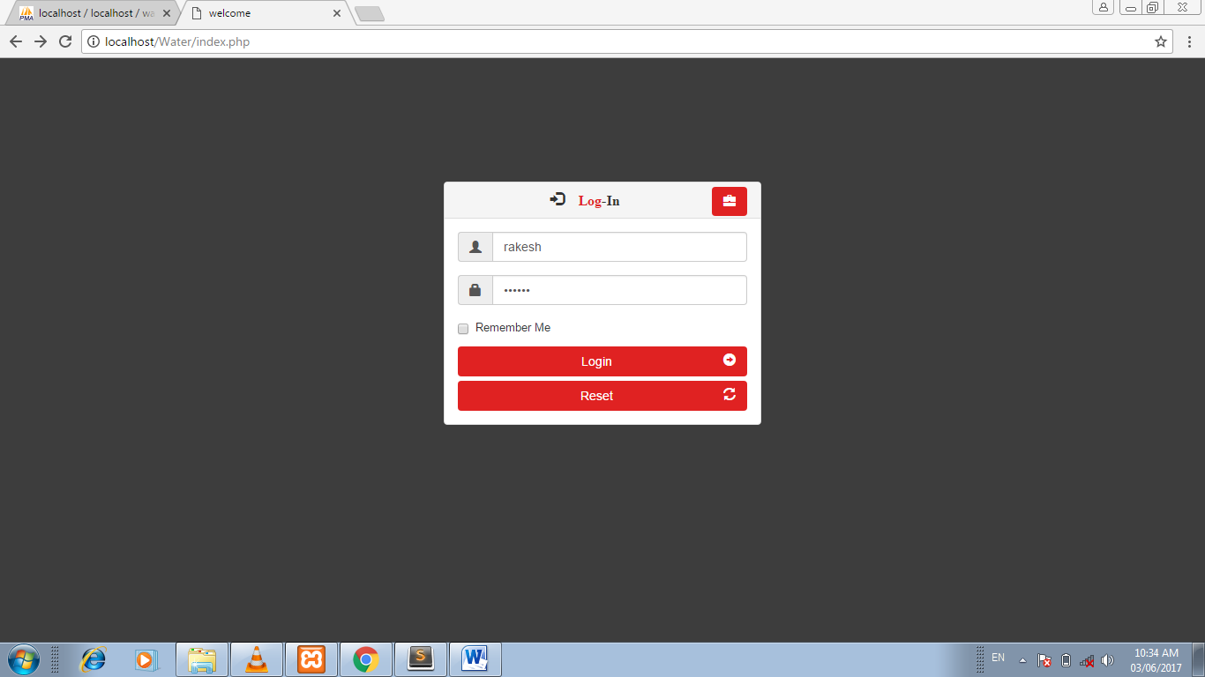

Delivery Boy Dashboard :

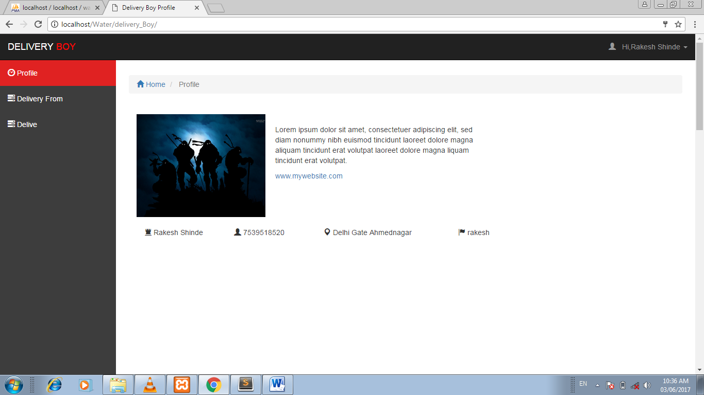

Maintain Delivery Details :

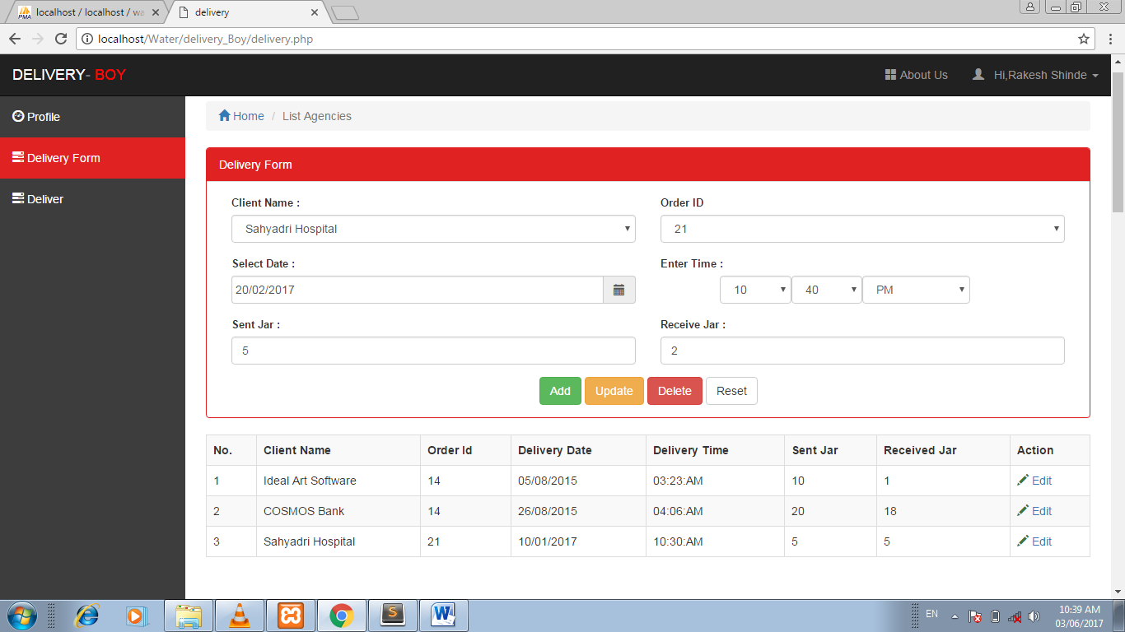

Client Login :

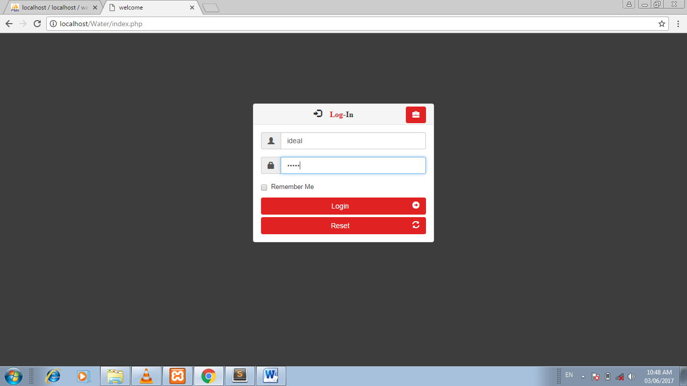

Client Dashboard :

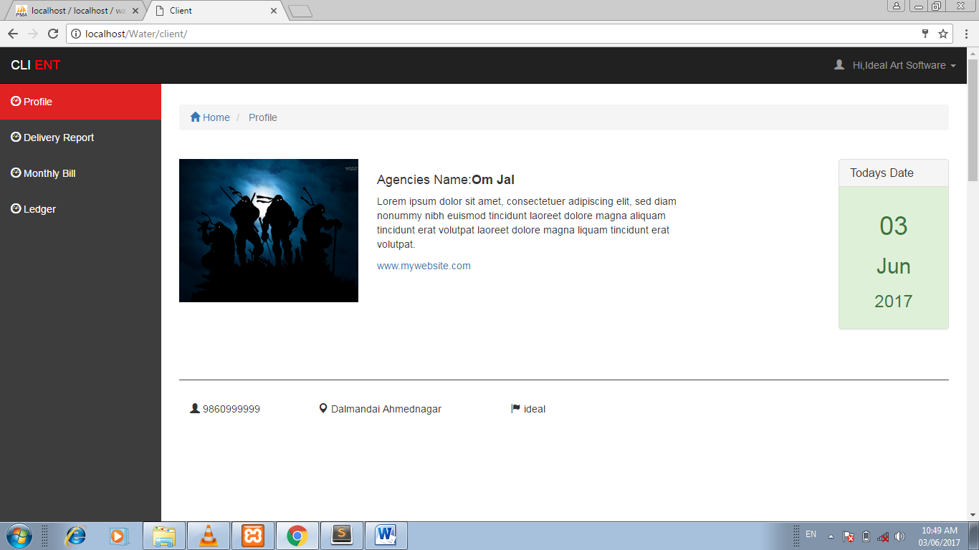

View Ledger Report :

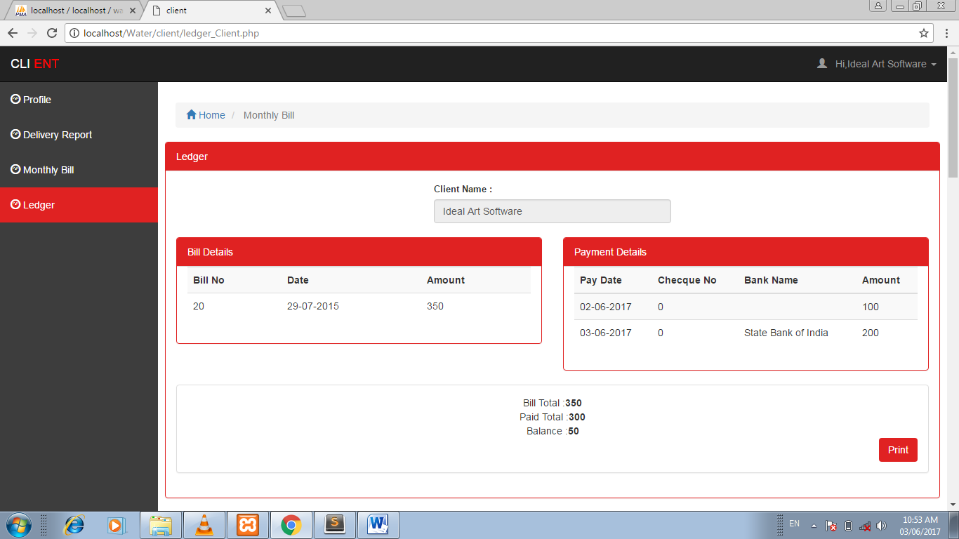

Print Ledger :

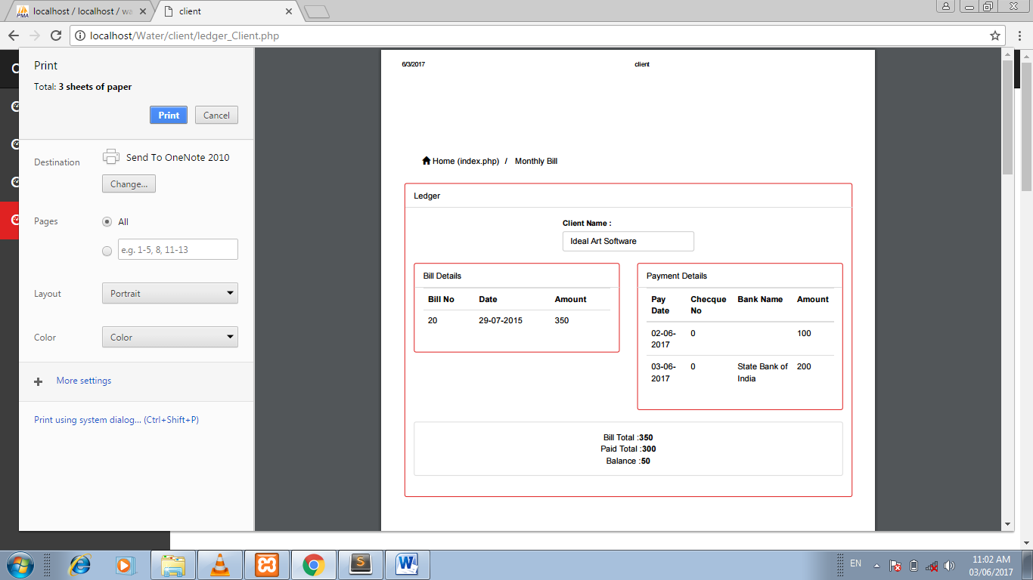

**Reports**

Generate Ledger :

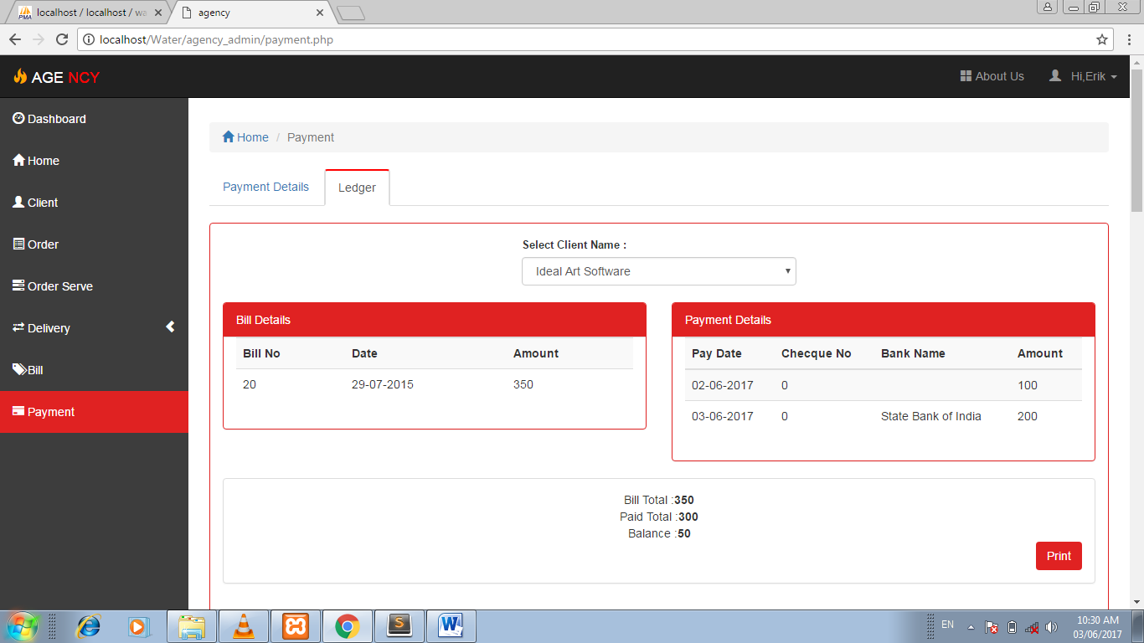

Print Bill And Ledger :

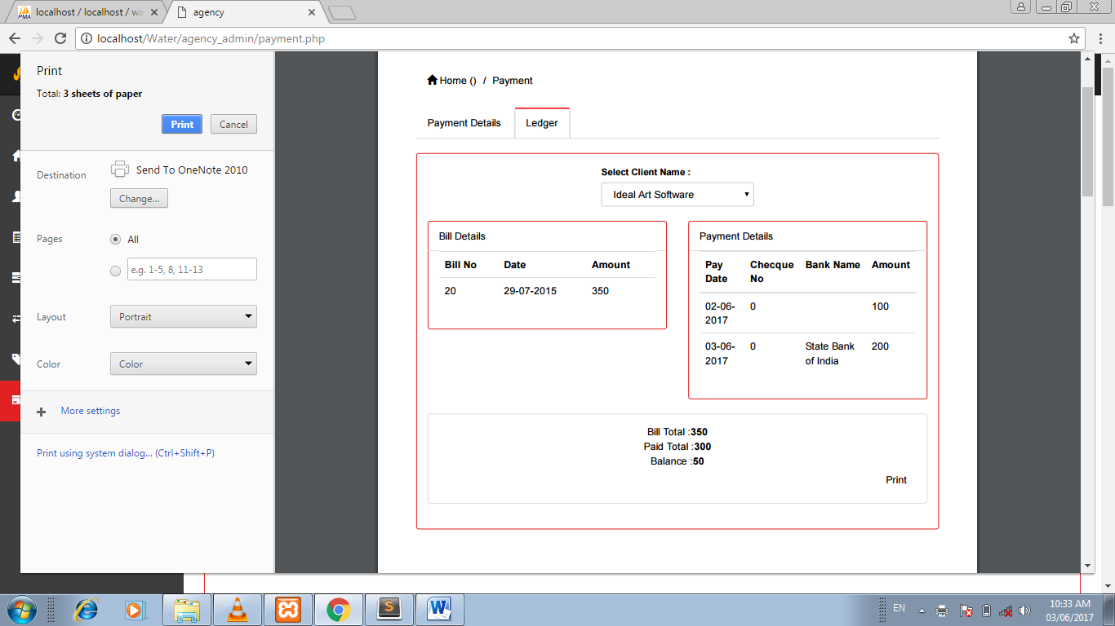

Manage Deliver Order :

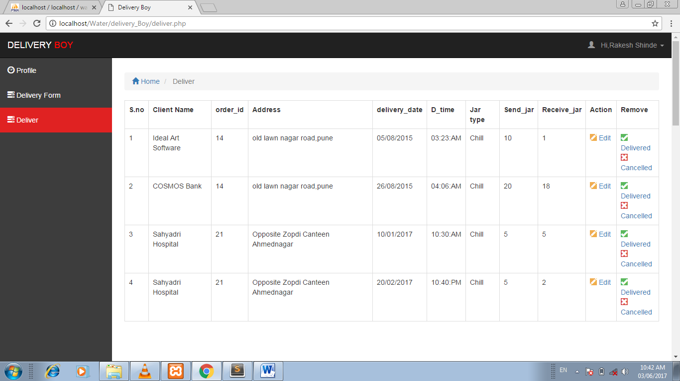

Delivery Report :

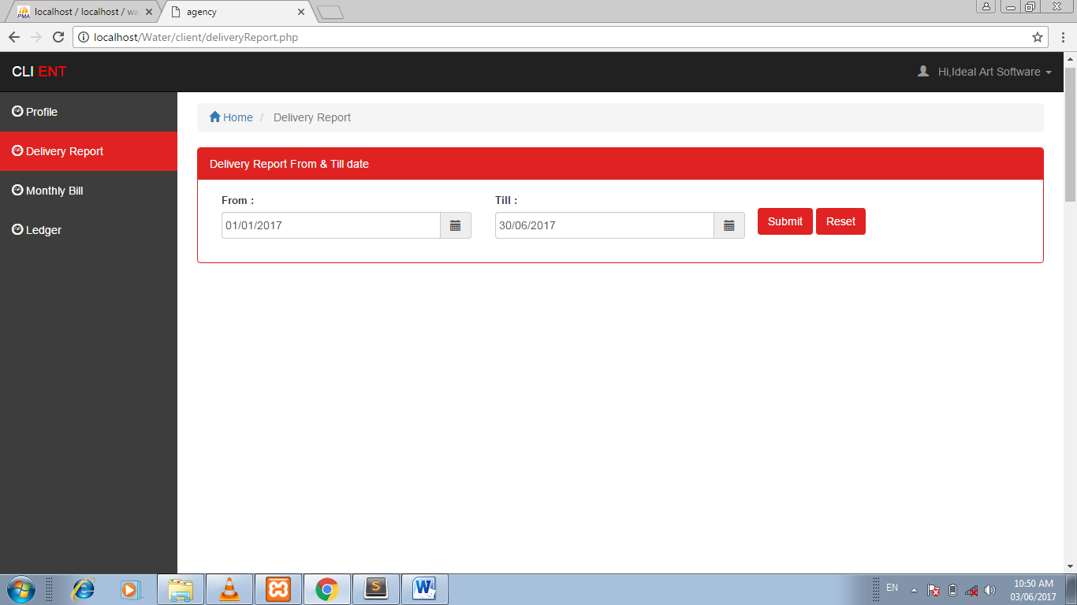

View Order Delivery Report :

