Indian Food Recognition and Information System
A project report on image classification using transfer learning and ResNet50

Prepared from the project implementation, evaluation artifacts, and application outputs

September 2026

Executive Summary
This project implements an end-to-end Indian food recognition system that classifies a food image into one of 80 predefined categories and returns useful contextual information for the predicted dish. The work compares three progressively stronger approaches: handcrafted visual descriptors with classical machine learning, frozen deep features from ResNet50 with classical classifiers, and end-to-end fine-tuning of ResNet50.
The evaluation artifacts report that the final fine-tuned ResNet50 reaches 66.75% validation accuracy on a fixed 800-image validation set. Its reported macro precision, macro recall, and macro F1-score are 0.685, 0.667, and 0.663 respectively. The Streamlit application exposes the model through image upload, confidence-aware prediction feedback, Top-5 alternatives, and a class-based food information module.
Item | Verified project artifact
Dataset | 4,000 processed images arranged in 80 class folders, with 50 images per class
Final model | ResNet50 with Dropout(0.5) and an 80-class linear head
Validation protocol | Stratified 80/20 split with random seed 42
Final evaluation | 66.75% accuracy; macro precision 0.685; macro recall 0.667; macro F1-score 0.663
Deployment | Local Streamlit web application using the resumed V2 checkpoint

Contents
Chapter 1 Introduction
Chapter 2 Dataset and Preprocessing
Chapter 3 Methodology
Chapter 4 Model Training and Experiments
Chapter 5 Results and Evaluation
Chapter 6 Application and Implementation
Chapter 7 Conclusion and Future Work
References

Chapter 1 Introduction

1.1 Background
Image-based food recognition is a practical computer vision problem with uses in dietary logging, restaurant automation, food cataloguing, and cultural documentation. Indian cuisine makes the problem particularly demanding because many visually related dishes share ingredients, colours, textures, serving styles, and regional variations. A robust system therefore needs representations that can capture more than basic colour and texture patterns.

1.2 Problem Statement
Given an RGB image of an Indian food item, the system must predict one class from 80 food categories. The central technical challenges are limited labelled data, high within-class variation from lighting and plating, and fine-grained similarity between categories such as curries, rice dishes, and breads.

1.3 Objectives
- Prepare and analyse a structured 80-class image dataset.
- Establish classical machine learning baselines using handcrafted colour and texture descriptors.
- Evaluate ResNet50 as a frozen feature extractor and as a progressively fine-tuned classifier.
- Compare approaches using validation accuracy and macro-averaged precision, recall, and F1-score.
- Deploy the selected model in a Streamlit application with transparent confidence and Top-5 outputs.

1.4 Scope
The scope is single-label classification of one dominant food item into the fixed 80-class taxonomy. The system does not perform object detection, ingredient recognition from pixels, calorie estimation, or continuous online learning. Food descriptions and ingredients shown by the application are retrieved from a class-to-information dictionary after classification, rather than inferred directly from the uploaded image.

Chapter 2 Dataset and Preprocessing

2.1 Dataset Description
The processed dataset is stored in a folder-per-class structure under processed_images. The directory contains 80 food categories with an equal 50 images in each class. This organisation supports both the handcrafted-feature scripts and the PyTorch data-loading pipeline.

2.2 Dataset Statistics
Parameter | Value
Total images | 4,000
Classes | 80
Images per class | 50
Processed-image organisation | One folder per class
Handcrafted feature export | 4,000 rows; 1,780 feature columns in food_features.csv
Compact handcrafted export | 4,000 rows; 424 feature columns in food_features_v2.csv
CNN feature exports | 4,000 rows; 2,048 deep feature columns in each CNN export

2.3 Train Validation Split
All comparable experiments use a stratified 80/20 split with random_state=42. Stratification preserves the balanced class distribution: 40 images per class for training and 10 images per class for validation, producing 3,200 training samples and 800 validation samples.

2.4 Image Preprocessing
The validation transform is deterministic: Resize(256), CenterCrop(224), conversion to tensor, and ImageNet normalisation using mean [0.485, 0.456, 0.406] and standard deviation [0.229, 0.224, 0.225]. The deterministic path ensures that reported validation results are repeatable.

2.5 Data Augmentation
The training transform increases variation without altering the validation protocol. It applies Resize(256), RandomResizedCrop(224, scale=(0.80, 1.0)), horizontal flip, modest rotation, colour jitter, TrivialAugmentWide, ImageNet normalisation, and RandomErasing.
Technique | Configuration | Purpose
Random crop | 224 pixels; scale 0.80 to 1.00 | Scale and framing robustness
Horizontal flip | Default probability 0.5 | Orientation robustness
Rotation and colour jitter | 15 degrees; brightness, contrast, saturation 0.3; hue 0.05 | Viewpoint and lighting robustness
TrivialAugmentWide | Torchvision policy | Broader visual variation
Random erasing | p=0.25; scale 0.02 to 0.20 | Partial-occlusion robustness

Chapter 3 Methodology

3.1 System Architecture
The training path begins with labelled image folders, applies split-specific preprocessing, and feeds images to a pretrained ResNet50 backbone. Its ImageNet classifier is replaced by Dropout(0.5) followed by Linear(2048, 80). The best checkpoint stores model_state_dict, class names, and the best validation accuracy. At inference, Streamlit loads the checkpoint, transforms an uploaded image, performs a forward pass, applies softmax, and displays ranked predictions.
Stage | Training pipeline | Application pipeline
Input | Labelled dataset folders | Uploaded JPG, JPEG, PNG, or WEBP image
Transform | Augmented training path or deterministic validation path | Deterministic Resize, CenterCrop, tensor conversion, normalisation
Model | Pretrained ResNet50 plus custom 80-class head | Loaded best ResNet50 checkpoint
Output | Saved checkpoint and evaluation artifacts | Top class, confidence, Top-5 list, food information

3.2 Handcrafted Features
The first feature pipeline combines RGB means and standard deviations, HSV means and standard deviations, Gray-Level Co-occurrence Matrix descriptors, and Histogram of Oriented Gradients. GLCM contributes contrast, correlation, energy, and homogeneity after grayscale quantisation. The V2 extractor uses RGB and HSV histograms, an 8-level GLCM, and a smaller HOG configuration to reduce the descriptor size.

3.3 Classical ML Algorithms
Support Vector Machines with linear and RBF kernels, Random Forest, K-Nearest Neighbours, and Logistic Regression are used as baselines. For split-based classifier experiments, features are standardised using the training partition only. The classical results establish the value of learned CNN features relative to manually engineered descriptors.

3.4 CNN Feature Extraction
A pretrained torchvision ResNet50 with its final classifier removed produces 2,048-dimensional vectors. These feature vectors are exported to CSV and used with Linear SVM, RBF SVM, and Logistic Regression. This phase retains ImageNet knowledge while keeping the backbone frozen.

3.5 ResNet50
ResNet50 is a residual convolutional architecture with skip connections that improve optimisation of deep networks. In this project, the ImageNet classifier is replaced with a regularised 80-class head. The architecture enables the model to adapt high-level visual representations to food-specific discriminative cues.

3.6 Transfer Learning
The project starts from ImageNet-pretrained ResNet50 weights rather than learning all visual filters from the 4,000 food images. This is appropriate for a relatively small dataset because lower and mid-level learned features can be reused, while later layers are adapted to the target categories.

3.7 Fine Tuning
Fine-tuning is progressive. Phase 1 updates only the classifier head. Phase 2 unfreezes layer4 and the head, then Phase 3 unfreezes layer3, layer4, and the head. AdamW, label smoothing, cosine annealing, mixed precision, and early stopping are used to control training on the limited dataset.

Chapter 4 Model Training and Experiments

4.1 Traditional ML Experiments
The handcrafted-feature pipeline was evaluated with multiple classical classifiers. The project report records a best accuracy of approximately 27% with RBF SVM. These results are useful baselines, but low-level colour and texture descriptors cannot fully separate visually similar Indian foods.
Feature representation | Classifier | Reported validation accuracy
RGB, HSV, GLCM, HOG | KNN | Approximately 22%
RGB, HSV, GLCM, HOG | Linear SVM | Approximately 24%
RGB, HSV, GLCM, HOG | Random Forest | Approximately 25%
RGB, HSV, GLCM, HOG | RBF SVM | Approximately 27%

4.2 CNN Feature Extraction Experiments
Frozen ResNet50 feature extraction materially improves the representation. The project output records approximately 52% accuracy for Logistic Regression, 54% for Linear SVM, and 58.5% for RBF SVM over the 2,048-dimensional CNN vectors. The non-linear SVM result suggests that class separation benefits from a non-linear decision boundary even after deep feature extraction.
Feature representation | Classifier | Reported validation accuracy
Frozen ResNet50, 2,048 dimensions | Logistic Regression | Approximately 52%
Frozen ResNet50, 2,048 dimensions | Linear SVM | Approximately 54%
Frozen ResNet50, 2,048 dimensions | RBF SVM | Approximately 58.5%

4.3 ResNet50 Training
The final model is trained in three stages on an NVIDIA RTX 4050 using batch size 32. The training code saves a checkpoint whenever validation accuracy improves. A separate resume script continues the V2 model from a 62.50% validation-accuracy checkpoint and writes best_resnet50_food_gpu_v2_resumed.pth, which is also the checkpoint configured in the application.

4.4 Training Configuration
Setting | Value
Input and batch size | 224 x 224 pixels; batch size 32
Optimiser and regularisation | AdamW; weight decay 0.01; CrossEntropyLoss with label smoothing 0.1
Phase 1 | Classifier head only; 5 epochs; learning rate 1e-3
Phase 2 | layer4 plus head; up to 20 epochs; learning rate 5e-5; cosine schedule to 1e-6
Phase 3 | layer3, layer4, and head; up to 20 epochs; learning rate 1e-5; cosine schedule to 1e-7
Stopping and precision | Patience 8 in later phases; CUDA mixed precision when available

Chapter 5 Results and Evaluation

5.1 Model Comparison
The experiments show a clear progression from hand-designed features to fixed deep features and then to end-to-end adaptation. The final model gains about 39.75 percentage points over the strongest reported handcrafted baseline and about 8.25 percentage points over the best frozen-feature model.
Approach | Best reported method | Validation accuracy
Handcrafted features | RBF SVM | Approximately 27.0%
Frozen CNN features | ResNet50 features plus RBF SVM | Approximately 58.5%
Fine-tuned CNN | Progressively fine-tuned ResNet50 | 66.75%

5.2 Accuracy
The final reported accuracy is 66.75% on the held-out 800-image validation partition. In an 80-class setting, random chance would be 1.25%, so the result demonstrates meaningful learned discrimination. Nevertheless, it should be interpreted within the limits of a small dataset and one fixed hold-out split.

5.3 Precision Recall and F1 Score
Metric | Reported value | Interpretation
Accuracy | 66.75% | Overall fraction of validation images classified correctly
Macro precision | 0.685 | Average positive predictive performance across classes
Macro recall | 0.667 | Average class coverage across classes
Macro F1-score | 0.663 | Balanced precision-recall summary across classes

5.4 Confusion Matrix
The saved 80 by 80 confusion matrix visualises predictions on the validation partition. A visible diagonal indicates correct classifications; off-diagonal cells identify the specific visual confusions that future data collection and error analysis should address.
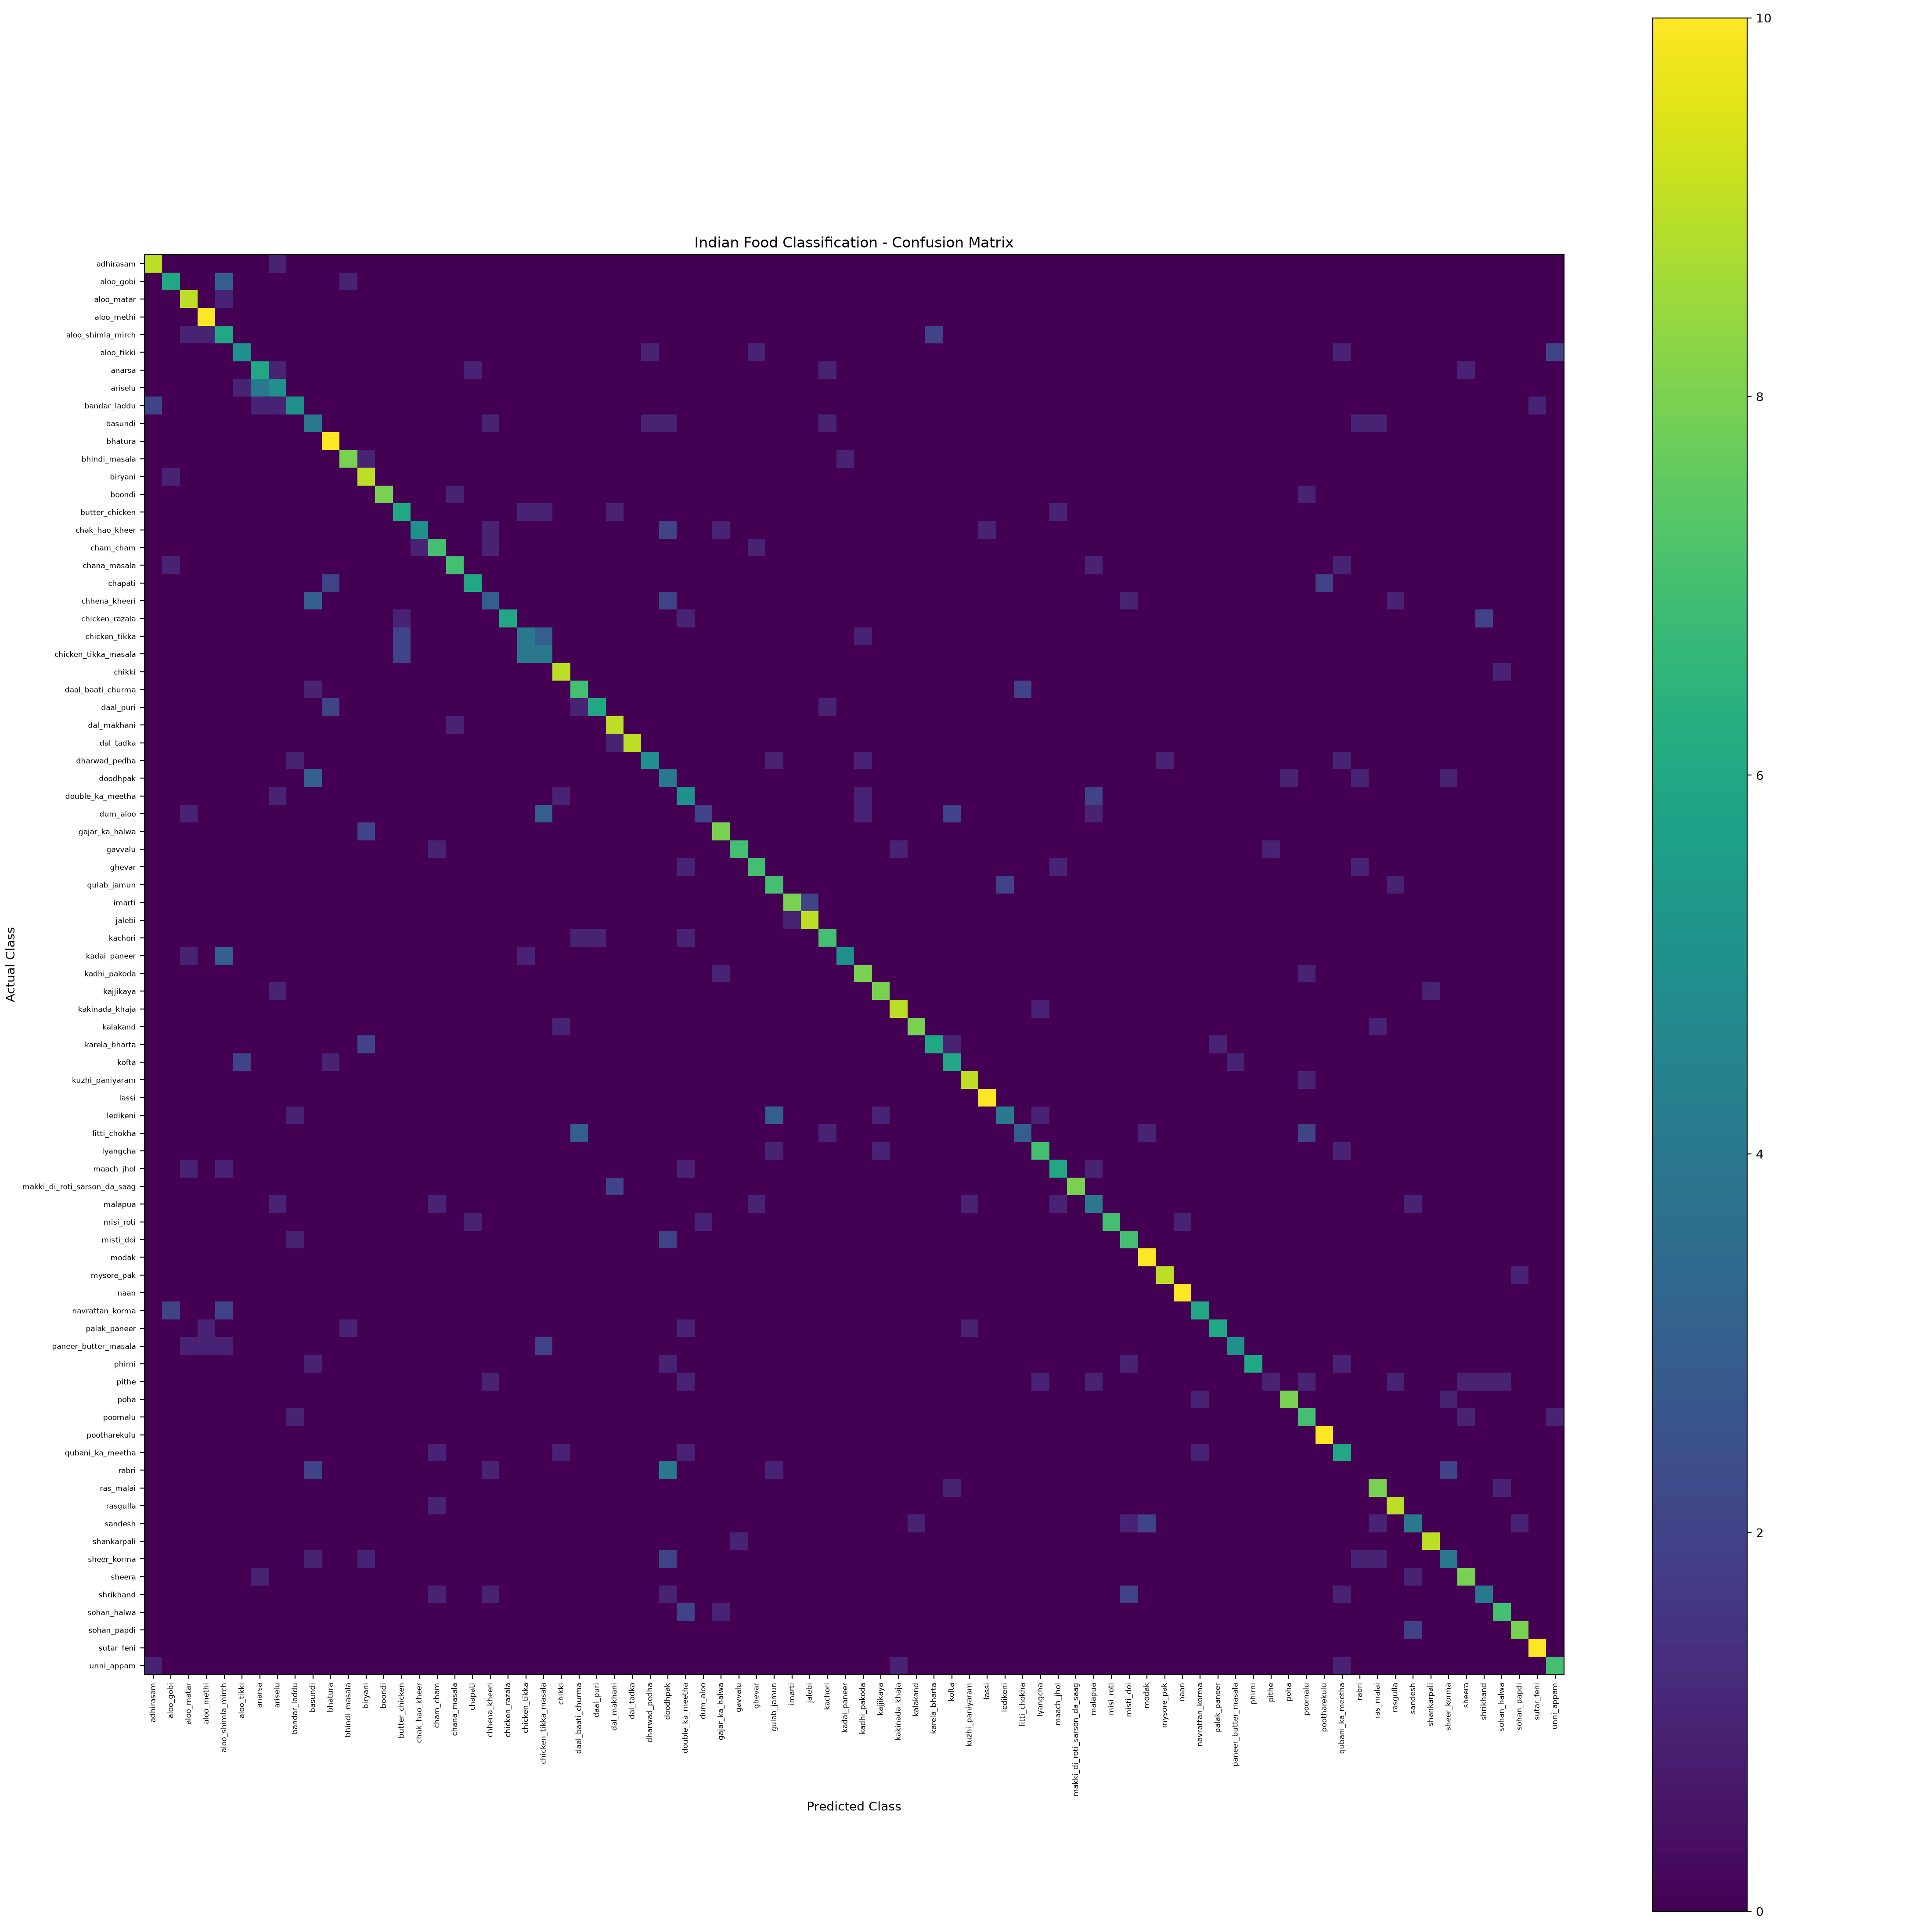
Figure 1. Validation confusion matrix generated by evaluate_resnet_v2.py.

5.5 Results Discussion
The main empirical finding is that learned deep representations are substantially more effective than handcrafted colour and texture descriptors for this fine-grained task. Fine-tuning improves on frozen CNN features because the later backbone layers adapt to the appearance of Indian foods. Similar curries, rice dishes, breads, and desserts remain difficult when image composition or lighting differs from the training examples. The application confidence indicator makes this uncertainty visible to users rather than presenting every prediction as equally reliable.

Chapter 6 Application and Implementation

6.1 Technology Stack
Technology | Role in the project
Python | Core implementation language
PyTorch and torchvision | ResNet50, transforms, training, inference, checkpoint loading
scikit-learn | Classical models, data splitting, metrics
OpenCV and scikit-image | Handcrafted colour, GLCM, and HOG feature extraction
Pandas and NumPy | Feature storage and numerical processing
Matplotlib | Confusion-matrix generation
Streamlit and Pillow | Interactive upload interface and image handling

6.2 Streamlit Application
The app uses a centered dark interface with a model badge, image uploader, prediction panel, and expandable model details. @st.cache_resource keeps the model in memory after the first load. The configured checkpoint is best_resnet50_food_gpu_v2_resumed.pth; the app builds a matching ResNet50 head from the classes stored in the checkpoint.

6.3 Image Upload
Users can submit JPG, JPEG, PNG, or WEBP files through Streamlit's file uploader. The uploaded file is converted to RGB, processed with the same deterministic inference transform used for validation, and displayed beside the result panel.
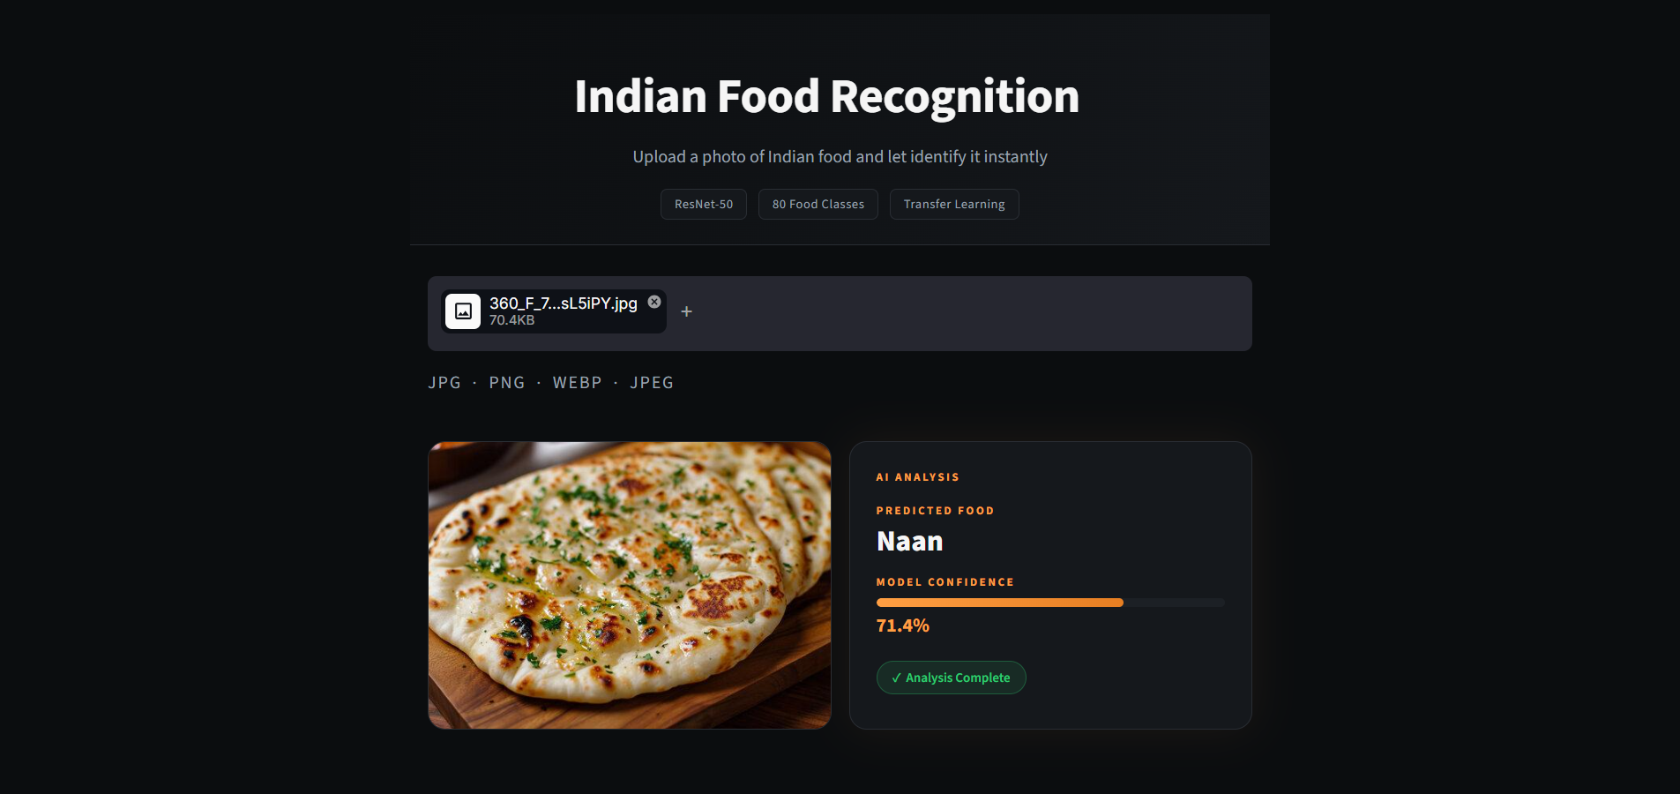
Figure 2. Application upload and high-confidence prediction example for Naan.

6.4 Prediction and Confidence Score
Softmax probabilities are calculated across the 80 classes. The app reports the top class and its percentage confidence. A 50% threshold distinguishes a completed-analysis state from a low-confidence warning, encouraging users to try a clearer photograph when the model is uncertain.
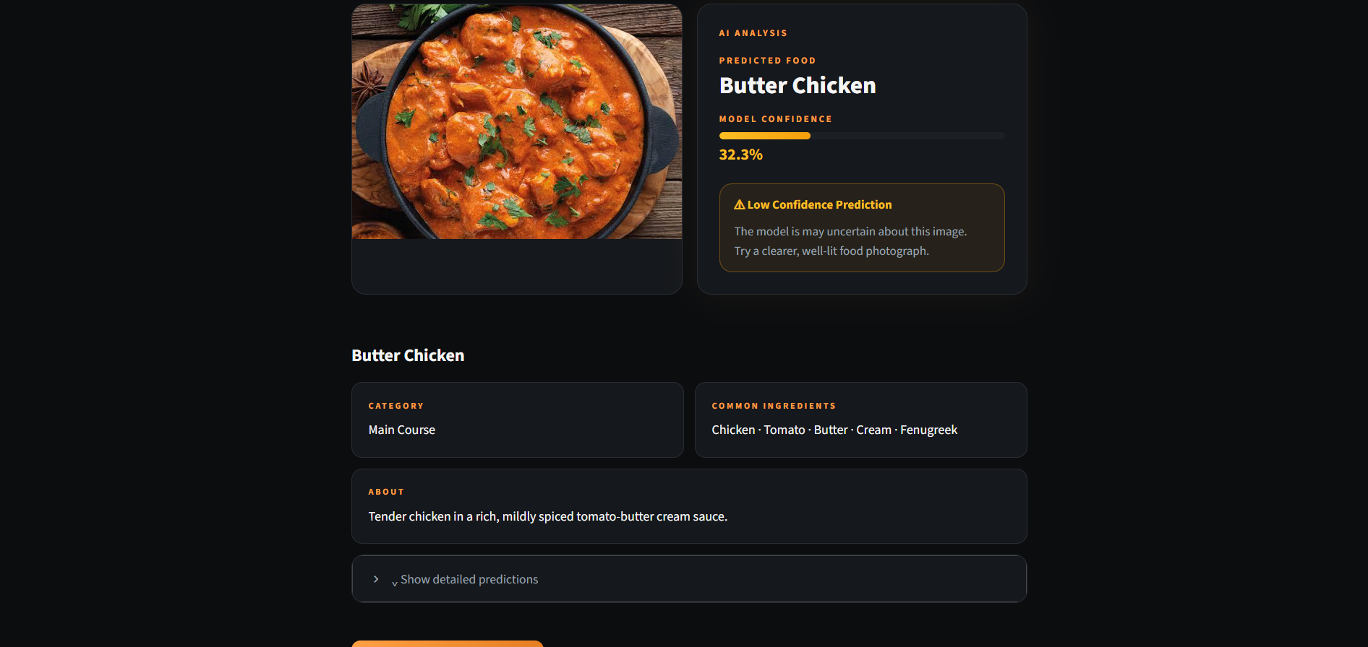
Figure 3. Low-confidence Butter Chicken example showing the application warning behaviour.

6.5 Top 5 Predictions
An expandable Top-5 section makes uncertainty inspectable instead of hiding alternatives. The Biryani example shows the main class at 81.5% followed by Poha, Karela Bharta, Gajar Ka Halwa, and Bhindi Masala with much lower scores.
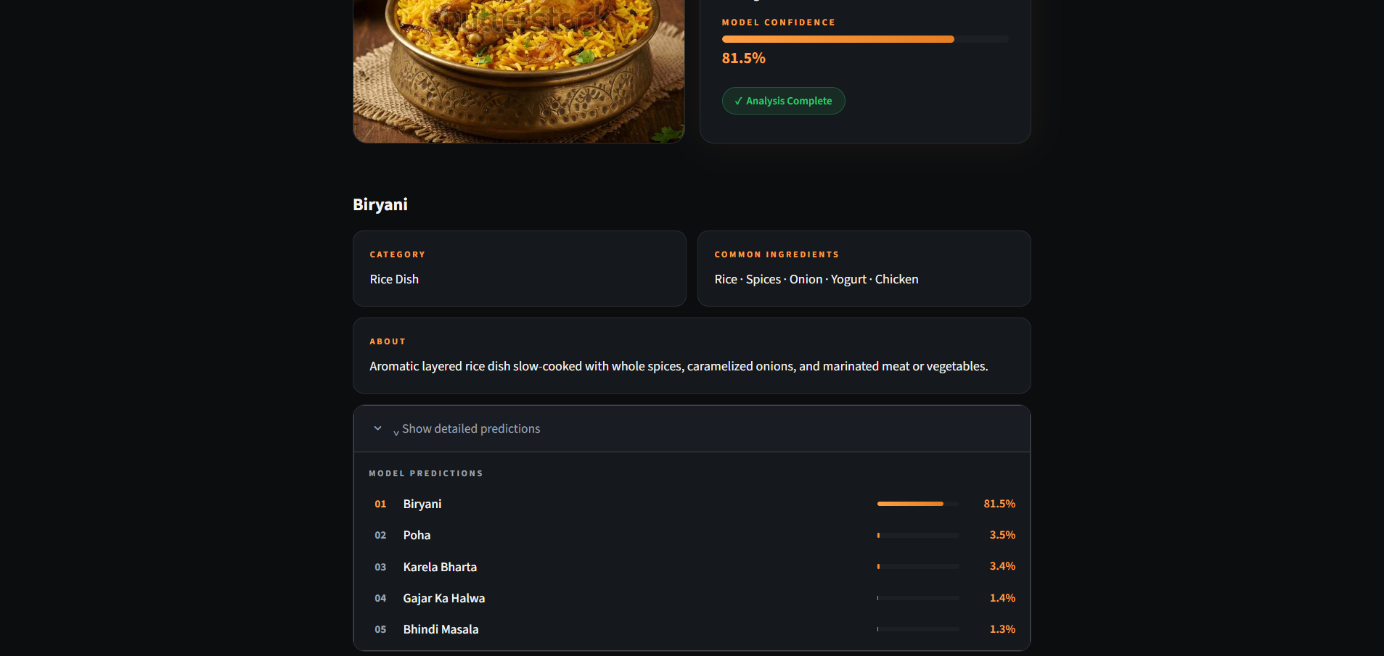
Figure 4. Expanded Top-5 predictions for a Biryani image.

6.6 Food Information Module
After a class is predicted, the app looks up category, common ingredients, and a short description in FOOD_INFO. The current dictionary includes detailed records for 15 classes such as Biryani, Naan, Jalebi, Lassi, Gulab Jamun, Palak Paneer, Butter Chicken, Chapati, and Rasgulla. Classes absent from the dictionary receive a generic fallback message. This module improves usability, but it is important to distinguish it from visual recognition: the food facts are class-mapped metadata, not properties detected in the image.

Chapter 7 Conclusion and Future Work

7.1 Conclusion
The project delivers a working 80-class Indian food image-recognition system and documents an evidence-based transition from handcrafted machine learning to transfer learning. The progressively fine-tuned ResNet50 is the strongest reported approach, with 66.75% validation accuracy and a macro F1-score of 0.663. The Streamlit application turns the trained checkpoint into a usable local interface with confidence-aware and explainable presentation of alternatives.

7.2 Limitations
- The dataset contains only 50 images per class, which constrains generalisation for a large model and for visually diverse dishes.
- Validation relies on one stratified hold-out split rather than repeated cross-validation for the deep model or a fully independent test set.
- Visually similar foods and real-world changes in lighting, viewpoint, plating, and background can lead to systematic errors.
- Food information is currently complete for a subset of the 80 classes and is static metadata rather than live nutritional or ingredient detection.
- The application is local and does not yet include authentication, cloud deployment, feedback collection, or production monitoring.

7.3 Future Enhancements
- Expand the dataset with more images per class, more region-specific dishes, and more variation in lighting and presentation.
- Evaluate newer backbones such as EfficientNet and Vision Transformers, and compare them using a fixed independent test set.
- Add class activation maps or similar visual explanations to show the image regions influencing a prediction.
- Complete the food-information dictionary for all classes and connect a vetted nutrition source where appropriate.
- Package the model for cloud and mobile deployment, using quantisation or pruning where latency and memory matter.
- Collect opt-in user corrections and use them to support an active-learning workflow for difficult classes.

References
K. He, X. Zhang, S. Ren, and J. Sun. Deep Residual Learning for Image Recognition. Proceedings of CVPR, 2016.
J. Deng et al. ImageNet A Large-Scale Hierarchical Image Database. Proceedings of CVPR, 2009.
PyTorch. PyTorch documentation. https://pytorch.org/docs/
Torchvision. ResNet50 model and image-transform documentation. https://pytorch.org/vision/stable/
F. Pedregosa et al. Scikit-learn Machine Learning in Python. Journal of Machine Learning Research, 2011.
I. Loshchilov and F. Hutter. Decoupled Weight Decay Regularization. ICLR, 2019.
C. Szegedy et al. Rethinking the Inception Architecture for Computer Vision. CVPR, 2016.
Z. Zhong et al. Random Erasing Data Augmentation. AAAI, 2020.

