**Docker**

Docker is an open-source platform that allows you to automate the deployment and management of applications within lightweight, isolated software containers.

**Step 1: Setup Docker’s package repositories**

Link 1: https://docs.docker.com/desktop/install/linux/ubuntu/

Note: Click on Download the latest **DEB package** link of **Docker official website**

Link 2: <https://docs.docker.com/engine/install/ubuntu/#install-using-the-repository>

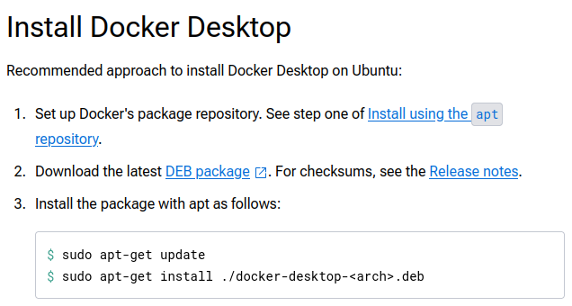

**Process 1: Add Docker's official GPG key:**

Command 1: sudo apt-get update

Command 2: sudo apt-get install ca-certificates curl

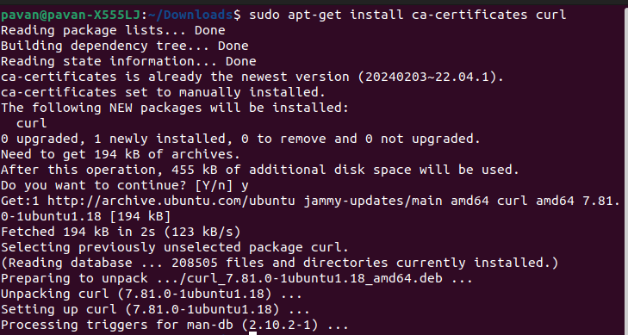

Command 3: sudo install -m 0755 -d /etc/apt/keyrings

Command 4: sudo curl -fsSL https://download.docker.com/linux/ubuntu/gpg -o /etc/apt/keyrings/docker.asc

Command 5: sudo chmod a+r /etc/apt/keyrings/docker.asc

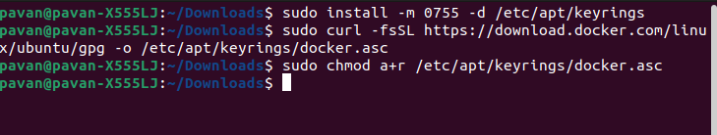

**Process 2: Add the repository to Apt sources:**

Command 1:

echo \

"deb [arch=$(dpkg --print-architecture) signed-by=/etc/apt/keyrings/docker.asc] https://download.docker.com/linux/ubuntu \

$(. /etc/os-release && echo "$VERSION_CODENAME") stable" | \

sudo tee /etc/apt/sources.list.d/docker.list > /dev/null

Command 2: sudo apt-get update

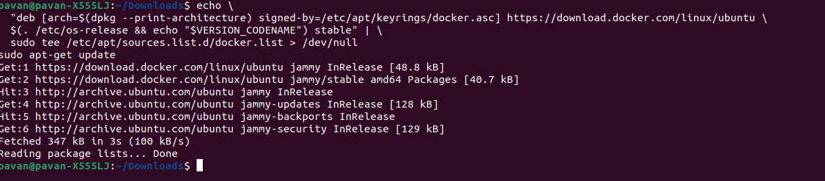

**Step 2:** Download the latest **DEB package** link of **Docker officeal website**

Link 1: <https://docs.docker.com/desktop/install/linux/ubuntu/>

**Step 3:** Install the package with apt as follows:

Command 1: sudo apt-get update

syntex: sudo apt-get install ./docker-desktop-<arch>.deb

Command: sudo apt-get install ./docker-desktop-amd64.deb

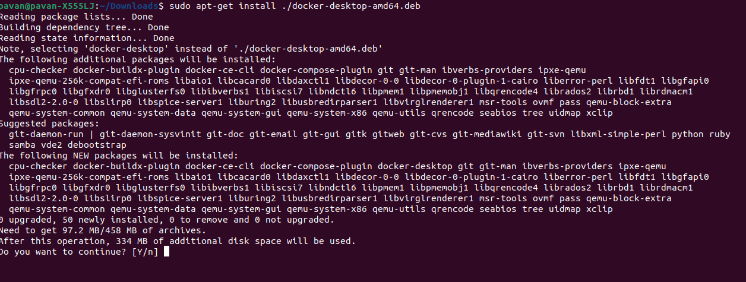

Note: After installation, you can use Docker without sudo by adding your user to the docker group:

Command: sudo usermod -aG docker $USER

**or Start using below command**

Command: systemctl --user start docker-desktop



Note: After you’ve successfully installed Docker Desktop, you can check the versions of these binaries by running the following commands:

Command 1: docker compose version

Command 2: docker –version

Command 3: docker version

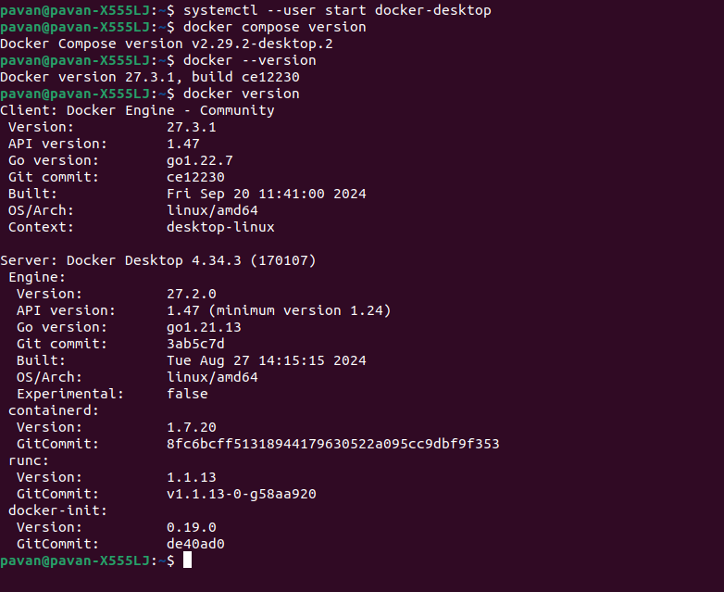

**To enable Docker Desktop to start:**

Command: systemctl --user enable docker-desktop

**To stop Docker Desktop**:

Command: systemctl --user stop docker-desktop

