**DevOps**

**Q.1** What is DevOps?

DevOps is a set of process and practices that aim to improve collaboration between development (Dev) and operations (Ops) teams in software development and IT. The primary goal of DevOps is to remove deployment time in the software development lifecycle with high-quality software and more frequently.

DevOps is a combination of the words "development" (Dev) and "operations" (Ops).

**Key principles of DevOps include:**

1) Collaboration: Collaboration between developers, operations staff, and other stakeholders throughout the software lifecycle.

2) Automation: Emphasizes automating repetitive tasks, such as testing, deployment, and infrastructure management, to reduce errors and increase efficiency.

3) Continuous Integration and Continuous Deployment (CI/CD): Involves regularly integrating code changes into a shared repository and automatically deploying them to production, enabling faster feedback and quicker releases.

4) Monitoring and Feedback: Implements continuous monitoring of applications and infrastructure to gather performance data.

**Challenges in DevOps:**

1) Organizational and IT departmental changes

2) Expensive tools and platforms

**DevOps Solve Problems:**

1) Many companies face its own challenges, but common problems include releases that take too long, software that doesn't meet expectations and IT that limits business growth.

2) DevOps solves communication and priority problems between IT specializations.

**Software Life Cycle:**

1) Planning: Setting goals, defining requirements, and creating a roadmap.

2) Coding: Writing the software.

3) Building: Compiling the code to create software packages.

4) Testing: Running tests to identify and fix bugs.

5) Release: Deploying the code to production environments.

6) Deploy: Making the application available to users.

7) Operate: Monitoring the application performance and user feedback.

8) Monitor: Continuous monitoring for bugs, improvements, and new features.

**Tools/Procss Used in DevOps:**

1. Docker:



2. Git:



3. Kubernetes:

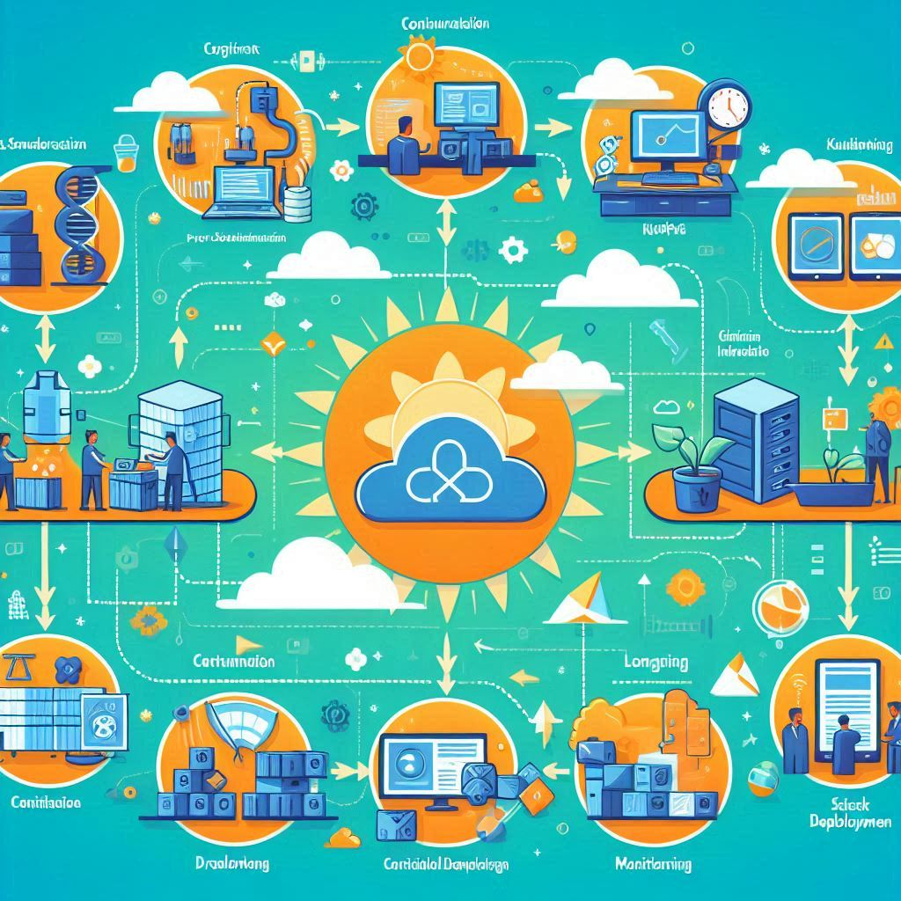

4. Terraform



5. CI/CD Pipeline:

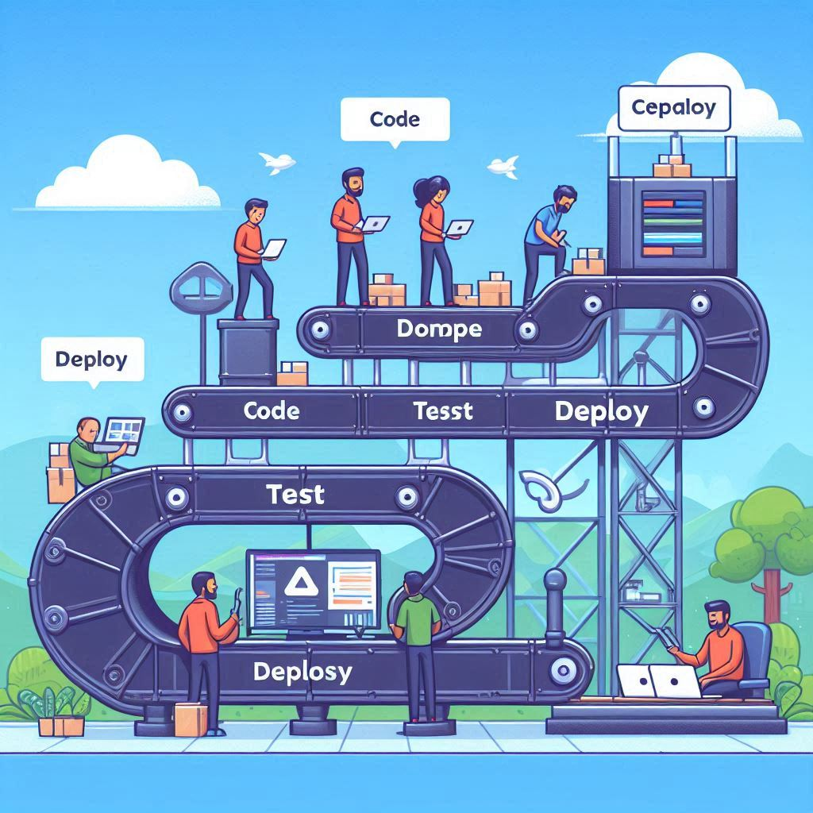

6. Monitoring Tools (e.g., Prometheus, Grafana):



7. Jenkins:



8. Ansible:



9. Cloud Providers (AWS, Azure, GCP):

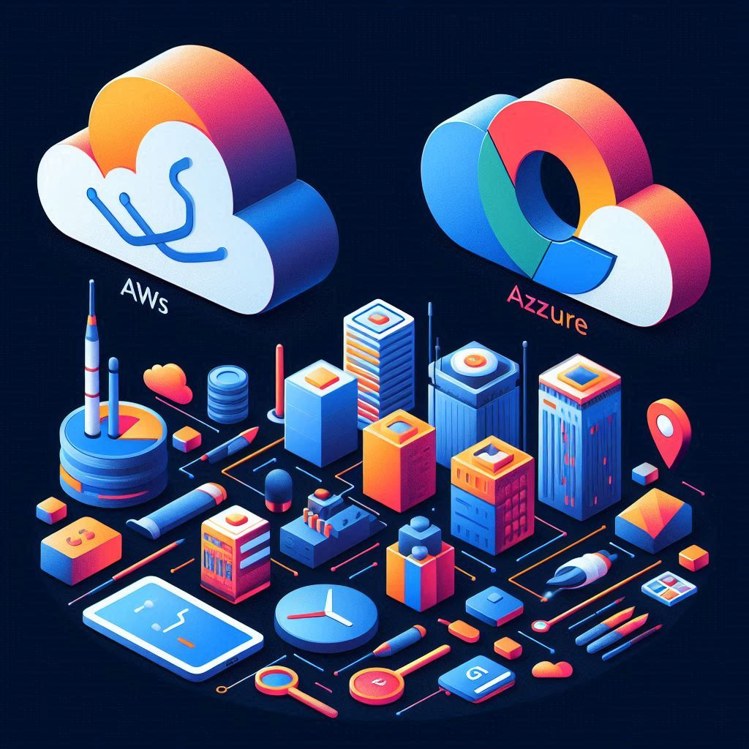

10. Infrastructure as Code:



**Q.2** What is Automation, Scaling, and Infrastructure?

1. Automation

Automation in the context of IT and software development refers to the use of technology to perform tasks with minimal human intervention. This can involve scripting and tools to automate repetitive processes such as:

Deployment: Automatically pushing code to production.

Testing: Running automated tests to ensure code quality.

Configuration Management: Automatically configuring servers and applications.

The primary benefits of automation include increased efficiency, reduced errors, and the ability to free up teams to focus on more strategic tasks.

2. Scaling

Scaling refers to the ability of a system to handle increased load or demand. There are two main types of scaling:

Vertical Scaling (Scaling Up): Adding more resources (CPU, RAM) to a single server to improve its capacity.

Horizontal Scaling (Scaling Out): Adding more servers to distribute the load. This is often used in cloud environments where you can easily spin up new instances as needed.

Effective scaling ensures that applications remain responsive and performant under varying workloads.

3. Infrastructure

Infrastructure refers to the foundational systems and services that support the operation of applications and services. This includes:

Physical Infrastructure: Data centers, servers, networking equipment, etc.

Virtual Infrastructure: Virtual machines, containers, and cloud services.

Network Infrastructure: Routers, switches, and other networking components that enable communication.

Infrastructure is critical for hosting applications, storing data, and providing the necessary resources for development and deployment.