Floyd Cycle detection algorithm proofs that Single linked list having the loop with mathematical representation

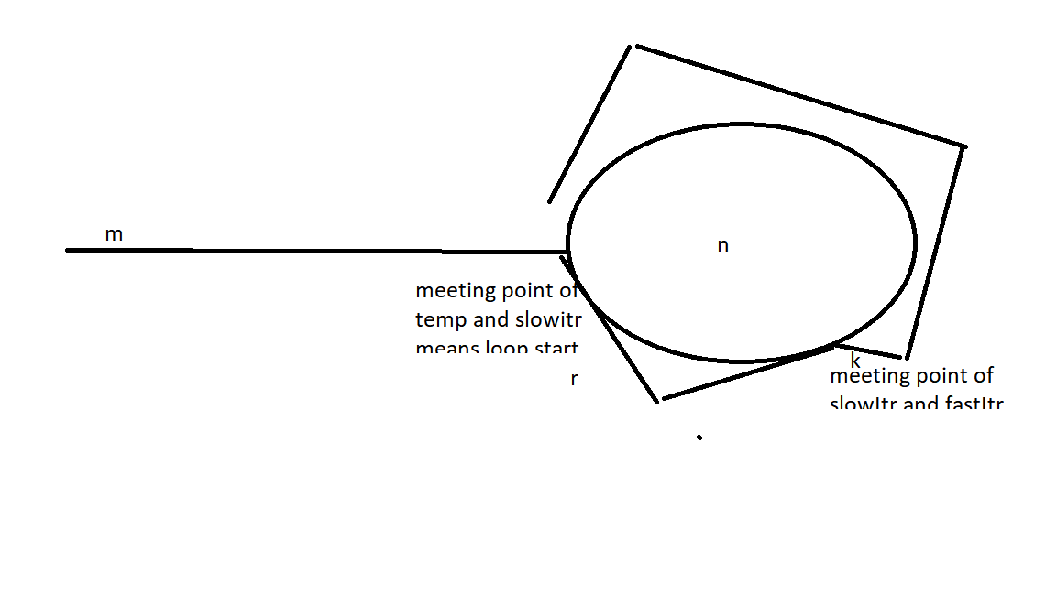

k=n-r

Formula for find the loop.

Suppose fastItr travelled the distance twice than slowitr

Df = m+n\*cf+k

Ds = m+n\*cs+k

Cs and Cf are constants represents the how many cycles has done

Lets assume slowItr distance is x and fastItr distance 2x

x= m+n\*cs+k

2x= m+n\*cf+k

x=n\*(cf-cs)

finding the start of loop formula

Df = 2Ds;

m+n\*cf+k = 2(m+n\*cf+k)

m+n\*cf+k = 2m+2ncs+2k

n\*cf = m+2ncs+k

ncf-2ncs-k=m

n(cf-2cs)-k=m

n(cf-2cs)-(n-r)=m

n(cf-2cs-1)+r=m