1.made a repo (assignment1-jenkins) and create 3 branches (24Q1,24Q2,24Q3)

2.made a index.html file on all 3 braches and merge (24Q2,24Q3)them on default branch (24Q1)

3.create 3 job with git and repo url and branches

4.build 3 jobs separately and check console output

5.check default workspace and cotent that we gave to all branches so right or wrong

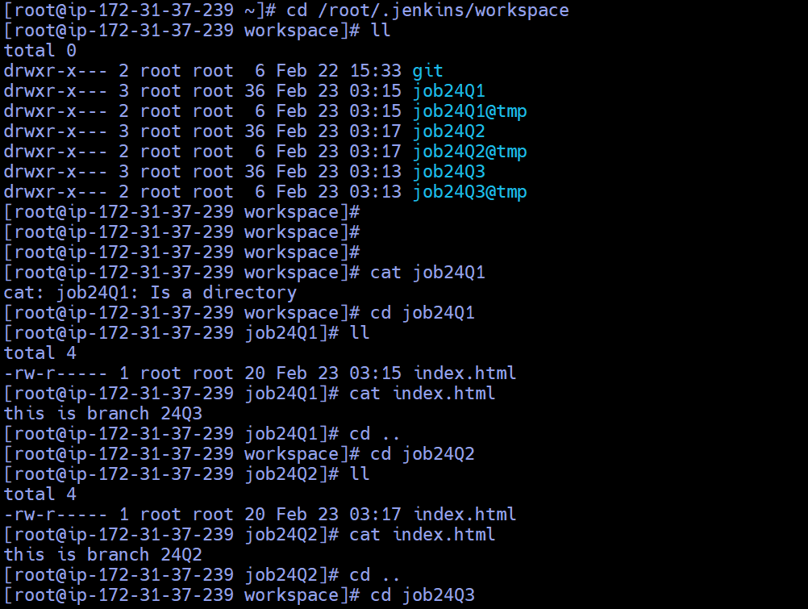

6.24Q1 build

7.24Q2 build

8.24Q3 build

