1.install java 11

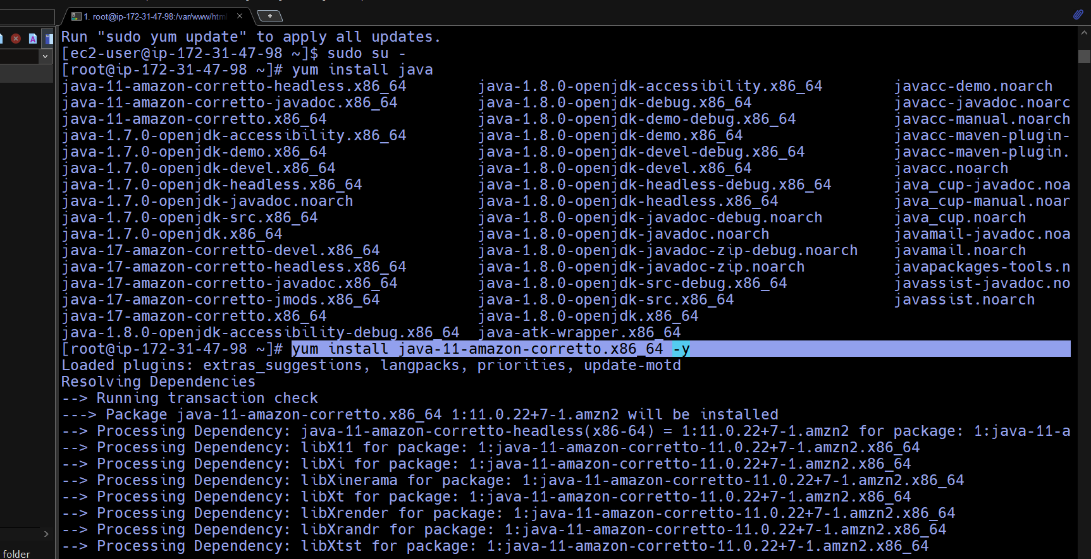

2.in mnt folder made a sever names directory and download tomcat.9 into server directory

3.unzip tomcat.9 and gave all permissions to it.

Now,from tomcat.9 ,deploy Jenkins.war file in webapp .

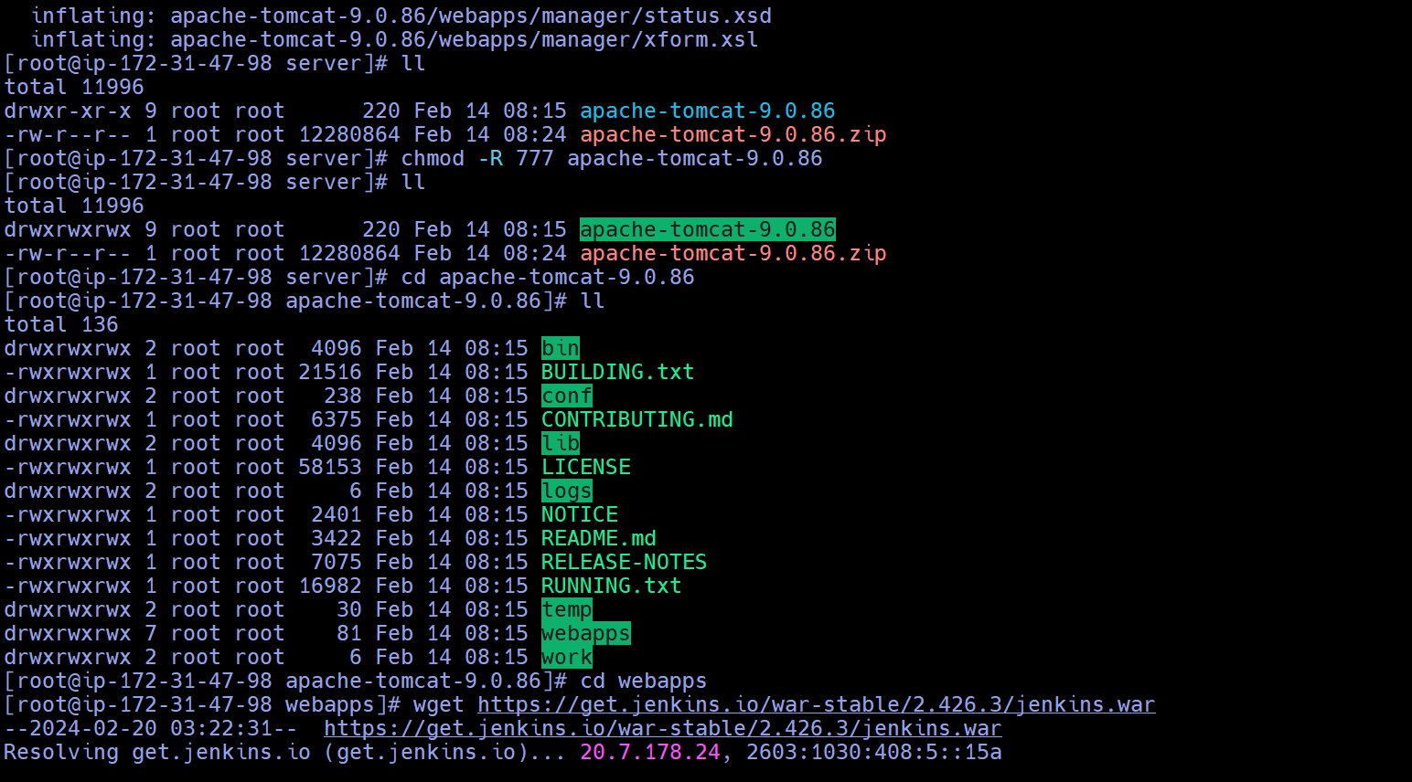

4.start deployment from bin and check logs from logs



5.google-------instance public ip:8080/Jenkins.

6.in Jenkins created a job …install httpd …made a index.html-----and write ----wel-come to latur.

7.verify from cli

8.upload file on github repository

