1.make credential for private repo to access

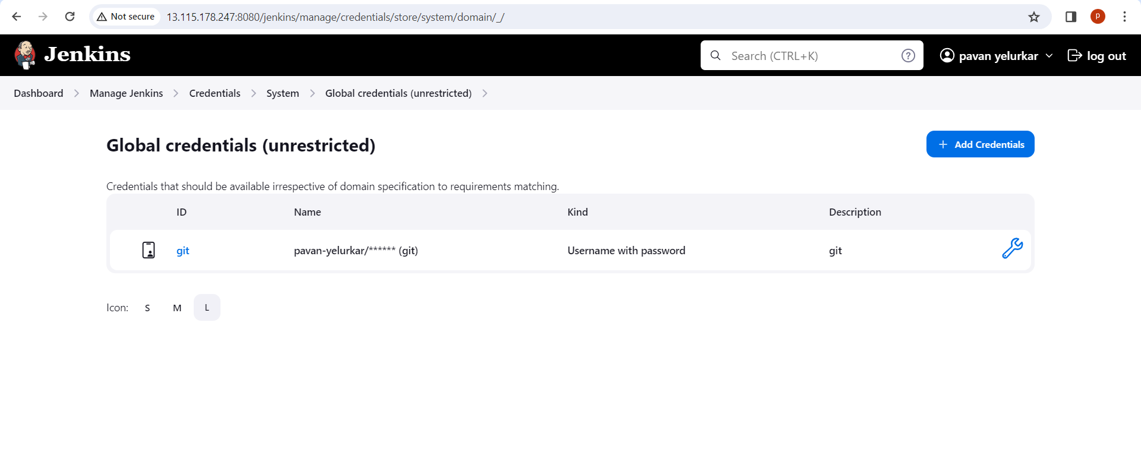

2.create a empty

3.download maven and start the maven form maven home/bin folder

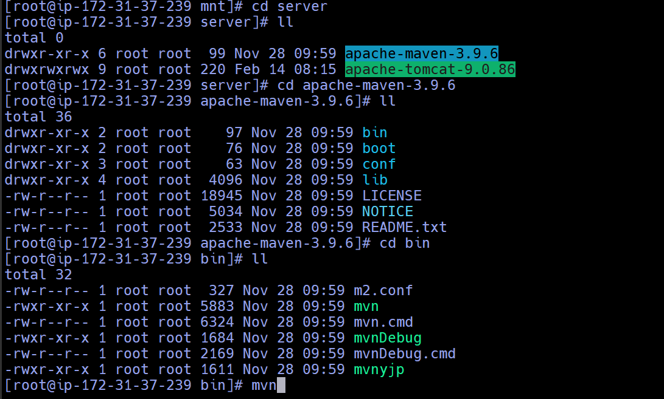

4.but we want to start maven from anywhere../root/.bash_profile update

5.now,setup maven in jenkins

6.

7.build the job and check console output

