**Q. Write a client program to enter the number and server program to calculate the square, square root, cube and cube root of the entered number using TCP Communication**

**tcpClientOperations.java**

import java.net.*;

import java.io.*;

class tcpClientOperations

{

    public static void main(String args[])

    {

        try

        {

            Socket cs = new Socket("LocalHost",8001);

            BufferedReader infu = new BufferedReader(new InputStreamReader(System.in));

            System.out.println("Enter a number : ");

            int num = Integer.parseInt(infu.readLine());

            DataOutputStream out = new DataOutputStream(cs.getOutputStream());

            out.writeInt(num);

            DataInputStream in = new DataInputStream(cs.getInputStream());

            System.out.println(in.readUTF());

            cs.close();

        }

        catch(Exception e)

        {

        System.out.println(e.toString());

        }

    }

}

**Output:**

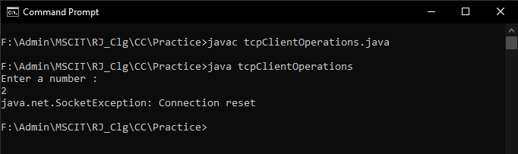

**tcpServerOperations.java**

import java.net.*;

import java.io.*;

import java.util.*;

class tcpServerOperations

{

    public static void main(String args[])

    {

        try

        {

            ServerSocket ss = new ServerSocket(8001);

            System.out.println("Server Started...............");

            Socket s = ss.accept();

            DataInputStream in = new DataInputStream(s.getInputStream());

            int x= in.readInt();

            DataOutputStream otc = new DataOutputStream(s.getOutputStream());

            //Square

            System.out.println("Square of " + x + " is: " + Math.pow(x, 2));

            //Square Root

            System.out.println("Square Root of " + x + " is: " + Math.sqrt(x));

            //Cube

            System.out.println("Cube of " + x + " is: " + Math.pow(x, 3));

            //Cube root

            System.out.println("Cube root of "+ x +" is: "+Math.cbrt(x));

        }

        catch(Exception e)

        {

            System.out.println(e.toString());

        }

    }

}

**Output:**

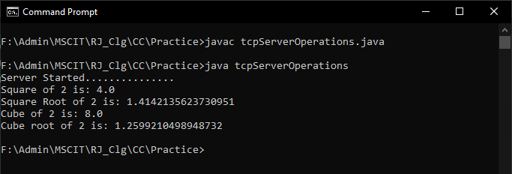

**Final output of TCP:**

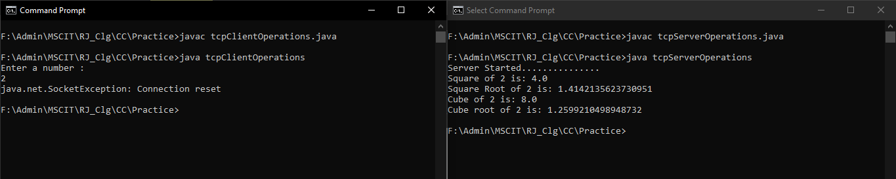

**File Structure**

