<https://www.vmware.com/try-vmware/try-hands-on-labs.html>

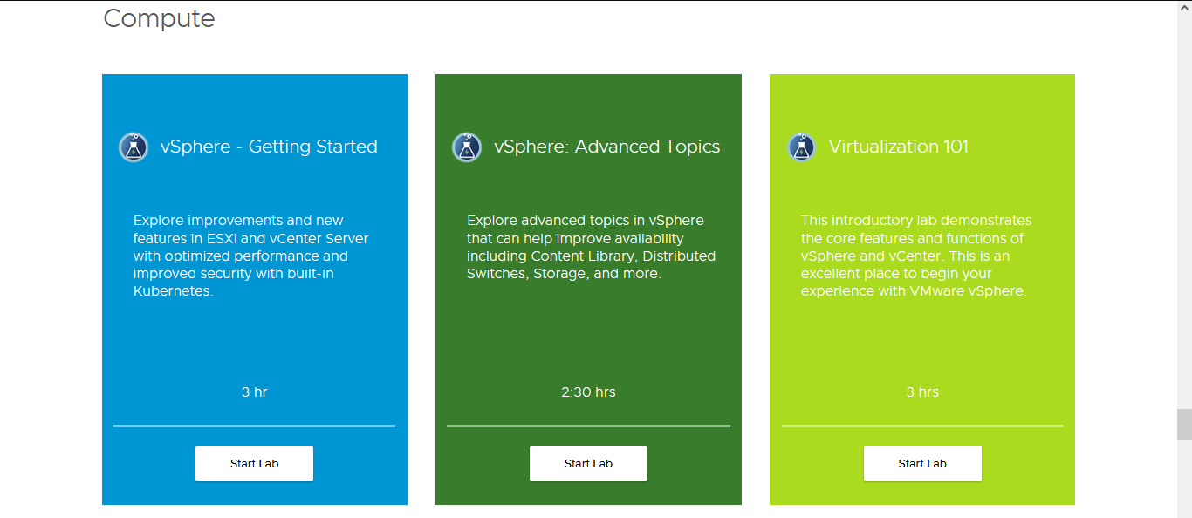

<https://customerconnect.vmware.com/en/web/vmware/evalcenter?p=virtualization-hol-gen-21>

