**NATIVE VIRTUALIZATION USING Hyper-V**

First we have to uninstall VMWare software if already installed on computer because the VMware Workstation installer does not support running on a Hyper-V virtual machine.

After uninstalling VMware, we can proceed to next step - go to control panel and click on uninstall a program

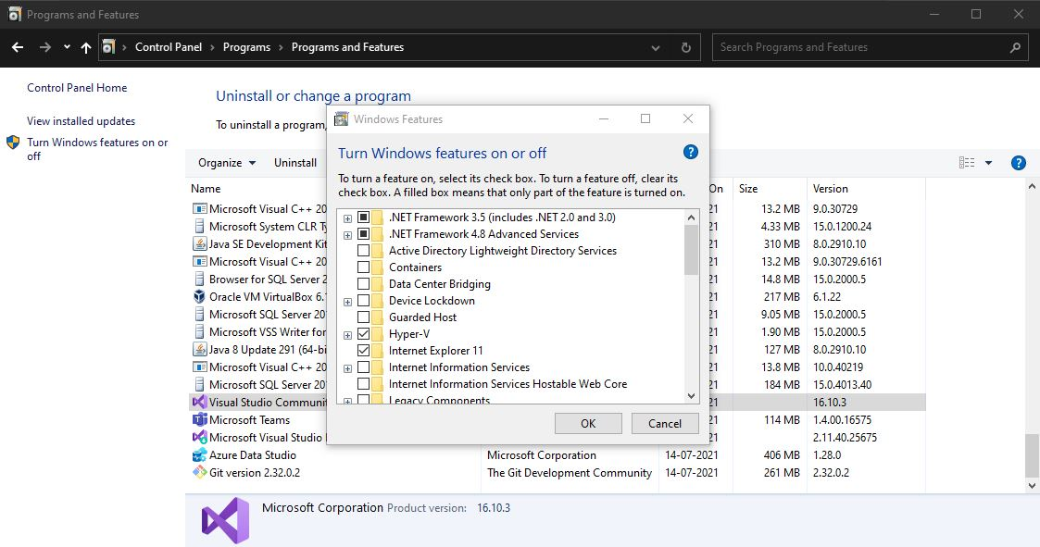

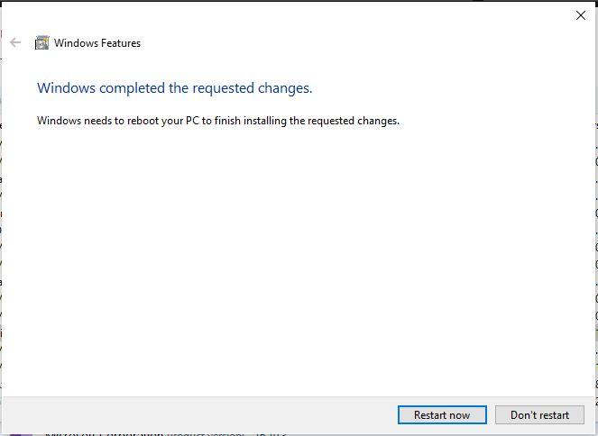

If Hyper V is not installed and if you couldn’t find it then follow the link to do installation

<https://www.how2shout.com/how-to/how-to-download-and-install-hyper-v-on-windows-11-home.html>

After Restart **Search for hyper-v manager in search box and click on that**

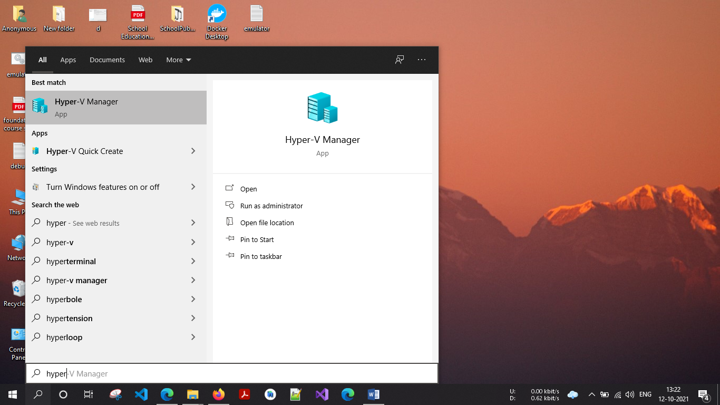

**for creating virtual machine, first we have to create virtual switch**

click on virtual switch manager option

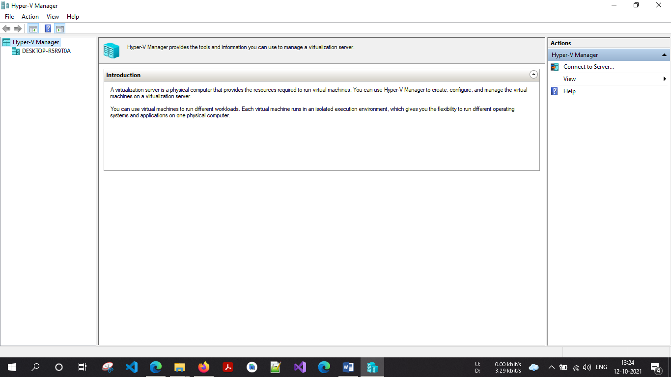

1. Select your Server

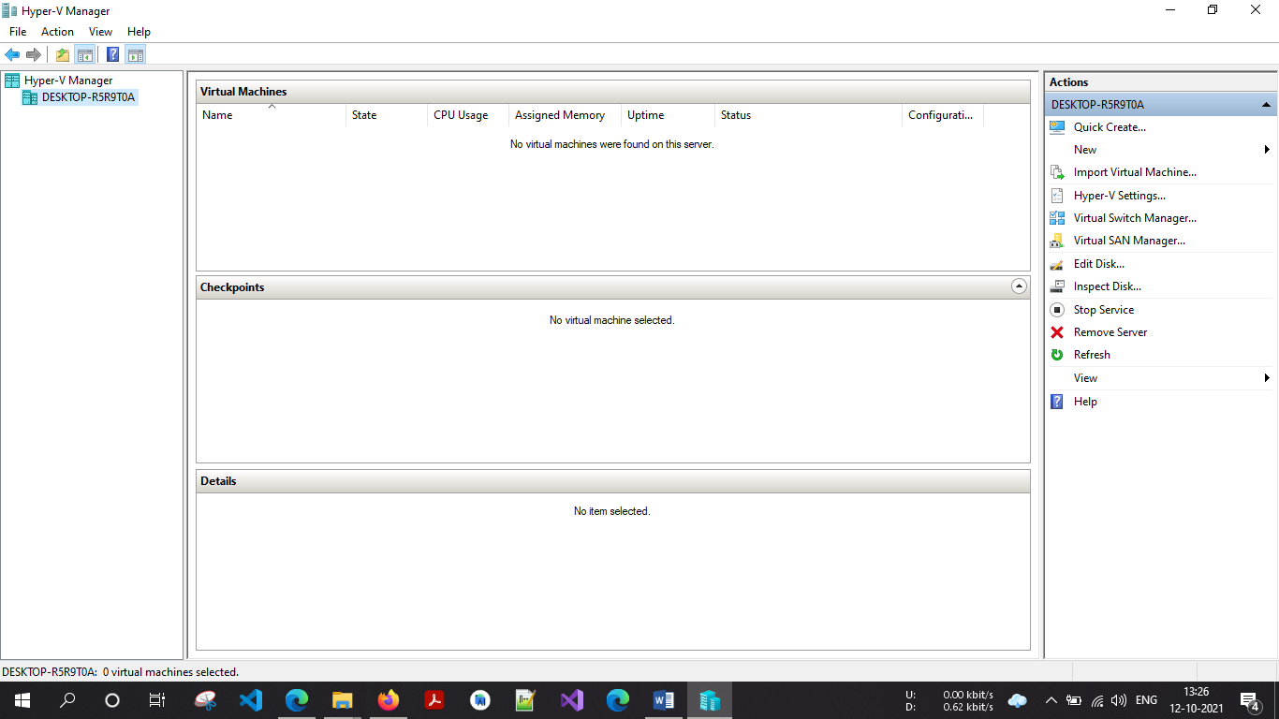

1. Select External as a connection type and then click on **create virtual switch**

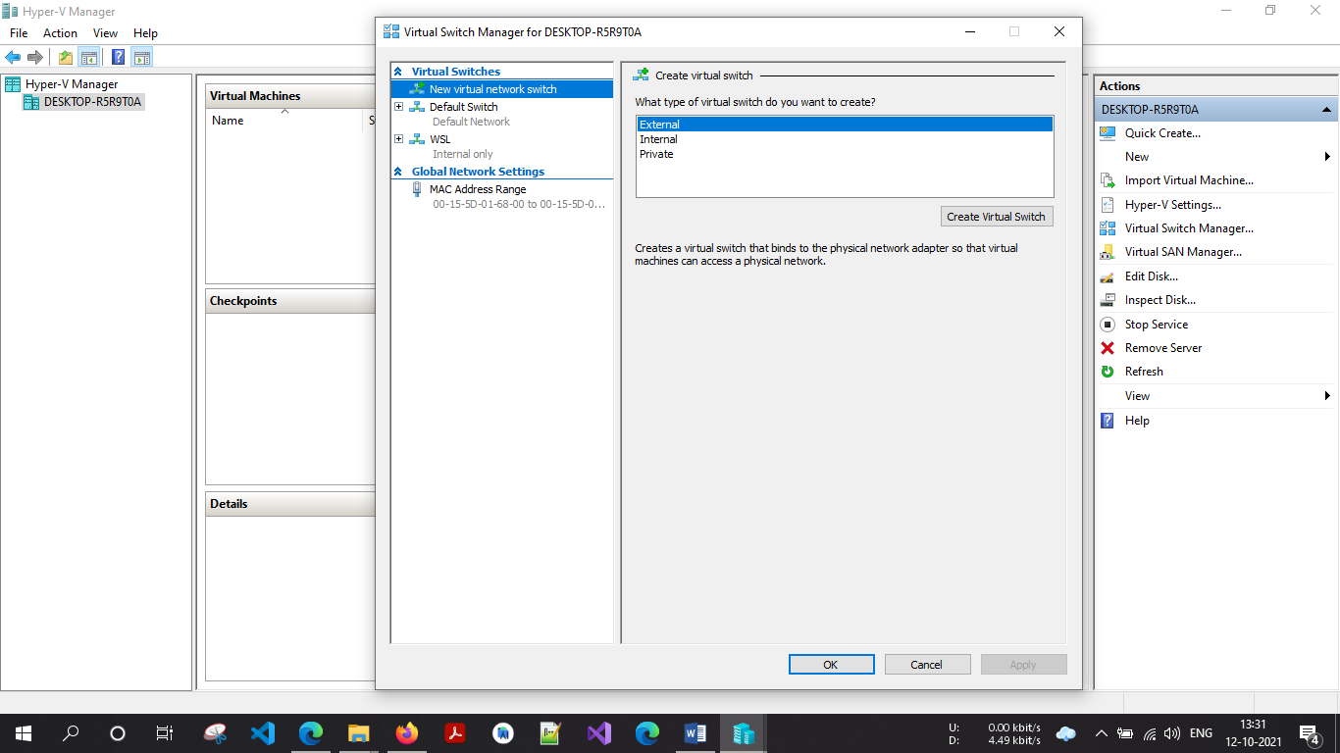

Give name to your virtual switch then click on **apply button**

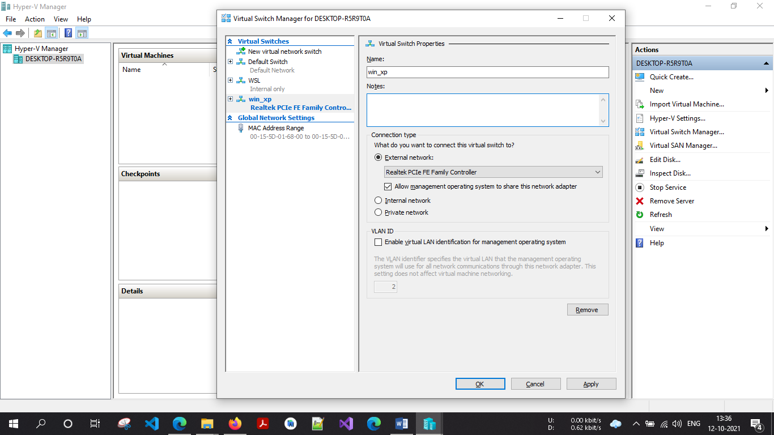

After click on Apply button it will show warning about our connection **click on yes**

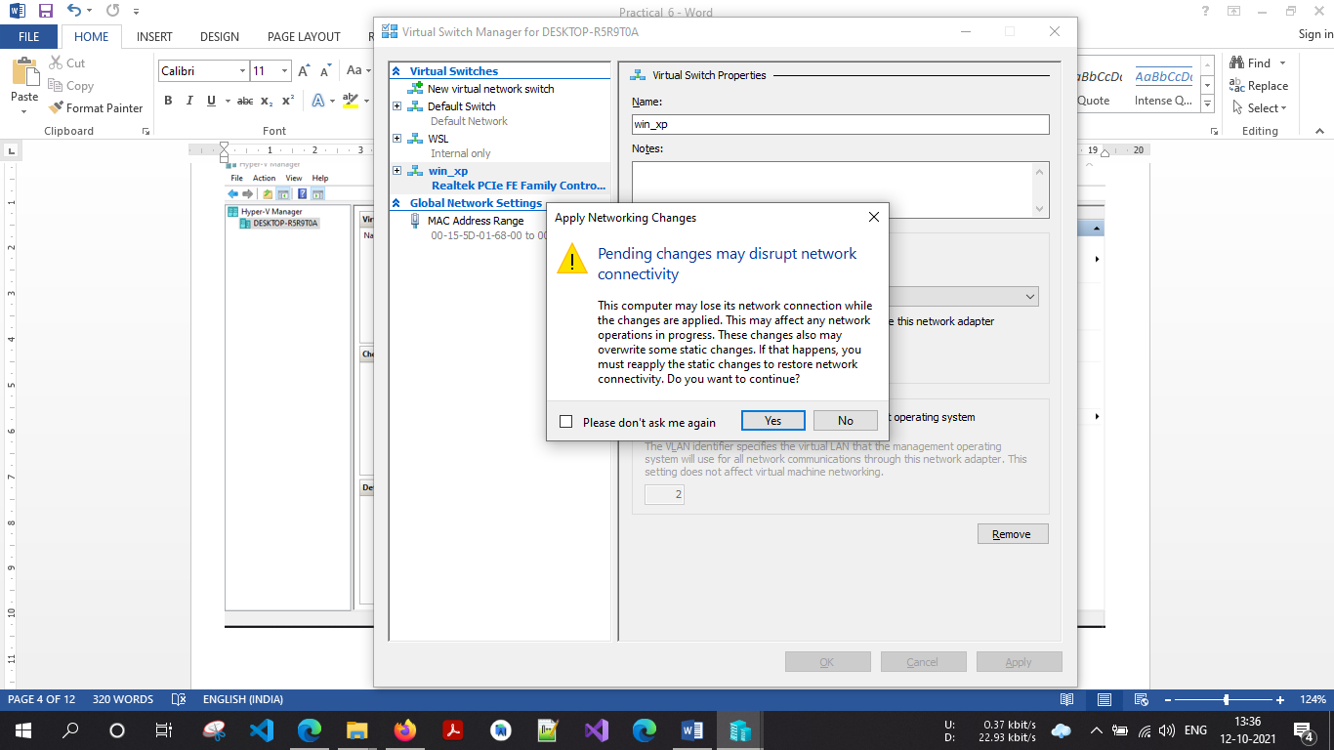

Now right click on server and select new virtual machine

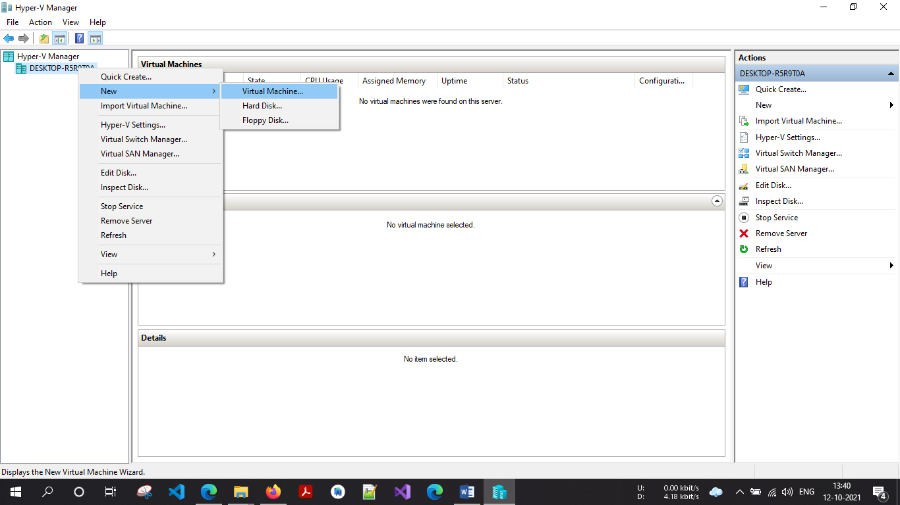

Click on next button

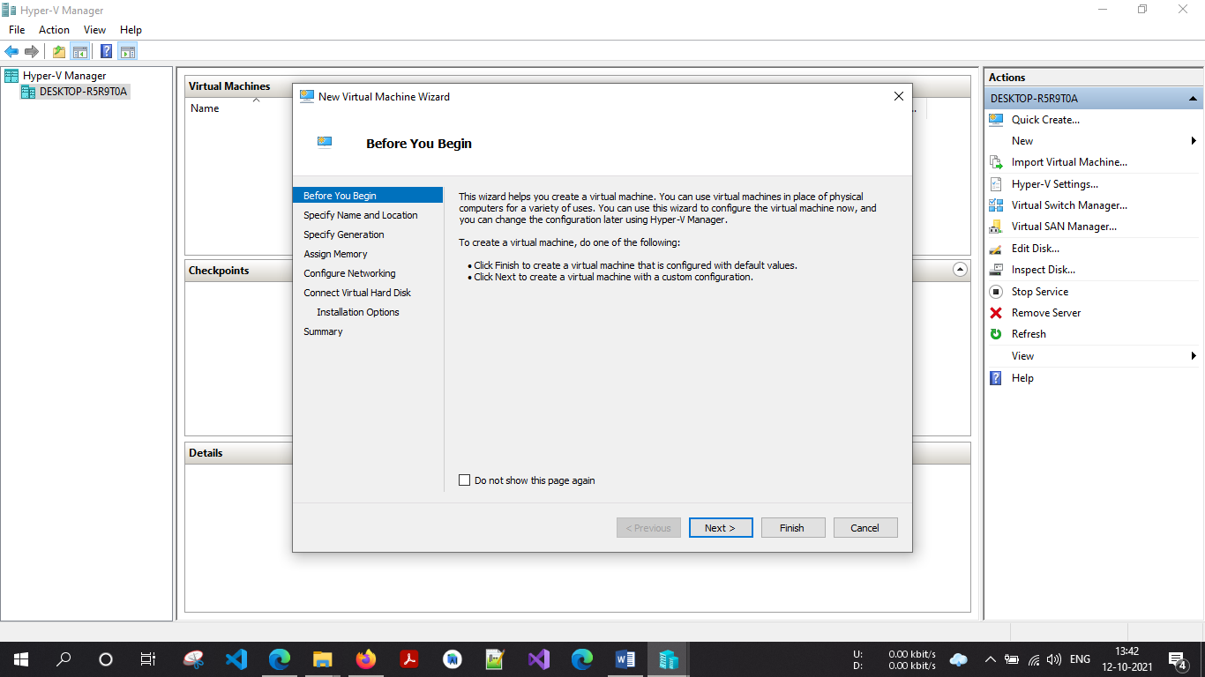  
  
  
Provide name to virtual machine then click on Next button

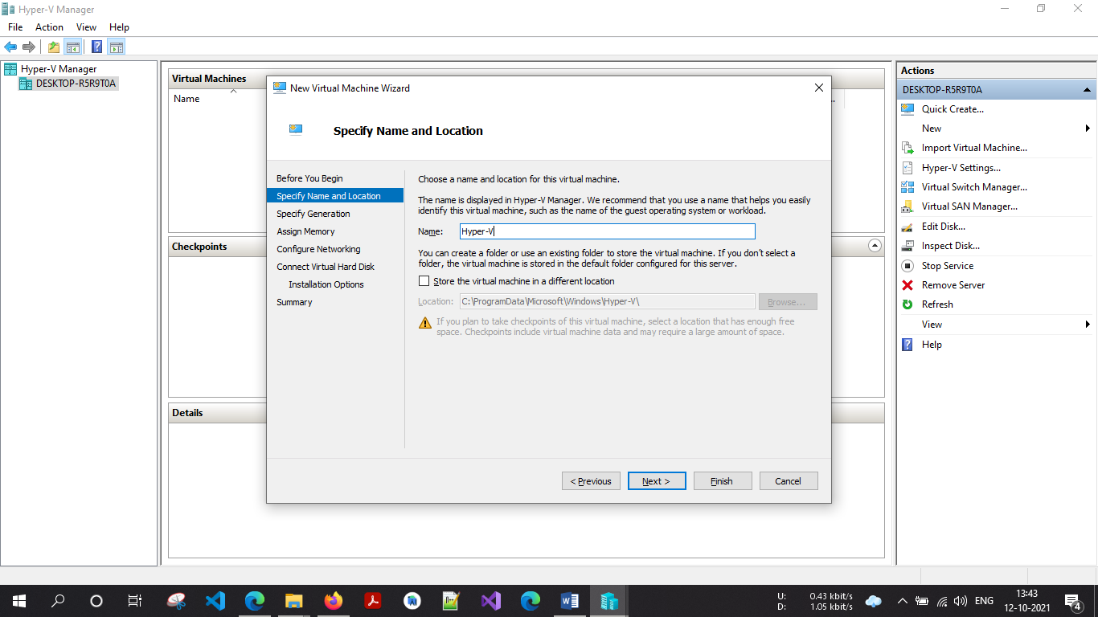

Specify generation: generation 1

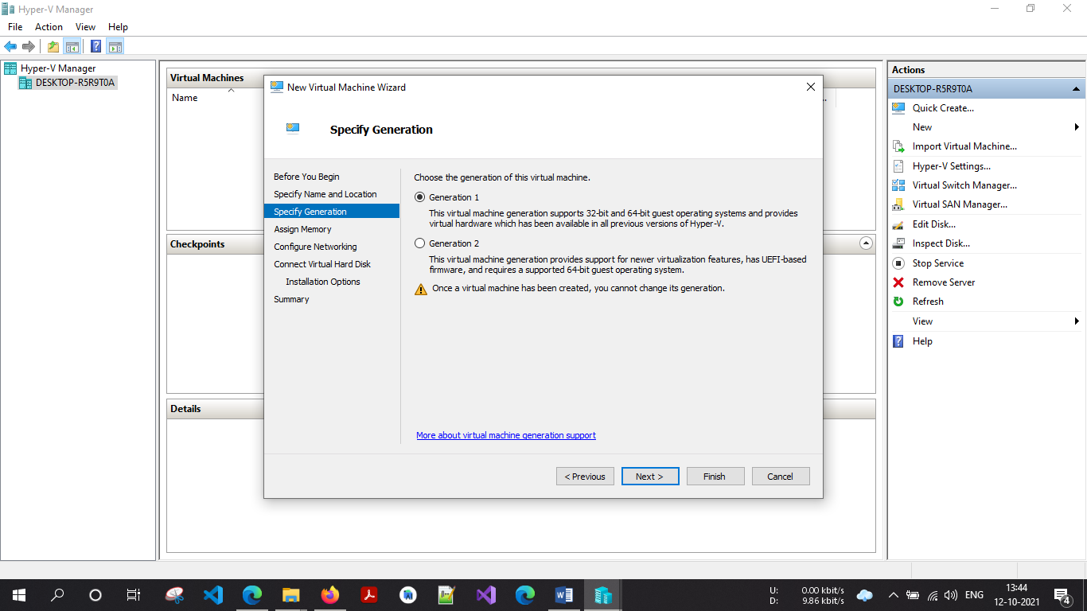  
  
  
tick on use **dynamic memory for this virtual machine**

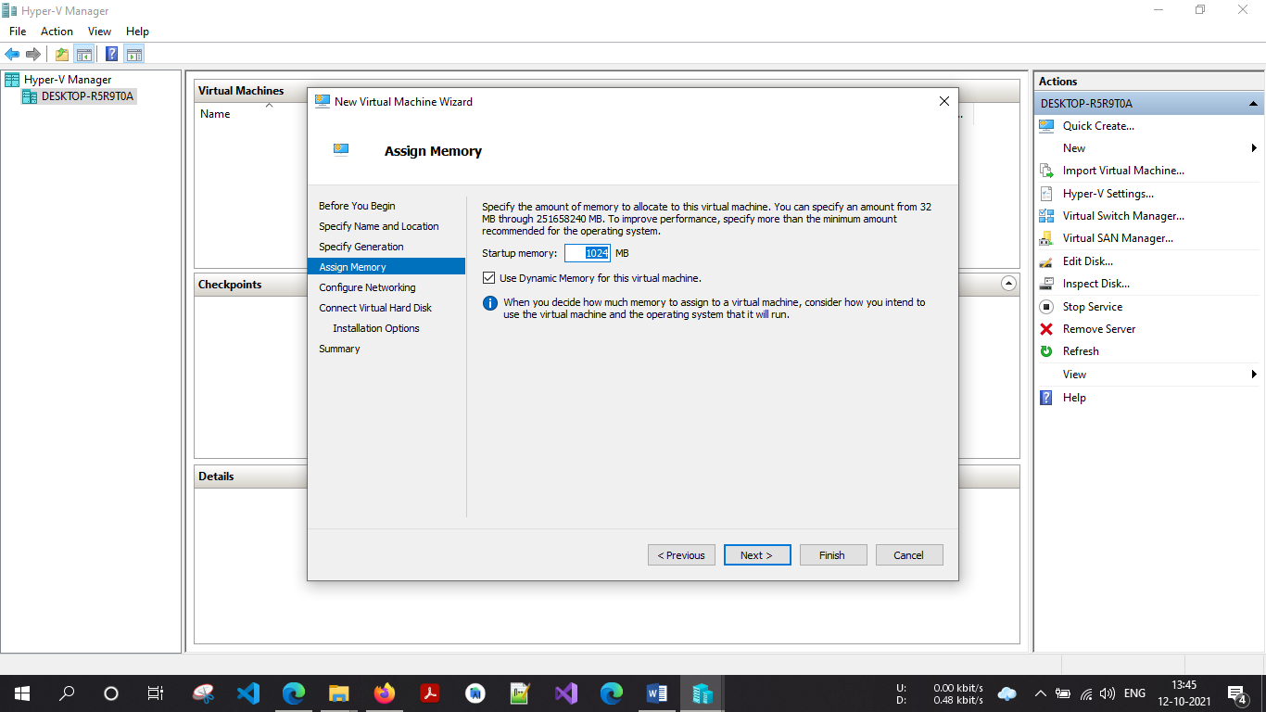

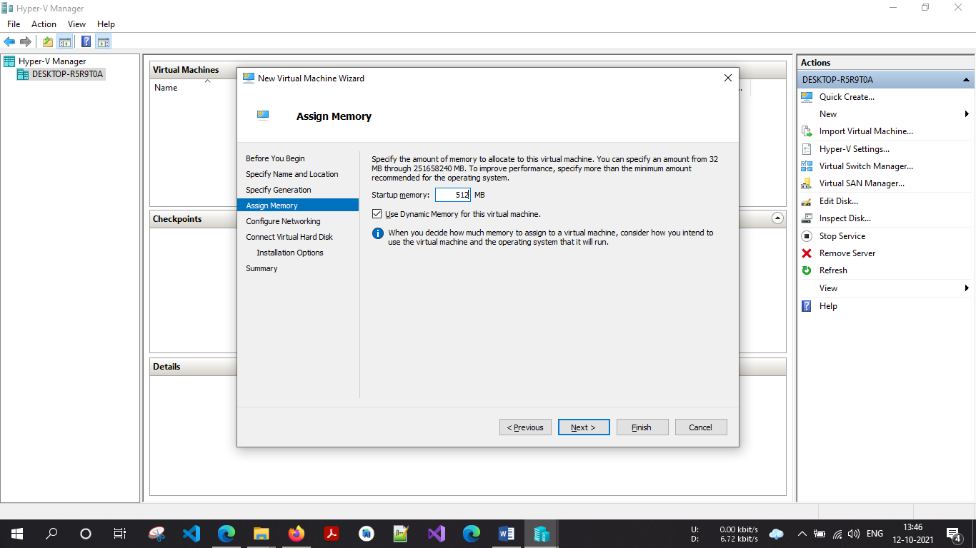

Select switch which we ***created earlier for our virtual machine*** from drop-down list and then click on next

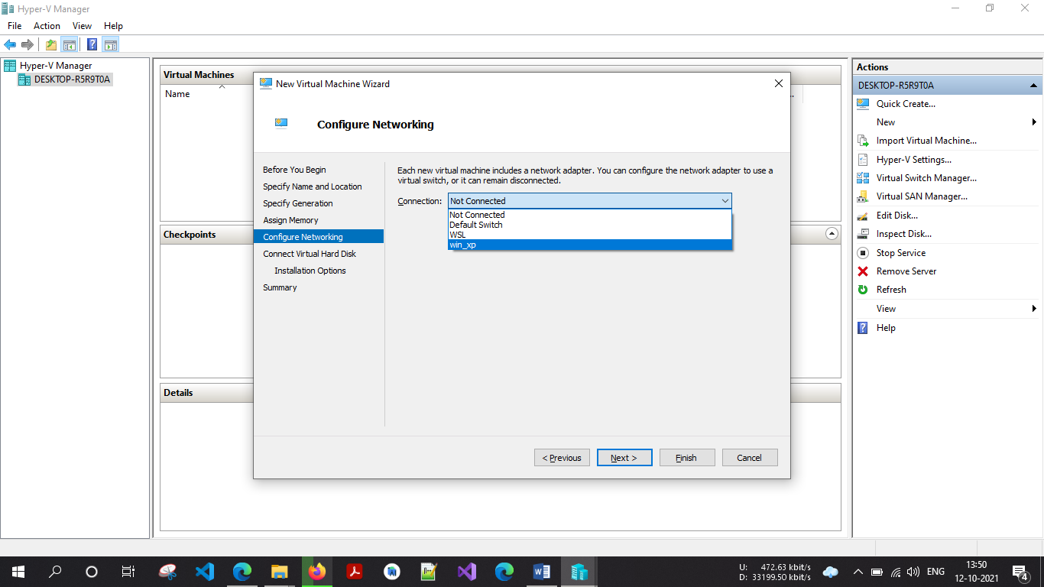

Description of virtual machine and location where it will store virtual machine related files and size require for this machine click on next

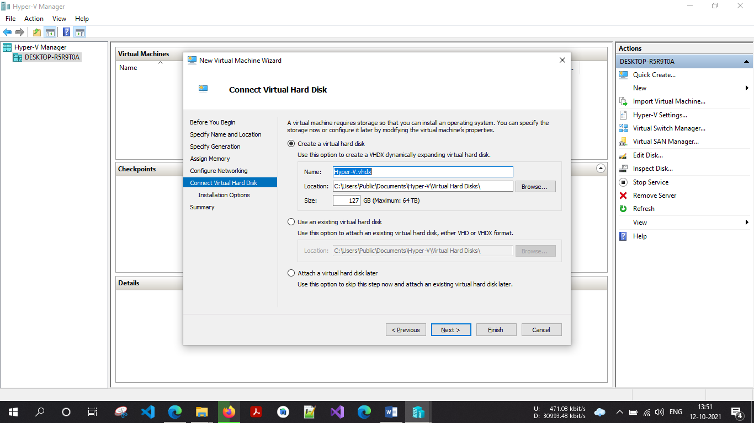

New virtual machine wizard panel will appear, where we will choose operating system which we want to install on virtual machine

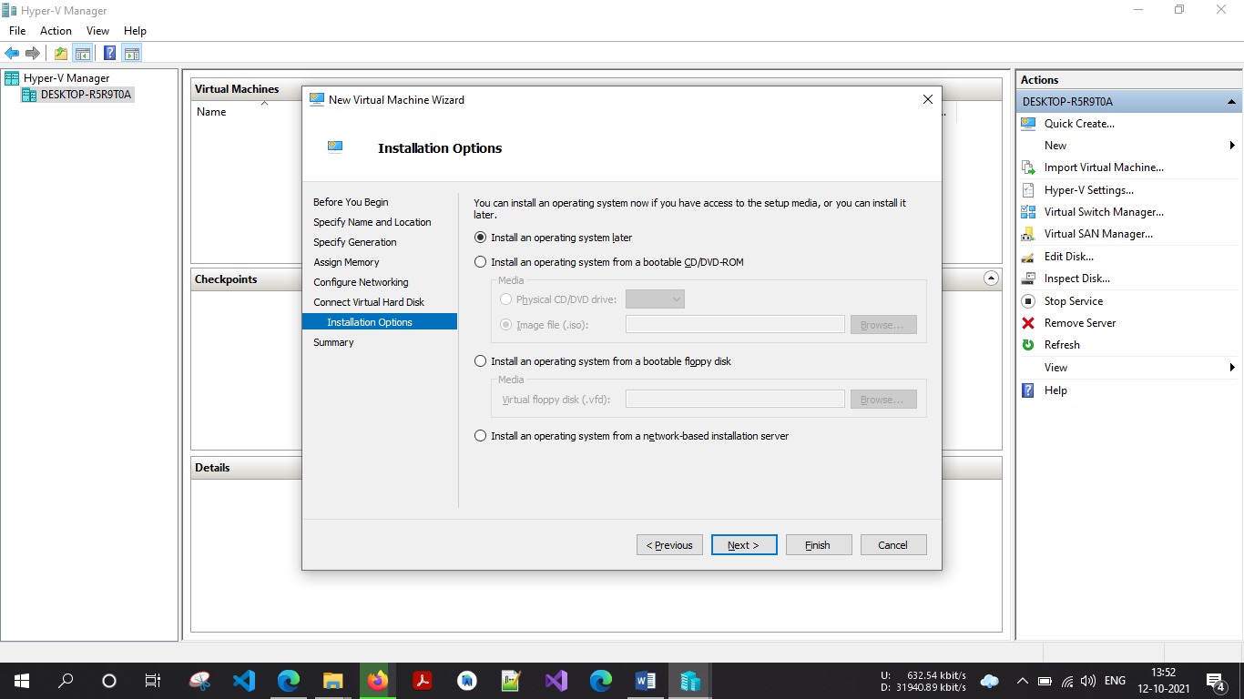

select install an operating system from boot CD/DVD-ROM and then select Image file(.iso) and browse your OS iso file then click on next button

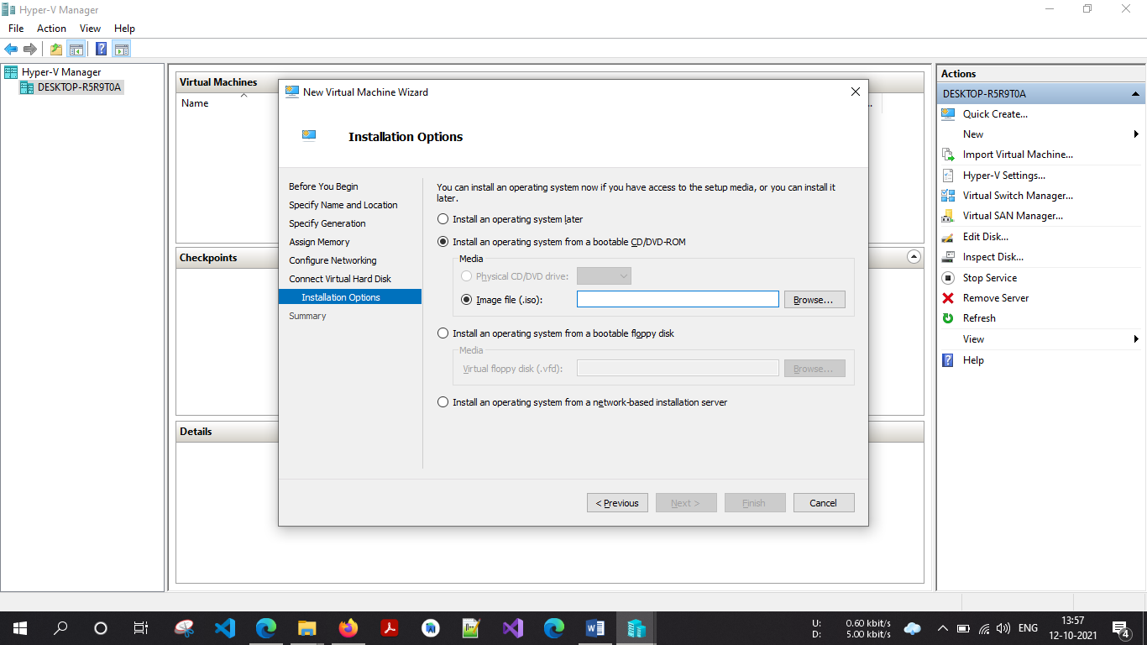

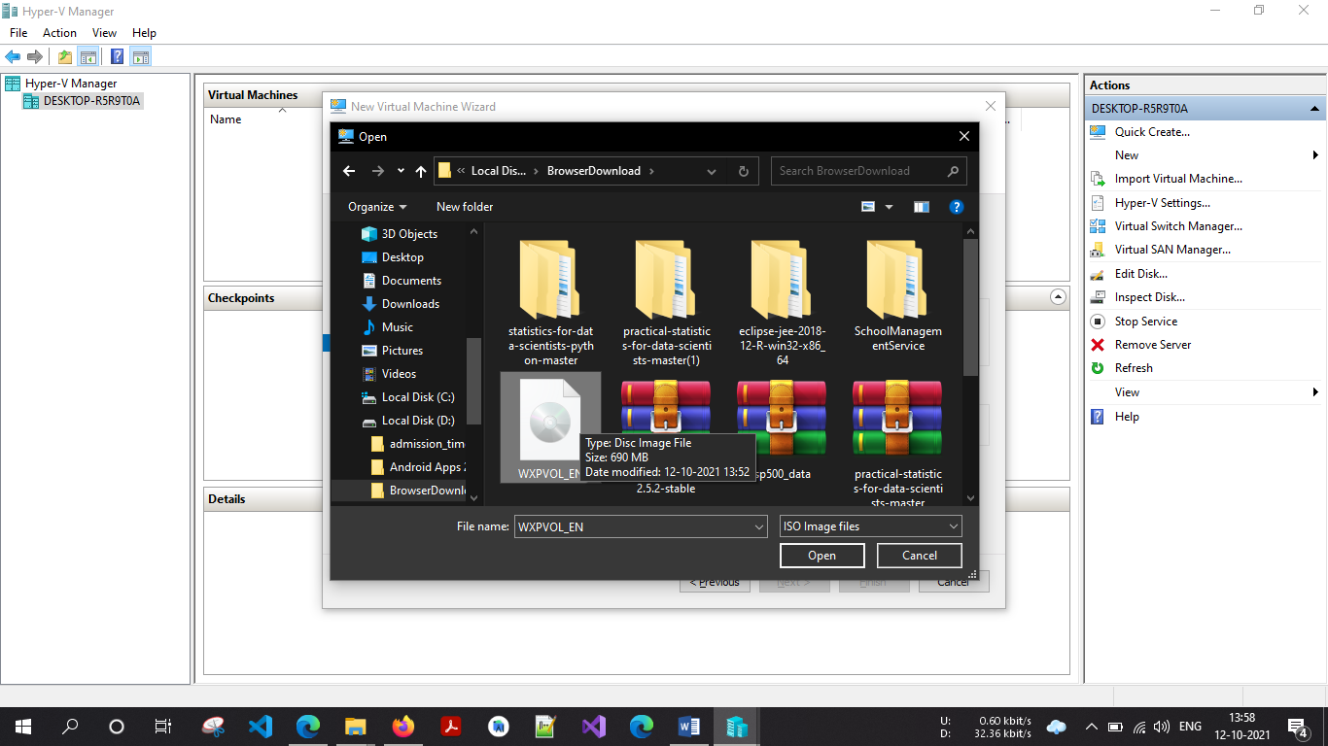

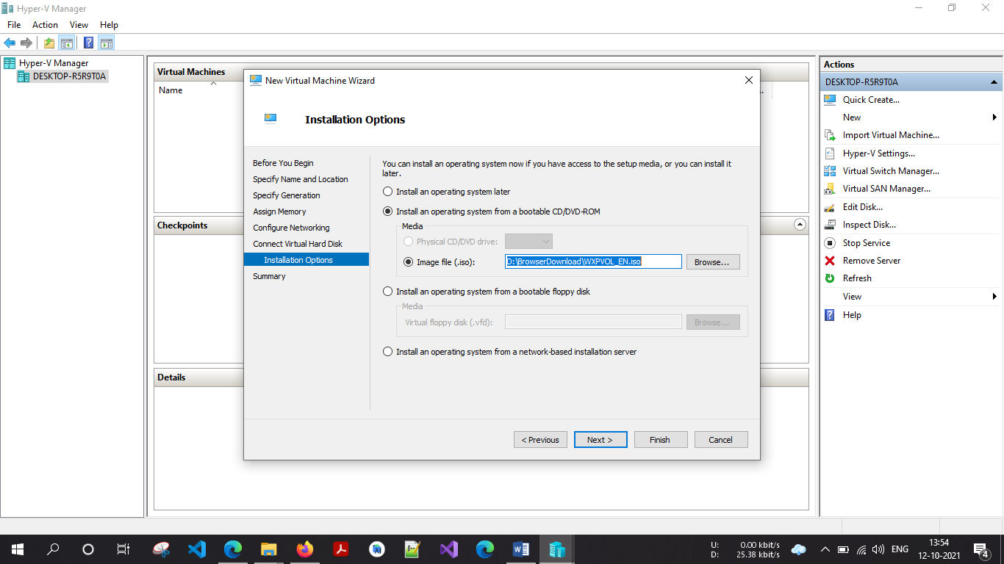

Click Next

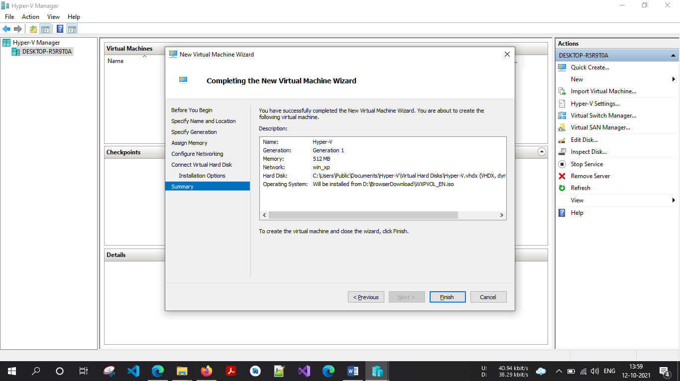

Summary report will be generated about virtual machine then click on Finish  button

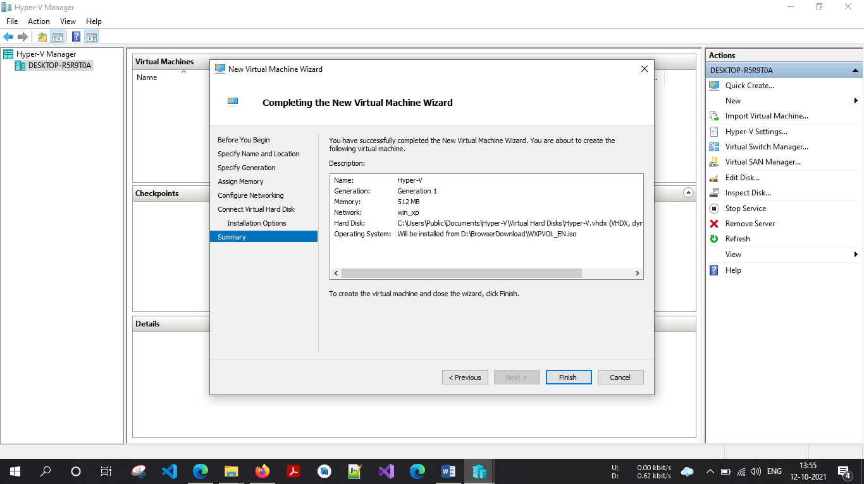

Click finish

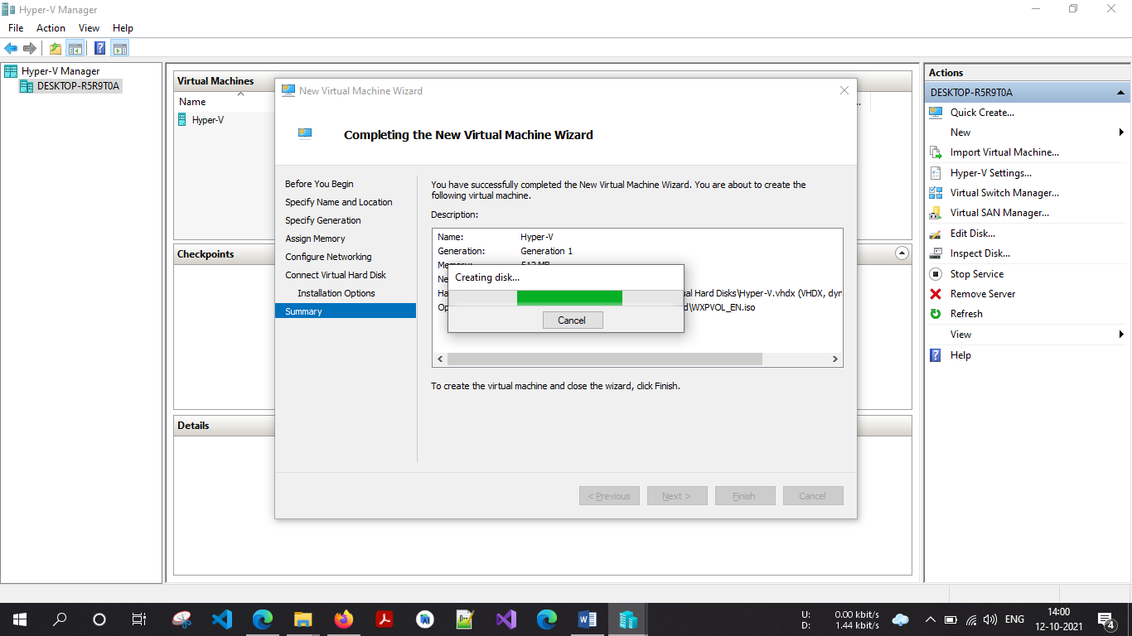

In virtual machine panel your virtual machine will appear which has off state

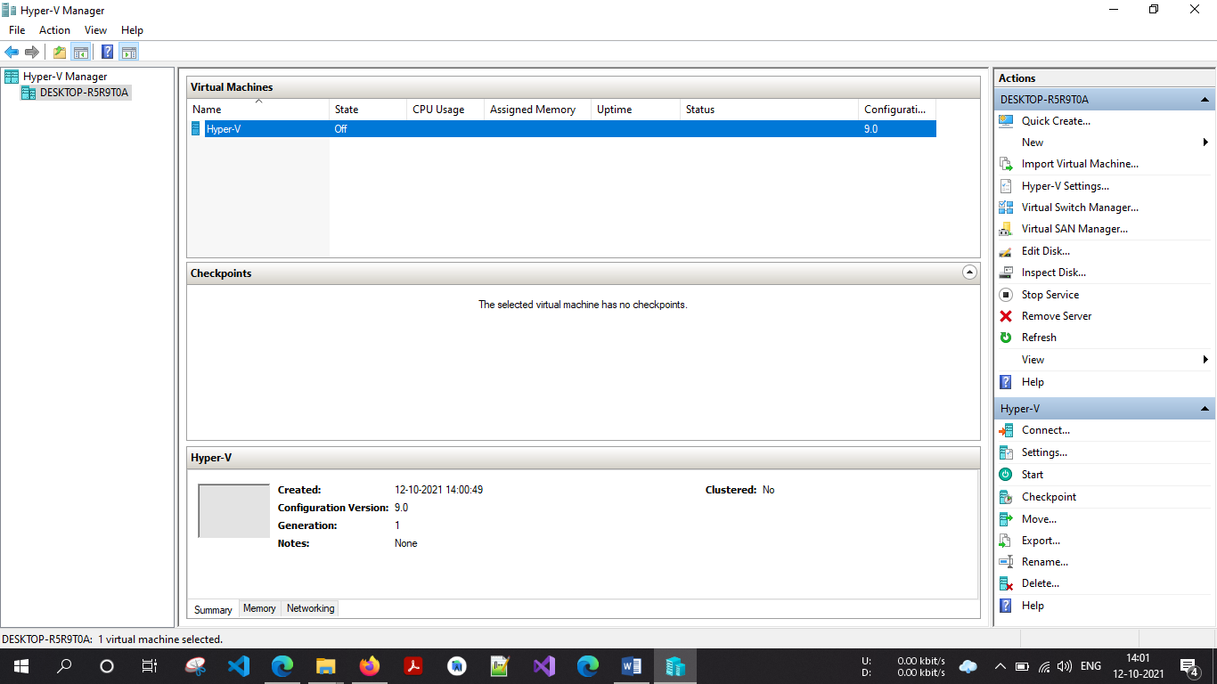

Right click on virtual machine and click on connect option

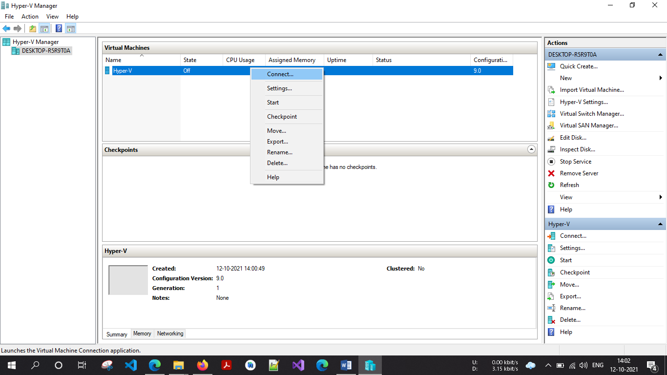

Now turn on virtual machine

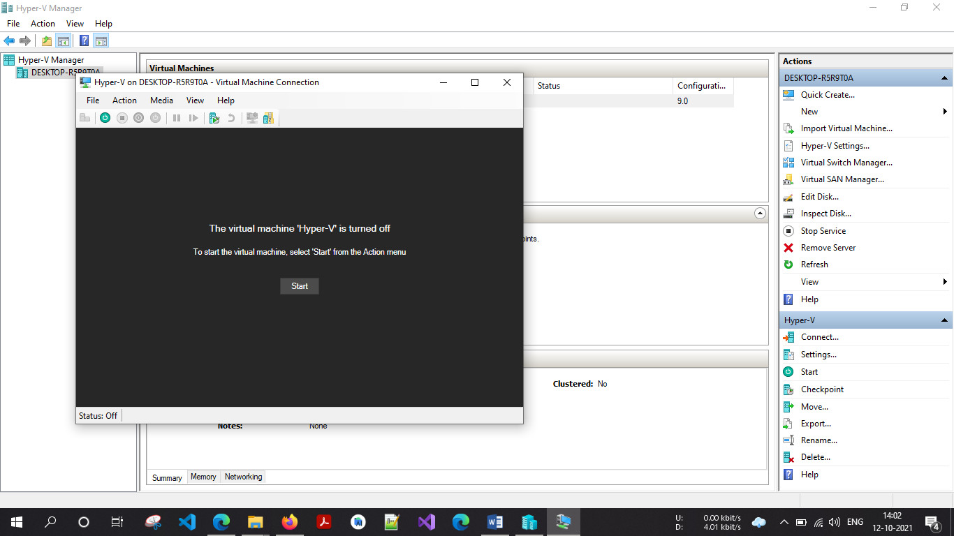

Click Start

Virtual machine will start with below screen

