- Overview

- Components

SpringBoot Microservices, MQTT (Mosquito) , JWT (Authentication)

- Lightweight Event Handling :
- Validation : Validate json schema
    - Enrich: Device metadata
    - Route: topic/ queue
Message payload:
Timestamp, speed,location,fuelLvel
Schemaversion
Metadata: deveicid ,source, correlationId for tracebility
QoS Quality of Services:
0—Atmost one (No retries)
1 – Message delivered >= 1 time (duplicate) -
2- Message delivered once (Highest reliability, but more handshake overhead, slower )

- Assumption:
Volume( Number User at time) 1000 user as devices could be sent messages 1000
QoS : 1 duplicate
- High Level diagram
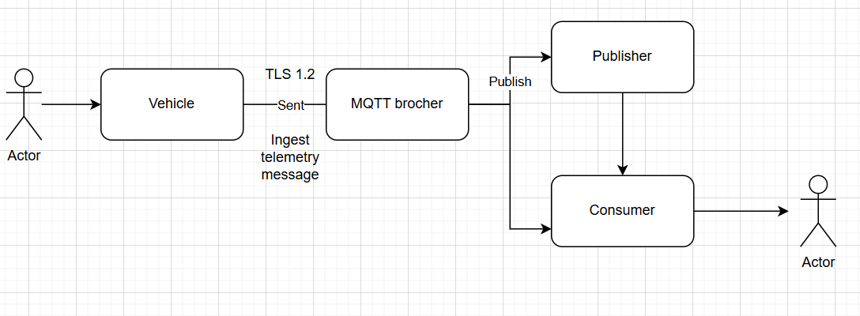
- Low level diagram
- Class Diagram:

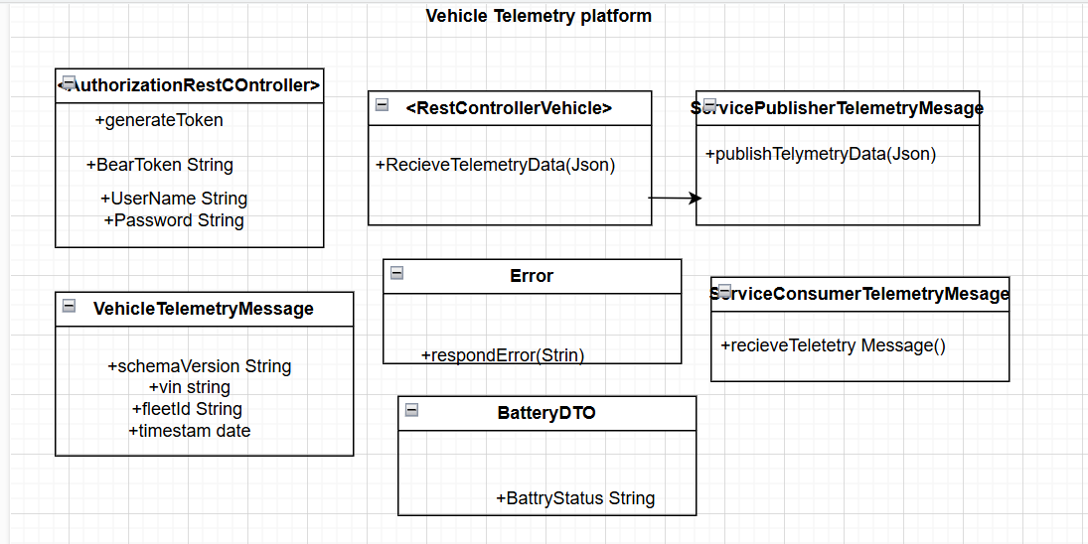
- Sequence Diagram:

- 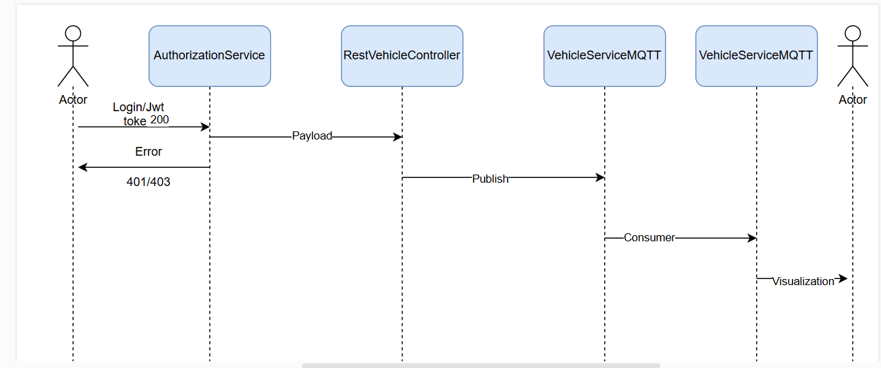

- Limitation of Problem statements:

- Security
Device to device connectivity:
Each device will have client cert signed like TSL.12 to validate client chain.
Jwt/SAS token will be used for

- Technical challenges :

