VEHICLE UPDATE CAMPAIGNS

High Level Design

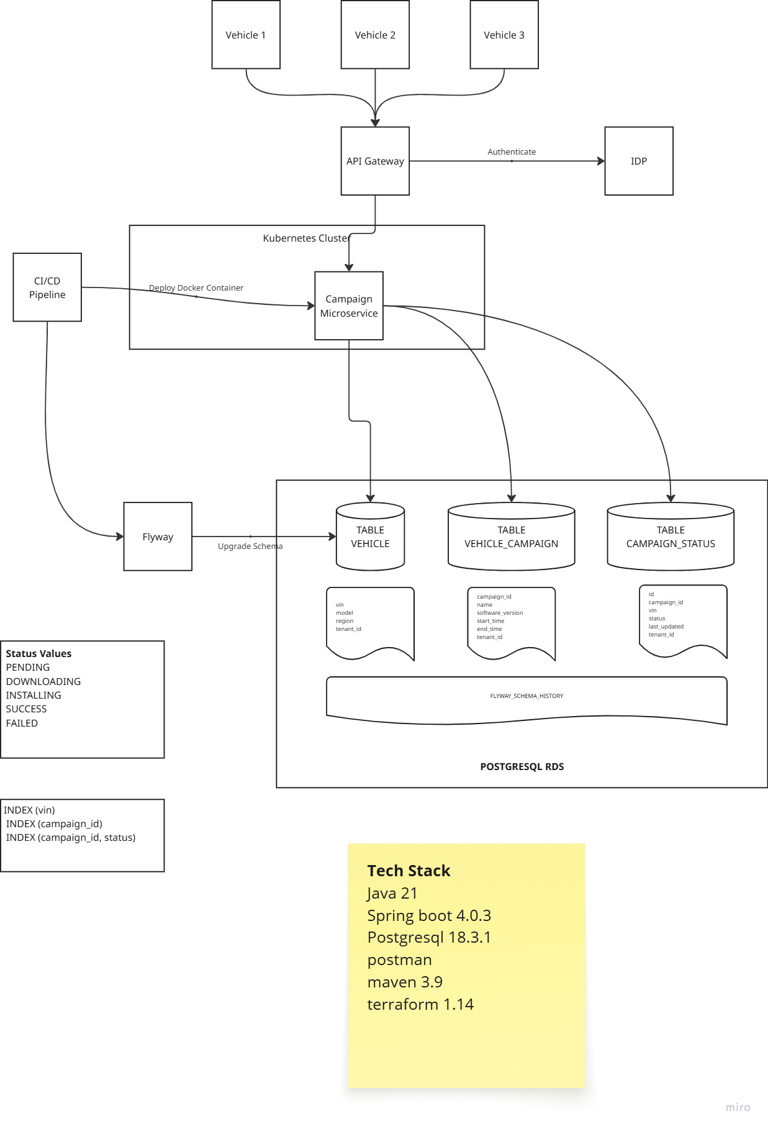

Database Design
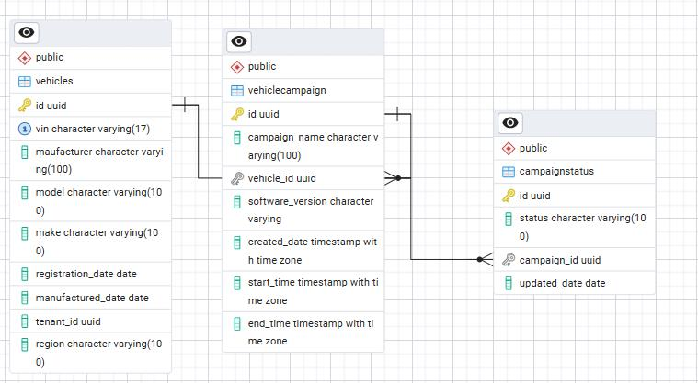

Create 3 tables as shown below

VEHICLES

COLUMN NAME | DATA TYPE | PURPOSE
ID | GUID | Unique Identification for a vehicle campaign table
VIN | VARCHAR
MODEL | VARCHAR
REGION | VARCHAR
TENANT_ID | GUID

VEHICLE_CAMPAIGN

COLUMN NAME | DATA TYPE | PURPOSE
ID | GUID | Unique Identification for a vehicle campaign table
NAME | VARCHAR
SOFTWARE_VERSION | VARCHAR
START_TIME | TIMESTAMP
END_TIME | TIMESTAMP
TENANT_ID | GUID

CAMPAIGN_STATUS

COLUMN NAME | DATA TYPE | PURPOSE
ID | GUID | Unique Identification for a vehicle campaign table
CAMPAIGN_ID | GUID
VIN | VARCHAR
STATUS | VARCHAR
LAST_UPDATED | TIMESTAMP
TENANT_ID | GUID

API Design
Create a spring boot application using spring boot 4.0.3, Java 21, which should have spring doc, postgresql driver, spring data JPA enabled.
Spring Doc – Open API specification document provided by spring accessible via /swagger-ui/index.html
Create a controller, service, JPA, entity, DTOs.

GET: /campaign/{{ID}}
Develop a GET API which should fetch all campaigns belongs to a given campaign ID.

GET: /campaign
Develop a GET API which should fetch all campaigns.

GET: /campaign&status={{STATUS}}
Develop a GET API which should fetch all active campaigns.

GET: /campaign/status/{{VIN}}
Develop a GET API which should fetch status information for a given VIN.

GET: /campaign/aggregate/{{STATUS}}
Develop a GET API which should fetch data from campaign for a given status and send the aggregate result.

Alerts, Logging and Monitoring

Container Logs
Install Grafana agent in EKS cluster which should push container logs to Grafana.

Database / Container Metrics
Install Grafana agent in EKS cluster which should push container metrics to Grafana.
Co0nfigure Grafana to monitor Database health, threshold, long running queries.

Configure Alerts
Configure Grafana to send alerts for database threshold and long running queries, container logs for continuous unauthorized 401 errors.

Security and Audit

Table Level Audit
Enable database table audits

Encryption at Rest
Using KMS symmetric keys, encrypt RDS data

oAuth2 / OIDC
Spring boot APIs / API gateway should be security enabled using Bearer Tokens (JWT)

NFR

Performance
Every API response time should be less than a second (< 1sec)

Rate Limiting
Configure rate limiting for frequently used GET APIs

Tenant Isolation
Include TENANT_ID in all the tables to isolate tenant specific data while doing read and writes.

