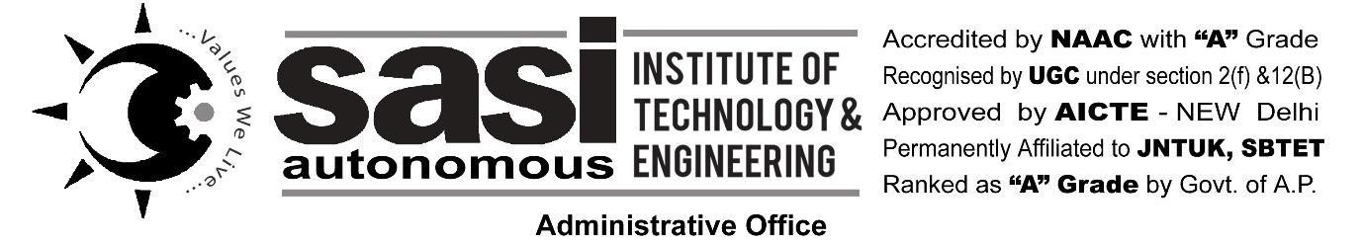

**Academic Year {year}-{next_year}**

**Enrollment Form For Existing {**Btech_year**} BTech {sem_no} Sem {****branch} Students**

|  |  |
| --- | --- |
| **Name:** {name} | **Registration No :** {rno} |
| **Father Name:** {fname} | **Aadhaar No :** {ano} |
| **Occupation:** {occ} | **Date of Birth :** {dob} |
| **Address :** {adddno}, {addstreet} | **Blood Group :** {bg} |
| {addarea} | **Mobile :** {mobile} |
| {addtown} | **Email :** {email} |
| {adddist}, {addstate} | **JVD Applicable :** {jvd} |
| **Pin code :** {pincode} | **Hostel :** {hostel} |
| **Parent Mobile :** {pmobile} | **No of Subjects passed :** {pass} |
| **RED ANTS Clubs:** {hobby1} | **No of Credits obtained :** {credits} |
| {hobby2} | **No of Subjects failed:** {fail} |

Subject for which candidate is Registering including practicals for the current semester

|  |  |  |  |  |  |  |
| --- | --- | --- | --- | --- | --- | --- |
| Total Subjects | | | | | |  |
| S.No. | Subject Code | Subject Name | S.No. | Subject Code | Subject Name | |
|  | {sc1} | {sn1} |  | {sc3} | {sn3} | |
|  | {sc2} | {sn2} |  | {sc4} | {sn4} | |
|  |  |  |  |  |  | |
|  |  |  |  |  |  | |
|  |  |  |  |  |  | |
|  |  | Certification Course |  |  | Certification Course | |
|  |  |  |  |  |  | |

Submission of this form should be with in one week of reopening of the institute

Signature of the student with date

**INSTRUCTIONS TO THE STUDENT**

1. Every student has to maintain discipline in all respects.
2. Minimum attendance of 75% is compulsory for attending the Semester Final examinations. In no case a student will be sent for End Examinations if he/she does not maintain required attendance.
3. Every student has to pay all the fees prescribed by the Institute at the time of admission.
4. Any damage made by the student to the institution/department will attract the fine.
5. General breakage charges will be collected from every student at the end of the academic year / Semester before issuing the hall ticket.
6. All students shall follow the dress code of the Institute and rules of Central Library .
7. Students shall strictly adhere to class timings. Late comers will not be allowed to attend the classes.
8. Use of cell phones, smoking and teasing by students in the college premises is strictly prohibited.
9. Disciplinary action shall be taken in case of Malpractices during Internal / End / Sem Examinations as per the rules framed by the university / institute.
10. Violations will lead to punishments including fines and debarring from the institute.

**UNDERTAKING BY THE STUDENT for ANTI-RAGGING**

I, {name} studying { branch }at  Sasi Institute of Technology and Engineering, Tadepalligudem, {childern_of}, {fname} residing at {addarea}, {addtown},undertake that I am aware of the system of punishment in case of ragging other students and that in case I am involved in any manner in any ragging case, I am liable for punishment, including:

1. Cancellation of admission
2. Suspension from attending classes.
3. Withholding / withdrawing scholarship / fellowship and other benefits.
4. Debarring from appearing for any test / examination or other evaluation process.
5. With holding results.
6. Debarring from appearing the institution in any national or international meet, sports, fests, etc.
7. Suspension, expulsion from the hostel.
8. Rustication from the Institution for a period varying from1 to 2 academic years.
9. Expulsion from the Institution and consequent debarring from admission to any other institution.
10. Fine upto Rs.50,000/- and Rigorous imprisonment upto three years(by Court of Law), etc.

*Signature of Parent                                                                           Signature of Applicant*

………………………………. For office use only …………………………………………..

No dues Verification by:

|  |  |  |  |  |  |  |  |
| --- | --- | --- | --- | --- | --- | --- | --- |
| Department | TuitionFee | Scholarships | Hostel | | Transport | Library | Book store |
| Term I | Term II |  |  |
|  |  |  |  | |  |  |  |
|  |  |  |  | |  |  |  |

Recommendations of Head of the Department (based on his / her previous behavior):

Signature of the Head of the Department with date. Signature of the Principal with date.