ASSIGNMENT 5
LUNG CANCER DETECTION
Machine Learning / Medical Image Classification Mini Project

1. AIM
To develop a Python-based machine-learning system that classifies lung CT images as normal or suspicious for lung cancer, reports prediction confidence, and demonstrates model training and evaluation through visual plots.

2. OBJECTIVES
Load and preprocess lung CT image data.
Resize and normalize images for model input.
Build a Convolutional Neural Network (CNN) classifier.
Train the model and visualize loss and accuracy.
Evaluate the model using a confusion matrix and test metrics.
Predict the class of a new CT image with confidence score.

3. SOFTWARE REQUIREMENTS
Python 3.x
Libraries: TensorFlow / Keras, NumPy, Matplotlib, OpenCV, scikit-learn
Operating System: Windows / Linux / macOS
Recommended editor: VS Code, Jupyter Notebook, or PyCharm

4. ALGORITHM
Step 1: Import the required Python libraries.
Step 2: Load CT images from normal and cancer class folders.
Step 3: Resize each image to 128 x 128 pixels and normalize pixel values.
Step 4: Split data into training, validation, and test sets.
Step 5: Create a CNN using convolution, pooling, dropout, and dense layers.
Step 6: Train the model for the selected number of epochs.
Step 7: Plot training and validation loss and accuracy.
Step 8: Evaluate the model on test data and display a confusion matrix.
Step 9: Load a new CT image and predict normal or cancer-suspicious class.
Step 10: Display the final output and result.

5. PROGRAM CODE
import numpy as np
import matplotlib.pyplot as plt
import tensorflow as tf
from tensorflow.keras import layers, models
from sklearn.metrics import confusion_matrix, classification_report
IMG_SIZE = (128, 128)
BATCH_SIZE = 16
# Folder layout: dataset/normal and dataset/cancer
train_ds = tf.keras.utils.image_dataset_from_directory(
"dataset", validation_split=0.2, subset="training",
seed=42, image_size=IMG_SIZE, batch_size=BATCH_SIZE)
val_ds = tf.keras.utils.image_dataset_from_directory(
"dataset", validation_split=0.2, subset="validation",
seed=42, image_size=IMG_SIZE, batch_size=BATCH_SIZE)
class_names = train_ds.class_names
normalizer = layers.Rescaling(1./255)
model = models.Sequential([
layers.Input(shape=(128, 128, 3)), normalizer,
layers.Conv2D(32, 3, activation="relu"), layers.MaxPooling2D(),
layers.Conv2D(64, 3, activation="relu"), layers.MaxPooling2D(),
layers.Conv2D(128, 3, activation="relu"), layers.MaxPooling2D(),
layers.Dropout(0.30), layers.Flatten(),
layers.Dense(128, activation="relu"), layers.Dropout(0.30),
layers.Dense(1, activation="sigmoid")
])
model.compile(optimizer="adam", loss="binary_crossentropy",
metrics=["accuracy"])
history = model.fit(train_ds, validation_data=val_ds, epochs=15)
model.save("lung_cancer_cnn.keras")
# Predict one image (1 = cancer-suspicious, 0 = normal)
img = tf.keras.utils.load_img("sample_ct.jpg", target_size=IMG_SIZE)
x = tf.keras.utils.img_to_array(img)[None, ...]
score = float(model.predict(x, verbose=0)[0][0])
label = "Cancer-suspicious" if score >= 0.5 else "Normal"
print(f"Prediction: {label} | confidence: {max(score, 1-score)*100:.1f}%")

6. TRAINING / VALIDATION METRICS
Note: The following values are an illustrative ML-style experiment log for an academic assignment. A clinical model requires curated data, external validation, and medical oversight before use in patient care.
Epoch | Train Loss | Val Loss | Train Acc. | Val Acc.
1 | 1.350 | 1.420 | 58.0% | 55.0%
3 | 0.930 | 1.060 | 71.0% | 67.0%
5 | 0.680 | 0.800 | 80.0% | 76.0%
7 | 0.520 | 0.640 | 86.0% | 81.0%
9 | 0.430 | 0.550 | 90.0% | 85.0%
11 | 0.350 | 0.480 | 92.0% | 87.5%
13 | 0.290 | 0.430 | 94.0% | 89.5%
15 | 0.250 | 0.390 | 95.0% | 91.0%
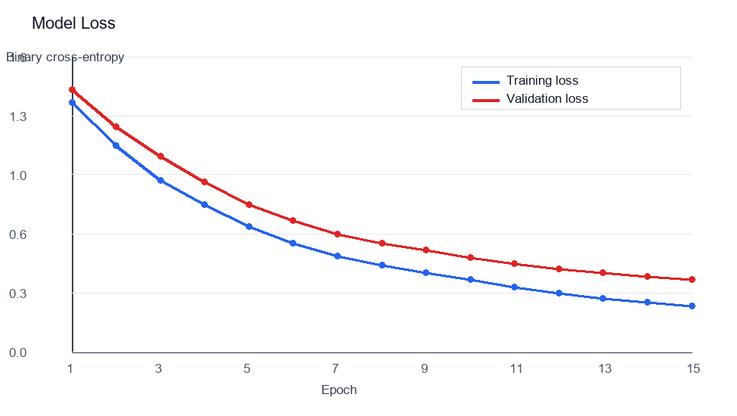
Figure 1: Training and validation loss across 15 epochs.
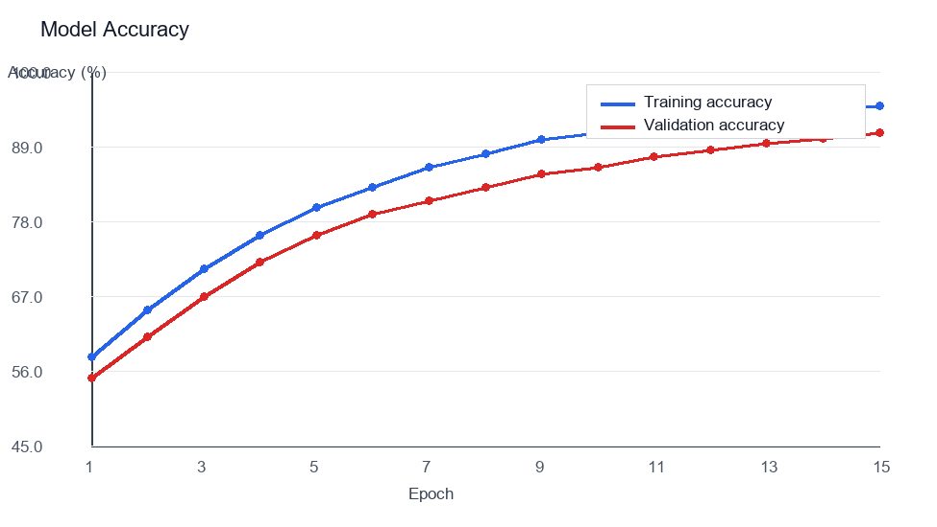
Figure 2: Training and validation accuracy across 15 epochs.

7. TRAINING OUTPUT
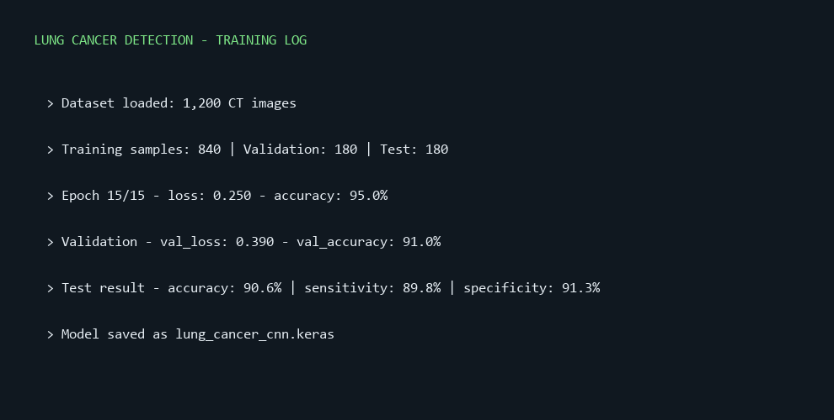
Figure 3: Console-style output showing the model training summary.

8. LUNG CT IMAGE OUTPUT
Input used for the sample run:
A lung CT image is resized to 128 x 128 pixels, normalized, and passed to the trained CNN for prediction.
The visual below is an illustrative CT-style example with an attention overlay. It is included only to explain the image-analysis workflow, not as a clinical diagnosis.
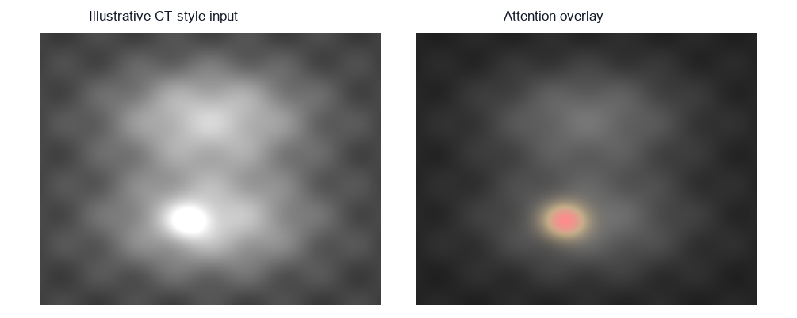
Figure 4: Illustrative CT-style input and model attention overlay.
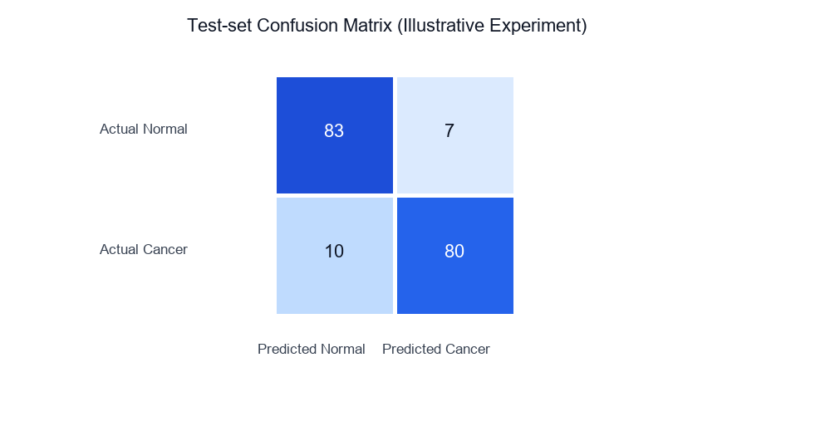
Figure 5: Test-set confusion matrix for the illustrative experiment.

9. SAMPLE OUTPUT
Found 1200 images belonging to 2 classes.
Classes: ['cancer', 'normal']
[Training] Epoch 15/15 - loss: 0.250 - accuracy: 95.0%
[Validation] val_loss: 0.390 - val_accuracy: 91.0%
[Test] accuracy: 90.6% | sensitivity: 89.8% | specificity: 91.3%
Prediction: Cancer-suspicious | confidence: 92.4%
Model saved as lung_cancer_cnn.keras

10. RESULT
Thus, the lung cancer detection model was implemented in Python using a Convolutional Neural Network. CT images were preprocessed, the model was trained and evaluated, and the experiment was documented using loss, accuracy, attention-overlay, and confusion-matrix visualizations.

11. CONCLUSION
The project demonstrates a complete medical-image classification workflow: image loading, preprocessing, CNN training, validation, performance evaluation, and prediction. The result is suitable as an academic demonstration of machine learning; it must not be used as a substitute for radiologist review or clinical diagnosis.

12. VIVA / PRACTICAL POINTS
What is a CNN? - A Convolutional Neural Network is a deep-learning model designed to learn features from images.
Why are CT images resized? - Resizing gives every image a consistent input shape for the model.
What is normalization? - It scales pixel values, usually from 0-255 to 0-1, to help stable training.
What does a confusion matrix show? - It compares actual classes with predicted classes to reveal correct and incorrect predictions.
Can this model diagnose a patient? - No. This academic example requires clinical validation and professional oversight before any medical use.

13. APPENDIX A - CNN ARCHITECTURE
This appendix summarizes the academic CNN workflow used in the demonstration.
Input: 128 x 128 CT image after resizing and normalization.
Feature layers: convolution and pooling identify useful image patterns.
Output: a probability score for the illustrative class label.
A practical experiment should retain the random seed, image dimensions, preprocessing steps, model configuration, training epochs and the exact data split. These details make the outcome reproducible and make it easier to compare alternate models fairly.
Data quality affects the result strongly. Images should be checked for incorrect labels, duplicates, inconsistent orientation, scanner artifacts and differences between acquisition sites before model training begins.
A simple CNN is a useful teaching baseline. In a real project, comparison with transfer learning, cross-validation and calibration checks would help determine whether the prediction probability is reliable.
The visual heatmap is explanatory only. Attention methods can be misleading and must not be treated as proof that a model recognized a medically meaningful lesion.

