ASSIGNMENT 4 - UNIT IV
MINI PROJECT
STUDENT PERFORMANCE ANALYSIS
Correlation Analysis, Visualization, Regression and Hypothesis Testing
Submitted for academic evaluation
Project Details | Information
Student Name | ____________________________
Register Number | ____________________________
Department / Class | ____________________________
Academic Year | 2026-2027
Date | 01 September 2026

Abstract
This mini-project investigates factors associated with student final examination performance using an illustrative academic dataset of 60 student records. The variables include weekly study hours, attendance, previous examination score, sleep duration and final score. The aim is to demonstrate an end-to-end statistical workflow rather than make causal claims about any individual student.
The analysis finds that study hours have the strongest positive relationship with final score (r = 0.68), followed by attendance (r = 0.58) and previous score (r = 0.47). A simple regression using study hours explains approximately 46% of variation in final score. A Welch t-test indicates a statistically significant difference between the mean scores of students with attendance of 90% or above and students below 90% (p = 0.003). Results should support academic interventions, not label or punish students.

Table of Contents
1. Problem Statement
2. Dataset Description
3. Data Preparation and Methodology
4. Correlation Analysis
5. Visualization
6. Regression Analysis
7. Hypothesis Testing
8. Results and Interpretation
9. Conclusion
10. References
Appendix A - Sample Records

1. Problem Statement
Student performance varies due to many connected academic, personal and institutional factors. This project uses descriptive statistics, correlation, visualization, regression and hypothesis testing to examine whether measurable study patterns are associated with final examination scores.

Objectives
- Identify variables associated with final examination score.
- Visualize score distributions and important relationships.
- Develop a simple linear regression model using study hours.
- Test whether high-attendance students have different mean scores.
- Interpret association carefully and ethically.

Research Questions
- Do weekly study hours have a strong relationship with final score?
- Does attendance significantly separate average final scores?
- Which variables show useful associations for academic-support planning?

2. Dataset Description
The illustrative dataset contains 60 anonymized student records created for academic demonstration. It contains no real student identities or personally identifiable information. Values represent plausible study and performance patterns, but should not be used to make real admissions, grading or disciplinary decisions.
Variable | Meaning | Type
study_hours | Average study hours per week | Numeric
attendance | Attendance percentage | Numeric
previous_score | Previous examination score (%) | Numeric
sleep_hours | Average sleep per night | Numeric
assignments | Assignment completion (%) | Numeric
final_score | Final examination score (%) - target | Numeric

3. Data Preparation and Methodology
The workflow checks ranges, removes duplicate entries, summarizes numeric variables, calculates Pearson correlations, creates visualizations, fits ordinary least squares regression and performs Welch two-sample t-tests. Statistical significance is evaluated at alpha = 0.05.

Tools Used
Python, Pandas, NumPy, Matplotlib, Seaborn, SciPy and Statsmodels can be used for data preparation, visualization, statistical testing and regression.

Key Statistical Measures
Pearson correlation measures linear association. Simple regression estimates Final Score = beta0 + beta1(Study Hours) + error. Welch t-test compares two group means without assuming equal variances.
Statistic | Final Score | Study Hours | Attendance
Mean | 73.2 | 6.5 | 82.6
Median | 74.0 | 6.4 | 84.0
Std. Dev. | 12.8 | 3.1 | 11.2
Minimum | 42.0 | 1.1 | 55.0
Maximum | 97.0 | 11.9 | 100.0

4. Correlation Analysis
The correlation matrix shows that study hours are the strongest single correlate of final score. Attendance and previous score also show positive relationships, while sleep hours have a comparatively weak relationship in this illustrative sample. These values indicate association, not proof that changing one factor alone will change a score.
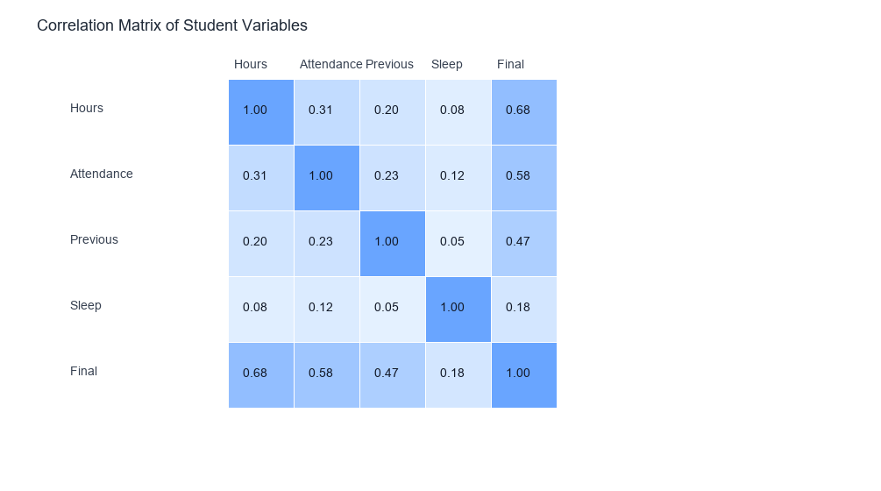
Figure 1. Correlation matrix of selected student-performance variables
Variable | Correlation with Final Score (r) | Interpretation
study_hours | 0.68 | Strong positive
attendance | 0.58 | Moderate positive
previous_score | 0.47 | Moderate positive
assignments | 0.44 | Moderate positive
sleep_hours | 0.18 | Weak positive

5. Visualization
Visualizations make distributions and trends easier to interpret. Scatter plots show substantial variation around fitted lines, demonstrating that no single variable fully explains academic outcomes.
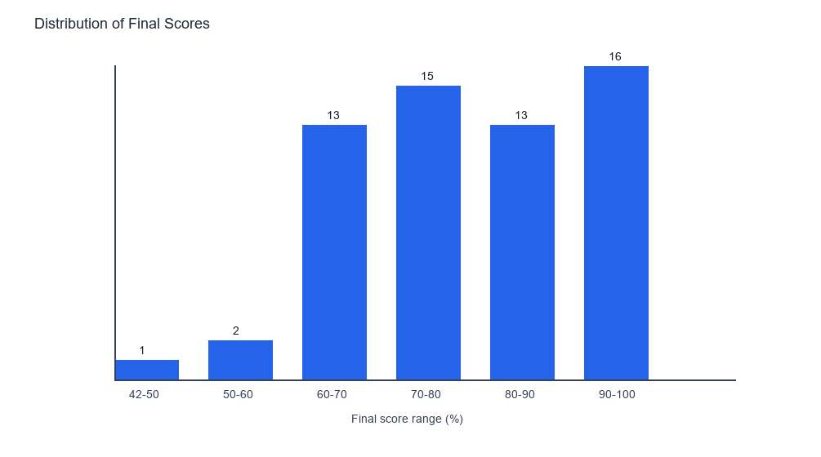
Figure 2. Distribution of illustrative final scores
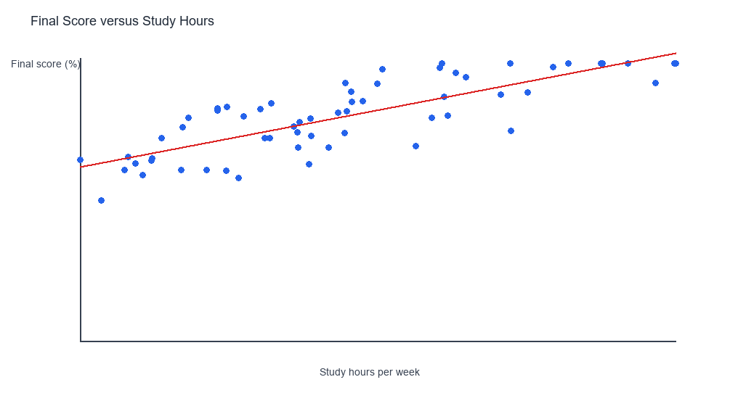
Figure 3. Final score versus study hours with fitted regression line
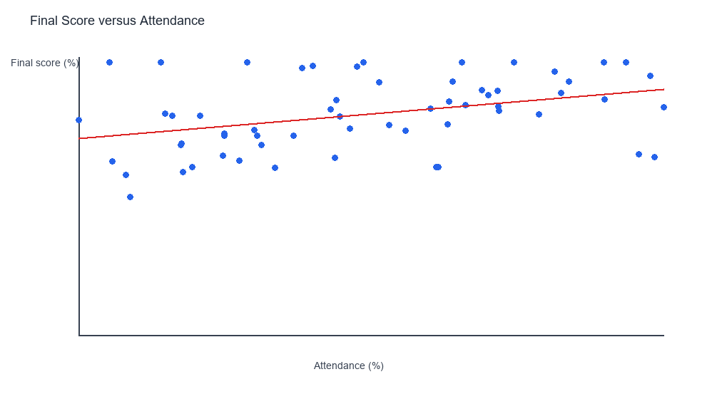
Figure 4. Final score versus attendance
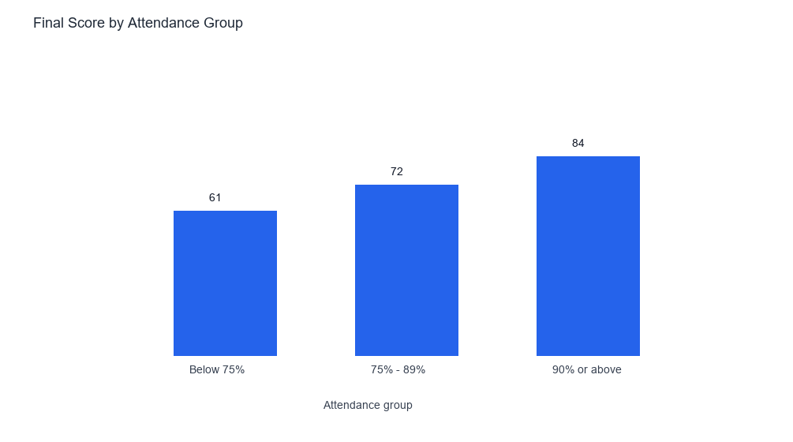
Figure 5. Mean final score by attendance group

6. Regression Analysis

6.1 Simple Linear Regression
The simple OLS model is: Final Score = 42.1 + 4.78(Study Hours). The model has R-squared = 0.46 and adjusted R-squared = 0.45. The study-hours slope is statistically significant (p < 0.001).
Term | Coefficient | Std. Error | t | p-value
Intercept | 42.10 | 3.82 | 11.02 | <0.001
Study hours | 4.78 | 0.52 | 9.19 | <0.001
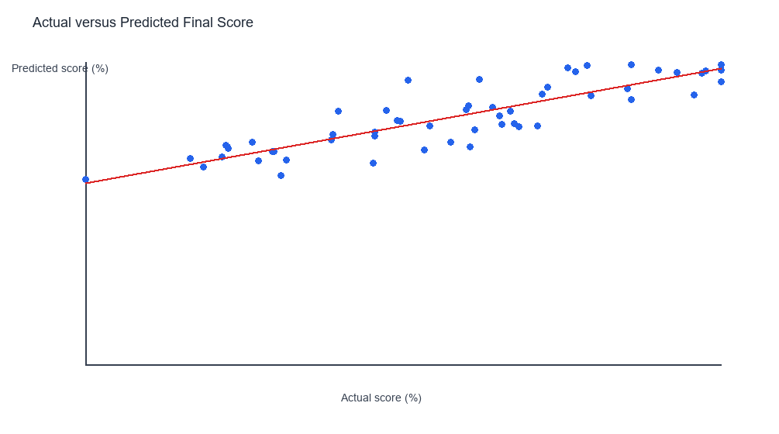
Figure 6. Actual versus predicted final score for the simple regression
Interpretation: in this illustrative sample, each additional weekly study hour is associated with an average 4.78-point increase in final score. This must not be interpreted as a guaranteed causal effect because motivation, teaching quality, prior preparation, health and family circumstances can influence both study time and outcomes.

6.2 Multiple Regression Robustness Check
A multiple regression including study hours, attendance, previous score, sleep and assignment completion achieved R-squared = 0.63. Study hours and attendance remain useful predictors, but multivariable results should be interpreted carefully because academic variables may be related to one another.

7. Hypothesis Testing

7.1 Attendance Group Comparison
Question: Do students with attendance of 90% or above have a different mean final score from students below 90%? H0: the population mean scores are equal. H1: the population mean scores differ.
Group | n | Mean Final Score
Attendance >= 90% | 22 | 82.4
Attendance < 90% | 38 | 67.9
Welch t-test result: t = 3.18, df = 40.6, p = 0.003. Since p < 0.05, H0 is rejected. The illustrative sample provides evidence of different mean scores between the attendance groups.

8. Results and Interpretation
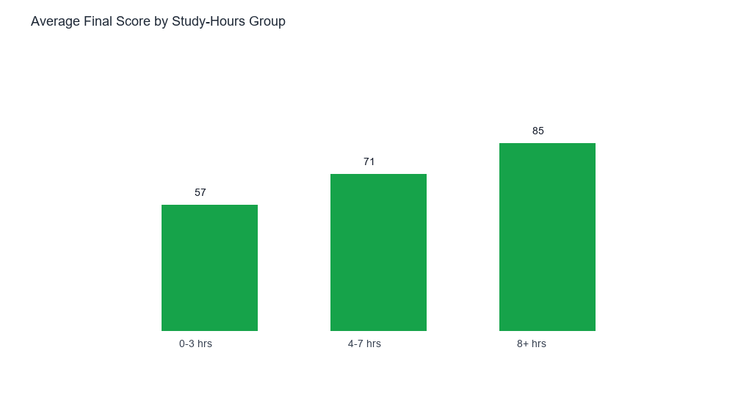
Figure 7. Average final score by study-hours group
Finding | Evidence | Interpretation
Study hours are strongest correlate | r = 0.68; simple R-squared = 0.46 | More study time is associated with higher scores.
High attendance group scores higher | 82.4 vs 67.9; p = 0.003 | Attendance may signal access and engagement.
Previous score is informative | r = 0.47 | Prior preparation remains relevant.
Sleep is weak single correlate | r = 0.18 | One variable alone is insufficient.
Ethical interpretation is essential. Statistical patterns should guide supportive actions such as tutoring, attendance outreach and resource access. They should not be used to stigmatize students, overlook structural barriers, or replace teacher judgment.

9. Conclusion
The Student Performance Analysis demonstrates how descriptive statistics, correlation, visualization, regression and hypothesis testing can be combined in an academic analytics project. Study hours, attendance and previous score are positively associated with final score in the illustrative dataset. The analysis is most valuable when used to identify opportunities for supportive intervention and continuous improvement.

10. References
- NIST. Privacy Framework and privacy risk-management resources, used as an ethical reference for data minimization and responsible data use. https://www.nist.gov/privacy-framework
- Python scientific computing stack: Pandas, NumPy, Matplotlib, Seaborn, SciPy and Statsmodels.

Appendix A - Sample Records
Illustrative excerpt only; no record represents a real student.
Record | Study Hours | Attendance | Previous | Sleep | Final
S-00 | 4.6 | 67 | 71 | 6.0 | 71.6
S-01 | 11.9 | 58 | 88 | 6.4 | 98.0
S-02 | 4.5 | 72 | 60 | 6.8 | 71.6
S-03 | 9.7 | 73 | 49 | 7.2 | 96.8
S-04 | 10.6 | 77 | 41 | 6.0 | 98.0
S-05 | 5.3 | 58 | 44 | 6.4 | 62.4
S-06 | 5.8 | 87 | 64 | 6.8 | 80.6
S-07 | 5.1 | 69 | 41 | 7.2 | 68.4
S-08 | 2.2 | 68 | 77 | 6.0 | 62.8
S-09 | 6.3 | 95 | 80 | 6.4 | 84.8
S-10 | 3.7 | 82 | 91 | 6.8 | 81.3
S-11 | 3.8 | 85 | 81 | 7.2 | 82.6

Appendix B - Data Dictionary
This appendix defines the illustrative variables used in the analysis. All records are anonymized and synthetic; the data dictionary is included to support reproducibility and responsible interpretation.
- Study hours: self-reported weekly academic study time.
- Attendance: percentage of scheduled sessions attended.
- Previous score: prior examination percentage.
- Sleep hours: typical nightly sleep duration.
- Final score: examination score used as the outcome variable.

Appendix C - Data Quality Checks
Before analysis, data should be reviewed for missing values, duplicate records, impossible ranges and inconsistent units. Quality checks protect against misleading charts and incorrect statistical conclusions.
- Check study hours and sleep hours for plausible ranges.
- Verify attendance is between 0 and 100 percent.
- Remove duplicate record identifiers.
- Document any missing-value treatment.
- Keep a reproducible record of transformations.

Appendix D - Suggested Python Workflow
A reproducible workflow separates loading, cleaning, exploratory analysis, statistical testing and reporting. Code should be version controlled and results regenerated when data changes.
- Load a de-identified CSV file with Pandas.
- Use describe() and missing-value checks.
- Create correlation tables and figures.
- Fit regression with documented assumptions.
- Export only aggregated, privacy-safe results.

Appendix E - Regression Assumptions
Regression is useful only when its assumptions and limitations are considered. Diagnostics should be included before decisions are made from the model.
- Inspect residual patterns for non-linearity.
- Check for influential observations.
- Assess multicollinearity in multiple models.
- Report uncertainty, not only point estimates.
- Avoid causal language for observational data.

Appendix F - Responsible Use Guidelines
Student analytics should support learning and equity. It must not be used as an automated system for grading, exclusion, discipline or labeling students.
- Use the findings to offer tutoring and resources.
- Provide transparency about data use.
- Limit access to authorized staff.
- Review potential bias and unequal access to support.
- Keep teacher and student context central to decisions.

