**PL/SQL PROGRAMMING:**

**Exercise 1: Control Structures**

**Scenario 1: Apply 1% Discount to Interest Rate if Age > 60**

BEGIN

FOR cust_rec IN (SELECT customer_id FROM CUSTOMERS WHERE age > 60) LOOP

UPDATE LOANS

SET interest_rate = interest_rate - 1

WHERE customer_id = cust_rec.customer_id;

END LOOP;

COMMIT;

END;

/

**Scenario 2: Promote to VIP if Balance > $10,000**

BEGIN

FOR cust_rec IN (SELECT customer_id FROM CUSTOMERS WHERE balance > 10000) LOOP

UPDATE CUSTOMERS

SET IsVIP = 'TRUE'

WHERE customer_id = cust_rec.customer_id;

END LOOP;

COMMIT;

END;

/

**Scenario 3: Send Reminders for Loans Due in Next 30 Days**

DECLARE

v_due_date DATE;

v_customer_id NUMBER;

BEGIN

FOR loan_rec IN (

SELECT customer_id, due_date

FROM LOANS

WHERE due_date BETWEEN SYSDATE AND SYSDATE + 30

) LOOP

DBMS_OUTPUT.PUT_LINE('Reminder: Loan for Customer ID ' || loan_rec.customer_id ||

' is due on ' || TO_CHAR(loan_rec.due_date, 'DD-MON-YYYY'));

END LOOP;

END;

/

**OUTPUT:**

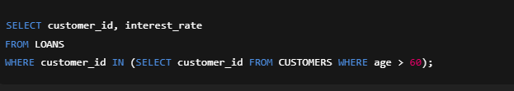

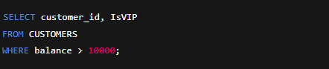



**Exercise 3: Stored Procedures**

**Scenario 1: Apply 1% Interest to Savings Accounts**

CREATE OR REPLACE PROCEDURE ProcessMonthlyInterest IS

BEGIN

UPDATE Accounts

SET balance = balance + (balance * 0.01)

WHERE account_type = 'SAVINGS';

COMMIT;

END;

/

Scenario 2: UpdateEmployeeBonus – Apply Bonus to a Department

CREATE OR REPLACE PROCEDURE UpdateEmployeeBonus(

p_department_id IN NUMBER,

p_bonus_percent IN NUMBER

) IS

BEGIN

UPDATE Employees

SET salary = salary + (salary * (p_bonus_percent / 100))

WHERE department_id = p_department_id;

COMMIT;

END;

/

**Scenario 3: Transfer Money Between Accounts**

CREATE OR REPLACE PROCEDURE TransferFunds(

p_from_account IN NUMBER,

p_to_account IN NUMBER,

p_amount IN NUMBER

) IS

v_balance NUMBER;

BEGIN

SELECT balance INTO v_balance

FROM Accounts

WHERE account_id = p_from_account

FOR UPDATE;

IF v_balance < p_amount THEN

RAISE_APPLICATION_ERROR(-20001, 'Insufficient funds in source account.');

END IF;

UPDATE Accounts

SET balance = balance - p_amount

WHERE account_id = p_from_account;

UPDATE Accounts

SET balance = balance + p_amount

WHERE account_id = p_to_account;

COMMIT;

END;

/

**OUTPUT:**





