

INTELLIGENT TRAFFIC PREDICTOR
A Machine Learning-Based Traffic Congestion Prediction System

A PROJECT REPORT SUBMITTED IN PARTIAL FULFILMENT
OF THE REQUIREMENTS FOR THE AWARD OF THE DEGREE OF
BACHELOR OF TECHNOLOGY
IN
COMPUTER SCIENCE AND ENGINEERING

Submitted by
PAVAN TEJA – 2420030497
AKSHAY – 2420030122
LOHITAKSH - 2420030160

Under the Esteemed Guidance of
Dr. N. Sunanda
[Associate Professor]
Department of [COMPUTER SCIENCE AND ENGINEERING]
AY – 2026-2027
Semester: [ODD]

Academic Year: 2026–2027
KLH Bachupally Campus, Hyderabad

DECLARATION
We hereby declare that the project report entitled “Intelligent Traffic Predictor: A Machine Learning-Based Traffic Congestion Prediction System” is a record of work carried out by us in partial fulfilment of the requirements for the award of the degree of Bachelor of Technology in Computer Science and Engineering at KLH Bachupally Campus.
We further declare that this report describes the project work carried out by our team and that the material presented here has not been submitted, in whole or in part, for the award of any other degree or diploma. Wherever the work of others has been used, it has been acknowledged in the references.

Student Name | University ID | Signature
Pavan Teja | 2420030497 | ________________________
Akshay | 2420030122 | ________________________
LOHIT | 2420030160

CERTIFICATE
This is to certify that the project report entitled “Intelligent Traffic Predictor: A Machine Learning-Based Traffic Congestion Prediction System” is a bonafide record of the project work carried out by Pavan Teja (2420030497) and Akshay (2420030122), students of the Department of Computer Science and Engineering, KLH Bachupally Campus, in partial fulfilment of the requirements for the award of the degree of Bachelor of Technology during the academic year 2026–2027.
The work has been carried out under the guidance and supervision of the undersigned.

Project Guide | Course Coordinator | Head of Department
Signature: ______________  Name: [Guide Name] | Signature: ______________  Name: ______________ | Signature: ______________  Name: ______________

ACKNOWLEDGEMENT
We express our sincere gratitude to the management of KLH Bachupally Campus and the Department of Computer Science and Engineering for providing the opportunity and facilities to undertake this project.
We are thankful to our faculty guide, [Faculty Guide Name], for the guidance, suggestions and encouragement provided during the planning, development and documentation of the Intelligent Traffic Predictor project. We also thank the course coordinator and the Head of the Department for their support.
We acknowledge the developers and maintainers of Python, Streamlit, pandas, NumPy, scikit-learn and Plotly for providing the open-source tools used in this project. Finally, we thank our parents, friends and classmates for their encouragement and cooperation.
Pavan Teja – 2420030497
Akshay – 2420030122
Lohit - 2420030160

ABSTRACT
Urban traffic congestion is a persistent problem in growing cities. It increases journey time, fuel consumption and air pollution, and can also contribute to road safety problems. Conventional traffic monitoring often focuses on observing current conditions; predicting congestion in advance can provide useful information for commuters and traffic-management teams.
The Intelligent Traffic Predictor is a Python-based web application that demonstrates how historical traffic information and related environmental or time-based attributes can be used for traffic analysis and congestion prediction. The application is developed using Streamlit and provides an interactive interface for exploring traffic data, training a machine learning model, entering values for prediction, and reviewing analytical insights. The project package includes a sample synthetic traffic dataset for demonstration. Users can also upload a compatible CSV dataset for exploration and model training.
The machine learning workflow includes data loading, preprocessing, feature selection, model training and evaluation. A Random Forest model is used in the current prototype for regression and/or congestion classification workflows. Regression performance can be assessed using Mean Absolute Error (MAE), Root Mean Squared Error (RMSE) and the coefficient of determination (R²). Classification performance can be assessed using accuracy, precision, recall and F1-score. The exact scores depend on the selected dataset and training configuration and should be recorded from the running application rather than assumed in advance.
The present version is a dataset-based academic prototype. It does not connect to live traffic cameras, GPS devices, Google Maps, or a real-time traffic API. Its purpose is to demonstrate a complete and understandable machine learning workflow through a browser-based dashboard. Future work can incorporate verified city traffic feeds, time-series forecasting, route-level information and deployment on a hosted platform.
Keywords: Intelligent Traffic Predictor, traffic congestion, machine learning, Random Forest, Streamlit, traffic volume, data preprocessing, prediction dashboard.

TABLE OF CONTENTS
Section | Contents
Preliminary | Declaration, Certificate, Acknowledgement, Abstract
Chapter 1 | Introduction
Chapter 2 | System Requirements
Chapter 3 | Technology Stack
Chapter 4 | System Architecture
Chapter 5 | System Design
Chapter 6 | Implementation
Chapter 7 | Features and Working
Chapter 8 | Testing and Evaluation
Chapter 9 | Deployment
Chapter 10 | Challenges and Limitations
Chapter 11 | Future Enhancements
Chapter 12 | Conclusion
Chapter 13 | References
Appendices | Screenshots, setup instructions, user guide, sample data notes

Note: Page numbers should be updated after the final screenshots and any institution-specific formatting are added.

CHAPTER 1 – INTRODUCTION

1.1 Background of the Project
Traffic congestion occurs when the number of vehicles using a road exceeds the road’s effective capacity. It is common around commercial areas, educational institutions, junctions and major city corridors, particularly during morning and evening peak periods. Congestion can cause unpredictable travel times, additional fuel use, pollution and stress for road users.
Traffic conditions are influenced by several factors, including vehicle volume, average speed, time of day, day of the week, weather and road conditions. These factors may interact in ways that are difficult to capture through fixed rules alone. Machine learning can identify patterns in historical observations and use them to estimate traffic volume or classify congestion levels for similar input conditions.
The Intelligent Traffic Predictor project applies this idea through a web-based application. It combines a dataset exploration interface, a model-training workflow and a prediction page so that users can understand how input data is transformed into a prediction.

1.2 Problem Statement
Many traffic monitoring approaches describe the current traffic situation but do not provide an accessible, educational workflow for predicting congestion from historical data. Manual interpretation of traffic records can be time-consuming, and fixed assumptions may not represent changing traffic patterns across different times and conditions.
The project addresses the need for a simple, data-driven application that can analyse traffic-related attributes, train a machine learning model and provide an estimated traffic outcome through an interactive dashboard. The current prototype focuses on dataset-based prediction rather than live road monitoring.

1.3 Scope of the Project
The scope of the current academic prototype includes:
- Loading and exploring the bundled sample traffic dataset.
- Uploading a user-provided CSV file when it contains compatible traffic-related columns.
- Displaying dataset summaries and visualisations to understand traffic patterns.
- Preprocessing data and selecting suitable input features for machine learning.
- Training a Random Forest model for supported regression or classification tasks.
- Evaluating model performance using appropriate regression or classification metrics.
- Accepting user inputs and displaying a predicted traffic volume or congestion category, depending on the selected prediction workflow.
- Presenting insights and project information through a Streamlit web interface.
The current version does not include live GPS tracking, traffic-camera integration, a live traffic API, automatic route recommendations, traffic-signal control, user login, or a production database.

1.4 Objectives
- To collect or load historical traffic data and identify relevant attributes.
- To clean and prepare traffic data for machine learning.
- To identify important factors that influence traffic conditions.
- To train a machine learning model for traffic prediction.
- To evaluate the model using suitable performance metrics.
- To provide an interactive dashboard for data exploration and prediction.
- To communicate the system’s outputs and limitations clearly.

1.5 Importance of the Application
A traffic prediction tool can help users understand how traffic conditions vary with time, vehicle volume and environmental factors. A prediction can be useful as an early indication of possible congestion, although it should not be treated as a guaranteed description of a live road. For students, the project demonstrates data analysis, preprocessing, supervised learning, model evaluation and deployment of a small web application.

1.6 Target Users / Audience
User group | Potential use
Students and evaluators | Understand the machine learning workflow and inspect model predictions.
Traffic-data learners | Explore historical traffic data and visualise patterns.
Researchers / project developers | Use the prototype as a starting point for experiments with traffic datasets.
Traffic-planning stakeholders | Review the concept and identify requirements for a future real-data system; current output is not an operational traffic-control recommendation.

CHAPTER 2 – SYSTEM REQUIREMENTS

2.1 Hardware Requirements
Component | Minimum requirement | Recommended
Processor | Dual-core processor | Modern quad-core processor or better
RAM | 4 GB | 8 GB or more
Storage | 1 GB free for project and packages | 2 GB or more free space
Display | 1366 × 768 | 1920 × 1080
Network | Internet for initial package installation | Stable broadband connection

The application can run on a typical student laptop. Training time depends on dataset size, selected features and available memory.

2.2 Software Requirements
Software | Requirement / version | Purpose
Operating system | Windows 10/11, Linux or macOS | Development and execution
Python | Python 3.9 or later; Python 3.14 was used in the setup workflow | Runs the application and ML code
Streamlit | Version specified in requirements.txt | Creates the browser-based interface
pandas | Version specified in requirements.txt | Loads, filters and analyses tabular data
NumPy | Version specified in requirements.txt | Numerical operations
scikit-learn | Version specified in requirements.txt | Preprocessing, model training and evaluation
Plotly | Version specified in requirements.txt | Interactive charts
Web browser | Recent Chrome, Edge or Firefox | Displays the application
Code editor | Visual Studio Code recommended | Editing and running project files

2.3 Development Tools and Frameworks
Visual Studio Code is used as the development environment. Python provides the programming language, while Streamlit is used to build the user interface without requiring a separate JavaScript front end. The Python data-science libraries support data manipulation, numerical computation, machine learning and chart rendering.

CHAPTER 3 – TECHNOLOGY STACK

3.1 Programming Language – Python
Python is used because it has a mature ecosystem for data analysis and machine learning. Its readable syntax also makes the application easier to maintain and explain during project evaluation.

3.2 Front End – Streamlit
Streamlit converts Python code into an interactive web application. It provides page navigation, input widgets, tables, charts and status messages. In this project, Streamlit presents the overview dashboard, data exploration, model training, prediction and insights pages.

3.3 Data Processing – pandas and NumPy
pandas is used to read CSV files, inspect columns, calculate summaries and prepare tabular data. NumPy supports numerical calculations and array operations used during data processing.

3.4 Machine Learning – scikit-learn
scikit-learn provides the machine learning components used in the project, including data splitting, preprocessing utilities, Random Forest estimators and evaluation metrics. The selected estimator depends on whether the target is numeric (regression) or categorical (classification).

3.5 Data Visualisation – Plotly
Plotly is used to create interactive charts. Visualisations help users inspect traffic distributions, compare values and understand relationships between selected variables.

3.6 Dataset and Storage
The project package contains a sample synthetic CSV dataset for demonstration. The application can also accept a compatible CSV upload. The current prototype does not require a database server; uploaded and processed data are handled during the application session. Synthetic sample records must not be represented as actual measurements from city roads.

3.7 External APIs and Version Control
The current version does not call a live traffic API or GPS service. Git and GitHub can be used for source-code version control, although a remote repository is not required to run the application locally.

CHAPTER 4 – SYSTEM ARCHITECTURE

4.1 High-Level Architecture
The system follows a simple data-to-prediction architecture. A user supplies the sample dataset or a compatible CSV file. The application validates and prepares the data, trains or loads the selected model workflow, evaluates it, and displays the prediction and visual summaries.
USER / CSV DATA
↓
STREAMLIT USER INTERFACE
↓
DATA LOADING AND VALIDATION
↓
PREPROCESSING AND FEATURE SELECTION
↓
RANDOM FOREST MODEL TRAINING
↓
MODEL EVALUATION
↓
TRAFFIC PREDICTION + CHARTS + INSIGHTS

4.2 Description of Each Layer
Layer | Responsibility
Presentation layer | Streamlit pages, forms, upload controls, metrics, charts and prediction output.
Data handling layer | Reads the bundled or uploaded CSV, checks columns, summarises records and prepares model inputs.
Machine learning layer | Splits data, applies preprocessing where required, trains the Random Forest estimator and calculates evaluation metrics.
Output layer | Displays predicted traffic values or congestion classes, model scores and data insights.

4.3 Data Flow
- The user opens the application in a browser.
- The application loads the sample dataset or accepts a compatible CSV upload.
- The data exploration page displays column information, sample rows and descriptive statistics.
- The training page identifies the target and input features, prepares the data and trains the selected Random Forest workflow.
- The model is evaluated on a held-out test portion of the data using suitable metrics.
- The prediction page accepts input values and displays the model output.
- The insights page presents charts and observations derived from the available dataset.

4.4 Deployment Architecture
During development, Streamlit runs a local server on the developer’s computer and the user opens the displayed localhost address in a web browser. The application can later be hosted on a compatible Python application platform, subject to dependency and resource limits. A hosted deployment is not included in the current local prototype.

CHAPTER 5 – SYSTEM DESIGN

5.1 User Interface Design
The interface is organised into separate sections so that a user can follow the machine learning workflow in a logical order. The Overview page introduces the dataset and key indicators. Explore Traffic Data supports inspection and CSV upload. Train ML Model provides the model-training and evaluation workflow. Predict Traffic accepts input values and displays the prediction. Insights & Reports presents visual patterns, while About Project describes the academic project.
Page / module | Main interface elements
Overview Dashboard | Project summary, dataset indicators and traffic visualisations.
Explore Traffic Data | CSV upload, preview table, column summary, descriptive statistics and charts.
Train ML Model | Target selection / model workflow, training controls and evaluation metrics.
Predict Traffic | Input fields, prediction action and predicted traffic result.
Insights & Reports | Charts and observations from the currently available dataset.
About Project | Project background, objectives, technology and limitations.

5.2 Data Fields and Dataset Schema
The bundled demonstration CSV contains traffic-related observations. The exact column names in the uploaded dataset determine which variables are available for analysis and prediction. Typical traffic variables represented in this project context include traffic volume, average speed, time-related information, weather and road conditions. The application should use the actual column names shown in its dataset preview; users uploading another CSV must map the appropriate target and feature columns.
A final schema table should be checked against the CSV file before submission. The table below describes the logical data categories rather than claiming a fixed schema for every user-uploaded file.
Data category | Example meaning | Role
Traffic measurement | Vehicle count / traffic volume | Possible prediction target or input feature
Speed measurement | Average vehicle speed | Traffic-condition feature
Time attribute | Hour, date or day of week | Temporal feature
Weather attribute | Weather condition or related measurement | Environmental feature
Road attribute | Road or surface condition | Context feature
Congestion label | Low, Medium or High | Classification target where available

5.3 Database Design
A relational database is not required by the current prototype. The sample dataset is stored as a CSV file, and user-uploaded datasets are processed in the application session. For a future production version, a database could store road identifiers, timestamped observations, weather conditions, model versions and prediction history.

CHAPTER 6 – IMPLEMENTATION

6.1 Module-wise Implementation
Module | Implementation responsibility
Overview Dashboard | Introduces the project and presents summary information and visualisations.
Explore Traffic Data | Loads the sample or uploaded CSV and displays previews, summaries and charts.
Train ML Model | Prepares features and target, trains a Random Forest estimator and reports metrics.
Predict Traffic | Collects prediction inputs and displays the estimated traffic output.
Insights & Reports | Shows analytical charts and patterns derived from the dataset.
About Project | Displays the project description, objectives, tools and scope.

6.2 Data Loading and Preprocessing
The data-loading stage reads the CSV dataset into a pandas DataFrame. The application inspects the available columns and record count before analysis. Depending on the selected dataset, preprocessing may include handling missing values, converting categorical variables, selecting relevant columns and separating model features from the target. Any preprocessing steps applied should be consistent between training and prediction.

6.3 Model Training
The current project uses a Random Forest machine learning approach. Random Forest is an ensemble method that combines predictions from multiple decision trees. For regression, the trees predict a numeric value and their outputs are aggregated. For classification, the trees vote for a class and the most supported class is selected.
The dataset is divided into training and testing portions. The model is fitted using the training portion and evaluated on the test portion. This separation helps estimate how the model performs on records that were not used during fitting. The final report should record the actual split ratio, random seed and selected features from the running application or source code.

6.4 Model Evaluation
For numeric traffic-volume prediction, the following metrics are relevant:
- MAE: the average absolute difference between actual and predicted values.
- RMSE: the square root of the average squared prediction error; larger errors receive greater weight.
- R²: indicates the proportion of target variation explained by the model relative to a baseline.
For congestion-level classification, the following metrics are relevant:
- Accuracy: proportion of predictions that match the true labels.
- Precision: proportion of predicted positive cases that are truly positive.
- Recall: proportion of actual positive cases correctly identified.
- F1-score: harmonic mean of precision and recall.
The appropriate metrics depend on whether the selected task is regression or classification. No benchmark score is stated in this report because the result depends on the dataset used at runtime. Insert the actual output from the Train ML Model page before final submission.

6.5 Prediction Logic
The prediction interface collects values for the features expected by the trained model. The application arranges these values in the same feature order and applies the same preprocessing used during training. The trained estimator then returns a numeric estimate or a congestion category. The result is displayed in the browser together with explanatory context where supported by the interface.

6.6 Database Connectivity, APIs and Authentication
The current prototype has no persistent database, external traffic API or user authentication. It is intended for local academic demonstration. These capabilities are identified as future enhancements rather than completed features.

CHAPTER 7 – FEATURES AND WORKING

7.1 Main Features
- Interactive web interface built with Streamlit.
- Bundled synthetic sample traffic dataset.
- CSV upload support for compatible datasets.
- Dataset preview and descriptive analysis.
- Traffic-related charts and visual insights.
- Random Forest model training workflow.
- Regression and classification evaluation metrics, depending on target type.
- User-input-based traffic prediction.
- Project information and limitations page.

7.2 How Each Feature Works

7.2.1 Overview Dashboard
The Overview page acts as the starting point. It introduces the Intelligent Traffic Predictor and presents a summary of the traffic dataset and available visualisations. It helps the user understand the purpose of the application before moving to detailed analysis.

7.2.2 Explore Traffic Data
The user can inspect the bundled sample data or upload a compatible CSV file. The page displays a preview and summary information such as rows, columns and descriptive statistics. Charts can be used to observe distributions and relationships between traffic-related attributes. The uploaded file must contain usable columns for the selected analysis.

7.2.3 Train ML Model
The user selects the available training workflow and starts model training. The application prepares the data, separates features and target, fits the Random Forest estimator and displays evaluation results. Regression metrics are used for numeric targets, while classification metrics are used for categorical targets.

7.2.4 Predict Traffic
The user enters values for the input attributes requested by the application and triggers prediction. The trained model processes the inputs and returns an estimated traffic result. The prediction is based on the model and dataset used in the current session; it is not a live reading from a road.

7.2.5 Insights & Reports
This section presents charts and observations that help users interpret the dataset. The insights are descriptive of the available data and should not be interpreted as proof of causation.

7.2.6 About Project
The About Project section explains the project title, problem statement, objectives, technology stack and scope. It also helps evaluators distinguish the current prototype from proposed future integrations.

CHAPTER 8 – TESTING AND EVALUATION

8.1 Testing Approach
Testing should verify that the application loads correctly, accepts valid data, handles invalid inputs safely, trains the model and displays results without inconsistent feature ordering. Since the application is a local Streamlit prototype and does not expose a separate REST API, Postman API testing is not applicable to the current version.

8.2 Functional Test Cases
Test ID | Test scenario | Expected result | Status to record
TC-01 | Launch the Streamlit application | Home / Overview page loads in browser | Run and mark Pass/Fail
TC-02 | Open the bundled sample dataset | Dataset preview and summary are displayed | Run and mark Pass/Fail
TC-03 | Upload a valid compatible CSV | File is accepted and can be explored | Run and mark Pass/Fail
TC-04 | Upload an invalid or incompatible CSV | Application displays a useful validation message | Run and mark Pass/Fail
TC-05 | Train the regression workflow | Model trains and regression metrics are displayed | Run and mark Pass/Fail
TC-06 | Train the classification workflow | Model trains and classification metrics are displayed where supported | Run and mark Pass/Fail
TC-07 | Enter valid prediction values | A prediction is displayed | Run and mark Pass/Fail
TC-08 | Enter missing or out-of-range values | Application handles input safely or shows validation | Run and mark Pass/Fail
TC-09 | Navigate between all pages | Each page opens without an application error | Run and mark Pass/Fail
TC-10 | Inspect charts and reports | Charts correspond to the currently loaded data | Run and mark Pass/Fail

8.3 Tools Used for Testing
Tool | Purpose
Python | Runs the application and model code.
Streamlit local server | Runs the web interface for manual testing.
Web browser | Checks page rendering, forms, navigation and prediction output.
pandas | Checks data loading, columns and summary operations.
scikit-learn | Provides model training and evaluation utilities.

8.4 Evaluation Results
The actual model evaluation results must be copied from the running application after training on the selected dataset. The following table is intentionally left for measured values so that no unverified accuracy or error score is reported.
Task | Metric | Measured result
Regression | MAE | [Enter value from application]
Regression | RMSE | [Enter value from application]
Regression | R² | [Enter value from application]
Classification | Accuracy | [Enter value from application]
Classification | Precision / Recall / F1 | [Enter values from application]

Only fill in the metric rows relevant to the task actually executed. If the app does not show a metric, do not invent it.

CHAPTER 9 – DEPLOYMENT

9.1 Steps to Run the Application Locally
- Install Python and verify the installation with: python --version
- Extract the Intelligent Traffic Predictor project ZIP file.
- Open PowerShell or the VS Code terminal in the folder that contains app.py and requirements.txt.
- Install the project dependencies using: python -m pip install -r requirements.txt
- Start the application using: python -m streamlit run app.py
- Open the local URL printed in the terminal, normally http://localhost:8501.
- Use the navigation in the application to explore data, train the model and make predictions.

9.2 Environment Configuration
Item | Configuration
Entry point | app.py
Dependency file | requirements.txt
Sample data | data/sample_traffic_data.csv
Application framework | Streamlit
Local web port | 8501 by default
Secrets / API keys | No live traffic API key is required by the current prototype.

9.3 Hosting
The application currently runs locally. A future deployment can use a Python-compatible hosting service. The deployment environment must install the dependencies listed in requirements.txt and include the sample data directory. The application should be tested with the hosting platform’s memory, file-upload and execution limits before it is shared publicly.

CHAPTER 10 – CHALLENGES AND LIMITATIONS

10.1 Challenges Faced
- Preparing a dataset with consistent traffic-related columns and usable target values.
- Handling missing values and categorical attributes before model training.
- Keeping training-time preprocessing consistent with prediction-time inputs.
- Selecting metrics that match the type of prediction task.
- Presenting model outputs in a simple interface that can be understood by non-technical users.
- Installing Python dependencies and ensuring compatibility with the local Python environment.

10.2 Solutions Applied
- Provided a bundled synthetic sample dataset so the application can be demonstrated without an external data source.
- Used pandas and scikit-learn utilities for data handling and machine learning.
- Organised the application into separate pages for exploration, training, prediction and insights.
- Displayed evaluation metrics appropriate to regression or classification.
- Documented that sample data are synthetic and that predictions are not live traffic measurements.

10.3 Current Limitations / Known Limitations
- The bundled sample dataset is synthetic and does not represent verified observations from a particular city or road.
- The model's usefulness depends on the quality, size and representativeness of the dataset supplied.
- The current prototype does not connect to live traffic cameras, GPS devices, Google Maps or real-time traffic APIs.
- The application does not provide turn-by-turn navigation or recommend an optimal route.
- The application does not control traffic signals or communicate with traffic infrastructure.
- The current local prototype does not include persistent database storage, user accounts or role-based access.
- Evaluation results on synthetic data cannot establish real-world traffic prediction performance.

CHAPTER 11 – FUTURE ENHANCEMENTS

11.1 Planned Features
- Integrate verified traffic datasets from public transport or municipal sources.
- Connect to a real-time traffic data API where access and licensing permit.
- Add time-series forecasting models such as LSTM or other suitable forecasting methods after collecting timestamped observations.
- Compare multiple algorithms such as Decision Tree, Random Forest, Gradient Boosting and suitable time-series models.
- Add location- or road-segment-specific prediction.
- Provide early-warning indicators for expected congestion.
- Improve interpretability through feature importance and model explanation tools.

11.2 Possible Integrations and Optimisations
- Store timestamped traffic observations and prediction history in a database.
- Deploy the Streamlit application to a cloud hosting platform.
- Add map visualisation after reliable road-location data become available.
- Schedule model retraining and monitor prediction error over time.
- Add user roles for data upload, model administration and report viewing.
- Optimise data processing for larger datasets and improve validation messages.

CHAPTER 12 – CONCLUSION

12.1 Summary of the Project
The Intelligent Traffic Predictor demonstrates a machine learning workflow for analysing traffic-related data and estimating traffic conditions. The Streamlit application brings together dataset exploration, model training, prediction and visual insights in a single browser-based interface. Python, pandas, NumPy, scikit-learn and Plotly provide the core implementation tools.

12.2 What Was Achieved
- A working Streamlit interface organised into clear project modules.
- A sample synthetic traffic dataset for demonstration.
- Support for exploring and uploading compatible CSV data.
- A Random Forest-based training workflow for supported prediction tasks.
- Model evaluation using metrics suited to regression or classification.
- A prediction interface and traffic-data visualisations.
- Documentation of the current scope, limitations and future development path.

12.3 Skills Learned
- Python programming and application development.
- Data loading, cleaning and exploration using pandas and NumPy.
- Supervised machine learning and Random Forest modelling.
- Regression and classification evaluation metrics.
- Interactive dashboard development using Streamlit.
- Data visualisation and technical documentation.
- Testing, debugging and dependency management.
The project provides a foundation for further work with real traffic observations. Its results should be interpreted as an academic demonstration until the model is trained and validated using representative real-world traffic data.

CHAPTER 13 – REFERENCES
- [1] L. Breiman, “Random Forests,” Machine Learning, vol. 45, pp. 5–32, 2001.
- [2] Streamlit Documentation, “Build data apps,” https://docs.streamlit.io/ (accessed 03-Nov-2026).
- [3] scikit-learn Documentation, “Ensemble methods: Random forests,” https://scikit-learn.org/stable/modules/ensemble.html (accessed 03-Nov-2026).
- [4] scikit-learn Documentation, “Model evaluation,” https://scikit-learn.org/stable/modules/model_evaluation.html (accessed 03-Nov-2026).
- [5] pandas Documentation, https://pandas.pydata.org/docs/ (accessed 03-Nov-2026).
- [6] NumPy Documentation, https://numpy.org/doc/ (accessed 03-Nov-2026).
- [7] Plotly Python Documentation, https://plotly.com/python/ (accessed 03-Nov-2026).
Note: The review presentation contains broad literature-survey topic labels but does not provide complete author, paper-title, journal and DOI details. Those incomplete entries have not been presented here as verified academic citations. Add the exact research papers consulted by the team before final submission.

APPENDICES

Appendix A – Application Screenshots
Insert screenshots captured from the running application in the spaces below. Use screenshots from your actual project rather than illustrative images.

A.1 Overview Dashboard
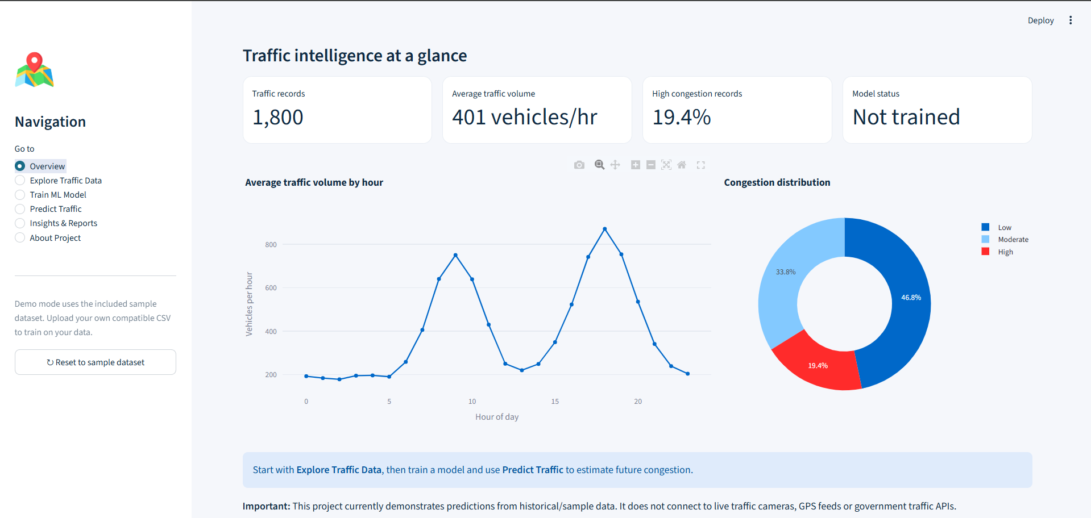

A.2 Explore Traffic Data
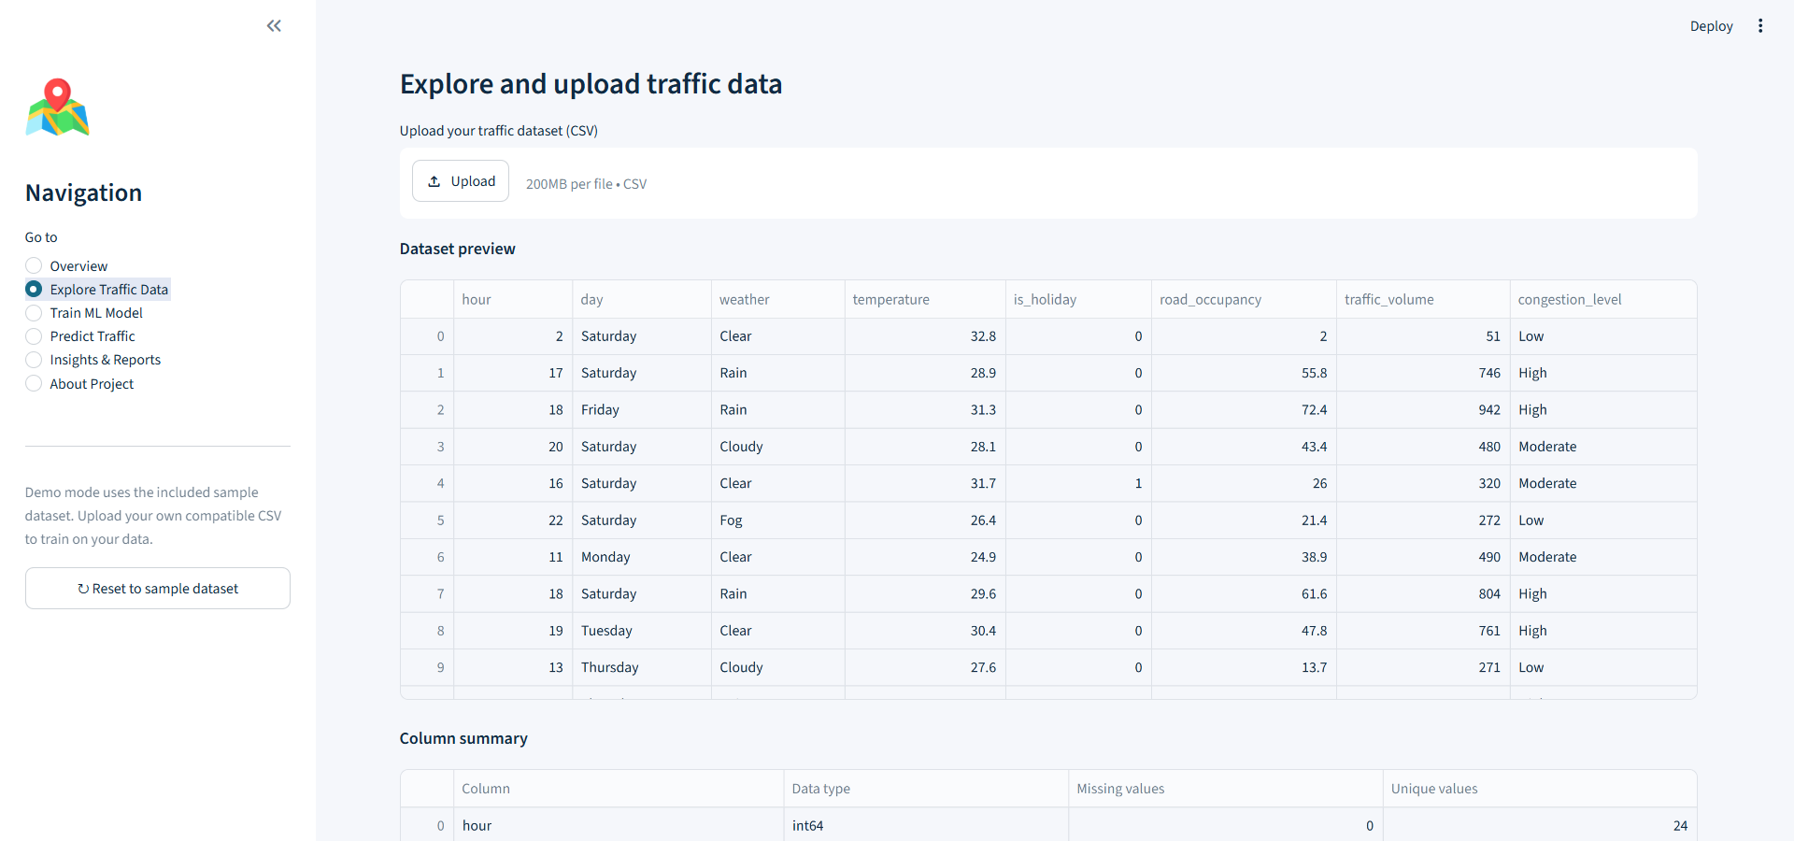

A.3 Train ML Model and Evaluation Output
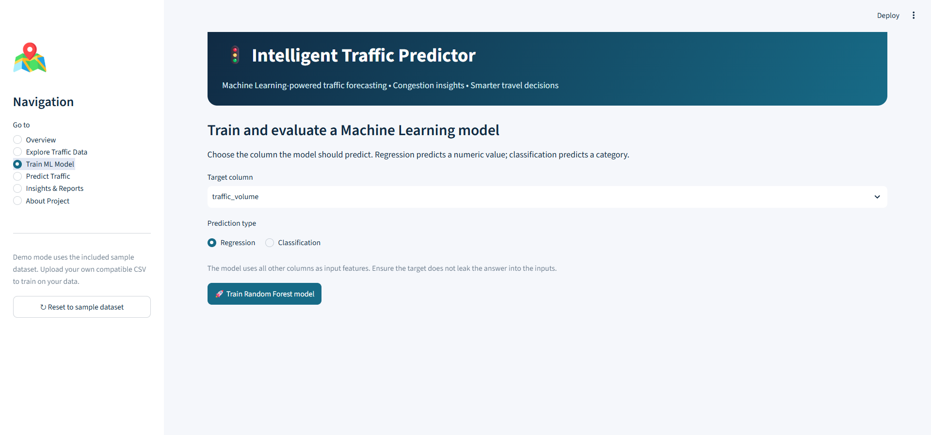

A.4 Predict Traffic Result
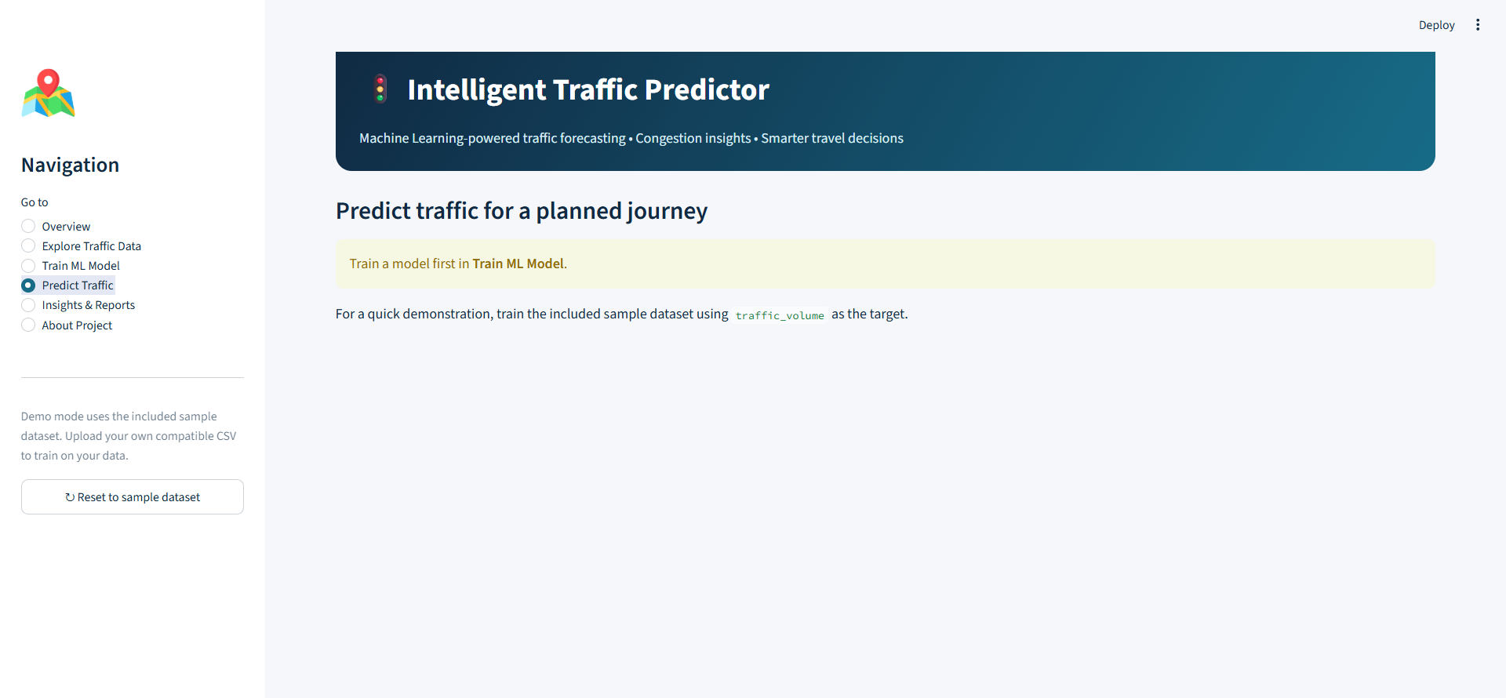

A.5 Insights & Reports
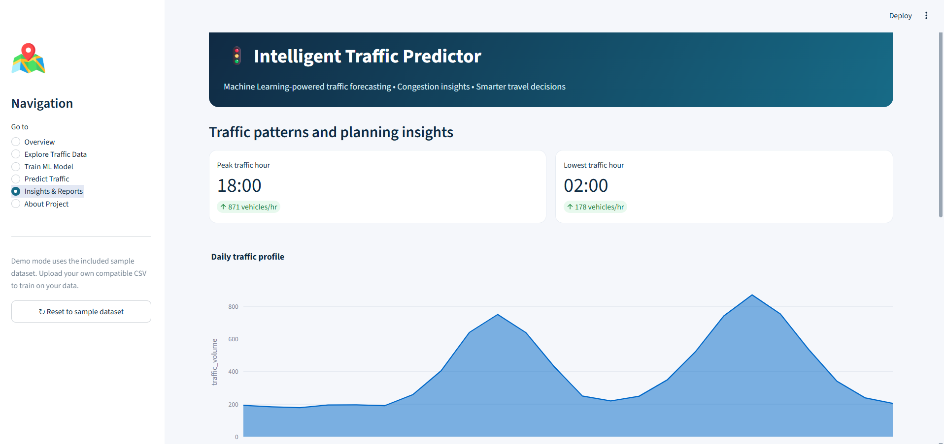

A.6 About Project
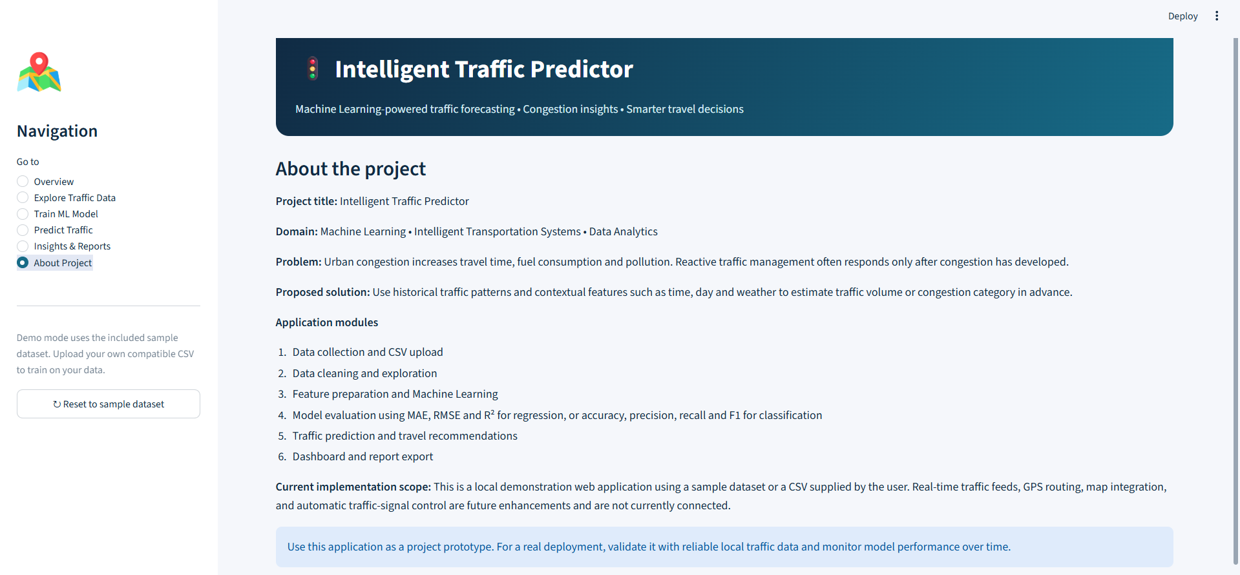

Appendix B – Sample Code Structure
The project package is organised around the Streamlit entry point, dependency list, and sample data file:
Intelligent_Traffic_Predictor/
├── app.py
├── requirements.txt
├── README.md
├── .streamlit/
│ └── config.toml
└── data/
└── sample_traffic_data.csv

Appendix C – Installation and Setup Instructions
Run these commands from the project folder in Windows PowerShell:
python --version
python -m pip install -r requirements.txt
python -m streamlit run app.py
If dependency installation takes time, allow the installation to finish. If it fails, capture the complete error message and check that the terminal is opened in the folder containing requirements.txt.

Appendix D – User Manual
- Open the application using the local Streamlit URL shown in the terminal.
- Start with Overview to understand the project and available dataset.
- Open Explore Traffic Data to inspect the sample data or upload a compatible CSV.
- Open Train ML Model and run the supported training workflow.
- Review the displayed metrics and record the actual values for the project report.
- Open Predict Traffic, enter the requested input values and run the prediction.
- Open Insights & Reports to review charts and patterns.
- Use About Project to review the project description and limitations.

Appendix E – Certifications
[Attach relevant course, internship, workshop or participation certificates here, if required by the department.]

DOCUMENTATION CHECKLIST – COMPLETE BEFORE SUBMISSION
- Confirm the faculty guide’s name and designation.
- Confirm the team member names and university IDs; the review PPT contains conflicting team details on its first two slides.
- Run the application and insert genuine screenshots in Appendix A.
- Train the model on the dataset intended for final demonstration and enter the actual metrics in Chapter 8.
- Verify the exact dataset columns and update Section 5.2 if necessary.
- Add the full bibliographic details of the research papers actually used in the literature survey.
- Update the table of contents and page numbers after final formatting.

