WEEK 3 REPORT
Advanced Data Analysis and Visualization in Logistics
Project: Logistics Delivery Performance Analysis and Optimization
Educational internship task | Dataset: simulated synthetic shipment records unless stated otherwise

1. Executive Summary
This report explores the cleaned synthetic logistics dataset to understand delivery duration, cost patterns, on-time performance, and relationships among operational variables. Descriptive statistics and four charts communicate transit-time distribution, on-time delivery by mode, monthly average cost, and correlations among numeric variables. All results are computed from the demonstration dataset, not a real logistics provider.

2. Analytical Questions
- What is the typical delivery duration and how spread out are delivery times?
- Does on-time performance vary by transport mode or region?
- How does average shipping cost change over time?
- Which numeric variables move together and deserve further investigation?
- Which operational actions should be tested rather than assumed from correlation?

3. KPI Snapshot
Metric | Calculated value
Unique shipments | 1,800
On-time delivery rate | 38.4%
Average delivery duration | 4.00 days
Average shipping cost | 91.14 synthetic cost units
Delay rate | 61.6%
Average delay when delayed | 0.70 days
Cost units are arbitrary synthetic units and should not be interpreted as Indian rupees or any real currency.

4.1 Delivery-Time Distribution
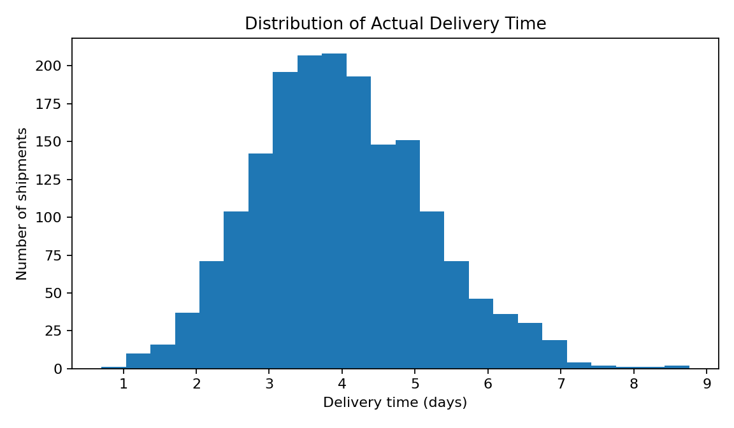
A histogram shows the frequency and spread of a continuous variable. It helps managers see the typical transit-time range and whether a long-delay tail exists. Compare this distribution with promised service levels and investigate extreme-duration shipments.

4.2 On-Time Delivery by Transport Mode
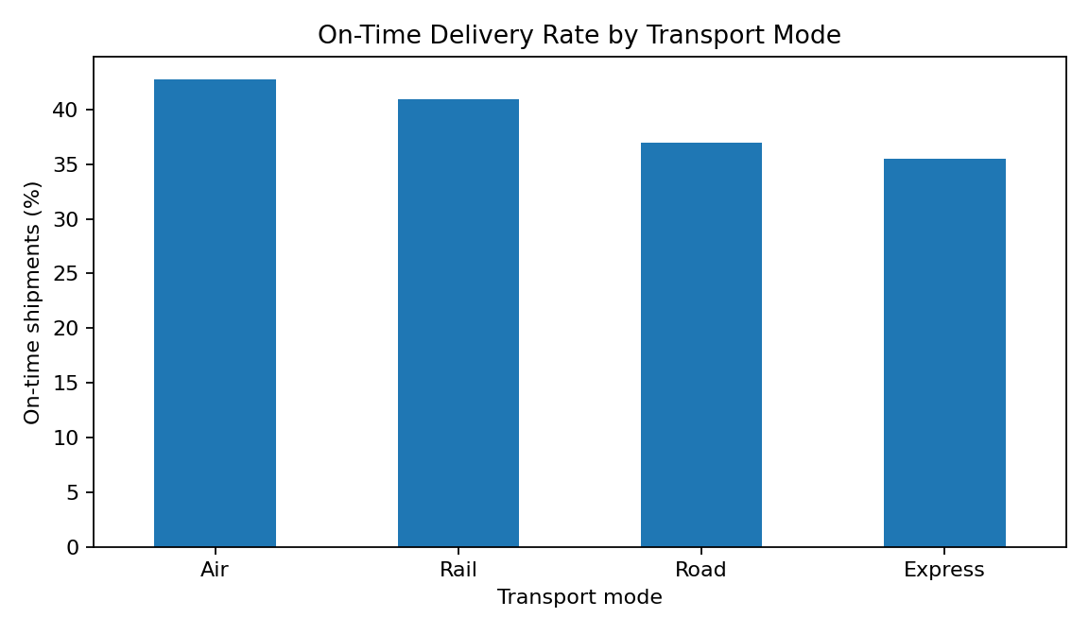
A bar chart compares a KPI across categories. Mode-level rankings can support investigation, but do not prove that a mode causes better performance: distance, weight, schedule commitments, and assigned routes may differ. Control for these factors before making a fair comparison.

4.3 Monthly Average Shipping Cost
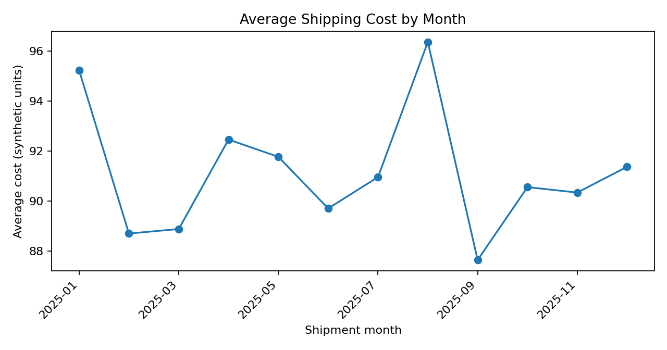
A line chart makes time trends easier to inspect. Monthly averages may reveal seasonality or unusual spikes, but shipment mix and volume must also be checked. A higher average may reflect a larger share of air or express shipments rather than a rate increase.

4.4 Correlation Matrix
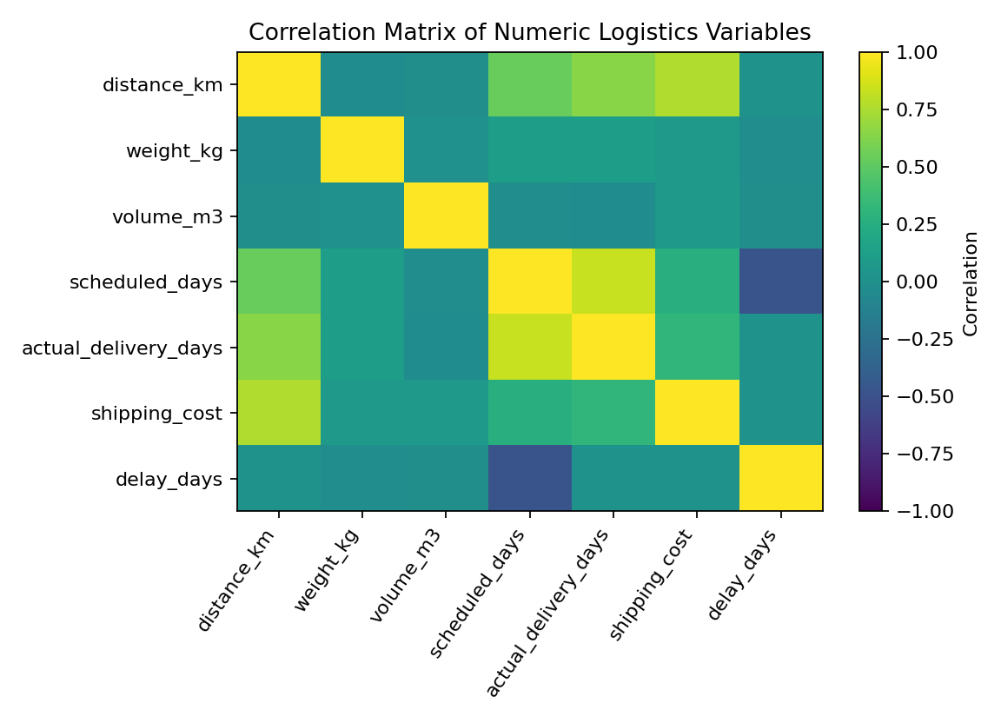
A correlation matrix summarizes linear relationships among numeric fields. Distance and duration may move together, while cost may rise with distance and weight. Correlation does not establish causation and can be affected by scheduling policies and confounding variables.

5. Python EDA Code
import pandas as pd
import matplotlib.pyplot as plt
import seaborn as sns
df = pd.read_csv("simulated_logistics_shipments_clean.csv")
df["ship_date"] = pd.to_datetime(df["ship_date"])
print(df[["actual_delivery_days", "shipping_cost", "distance_km"]].describe())
print("On-time rate (%):", round(df["on_time"].mean() * 100, 2))
sns.histplot(data=df, x="actual_delivery_days", bins=24, kde=True)
plt.title("Distribution of Actual Delivery Time"); plt.tight_layout(); plt.show()
mode_rate = df.groupby("transport_mode")["on_time"].mean().mul(100)
mode_rate.plot(kind="bar", title="On-Time Delivery Rate by Transport Mode")
plt.ylabel("On-time shipments (%)"); plt.tight_layout(); plt.show()
sns.heatmap(df[["distance_km", "weight_kg", "scheduled_days",
"actual_delivery_days", "shipping_cost", "delay_days"]].corr(),
annot=True, cmap="coolwarm", center=0)
plt.tight_layout(); plt.show()

6. Transport Mode Segment Review
Mode | Shipments | On-time rate | Average days | Average cost
Air | 288 | 42.7% | 3.21 | 119.77
Rail | 332 | 41.0% | 4.83 | 86.75
Road | 873 | 37.0% | 4.14 | 76.87
Express | 307 | 35.5% | 3.42 | 109.62
Always report segment counts alongside percentages; small groups can have unstable rates. Compare like-for-like service windows and, where appropriate, use confidence intervals or multiple time periods.

7. Recommendations
- Create a weekly exception report for shipments exceeding their scheduled duration.
- Compare modes after controlling for distance, weight, region, and promised window.
- Investigate months or regions with high costs using invoice and shipment-mix data.
- Track on-time rate, delivery time, and cost together to avoid optimizing one metric at another's expense.
- Validate patterns on real operational data before changing carrier allocation or service promises.

8. Conclusion and Limitations
Visual analysis turns shipment records into patterns managers can discuss and test. The charts prioritize investigation but do not prove causal explanations. Because the dataset is synthetic, figures demonstrate an analytical workflow; real decisions require validation with actual records and operational context.

