# Create Table 1

CREATE TABLE movies (

movie_id INT NOT NULL PRIMARY KEY,

title VARCHAR(100),

genre VARCHAR(100),

realising_year INT,

rating DECIMAL(3,1)

);

# insert values in table 1

INSERT INTO movies (movie_id, title, genre, realising_year, rating) VALUES

(1, 'Albela', 'Romance', 2001, 3.7),

(2, 'Lagaan', 'Drama', 2001, 8.1),

(3, 'Devdas', 'Romance', 2002, 7.1),

(4, 'yaadein', 'Drama', 2001, 5.1),

(5, 'Masti Express', 'Comedy', 2011, 5.6),

(6, 'Trump Card', 'Action', 2010, 6.7),

(7, '99', 'Crime', 2009, 6.8),

(8, 'Wake up Sid', 'Drama', 2009, 9.3),

(9, 'Jumbo', 'Animation', 2008, 6.3),

(10, 'Kalyug', 'Crime', 2005, 4.5);

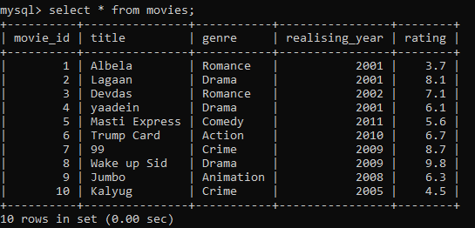

# create table 2

CREATE TABLE movie_details (

detail_id INT NOT NULL PRIMARY KEY,

movie_id INT,

director VARCHAR(100),

runtime INT,

box_office DECIMAL(10,2),

FOREIGN KEY (movie_id) REFERENCES movies(movie_id)

);

# insert values in table 2

INSERT INTO movie_details (detail_id, movie_id, director, runtime, box_office) VALUES

(1, 1, 'Deepak Sareen', 147, 10.52),

(2, 2, 'Ashutosh Gowariker', 224, 65.97),

(3, 3, 'Sanjay Leela Bhansali', 185, 99.88),

(4, 4, 'Shubhash Ghai', 171, 14.65),

(5, 5, 'Laxman Utekar', 111, 0.58),

(6, 6, 'Arshad Khan', 137, 0.75),

(7, 7, 'C.Premkumar', 135, 10.78),

(8, 8, 'Ayan Mukherji', 137, 47.10),

(9, 9, 'Kompin Kemgumird', 98, 2.53),

(10, 10, 'Mohit Suri', 126, 7.21);

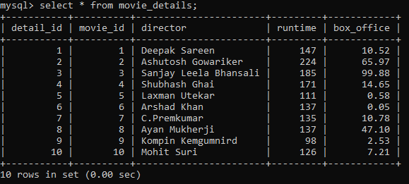

# SELECT, WHERE, GROUP BY, ORDER BY

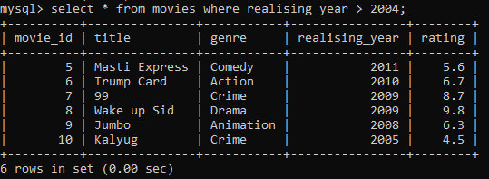

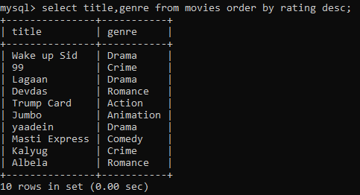

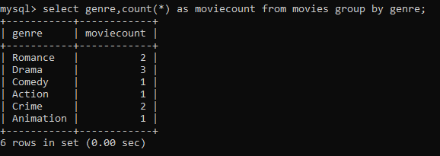

# JOIN operations (INNER, LEFT, RIGHT)

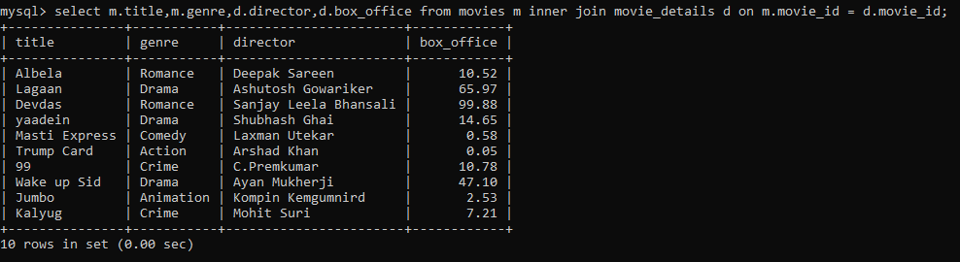

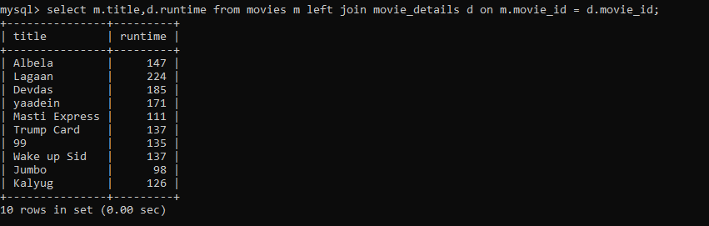

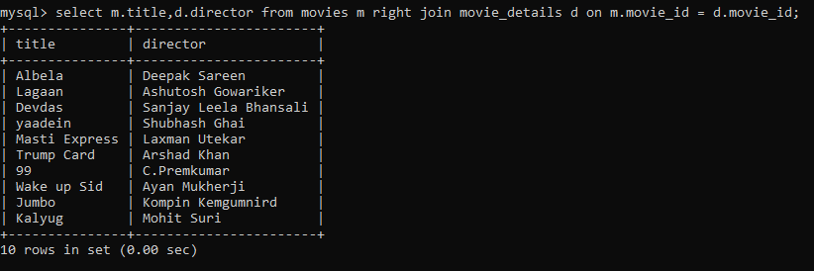

# sub queries

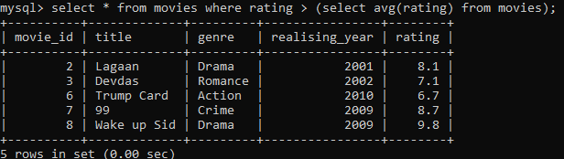

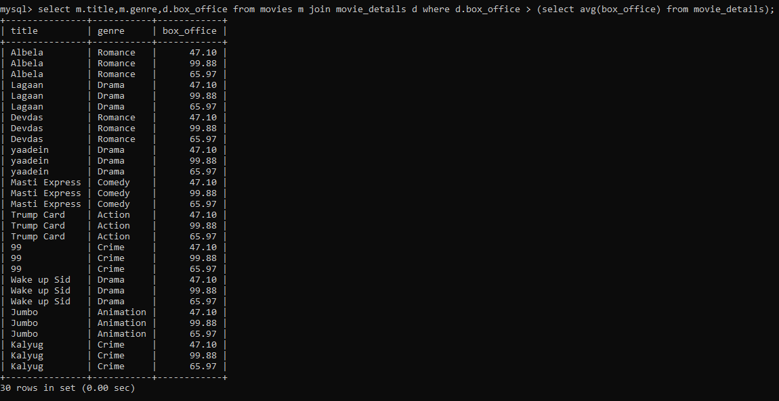

# Aggregate Functions(SUM, MIN, MAX, AVG, COUNT)

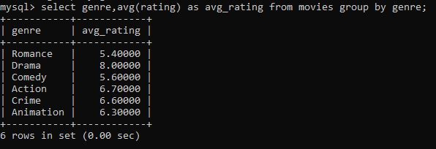

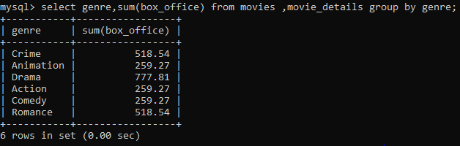

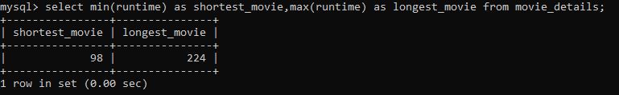

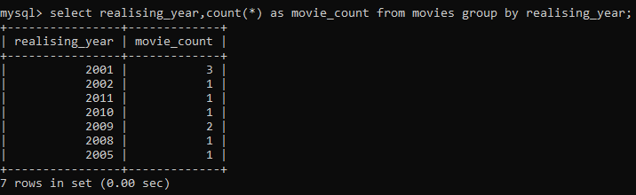

# views for analysis

CREATE VIEW highrated_movies AS

SELECT

m.title,

m.rating,

md.box_office

FROM

movies m

JOIN

movie_details md ON m.movie_id = md.movie_id

WHERE

m.rating >= 8.0;

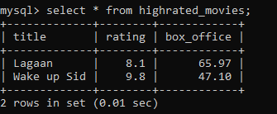

# Query optimization with indexes

