1. **What is the difference between css2 and css3? Is it css3 compactable with all browsers? If not what u will do for remaining browsers?**

ANS: CSS3 comes with new features like text-borders, borders, shadows... It won’t works with internet explorer for that we need to take it that as image and place it that image in style or HTML, (U NEED GIVE DIFFERNT STYLE FOR IE USING JAVASCRIPT).

* Border- radius
* Text-shadow
* Box-shadow , @font-face
* Outline
* Transition and transform
* Box gradient
* Media queries
* Border-image

1. **What is CSS Box Model?**

Margin, border,padding,content.

* Content - The content of the box, where text and images appear
* Padding - Clears an area around the content. The padding is transparent
* Border - A border that goes around the padding and content
* Margin - Clears an area outside the border. The margin is transparent

1. **What are CSS3 Animations?**

You can change as many CSS properties you want, as many times you want.

To use CSS3 animation, you must first specify some keyframes for the animation.

Keyframes hold what styles the element will have at certain times.

@keyframes example {  
    from {background-color: red;}  
    to {background-color: yellow;}  
}

1. **What is css3 transition?**

CSS3 transitions allows you to change property values smoothly (from one value to another), over a given duration.

transition: width 2s;

1. **What is css3 transform?**

CSS3 transform allows you translate, scale, skew, and rotate elements.

A transformation is an effect that lets an element change shape, size and position.

1. **What are the pseudo classes?**

ANS : :active , :hover , :link , :focus , :before , :after , :fisrt-letter , :first-line , :first-child for more details visit this site <http://www.w3schools.com/css/css_pseudo_classes.asp>

|  |  |  |  |
| --- | --- | --- | --- |
| [:link](http://www.w3schools.com/cssref/sel_link.asp) | a:link | Selects all unvisited links | 1 |
| [:visited](http://www.w3schools.com/cssref/sel_visited.asp) | a:visited | Selects all visited links | 1 |
| [:active](http://www.w3schools.com/cssref/sel_active.asp) | a:active | Selects the active link | 1 |
| [:hover](http://www.w3schools.com/cssref/sel_hover.asp) | a:hover | Selects links on mouse over | 1 |
| [:focus](http://www.w3schools.com/cssref/sel_focus.asp) | input:focus | Selects the input element which has focus | 2 |
| [:first-letter](http://www.w3schools.com/cssref/sel_firstletter.asp) | p:first-letter | Selects the first letter of every <p> element | 1 |
| [:first-line](http://www.w3schools.com/cssref/sel_firstline.asp) | p:first-line | Selects the first line of every <p> element | 1 |
| [:first-child](http://www.w3schools.com/cssref/sel_firstchild.asp) | p:first-child | Selects every <p> element that is the first child of its parent | 2 |
| [:before](http://www.w3schools.com/cssref/sel_before.asp) | p:before | Insert content before  the content of every <p> element | 2 |
| [:after](http://www.w3schools.com/cssref/sel_after.asp) | p:after | Insert content after every <p> element | 2 |
| [:lang(*language*)](http://www.w3schools.com/cssref/sel_lang.asp) | p:lang(it) | Selects every <p> element with a lang attribute equal to "it" (Italian) |  |
| [:first-of-type](http://www.w3schools.com/cssref/sel_first-of-type.asp) | p:first-of-type | Selects every <p> element that is the first <p> element of its parent | 3 |
| [:last-of-type](http://www.w3schools.com/cssref/sel_last-of-type.asp) | p:last-of-type | Selects <p> element that is the last <p> element of its parent | 3 |
| [:only-of-type](http://www.w3schools.com/cssref/sel_only-of-type.asp) | p:only-of-type | Selects every <p> element that is the only <p> element of its parent | 3 |
| [:only-child](http://www.w3schools.com/cssref/sel_only-child.asp) | p:only-child | Selects every <p> element that is the only child of its parent | 3 |
| [:nth-child(n)](http://www.w3schools.com/cssref/sel_nth-child.asp) | p:nth-child(2) | Selects every <p> element that is the second child of its parent | 3 |
| [:nth-last-child(n)](http://www.w3schools.com/cssref/sel_nth-last-child.asp) | p:nth-last-child(2) | Selects every <p> element that is the second child of its parent, counting from the last child | 3 |
| [:nth-of-type(n)](http://www.w3schools.com/cssref/sel_nth-of-type.asp) | p:nth-of-type(2) | Selects every <p> element that is the second <p> element of its parent | 3 |
| [:nth-last-of-type(n)](http://www.w3schools.com/cssref/sel_nth-last-of-type.asp) | p:nth-last-of-type(2) | Selects every <p> element that is the second <p> element of its parent, counting from the last child | 3 |
| [:last-child](http://www.w3schools.com/cssref/sel_last-child.asp) | p:last-child | Selects every <p> element that is the last child of its parent | 3 |
| [:root](http://www.w3schools.com/cssref/sel_root.asp) | :root | Selects the document’s root element | 3 |
| [:empty](http://www.w3schools.com/cssref/sel_empty.asp) | p:empty | Selects every <p> element that has no children (including text nodes) | 3 |
| [:target](http://www.w3schools.com/cssref/sel_target.asp) | #news:target | Selects the current active #news element (clicked on a URL containing that anchor name) | 3 |
| [:enabled](http://www.w3schools.com/cssref/sel_enabled.asp) | input:enabled | Selects every enabled <input> element | 3 |
| [:disabled](http://www.w3schools.com/cssref/sel_disabled.asp) | input:disabled | Selects every disabled <input> element | 3 |
| [:checked](http://www.w3schools.com/cssref/sel_checked.asp) | input:checked | Selects every checked <input> element | 3 |
| [:not(selector)](http://www.w3schools.com/cssref/sel_not.asp) | :not(p) | Selects every element that is not a <p> element | 3 |
| [::selection](http://www.w3schools.com/cssref/sel_selection.asp) | ::selection | Selects the portion of an element that is selected by a user | 3 |

1. **Types of position attributes? Definition of each position? (Important question please study definition of all positions)?**

ANS:Position: static; ----- default position for positionattribute, Elements renders in order, as they appear in the document flow.

Position: absolute; ----- The element is positioned relative to its first positioned (left: 20; will take it from body

Position: relative; ----- The element is positioned relative to its normal position, so "left: 20" adds 20 pixels to the element's LEFT position. It will take left from the particular div which u havegivenposition: absolute;

Position: Fixed; ------- The element is positioned relative to the browser window. (It will be in same position if you scroll the window) posttion: inherit; ------ The value of the position property is inherited from the parent element

1. **Default position of position attributes?**ANS: static
2. **By default left: 45; will take it from where? Keyword: from body or fromdiv?**

ANS: If u give postion: relative; left: 20; it will take it from particular div but if u write position: absolute; left: 20; it will display left 20px from body....

1. **What is difference between margin and padding...?**

Space between each border is margin……………….Space between border and content is padding

1. **Difference between display: none; visibility: hidden;**

ANS: visibility: hidden; means not showing the text but there is a space for particular text.

Display: none; wont display text as well as no space

1. **Difference between cell padding and cell spacing?**

ANS: Spacing between each table cell is called cell spacing

Spacing between cell wall and content of the cell is called cell padding

1. **How @font-face will work?**

body { font: 90%/150% 'BemioITalic', Arial, Helvetica, sans-serif;}

@font-face {font-family: 'BemioITalic'; src: url('bemio_italic-webfont.eot?#iefix') format('embedded-opentype'), url('bemio_italic-webfont.ttf') format('truetype');}

1. **What is the difference between ID and class?**

ANS: for entire website common header, footer, left, right those we will use it for ID. wecan’t use it again and again

We can repeat the class multiple times.

1. **What is Preprocessor? Advantages?**

CSS preprocessor is basically a scripting language that extends CSS and then compiles it into regular CSS.

**Advantages:**

* Cleaner code with reusable pieces and variables
* Saves you time
* Easier to maintain code with snippets and libraries
* Calculations and logic
* More organized and easy to setup

16) **Difference between LESS and SASS?**

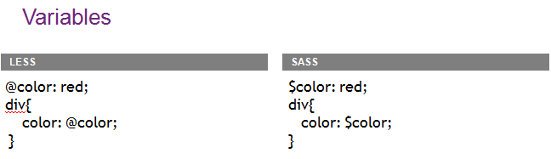

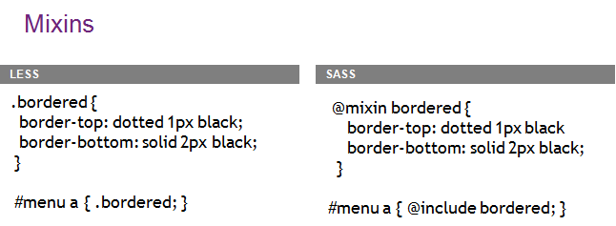

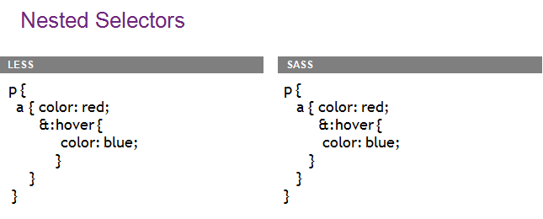

|  |  |
| --- | --- |
| **LESS**   * LESS (Lerner CSS) * Variables * Color Transformation * Mixins * Nesting * Loops & Conditionals * Importing * MATH | **SASS**   * Syntactically Awesome Style sheets * Variables * Color Transformation * Mixins * Nesting * Loops & Conditionals * Importing * MATH * @extend * @media * @content |