MySQL
MySQL is a standard language for accessing and manipulating databases.

Database
Connecting to MySQL the Server:
To learn MySQL, first we need to learn how to connect to MySQL server?
First you need to open command prompt on your system. To open command prompt on windows, click on the start menu on bottom left corner of your desktop, then click on “Run..”., type cmd and click ok. Now you have command prompt open. Now you need to navigate to MySQL folder under wamp, to do this , if you have wamp server installed on C: drive ,
Type
C:\wamp\bin\mysql\mysql5.1.33\bin and hit the enter key.
You are now in the bin directory under mysql5.1.33 folder.
To connect to MySQL server through command prompt we use “mysql” command. Login to
MySQL server we need to pass two values with, one is MySQL user and password for that user. The command looks like:
mysql –u username –p
When we have installed WAMP sever by default one user (root) MySQL has been created for MySQL server, with password blank.
To login to MySQL server do to the installation folder of MySQL and write “mysql –u root –p” and it
will ask for, then press enter as because no password has been set for MySQL.
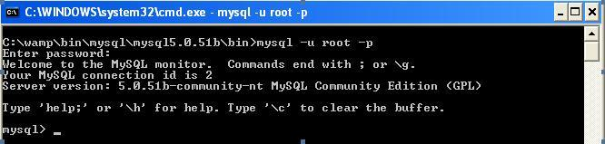
Ref: http://dev.mysql.com/doc/refman/5.1/en/connecting-disconnecting.html
Using SHOW DATABASE statement:
Lets start out MySQL learning journey with simple statement “SHOW DATABASES”. This statement will display all available databases in MySQL.
If we execute “SHOW DATABASE;” then it will generate a output like the following:
l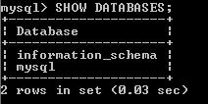
We have added one semicolon(;) at the end of our SQL statement, to tell MySQL statement ends there.
If we don’t add the semicolon then MySQL wait for the end of the statement, as shown in the following output.

Ref: http://dev.mysql.com/doc/refman/5.1/en/getting-information.html
Using CREATE DATABASE statement:
To create database “CREATE DATABASE” statement, followed by the name of the database. Now we are going to create a database named as “siliconindia”.
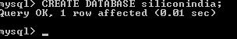
SQL will be “CREATE DATABASE siliconindia;”.
Using USE statement:
We have learnt how to create a database, but how to use the database. By term ‘use’ we mean to say how to fetch data from the database, or adding a new table etc.
To use the database ‘siliconindia’ we have to run the “USE siliconindia;” statement.
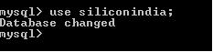
Using DROP DATABASE statement:
Say the siliconindia database we have created is no more required, then how to delete the database?
To delete the database we will use the “DROP” statement. Here as because we are deleting database we
will add one more command “DATABASE” with the statement followed by the name of the database
we are going to delete.
SQL statement will be “DROP DATABASE siliconindia;”
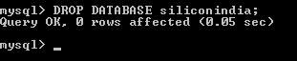
We will learn more about “DROP” statement later in this course.
Using EXIT or QUIT statement:
To log out from MySQL server we can use “EXIT” or “QUIT” statement. Type QUIT and press “Enter” key.
l
There is no need semicolon(;) with this statement.
Throughout the rest of this MySQl Course, you will be using the database “siliconindia” which you will create using the below statement

Create database siliconindia;

Once you download the assignment for the first chapter, you will get two files named siliconindia_new.sql and si_employee_new.sql, which holds the tables and sample data for these tables which will be under siliconindia database.

Following are the steps you have to follow to import these tables into siliconindia database.

Open PHPMyadmin in your system by using the following link: http://localhost/phpmyadmin/index.php on your browser. (phpMyAdmin is a free software tool written in PHP intended to handle the administration of MySQL over the World Wide Web.)

From the left menu of phpmyadmin, select the “siliconindia” database. Once the siliconindia database has been selected, upload the files by using “import” option which is on the top menu of phpmyadmin. Upload the files in this order:

siliconindia_new.sql

si_employee_new.sql

Once you have uploaded these two files you will have five tables in “siliconindia” database with some sample data inserted.
Ref: http://dev.mysql.com/doc/refman/5.1/en/database-use.html
If you are done with the above sections, please get the assignment using below option.

Retrieving and Sorting
Displaying table structure (DESC)
How can we see the table structure of a table?
We can use DESCRIBE or in DESC statement to see the table structure of a table.
DESC si_employees;
Writing basic SELECT statement:
The SELECT statement retrieves information from one or more tables. Syntax of SELECT statement:
SELECT values_to_display
FROM table_name
WHERE expression
GROUP BY how_to_group
HAVING expression
ORDER BY how_to_sort
LIMIT row_count;
We will learn Group By and Having clause in chapter 6.
Selecting all and specific column:
How display all details of SiliconIndia employees?
We can display all columns of a table with the following “SELECT” statement with an asterisk(*) sign.
SELECT *
FROM si_employee;
How display the first name, last name and salary of SiliconIndia employees?
Here we want to get specific details of employees. The query will be
SELECT f_name, l_name, salary
FROM si_employee;
Removing duplicate data:
SELECT dept_id FROM si_employees;
From the output of the previous query we can see that, it shows same department id repeated times.
How to remove the duplicate data?
To remove duplicate data, we can use DISTINCT keyword in the above “SELECT” statement.
SELECT DISTINCT dept_id
FROM si_employees;
Using arithmetic operators:
We can use arithmetic operators
‘*’ for multiplication
‘+’ for addition
‘-‘ for subtraction
‘/’ for division
How to calculate annual salary of SiliconIndia employees?
The following query will give the desired.
SELECT salary*12
FROM si_employees;
What is NULL?
A null is a value that unavailable, unassigned, unknown or inapplicable. This is not same a zero or a space.
Defining column aliasing
If we want to display, preceding example output “salary*12” as “Annual Salary”. Then we can use
column aliasing.
SELECT salary*12 AS “Annual Salary”
FROM si_employees;
Using ORDER BY clause:
We use ORDER BY clause to short data. If we use ORDER BY clause in the previous statement it will sort the data in ascending order.
SELECT salary*12 AS “Annual Salary”
FROM si_employees
ORDER BY “Annual Salary” ;
In ORDER BY clause we include either “ASC” or “DESC”. ASC stands for ascending order which is
default and DESC which sorts by descending order.
We can change the query to sort data in descending order to see who is getting highest annual salary in
SiliconIndia.
SELECT salary*12 AS “Annual Salary”
FROM si_employees
ORDER BY “Annual Salary” DESC;

Restricting Data
Limiting row selection:
By using LIMIT clause in SELECT statement we can limit no of record fetching. In limit clause you have to pass two parameters first one starting point and last one is the length of the returned result set.
How to find out who is getting highest salary in SiliconIndia?
SELECT f_name, l_name, salary
FROM si_employee
ORDER BY salary DESC
LIMIT 0,1;
In the above query first we are sorting the records on the basis of salary in descending order and then
limiting the records by one to get the highest salary.
Using WHERE clause
With the help of WHERE clause we can include condition or expression in our SQL statement.
How to get the details of SiliconIndia employees who earns 10000?
SELECT f_name, l_name, salary
FROM si_employee
WHERE salary=10000;
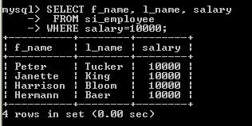
How to get the details of SiliconIndia employees whose last name is Bloom?
SELECT f_name, l_name, salary
FROM si_employee
WHERE l_name=’Bloom’;
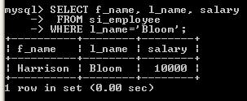
Note: Always put string or date values in between single or double quote.
Using Less Than (<) operator
Say that we want to see first name, salary and email of employee’s who earns less than “2500” as salary.
If see the requirement, then we can easily find out there is one condition employee’s salary is less than
“2500”.
We can write down the query as below
SELECT f_name, salary, email
FROM si_employee
WHERE salary<2500;
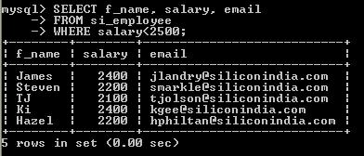
Using Less Than (<=) operator
Say that we want to see first name, salary and email of employee’s, who earns less than “2500” or equal
to “2500” as salary.
If see the requirement then we can find out there are two conditions employee’s either salary is less than
“2500” or salary is “2500”.
The query will be
SELECT f_name, salary, email
FROM si_employee
WHERE salary<=2500;
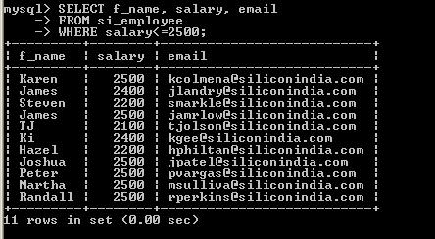
Using Greater Than (>) operator
Say that we want to the first name, last name and email of employee’s, whose earns more than “15000” as
salary.
If see the requirement then we can find out there is one condition employee’s salary is more than “15000”.
We can write down the query as below
SELECT f_name, salary, email
FROM si_employee
WHERE salary>15000;
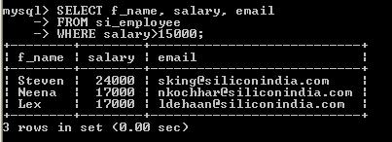
Using Greater Than (>=) operator
Say that we want to the first name, last name and email of employee’s, whose earns more than “14000” or
equal to “14000” as salary.
First we need analyze the requirement. If see the requirement then we can find out there are two
conditions employee’s either salary is more than “14000” or salary is “14000”
We can write down the query as below
SELECT f_name, salary, email
FROM si_employee
WHERE salary>=14000;
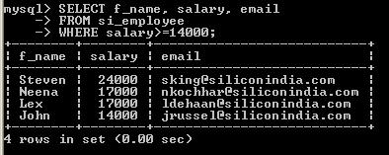
Using AND Operator (&&)
Say that we want to the first name, last name and email of employee’s, whose last name is “king” and
salary is “10000”.
If see the requirement then we can find out there are two conditions
1) employee’s last name should be ‘king’ and
2) employee should earn 10000 as salary.
We can write down the query as below
SELECT f_name, l_name, email
FROM si_employee
WHERE l_name=’king’ AND salary=10000;
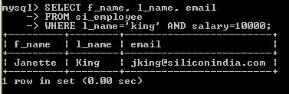
Using OR Operator (||)
Say that we want to the first name, last name and email of employee’s, whose last name is “king” or salary
is “10000”.
If see the requirement then we can find out there are two conditions either
1) employee’s last name should be ‘king’ or
2) employee should earn 10000 as salary.
We can write down the query as below
SELECT f_name,l_name, email
FROM si_employee
WHERE l_name=’king’ OR salary=10000;
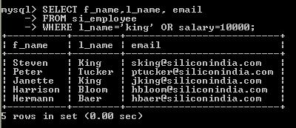
Using NOT Operator (!)
Say that we want to the first name and email of employee’s, whose last name is not “king”.
If see the requirement then we can find out there is one condition employee’s last name should not be
‘king’.
We can write down the query as below
SELECT f_name, l_name,email
FROM si_employee
WHERE !(l_name=’king’);
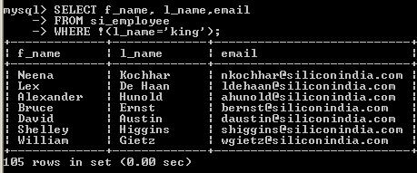
Using BETWEEN operator:
We can use this operator where values is in a range.
Syntax for BETWEEN operator
BETWEEN low_limit AND Upper_limit
We can easily understand BETWEEN operator with one example. Say that we want to see the first name
and email address of employee’s, who earns more than “14000”, but not more than “20000” as salary.
We can write down the query as below
SELECT f_name, salary, email
FROM si_employee
WHERE salary BETWEEN 14000 AND 20000;
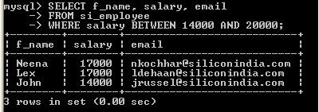
Note: We can use BETWEEN operator over date data type also.
Using LIKE operator
With help of LIKE operator we can search pattern in column.
SELECT f_name, l_name
FROM si_employee
WHERE l_name LIKE “king”;
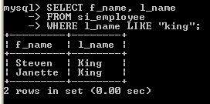
With LIKE operator we can use two “wildcards” and as described below
The '%' character matches any sequence of zero or more characters. For example, the pattern 'x%' matches any string that begins with 'x', '%y' matches any string that ends with 'y', and '%z%' matches any string that contains a 'z'. The pattern '%' matches any string, including empty strings.
SELECT f_name, l_name
FROM si_employee
WHERE l_name LIKE “k%”;
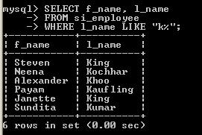
In the above example we are fetching employees whose last name starts with “k”.
The '_' (underscore) character matches any single character. 'm_n' matches strings such as 'man', 'men',
and 'm@n'. Because '_' matches any single character, it matches itself and the pattern 'm_n' also matches
the string 'm_n'.
SELECT f_name, l_name
FROM si_employee
WHERE l_name LIKE “f_y”;
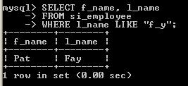
In the above example we are fetching employee’s details, whose last name is of 3 characters and starts
with “f” and ends with “y”.
A pattern can use these meta characters in combination. For example, '_%' matches any string containing
at least one character.
Using NULL operator
How can see the details of employee whose department id is null?
Using IS Null operator we can find out where department id is null.
SELECT f_name, l_name , dept_id
FROM si_employee
WHERE dept_id IS NULL;
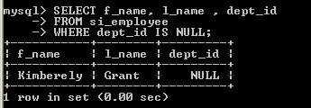
Using IN operator
IN operator is an extended version of OR operator. This will be easy to understand by an example. Say
that we want the details of employee’s whose employee id is either 102 or 156 or 197 or 206.
If we write this query with the help of OR operator it will look like
SELECT emp_id, f_name, l_name
FROM si_employee
WHERE emp_id=102
OR emp_id=156
OR emp_id=197
OR emp_id=206;
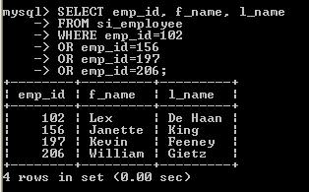
Now, we can rewrite the previous query with the help of IN operator
SELECT emp_id, f_name, l_name
FROM si_employee
WHERE emp_id IN (102 ,156, 197, 206);
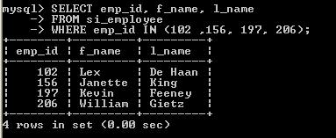

MySQL Functions
There are two types of functions available in MySQL
1.single row
2.multiple row.
What is single row function?
SINGLE ROW FUNCTION is those, which are executed once for each and every row returned by the query.
Types of single row function
The different types of SINGLE ROW FUNCTIONS are:
1. NUMBER Functions
2. DATE Functions
3. CHARACTER Functions
4. Control Flow Functions
What is dual table?
Dual table is a dummy table; it contains a single row and single column. If we return a data from dual table it gives a single row.
Using NUMBER Functions:
ROUND(m,[n])
Round the number m to n decimal places (n is optional)
SELECT ROUND(2.355,2) FROM dual;
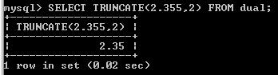
TRUNCATE(m,[n])
Truncate the number m to n decimal places (n is optional)
SELECT TRUNCATE(2.355,2) FROM dual;
MOD(m,n)
Return the remainder of the number m divided by n
SELECT MOD(3,2) FROM dual;
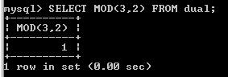
CEIL(m)
Returns nearest largest integer (Whole Number) without decimal place larger than the number m
SELECT CEIL(1.2) FROM dual;
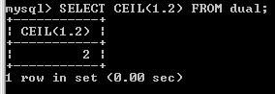
The nearest largest integer, larger than 1.5 is 2, so this query returns 2.
FLOOR(m)
Returns nearest smallest integer (Whole Number) without decimal place smaller than the number m.
SELECT FLOOR(1.4) FROM dual;
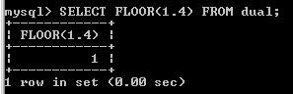
The nearest smallest integer, smaller than 1.4 is 1, so this query returns 1.
POWER(m,n)
Returns multiplication of m, n times
SELECT POWER(2,2) FROM dual;
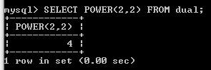
SIGN(m)
Returns +1 if the number m >0 else Returns -1 if the number m is < 0
SELECT SIGN(-23) FROM dual;
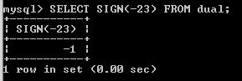
SELECT SIGN(23) FROM dual;
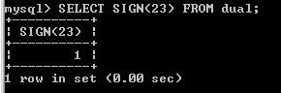
Ref: http://dev.mysql.com/doc/refman/5.1/en/mathematical-functions.html
Using DATE Functions
CURDATE()
SELECT CURDATE() from dual;
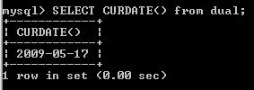
Returns current date of the system;
CURTIME()
SELECT CURTIME() from dual;
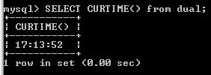
Returns current time
NOW() or CURRENT_TIMESTAMP()
SELECT NOW() from dual;
or SELECT CURRENT_TIMESTAMP()dual;
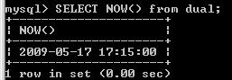
Returns date and time both.
DATE()
SELECT DATE(NOW()) from dual;
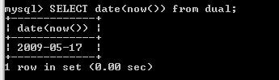
Returns the full date value with out time segment.
DATEDIFF()
SELECT DATEDIFF(’2004-12-31’, ’2003-12-31’) from dual;
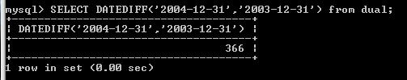
Returns date difference of the given dates in days
TIMEDIFF()
SELECT TIMEDIFF(’2004-12-31 23:59:59’, ’2004-12-30 23:59:59’) from dual;
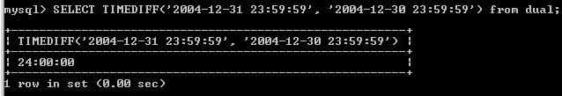
Returns time difference between two dates
ADDDATE();
ADDDATE(<date>, INTERVAL <expression> <type>) from dual;
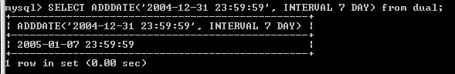
Adds date according to given expression and type.
SUBDATE()
SELECT SUBDATE(’2004-10-31 23:59:59’, INTERVAL 7 DAY) from dual;
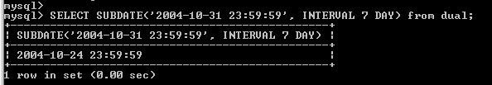
subtract date according to given expression and type.
Ref: http://dev.mysql.com/doc/refman/5.1/en/date-and-time-functions.html
Using CHARACTER Functions
LOWER(string)
Returns string in lower case
SELECT LOWER('SILICONINDIA') FROM dual;
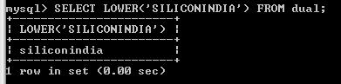
UPPER(string)
Returns string in UPPER CASE
SELECT UPPER('siliconindia') FROM dual;
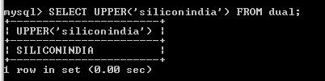
SUBSTR(string,m,[n])
Returns n no of characters from position m for string (n is optional)
SELECT SUBSTR('Welcome to SiliconIndia',1,3) from dual;
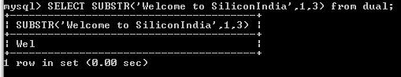
INSTR(string,c)
Returns the first position of character c from string. INSTR is case sensitive
SELECT INSTR('SiliconIndia', 'D') FROM dual;
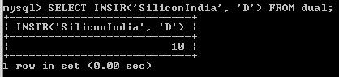
LENGTH(string)
Returns length of string
SELECT LENGTH('siliconindia') FROM dual;
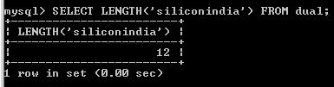
RPAD(string,m,[c])
Returns string of length m right padded with character c. If c is not specified, then the string will be right padded with SPACE
SELECT RPAD('silicon',10,'*') FROM dual;
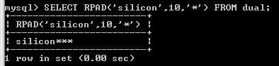
LPAD(string,m,[c])
Returns string of length m left padded with character c. If c is not specified, then the string will be left padded with SPACE.
SELECT LPAD('silicon',10,'*') FROM dual;
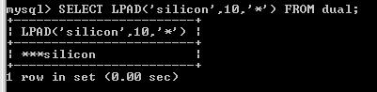
CONCAT(string1,string2)
Returns concatenated string string1string2
SELECT CONCAT('silicon','india') FROM dual;
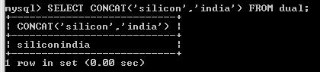
TRIM(string)
Returns string after trimming spaces on both the sides of the string
SELECT TRIM(' siliconindia ') FROM dual;
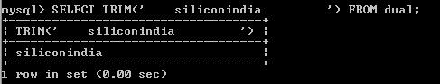
REPLACE(string,m,[c])
Returns string after replacing all the occurances of character m with character c. If c is not specified, then the character m is truncated from the string
SELECT REPLACE('SilifonIndia','f','c') FROM dual;
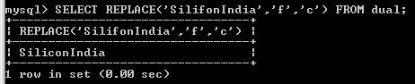
Ref: http://dev.mysql.com/doc/refman/5.1/en/string-functions.html
Using Control Flow Functions
Control flow functions enable us to choose between different values based on the result of an expression.
IF(expr,argv1,argv2)
IF(expr,argv1,argv2) tests the expression in its first argument and returns its second or third argument depending on whether the expression is true or false:
Select IF(1>0,’True’,’False’) from dual;
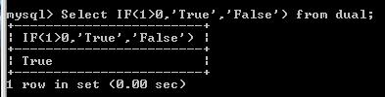
IFNULL (column_name,value)
This function checks whether the returned column value is NULL, if it is NULL then it replaces NULL with the specified value.
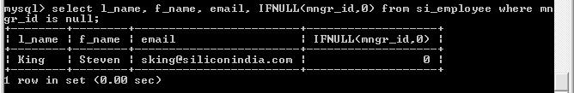
CASE
Case statement in MySQL is just like as switch statement in any other programming language. We case say that CASE is an extended version of IF statement. If matches over a range of values and returns the result. Case statement’s syntax is as follows
CASE WHEN <expression> THEN <result>
[{WHEN <expression> THEN <result>}...]
[ELSE <result>]
END
SELECT CASE WHEN 20*2=30 THEN ’30 correct’
WHEN 20*2=50 THEN ’50 correct’
ELSE ’Should be 20*2=40’
END from dual;
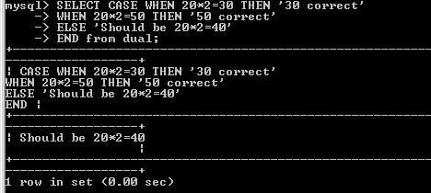
Ref: http://dev.mysql.com/doc/refman/4.1/en/control-flow-functions.html

Displaying Data from Multiple Table (Joining)
What is joining?
The act of joining in MySQL refers to smashing two or more tables into a single table. In short, a join command unites some or all of the data from two or more tables into one comprehensive structure.
Types of Join
1. Cross Join
2. Natural Join
3. Outer Join
Left Outer Join
Right Outer Join
4. Self Join
Cross Join
Cross join is created when joining condition fails to join tables or we want to create more data then we can use cross join or when there is no join condition.
SELECT f_name, l_name, si_employee.dept_id, dept_name
FROM si_employee, si_dept;
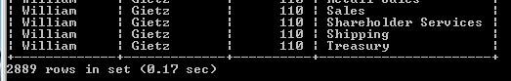
Natural Join:
A join that identifies combinations of matching rows from two tables is called an inner join. Inner joins may be written using two different syntaxes. One way by using joining condition in “WHERE” clause and the other way by using “INNER JOIN” keywords.
SELECT f_name, l_name, si_employee.dept_id, dept_name
FROM si_employee , si_dept
WHERE si_employee.dept_id = si_dept.dept_id;
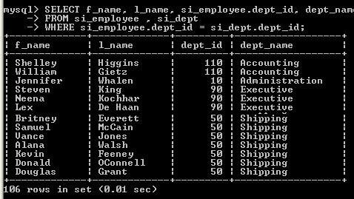
SELECT f_name, l_name, si_employee.dept_id, dept_name
FROM si_employee INNER JOIN si_dept ON si_employee.dept_id = si_dept.dept_id;
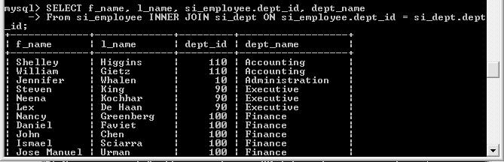
Table Alias
You can see that the query became large because of table name using table name again and again. To solve this problem there is a terminology called “Alias” is there in MySQL. When we this terminology for table it’s called “Table Alias”.
Now we will learn “Table Alias” by rewriting the previous query
SELECT f_name, l_name, s1.dept_id, dept_name
FROM si_employee AS s1, si_dept as s2
WHERE s1.dept_id = s2.dept_id;
OUTER JOIN:
An outer join finds matches (just like an inner join), but also identifies mismatches. Furthermore, with an appropriate WHERE clause, an outer join can filter out matches to display only the mismatches.
1.LEFT OUTER JOIN:
A left join is a type of outer join, written using the LEFT JOIN keywords. A left join treats the left table (the first one named) as a reference table and produces output for each row selected from it, whether or not the row is matched by rows in the right table.
We discuss left pouter join by example. In inner join example we can the returned no of employee is 106, but the total no employee are 107. So, one employee is there who don’t have any department id.
So, in this condition left outer join can effective.
SELECT f_name, l_name, s1.dept_id, dept_name
FROM si_employee s1 LEFT JOIN si_dept s2 ON s1.dept_id = s2.dept_id;
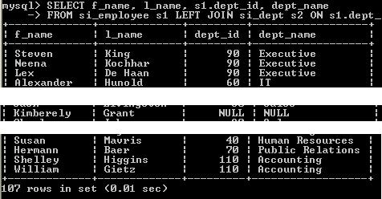
2.RIGHT OUTER JOIN:
A right join is another type of outer join, written using the RIGHT JOIN keywords. Every right join corresponds to an equivalent left join. The only difference is that the roles of the tables in a right join are reversed relative to the roles in a left join. That is, the right table is the reference table, so a RIGHT JOIN produces a result for each row in the right table, whether or not it has any match in the left table.
We can write the previous example just changing the oreder of reference.
SELECT f_name, l_name, s1.dept_id, dept_name
FROM si_dept s2 RIGHT JOIN si_employee s1 ON s2.dept_id = s1.dept_id;
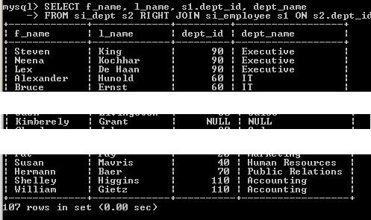
SELF JOIN:
A join does not always have to involve two different tables. You can join a table to itself, creating a self-join. Joining a table to itself can be useful when you want to compare values in a column to other values in the same column.
Say that we want to find out the manager’s (employee’s id, employee’s last name, employee’s manager id, manger’s last name, manger’s employee is) of each employee’s. Here we can implement self join because each employee’s record is stored in the si_employee table.
SELECT s1.emp_id AS “emp id”, s1.l_name AS “emp last name”, s1.mngr_id AS “emp's mngr id”, s2.l_name AS “mngr last name”,s2.emp_id AS “mngr’s emp id”
FROM si_employee AS s1, si_employee AS s2
WHERE s2.emp_id = s1.mngr_id;
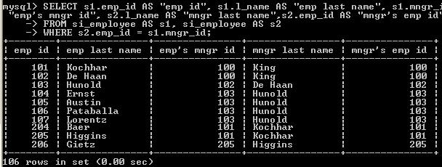
Ref: http://dev.mysql.com/doc/refman/5.1/en/join.html

Aggregate Functions and Aggregation Using GROUP BY Clause (Grouping)
Multiple Row Functions or Aggregate Functions:
Multiple row functions are the basic functions that you’re most likely to use when using a GROUP BY clause to group together columns of data.
Using AVG(expr)
Average the values returned by a specified expressions.
Calculate the average salary of siliconindia employees?
SELECT AVG(salary)
FROM si_employee;
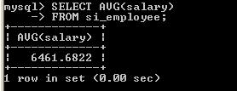
Using SUM(expr)
Returns the sum of the expressions.
Calculate the total salary of siliconindia employees?
SELECT SUM(salary)
FROM si_employee;
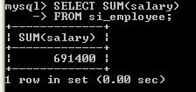
Using MIN(expr)
Returns the minimum of the expressions.
Calculate the lowest salary of siliconindia employee?
SELECT MIN(salary)
FROM si_employee;
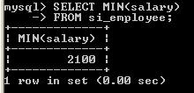
Using MAX(expr)
Returns the maximum of the expressions.
Calculate the highest salary of siliconindia employee?
SELECT MAX(salary)
FROM si_employee;
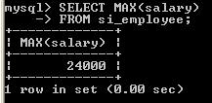
Using COUNT(expr)
Return the no of records found in the returned result set. Syntax look like
COUNT([DISTINCT] {<expression> | *})
Calculate the number of employees in siliconindia?
SELECT COUNT(emp_id)
FROM si_employee;
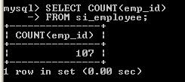
Ref: http://dev.mysql.com/doc/refman/5.1/en/group-by-functions.html
How to use group by clause and why?
If we look at the query then we can easily find out the problem; i.e. count() is a group function so it will return one result,. But we want to see the department id also which will return for each and every record.
If a query does not contain a GROUP BY clause to place rows of the result set into groups, an aggregate function produces a result that is based on all the selected rows. A GROUP BY clause may be added to generate a more fine-grained summary that produces values for subgroups within a set of selected rows.
e.g. To see how many employees work’s in each department we have to make group of employees based on their department.
SELECT count(emp_id)
FROM si_employee
GROUP BY dept_id;
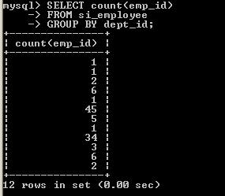
Now how can get the minimum, maximum and average salary of siliconindia employee’s from each department?
SELECT dept_id, MIN(salary), MAX(salary), AVG(salary)
FROM si_employee
GROUP BY dept_id;
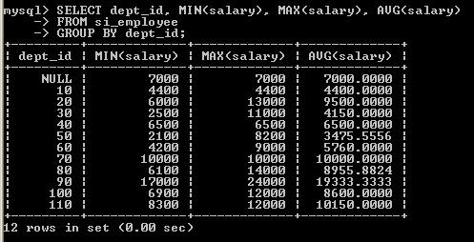
How can we restrict data when we are using group by function?
When we are using group by clause, if we are interested only in groups that have particular summary characteristics, we can restrict that group by using HAVIG clause, HAVING acts in a manner somewhat similar to WHERE. We will discuss it by example.
Now say that we want to display employee’s last name, salary and average salary from each department who is earning more than average salary.
SELECT l_name,salary, AVG(salary)
FROM si_employee
WHERE salary>AVG(salary)
GROUP BY (dept_id);
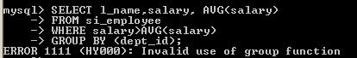
If we execute the above query then it will show the above error message.
So, how can we get the details? Here “Having” clause plays the rule. When we want to do some operation, such as like the above example we should use “Having” clause instead of “where” clause.
We can rewrite the query as below.
SELECT l_name,salary, AVG(salary)
FROM si_employee
GROUP BY (dept_id)
HAVING salary>AVG(salary);
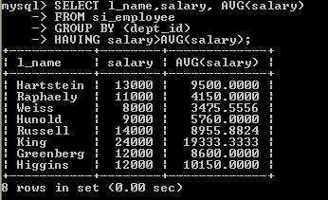
Ref: http://dev.mysql.com/doc/refman/5.1/en/group-by-functions-and-modifiers.html

Subquery
What is Subquery?
A subquery is a SELECT statement that is embedded in another SQL statement. The outer statement uses the result returned by the inner statement.
For example, we want see all employee’s details (like employee id, last name and department id), in which department employee with id “104” works.
SELECT emp_id,l_name,dept_id
FROM si_employee
WHERE dept_id=(SELECT dept_id FROM si_employee WHERE emp_id=104);
Subquery Operators
The ANY operator, which allow us to create an expression that compare a column to any of the values returned by a subquery. For the expression to evaluate to true, any value returned by the subquery can be used.
SELECT emp_id, l_name, dept_id, salary
FROM si_employee
WHERE salary > ANY ( SELECT salary FROM si_employee WHERE dept_id=80);
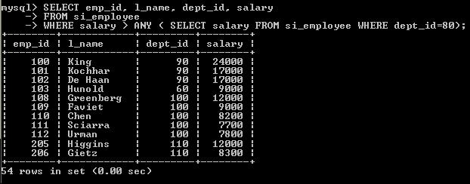
There are 54 employees who earns more than the salary earned a employee who works in department with id 80 including department with id 80.
The ALL operator is different from the ANY because it requires that all values returned by the subquery must cause the expression to evaluate to true before the outer statement can return a row. For example, modify the previous example to use the ALL operator rather than the ANY operator.
SELECT emp_id, l_name, dept_id, salary
FROM si_employee
WHERE salary > ALL ( SELECT salary FROM si_employee WHERE dept_id=80);
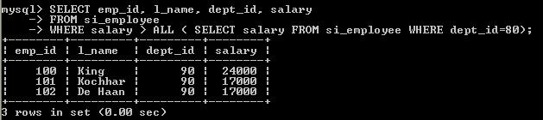
The IN and NOT IN operators provide the most flexibility when comparing values to the results returned by a subquery. For example, modify the previous example to use the ALL operator rather than the ANY operator.
SELECT emp_id, l_name, dept_id, salary
FROM si_employee
WHERE salary IN ( SELECT salary FROM si_employee WHERE dept_id=80);
Ref: http://dev.mysql.com/doc/refman/5.1/en/subqueries.html

Manipulating table
In this chapter we are going to learn how to use table as container. First we will learn how to add
data in a table.
Adding record using INSERT statement
The INSERT statement adds new records to a table. It has two basic formats, one of which allows for insertion of multiple rows using a single statement:
INSERT INTO table_name (column_list) VALUES (value_list);
Now we are going to add a record in si_emp table that we have created in last chapter.
Here if you look at query then you can see there we have used default date format for MySQL (YYYY-MM-DD).
Ref: http://dev.mysql.com/doc/refman/5.1/en/insert.html
How to see the previous statement has added the records in the table or not?
To display the in a table we can use the select statement. Now execute the following query to display the records from the table.
Select * from si_emp;

If you want to insert multiple rows in a single insert statement then use the following statement.
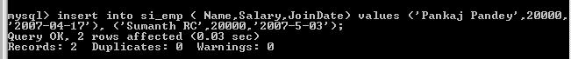
The second INSERT syntax follows the table name by a SET clause that lists individual column assignments separated by commas:
The SET clause must assign a value to at least one column
• Inserting DATE and STRING values
• Deleting record using DELETE statement
To remove record or records from tables, we can use DELETE statement.
Delete from si_emp;
If we execute the above query then it will remove all records from the table. So, take special care when you are using Delete statement.

Ref: http://dev.mysql.com/doc/refman/5.1/en/delete.html
Deleting record using WHERE clause
How we can delete the employee, whose name is “Rajib Das”?
The DELETE statement allows a WHERE clause that identifies which records to remove. This is a safe way to delete record or records from a table. Use the following query to delete the employee’s record.
Delete from si_emp where name=’Rajib Das’;
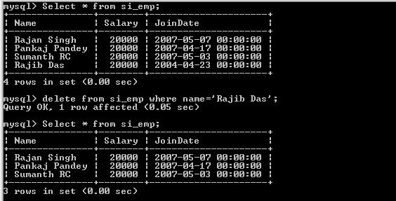
Updating record using UPDATE statement
To update the age we need to use “Update” statement , by default it will update all records in the table.
Updating record using WHERE clause
Now we want to change the salary for “Rajan Singh” from 20000 to 22000?
To update the salary we need to use “Update” statement. If we don’t use the where clause to restrict the updating it will update salary for all employees.
Update si_emp set salary=22000 where name=’Rajan Singh’ ;
Ref: http://dev.mysql.com/doc/refman/5.1/en/update.html

Creating and Managing Table
Using CREATE TABLE statement
To create the table issue the SQL command
Create table SI_EMP
(Name varchar(50),
Salary int,
JoinDate datetime);
Output: will be

How to see the table structure?
To see the table structure, we can “Describe” or “Desc” statement.
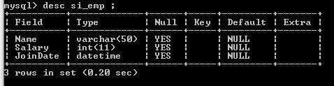
Ref: http://dev.mysql.com/doc/refman/5.1/en/create-table.html
Mysql data types
There are several data types available in MySQL, but we are going learn few of them, which are mostly used in MySQL.
There are three data types mostly used in MySQL and are
1. String
2. Integer
3. Date
But, going any further we will learn how create a table?
To create a table will use “create” command. We are going to create table named SI_EMP under siliconindia database that we have created in last chanter. This table will atore the information about the employees who works in siliconindia. This table we have three columns named “Name”, “Salary” and “JoinDate”. “Name” Table will store the name of the employees, “Salary” will store the salary earned by employee and “JoinDate” to store on which date the employee joined company.
String data types
To store string values, say name and address. There are several different ways to define a column, that can store string values. But, we will learn two ways to create and are char and varchar.
The following table lists the string data types provided in MySQL.
Type Description
CHAR Fixed-length non-binary string
VARCHAR Variable-length non-binary string
TEXT Variable-length non-binary string
BINARY Fixed-length binary string
VARBINARY Variable-length binary string
BLOB Variable-length binary string
ENUM Enumeration consisting of a fixed set of legal
values
SET Set consisting of a fixed set of legal values
Numeric data types
To store numeric values. In this session we learn how create integer data type and decimal data type.
Integer: Integer data types include TINYINT, SMALLINT, MEDIUMINT, INT, and BIGINT. Following are range for the available values:
Type Storage Required Signed Range
TINYINT 1 byte –128 to 127
SMALLINT 2 bytes –32,768 to 32,767
MEDIUMINT 3 bytes –8,388,608 to 8,388,607
INT 4 bytes –2,147,683,648 to 2,147,483,647
BIGINT 8 bytes –9,223,372,036,854,775,808
to ,223,372,036,854,775,807
Now, say that we are going to create a table, which will store information about a class. It will store student’s name, roll no, and class.
Date data types
We need date type to store date or date with or with timestamp. As in our previous example to create an table named “SI_EMP” we have created a column named “JoinDate” which is of DateTime which means it can store a date value with time.
In MySQL the following are valid date data type:
Type Storage Required Range
DATE 3 bytes '1000-01-01' to '9999-12-31'
TIME 3 bytes '-838:59:59' to '838:59:59'
DATETIME 8 bytes '1000-01-01 00:00:00'
to '9999-12-31 23:59:59'
TIMESTAMP 4 bytes '1970-01-01 00:00:00'
to mid-year 2037
YEAR 1 byte 1901 to 2155 (for YEAR(4)),
1970 to 2069 (for YEAR(2))
AUTO_INCREMENT attribute
The AUTO_INCREMENT attribute is usually added to an integer column definition to create a column for which MySQL automatically generates a new sequence number each time you create a new row. The column must be indexed, and the column must be defined as NOT NULL.
The AUTO_INCREMENT attribute is used in conjunction with an index (usually a primary key). MySQL also provides a LAST_INSERT_ID() function that returns the most recently generated AUTO_INCREMENT value. We can create a table say “User” with an AUTO_INCREMENT column userid with the following query.
CREATE TABLE user(
user_id INT UNSIGNED NOT NULL AUTO_INCREMENT,
name Varchar(100),
password Varchar(40),
PRIMARY KEY (user_id)
);
Ref: http://dev.mysql.com/doc/refman/5.1/en/example-auto-increment.html
Adding a new column
We want to add a column to the table si_emp for date of birth of employee.
To add a new column to a table, use ALTER TABLE with an ADD clause that specifies the column’s definition.
The ALTER TABLE statement changes the table structure as follows
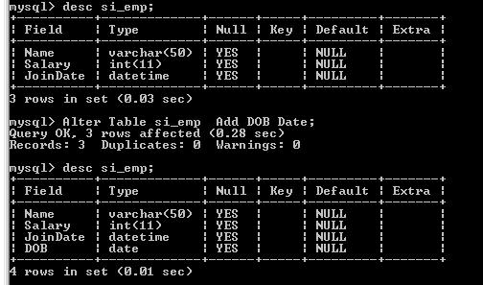
Changing a column
We can change the declared column “salary” to “sal” use the following statement:
ALTER TABLE si_emp CHANGE Salary Sal MediumInt UNSIGNED NOT NULL;
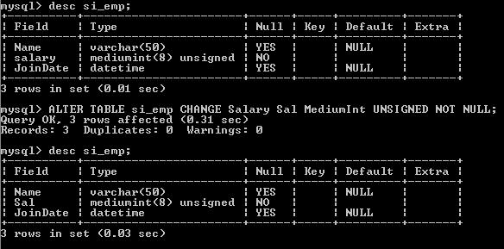
Deleting or Truncating a column
To remove records from tables, use a DELETE statement or a TRUNCATE TABLE statement. The DELETE statement allows a WHERE clause that identifies which records to remove, whereas TRUNCATE TABLE always removes all records. DELETE therefore can be more precise in its effect.
DELETE FROM table_name;
TRUNCATE TABLE table_name;
The word TABLE in TRUNCATE TABLE is optional.
To remove only specific records in a table, TRUNCATE TABLE cannot be used. You must issue a DELETE statement that includes a WHERE clause that identifies which records to remove:
Dropping a column
To drop a column, use a DROP clause that names the column to be removed:
ALTER TABLE table_name DROP column_name;
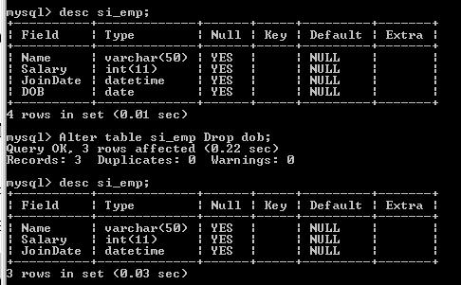

Constraints
What is constraints and when we can apply constraints on table?
Constraints is a set of rule that we can impose on table to use table in a better way. We can create table at the time of table creation and after creation of a table.
Available constraints in MySQL are:
Not null
Primary key
Unique key
Foreign key
NOT NULL
But, before we go any further we need to know what is null?
Null is a defined as
The SQL NULL value represents a null or empty value in a database column. The NULL value is distinct from all valid values for a given data type.
PRIMARY KEY:
A primary key is one which uniquely identifies a row
of a table. this key does not allow null values and also
does not allow duplicate values.
UNIQUE KEY:
A unique is one which uniquely identifies a row
of a table, but there is a difference like it will not
allow duplicate values and it will any number of allow
null values
FOREIGN KEY:
a foreign key is one which will refer to a
primary key of another table
USING CONSTRAINTS:
PRIMARY KEY:
CREATE TABLE Attributes
(
ID SMALLINT NOT NULL PRIMARY KEY,
Settings TINYINT UNSIGNED NOT NULL
);
ALTER TABLE HeadOfState ADD PRIMARY KEY (ID);
UNIQUE KEY:
CREATE TABLE HeadOfState
(
ID INT NOT NULL,
LastName CHAR(30) NOT NULL,
FirstName CHAR(30) NOT NULL,
CountryCode CHAR(3) NOT NULL,
Inauguration DATE NOT NULL,
UNIQUE (ID)
);
FOREIGN KEY:
CREATE TABLE score
(
id integer,
questionnumber integer,
score integer,
FOREIGN KEY (id) REFERENCES reviewing (reviewingid) on delete cascade
);
Dropping a constraints
To drop an index with ALTER TABLE, use a DROP clause and name the index to be dropped. Dropping a PRIMARY KEY is easy:
ALTER TABLE HeadOfState DROP PRIMARY KEY;
To drop another kind of index, you must specify its name. If you don't know the name, you can use SHOW CREATE TABLE to see the table's structure, including any index definitions
mysql> SHOW CREATE TABLE HeadOfStateG
************ 1. row *************
Table: HeadOfState
Create Table: CREATE TABLE `HeadOfState` (
`ID` int(11) NOT NULL default '0',
`LastName` char(30) NOT NULL default '',
`FirstName` char(30) NOT NULL default '',
`CountryCode` char(3) NOT NULL default '',
`Inauguration` date NOT NULL default '0000-00-00',
PRIMARY KEY (`ID`),
KEY `LastName` (`LastName`,`FirstName`)
) TYPE=MyISAM
The KEY clause of the output shows that the index name is LastName, so you can drop the index using the following statement:
ALTER TABLE HeadOfState DROP INDEX LastName;

Indexing & Engine
What is index?
Tables in MySQL can grow very large, but as a table gets bigger, retrievals from it become slower. To keep your queries performing well, it's essential to index your tables. Indexes allow column values to be found more efficiently, so retrievals based on indexes are faster than those that are not. For large tables, the presence of an index can make the difference between a query that executes quickly and one that is unacceptably slow.
Another reason to use indexes is that they can enforce uniqueness constraints to ensure that duplicate values do not occur and that each row in a table can be distinguished from every other row.
Merits and demerits of indexing on a table?
• Each index requires storage or disk space. The exact amount depends on the size of the table and the size and number of columns in the index.
• Each INSERT or DELETE operation performed on a table requires additional updating of each index on that table. This is also true for each UPDATE operation that changes the value of an index key.
• The LOAD utility rebuilds or appends to any existing indexes.
The indexfreespace MODIFIED BY parameter can be specified on the LOAD command to override the index PCTFREE used when the index was created.
• Each index potentially adds an alternative access path for a query for the optimizer to consider, which increases the compilation time.
Creating Index:
You can create indexes at the same time that you create a table by including index definitions in the CREATE TABLE along with the column definitions. It is also possible to add indexes to an existing table with ALTER TABLE or CREATE INDEX.
To define indexes for a table at the time you create it, include the index definitions in the CREATE TABLE statement along with the column definitions. An index definition consists of the appropriate index-type keyword or keywords, followed by a list in parentheses that names the column or columns to be indexed.
CREATE TABLE HeadOfState
(
ID INT NOT NULL,
LastName CHAR(30) NOT NULL,
FirstName CHAR(30) NOT NULL,
CountryCode CHAR(3) NOT NULL,
Inauguration DATE NOT NULL
);
To create the table with the same columns but with a non-unique index on the date-valued column Inauguration, include an INDEX clause in the CREATE TABLE statement as follows:
CREATE TABLE HeadOfState
(
ID INT NOT NULL,
LastName CHAR(30) NOT NULL,
FirstName CHAR(30) NOT NULL,
CountryCode CHAR(3) NOT NULL,
Inauguration DATE NOT NULL,
INDEX (Inauguration)
);
To add an index to a table with ALTER TABLE, use ADD followed by the appropriate index-type keywords and a parenthesized list naming the columns to be indexed.
ALTER TABLE HeadOfState ADD INDEX (LastName,FirstName);
WHAT IS ENGINE?
The storage engines manage data storage and index management for MySQL. The MySQL server communicates with the storage engines through a defined API. Each storage engine is a class with each instance of the class communicating with the MySQL server through a special handler interface.
Handlers are instanced on the basis of one handler for each thread that needs to work with a specific table. For example: If three connections all start working with the same table, three handler instances will need to be created. Once a handler instance is created, the MySQL server issues commands to the handler to perform data storage and retrieval tasks such as opening a table, manipulating rows, and managing indexes.
CHANGING TABLE ENGINE:
The ALTER TABLE statement also understands the ENGINE option. This allows you convert a table from one storage engine to another. The following statement changes t to use the MyISAM storage engine:
ALTER TABLE t ENGINE = MyISAM;
ALTER TABLE tblMyISAM CHANGE TYPE=InnoDB
CHOSSING RIGHT ENGINE
We can choose suitable engine according the need of the tables which we are creating. The features of engines in mysql are as follows ,
MyISAM: The default engine. No transactions support, average data reliability. Offers great performance for read heavy applications. Most web services and data warehousing applications use MyISAM heavily.
HEAP: All in-memory. Very fast for data retrieval, however due to being stored only in memory - all data is lost on shutdown. Great for temporary tables.
Archive: Used for storing large amounts of data without indexes in a small footprint.
Merge: Collection of MyISAM tables logically merged together to provide a single view.
InnoDB: Transaction-safe storage engine, best suited for write heavy environments thanks to row-level locking. Offers good built-in recovery and solid data reliability. InnoDB engine was acquired by Oracle on 2005.
NDB: A clustered engine - data is automatically split and replicated across several machines, a.k.a data nodes. Best suited for applications that require high performance lookups with the highest possible degree of uptime and availability. Originally designed by Ericsson for the Telco market, NDB offers the highest levels of data reliability (99.999%). NDB works well in read heavy environments. For write heavy environments with multiple concurrent writes, consider InnoDB.
The biggest disadvantadge of NDB, is that by design your entire database must fit in memory. If your database size times 2 is too big to fit in memory, NDBCluster is not for you.
According to our need and requirement we can choose suitable engine from above list.

Procedure, Trigger and Prepared statement
What prepared statement and how to use prepared statement?
Prepared statements are the ability to set up a statement once, and then execute it many times with different parameters. They are designed to replace building ad hoc query strings, and do so in a more secure and efficient manner. A typical prepared statement would look something like:
SELECT * FROM Country WHERE code = ?
The ? is what is a called a placeholder. When you execute the above query, you would need to supply the value for it, which would replace the ? in the query above.
Using prepared statement:
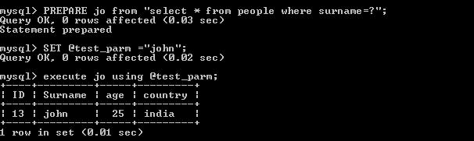
What stored procedure and how to use stored procedure?
A stored procedure, by definition, is a segment of declarative SQL code which is stored in the database catalog and can be invoked later by a program, a trigger or even a stored procedure.
Stored procedure increases performance of application. Once created, stored procedure is compiled and stored in the database catalog. It runs faster than uncompiled SQL commands which are sent from application.
Creating Stored Procedures
DELIMITER //
CREATE PROCEDURE productpricing()
BEGIN
SELECT Avg(prod_price) AS priceaverage
FROM products;
END //
DELIMITER ;
Here, DELIMITER // tells the command-line utility to use // as the new end of statement delimiter, and you will notice that the END that closes the stored procedure is defined as END // instead of the expected END;. This way the ; within the stored procedure body remains intact and is correctly passed to the database engine. And then, to restore things back to how they were initially, the statement closes with a DELIMITER ;
Using call procedure
CALL productpricing();
• Output
+--------------+
| priceaverage |
+--------------+
| 16.133571 |
+--------------+
What trigger and how to use trigger?
A trigger is defined to activate when an INSERT, DELETE, or UPDATE statement executes for the associated table. A trigger can be set to activate either before or after the triggering statement. For example, you can have a trigger activate before each row that is inserted into a table or after each row that is updated.
MySQL triggers are activated by SQL statements only. They are not activated by changes in tables made by APIs
Creating trigger
delimiter |
CREATE TRIGGER testref BEFORE INSERT ON test1
FOR EACH ROW BEGIN
INSERT INTO test2 SET a2 = NEW.a1;
DELETE FROM test3 WHERE a3 = NEW.a1;
UPDATE test4 SET b4 = b4 + 1 WHERE a4 = NEW.a1;
END;
|
delimiter ;

