Queries & Results

Query – 1

Top 3 Results

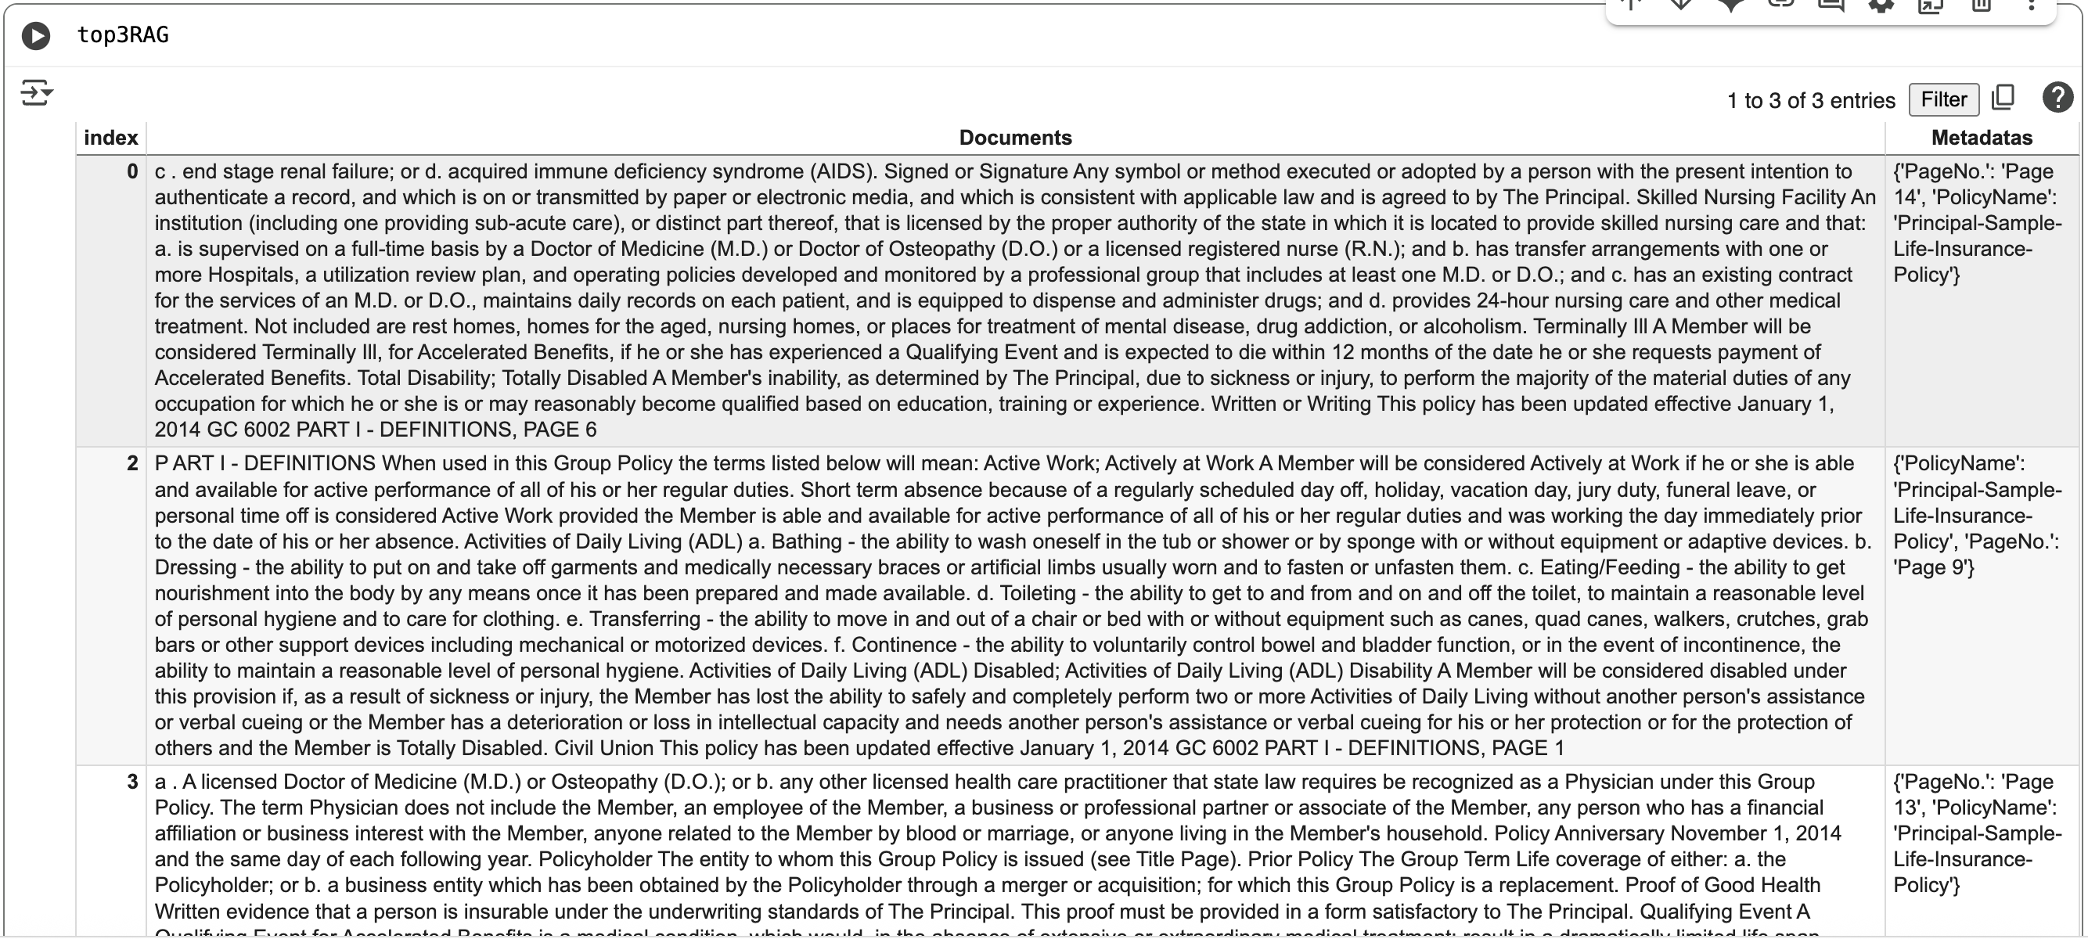

Final Result

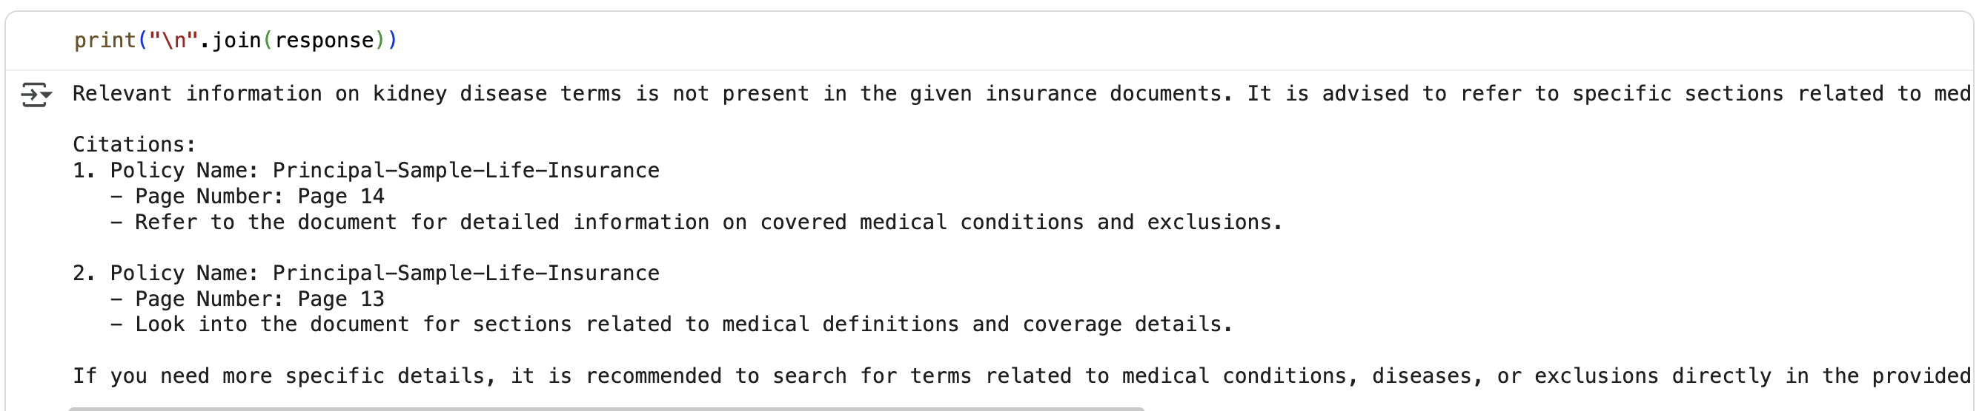

Query – 2

Top 3 Results
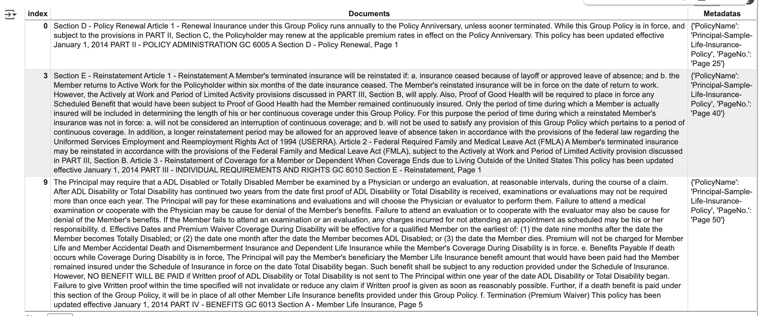
Final Result
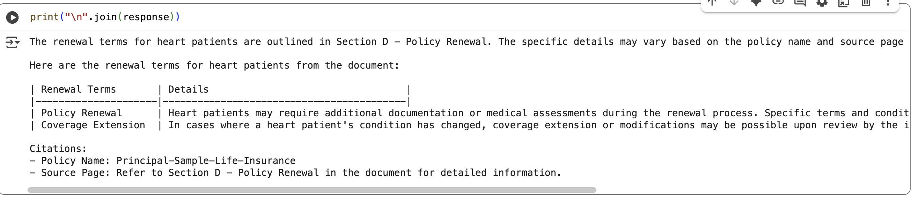

Query – 3
Top 3 Results
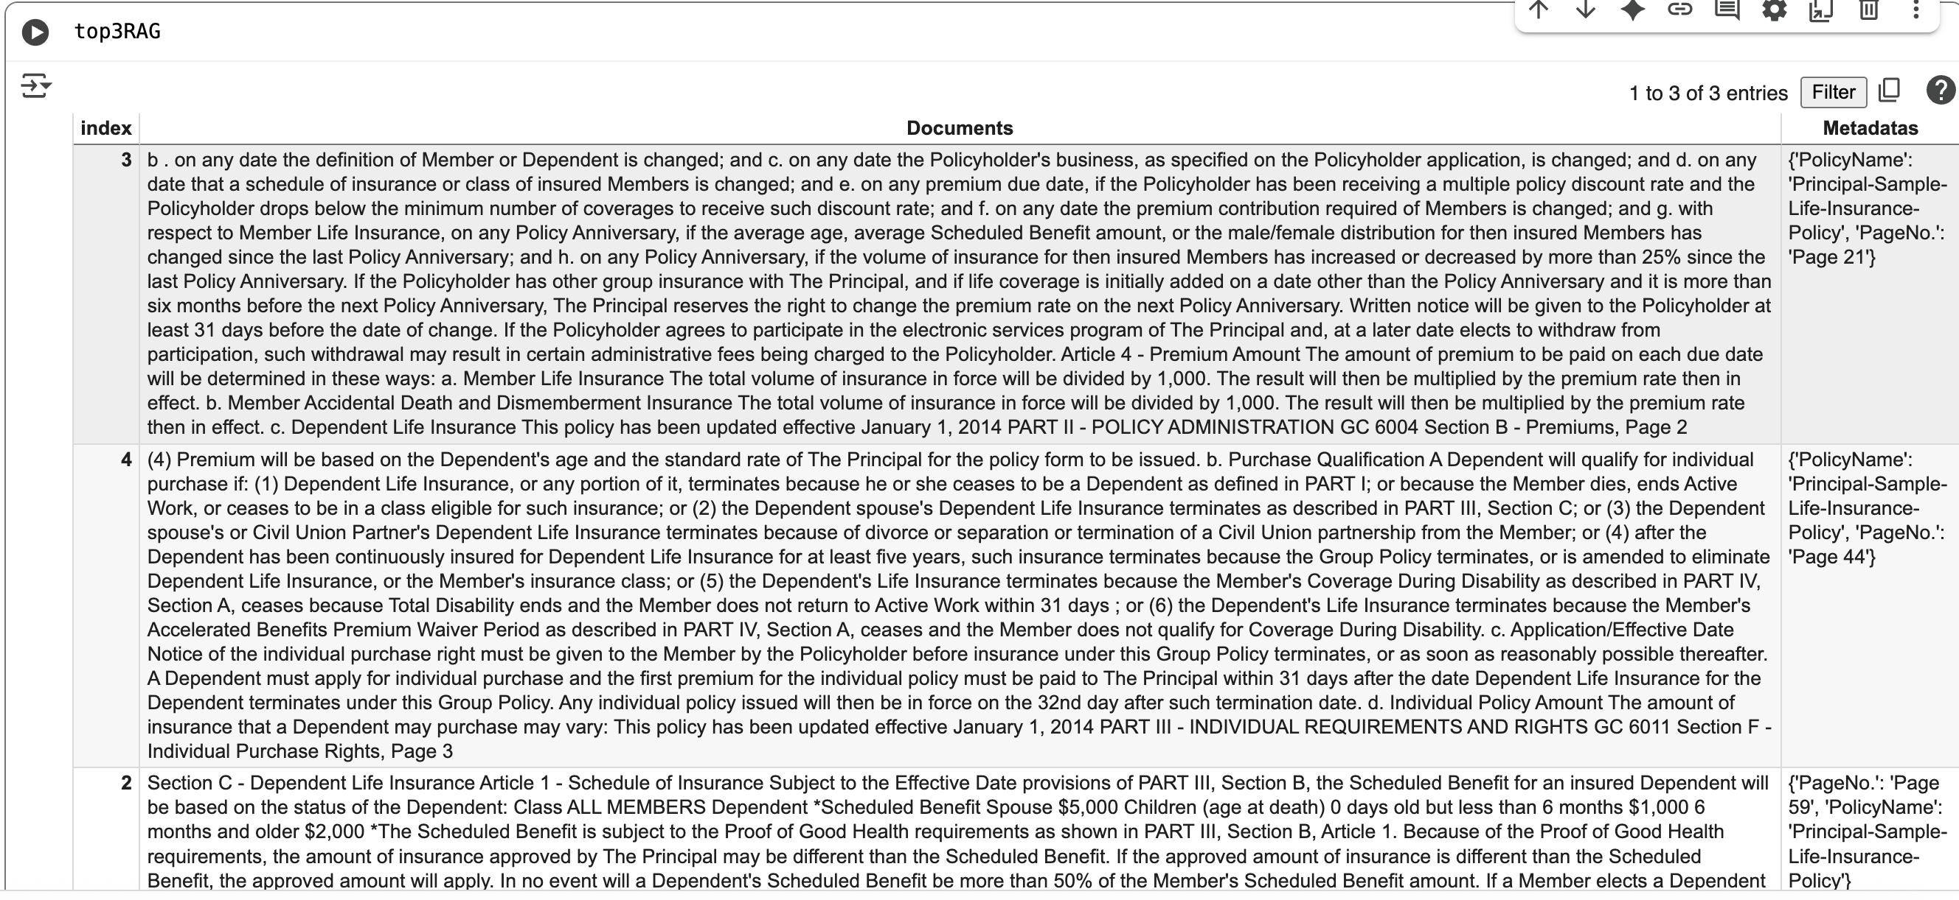

Final Result

