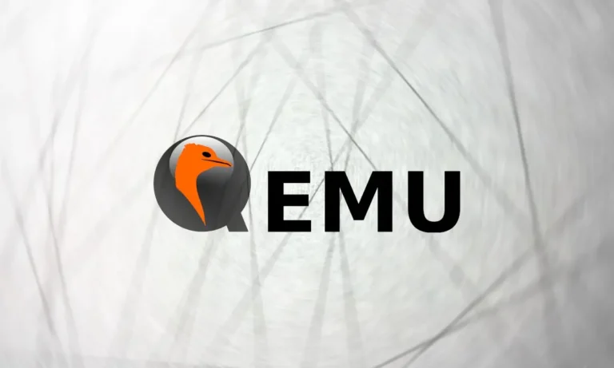
QEMU

Pavankumar Balija | 3/20/25 | QEMU

Table of Contents
Acronym/Abbreviation 2
QEMU (Quick Emulator) 3
What is QEMU? 3
How QEMU Works 3
1. Emulation Mode (Full System Emulation) 3
2. Virtualization Mode (User Mode) 3
Supported Architectures 4
Installation of QEMU 4
Update the package list: 4
Install QEMU: 4
Verify QEMU installation: 4
Deployment of Adaptive Autosar Development Image on QEMU A55 CORE 4
R-Car S4 Virtual Platform (VP) 6
What is the R-Car S4 VP? 6
Why Use R-Car S4 VP? 6
Capability of R CAR S4 VP 6
R-Car S4 VP Architecture Overview 7
Limitations of R CAR S4 VP 8
R CAR S4 VP Setup 8

Acronym/Abbreviation | Definition
RCAR | Renesas Car Application Processor
S4 | Series 4
A55 | ARM Cortex-A55 Processor
EXT4 | Fourth Extended Filesystem, commonly used in Linux
QEMU | Quick Emulator
VP | Virtual Platform
SoC | System-on-Chip

Acronym/Abbreviation

QEMU (Quick Emulator)
QEMU (Quick Emulator) is a powerful, open-source machine emulator and virtualizer that allows you to create and run virtual machines (VMs) on different hardware architectures. It enables developers to simulate real hardware environments for development, debugging, and testing purposes without needing actual hardware.
QEMU is widely used for developing and testing embedded systems, operating systems, and virtualization platforms. It can emulate multiple CPU architectures, peripheral devices, and networking components, making it a versatile tool for software development and testing.
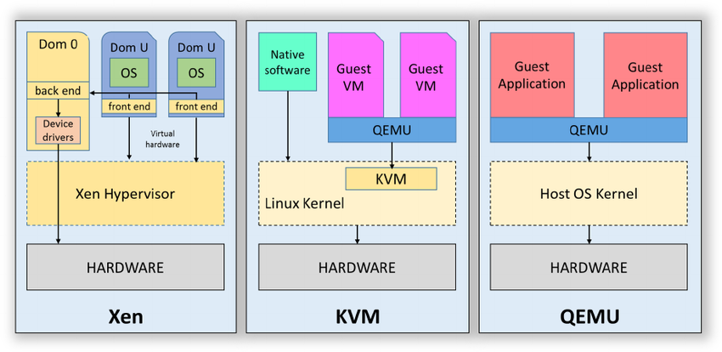

What is QEMU?
QEMU is a cross-platform machine emulator and virtualizer.
It can perform two main tasks:
- Emulation – Imitating a complete hardware environment (CPU, memory, peripherals, etc.).
- Virtualization – Running code natively using CPU virtualization for improved performance.

How QEMU Works
QEMU works in two main modes:

1. Emulation Mode (Full System Emulation)
- QEMU fully emulates the hardware (CPU, memory, peripherals) in software.
- It translates the target architecture’s instructions into the host architecture’s instructions.
- Allows running binaries compiled for one architecture on a different architecture.
✅ Example:
Running ARM-based software on an x86-based machine using QEMU's instruction translation.

2. Virtualization Mode (User Mode)
- QEMU uses KVM (Kernel-based Virtual Machine) or other hypervisors for near-native performance.
- In virtualization mode, QEMU executes guest code directly on the host CPU using hardware-assisted virtualization (Intel VT-x, AMD-V).
- This is faster because it avoids instruction translation.
✅ Example:
Running a Linux VM on a Linux host using KVM.

Supported Architectures
QEMU supports a wide range of CPU architectures:
Architecture | Description
x86 | 32-bit and 64-bit Intel/AMD processors
ARM | 32-bit and 64-bit ARM processors
PowerPC | 32-bit and 64-bit PowerPC processors

Installation of QEMU
Follow these steps to install QEMU on a Linux-based system (like Ubuntu):

Update the package list:
sudo apt-get update

Install QEMU:
This command installs the QEMU system and required dependencies:
sudo apt-get install qemu-system

Verify QEMU installation:
To verify that QEMU is installed correctly:
qemu-system-aarch64 --version

Deployment of Adaptive Autosar Development Image on QEMU A55 CORE
Pre-Requisites:
- QEMU must be installed and available in the system path.
- A valid Adaptive AUTOSAR Development image (.ext4) and kernel image (.bin) should be available.
Execute the Adaptive AUTOSAR Binary Image:
Use the following qemu-system-aarch64 command to execute the Adaptive AUTOSAR development image and kernel:
sudo qemu-system-aarch64 \
-machine virt \ # Use the 'virt' machine type for ARM architecture
-cpu cortex-a55 \ # Use the Cortex-A55 CPU model
-m 512M \ # Allocate 512 MB memory to the VM
-serial mon:stdio \ # Redirect serial output to the terminal
-serial null \ # Discard secondary serial output
-device virtio-net-device,netdev=net0,mac=52:54:00:12:34:02 \ # Create a network device with MAC address
-netdev tap,id=net0,ifname=tap0,script=no,downscript=no \ # Use tap0 for networking
-object rng-random,filename=/dev/urandom,id=rng0 \ # Provide entropy to the VM
-device virtio-rng-pci,rng=rng0 \ # Connect the entropy source
-drive id=disk0,file=core-image-apd-devel-qemuarm64-20241113044050.rootfs.ext4,if=none,format=raw \ # Attach rootfs image
-device virtio-blk-device,drive=disk0 \ # Create a virtio block device for the root filesystem
-device qemu-xhci \ # Enable USB 3.0 controller
-device usb-tablet \ # Enable USB tablet (for mouse support)
-device usb-kbd \ # Enable USB keyboard
-nographic \ # Run in console mode without a graphical display
-kernel apd.bin \ # Load the kernel image
-append 'root=/dev/vda rw mem=1024M ip=192.168.7.2::192.168.7.1:255.255.255.0 console=ttyAMA0 console=hvc0 REDIREC T_TERMINAL=0'

R-Car S4 Virtual Platform (VP)
The R-Car S4 Virtual Platform (VP) is a software-based simulation of the Renesas R-Car S4 SoC. It allows you to develop, test, and validate software for automotive applications without needing physical hardware. The VP simulates the actual R-Car S4 hardware, making it easier to work on early-stage development, debugging, and performance tuning.

What is the R-Car S4 VP?
- The R-Car S4 VP is a QEMU-based virtual platform that models the R-Car S4 SoC.
- It simulates the CPU, memory, peripherals, and communication interfaces of the R-Car S4.
- It allows for full software validation in a controlled environment.

Why Use R-Car S4 VP?
- Early development without hardware
- Faster debugging and validation
- Testing of complex automotive software stacks
- Secure and safe functional validation

Capability of R CAR S4 VP
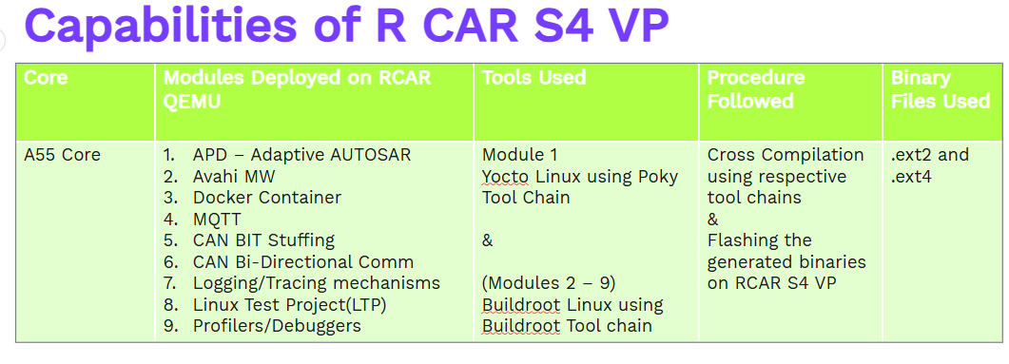

R-Car S4 VP Architecture Overview
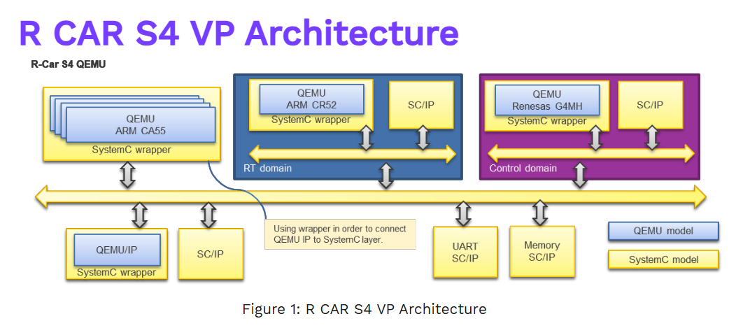

Component | Description
CPU | 4x Cortex-A55 for high-performance processing + 1x Cortex-R52 for real-time processing
Memory | LPDDR4X controller
Graphics | 3D and 2D GPU support
Networking | 10GbE and 1GbE Ethernet, CAN-FD, LIN
CPU | 4x Cortex-A55 for high-performance processing + 1x Cortex-R52 for real-time processing
Memory | LPDDR4X controller
Graphics | 3D and 2D GPU support
Networking | 10GbE and 1GbE Ethernet, CAN-FD, LIN
Security | Hardware Security Module (HSM)
Audio | High-quality audio processing
Virtualization | ARMv8.4-A virtualization support
Safety | ISO 26262 ASIL-D compliant

Limitations of R CAR S4 VP
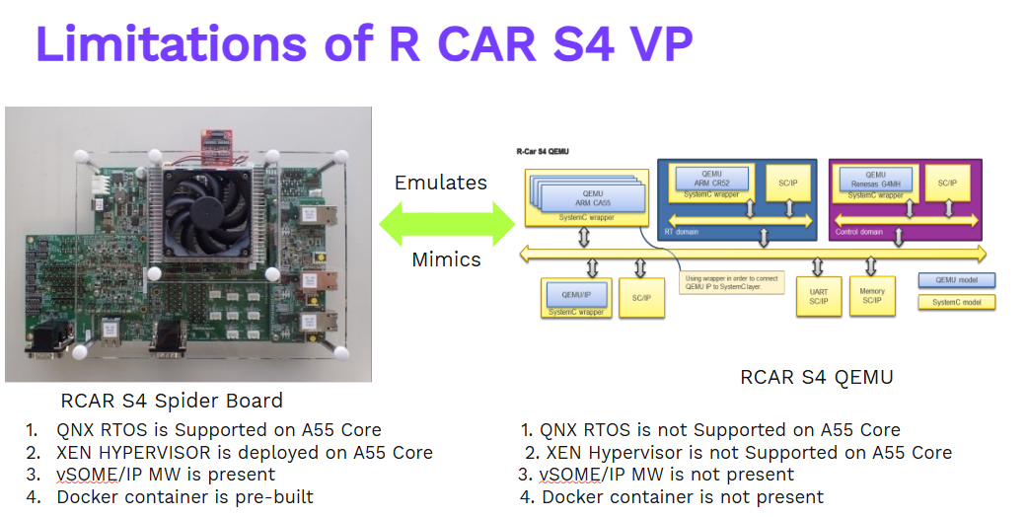

R CAR S4 VP Setup
