
Communication Protocols

Balija Pavan Kumar | 10/14/23 | Protocols

Table of Contents
SOME/IP 3
What is SOME/IP 3
SOME/IP Short Overview 3
Where is SOME/IP Present in the OSI Model? 4
Here are the key details about SOME/IP protocol 4
Understanding how Communication through Ethernet and SOME/IP Works 8
Signal-Based Communication vs Service-Oriented Architecture 10
SOME/IP Workflow in Adaptive AUTOSAR 11
Examples 14
Request / Response 14
Subscribe / Notify 18
SomeIp_Method 21
Advantages of SOME/IP 23
Reference Links: 24
TCP/IP 25
TCP (Transmission Control Protocol) 25
Does TCP/IP Support Multicast? 25
Where is TCP/IP Present in the OSI Model? 25
What Happens When You Send a Message? 26
Why Do We Need TCP/IP? 26
Where is TCP/IP Used? 26
How Much Data Can TCP/IP Support? 27
Limitations of TCP/IP 27
Advantages of TCP/IP 27
How Client-Server Communication Works Over TCP/IP 27
Do Both IP Address and Port Need to Be the Same for Server and Client? 29
What is the Three-Way Handshake? 29
TCP/IP Client & Server Code in C++ 31
UDP 33
UDP (User Datagram Protocol) 33
Does UDP Support Multicast? 33
Where is TCP/IP Present in the OSI Model? 33
What Happens When You Send a UDP Message? 34
Why Do We Need UDP? 34
Where is UDP Used? 34
How Much Data Can UDP Support? 34
Limitations of UDP 35
dvantages of UDP 35
How Client-Server Communication Works Over UDP 35
UDP Handshake? 36
UDP Client & Server Code in C++ 36
Full Comparison: TCP vs UDP vs SOME/IP 38
OSI Model – Full Overview 40

SOME/IP

What is SOME/IP
- SOME/IP stands for Scalable Service-Oriented Middleware over IP and was developed by BMW group in the year 2011.
- SOME/IP is a communication protocol used in automotive and other industries for exchanging data and services between electronic control units (ECUs) and other networked devices within a vehicle or a larger system.
- SOME/IP offers a wide range of middleware features like serialization and Remote Procedure Call (RPC) to enable the ECU software to communicate with each other.
- SOME/IP can be implemented on both OS (Genivi, AUTOSAR, Linux and OSEK) and Non-OS embedded system. In the recent past, it has emerged as the middleware of choice for Adaptive AUTOSAR implementation.
- As already mentioned, the service-oriented architecture makes it easier for the software components over diverse networks to communicate with each other. Therefore, in order for these applications on different networks to understand each other, there has to be some kind of a middleware. Its primary role is to resolve the message format and make it comprehendible to the intended recipient of the message. SOME/IP has been specifically designed for this purpose.
- SOME/IP protocol is designed to support the increasing complexity and connectivity demands of modern automotive systems.

SOME/IP Short Overview
Before we start to implement the introductory example, let's have a short look to the basic structure of the GENIVI implementation of SOME/IP.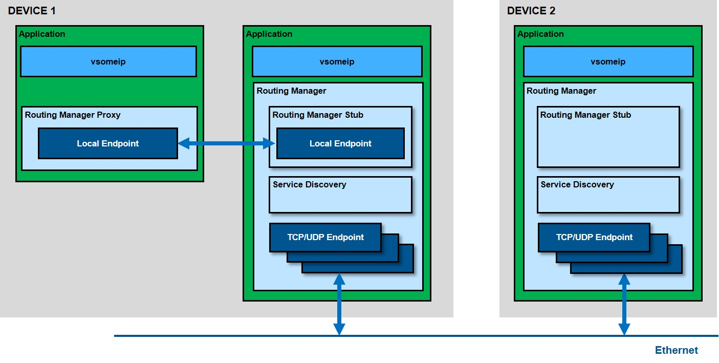
As shown in the picture SOME/IP covers not only the SOME/IP communication between devices (external communication) but also the internal inter process communication. Two devices communicate via so-called communication endpoints which determine the used transport protocol (TCP or UDP) and its parameters as the port number or other parameters. All these parameters are configuration parameters which can be set in a SOME/IP configuration file (json file). The internal communication is done via local endpoints which are implemented by unix domain sockets using the Boost.Asio library. Since this internal communication is not routed via a central component (e.g. like the D-Bus daemon), it is very fast.
The central SOME/IP routing manager gets messages only if they have to be sent to external devices and he distributes the messages coming from outside. There is only one routing manager per device; if nothing is configured the first running SOME/IP application also starts the routing manager.
❗ SOME/IP does not implement the serialization of data structures! This is covered by the SOME/IP binding of CommonAPI. SOME/IP just covers the SOME/IP protocol and the Service Discovery.

Where is SOME/IP Present in the OSI Model?
SOME/IP (Scalable service-Oriented Middleware over IP) is not a transport protocol like TCP or UDP — it's a middleware protocol used primarily in automotive systems, particularly in Adaptive AUTOSAR.
📌 SOME/IP fits at the following levels:
OSI Layer | Role | SOME/IP Position
Application Layer (Layer 7) | User-facing services, interfaces | ✅ SOME/IP Core Functionality
Presentation Layer (Layer 6) | Data encoding, formatting (optional) | (May include encoding like serialization)
Session Layer (Layer 5) | Session control, service discovery | ✅ SOME/IP-SD (Service Discovery)
Transport Layer (Layer 4) | Reliable/Unreliable delivery (TCP/UDP) | ⬇️ Uses TCP or UDP
Network Layer (Layer 3) | IP addressing, routing | ⬇️ IP (underlying layer)
Data Link & Physical Layers | Ethernet, CAN, etc. (hardware transport) | ⬇️ Underlying hardware

Here are the key details about SOME/IP protocol
Origin and Purpose:
SOME/IP was developed by the Automotive Special Interest Group (ASIG), a part of the AUTOSAR (AUTomotive Open System ARchitecture) consortium. It was created to provide a standardized and efficient means of communication between ECUs in modern vehicles. The protocol is designed to support the increasing complexity and connectivity demands of modern automotive systems.
Communication Model:
SOME/IP uses a client-server communication model. ECUs can act as clients that request services or data from server ECUs. The protocol defines how these clients and servers communicate, making it easier to implement a service-oriented architecture (SOA) in automotive systems.
Message Format:
SOME/IP messages are structured using a message header and payload. The message header includes information like message type, service ID, instance ID, method ID, and message length. The payload carries the actual data or parameters being exchanged between clients and servers.
In principle, SOME/IP communication consists of messages sent between devices or subscribers over IP.
Consider the following picture:
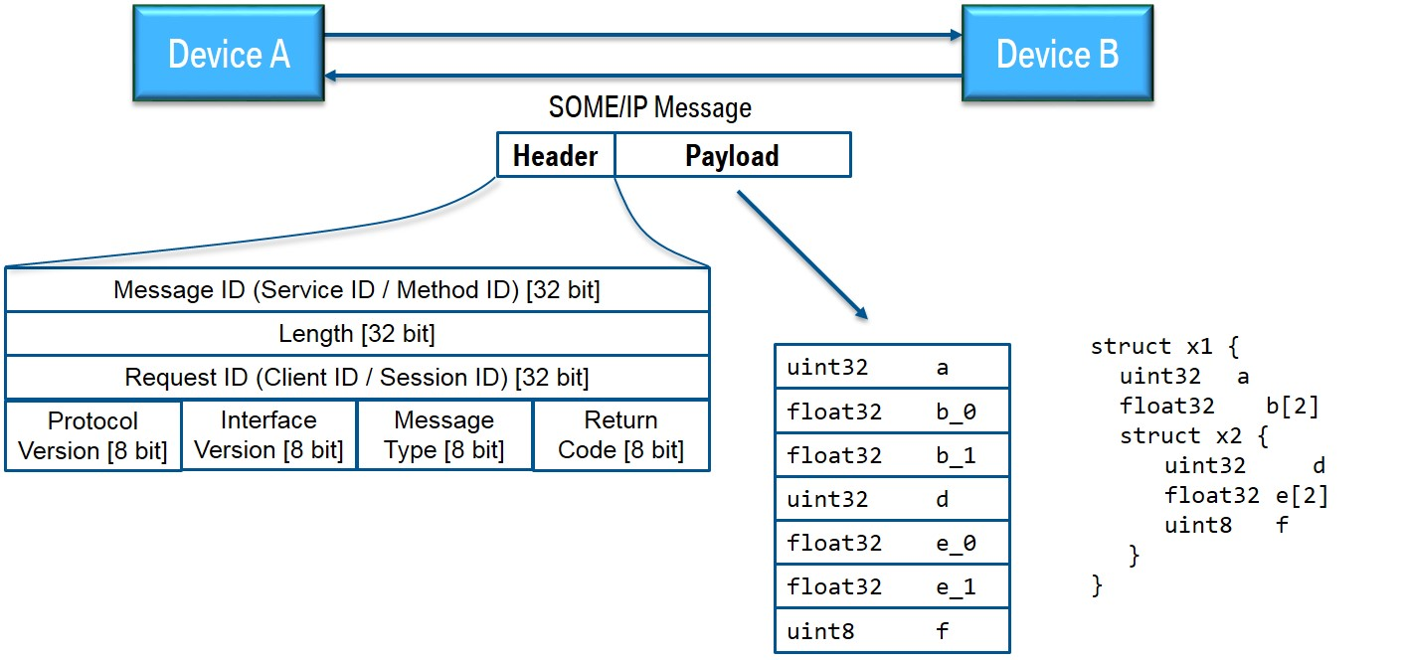
There you see two devices (A and B); Device A sends a SOME/IP message to B and gets one message back. The underlying transport protocol can be TCP or UDP; for the message itself this makes no difference. Now we assume that on device B is running a service which offers a function that is called from device A by this message and the message back is the answer.
SOME/IP messages have two parts: header and payload. In the picture you see that the header consists mainly of identifiers:
Service ID: unique identifier for each service
Method ID: 0-32767 for methods, 32768-65535 for events
Length: length of payload in byte (covers also the next IDs, that means 8 additional bytes)
Client ID: unique identifier for the calling client inside the ECU; has to be unique in the overall vehicle
Session ID: identifier for session handling; has to be incremented for each call
Protocol Version: 0x01
Interface Version: major version of the service interface
Message Type: -- REQUEST (0x00) A request expecting a response (even void) -- REQUEST_NO_RETURN (0x01) A fire & forget request -- NOTIFICATION (0x02) A request of a notification/event call back expecting no response -- RESPONSE (0x80) The response message
Return Code: -- E_OK (0x00) No error occurred -- E_NOT_OK (0x01) An unspecified error occurred -- E_WRONG_INTERFACE_VERSION (0x08) Interface version mismatch -- E_MALFORMED_MESSAGE (0x09) Deserialization error, so that payload cannot be deseria-lized -- E_WRONG_MESSAGE_TYPE (0x0A) An unexpected message type was received (e.g. RE-QUEST_NO_RETURN for a method defined as RE-QUEST)
We see that there are "REQUESTs" and "RESPONSEs" for normal function calls and notification messages for events to which the client has been subscribed. Errors are reported as normal responses or notifications but with an appropriate return code.
The payload contains the serialized data. The picture shows the serialization in the simple case that the transmitted data structure is a nested structure with only base data types. In this case it is easy: the struct elements are just flattened, that means that they are simply written one after the other into the payload.
Transport Layer:
SOME/IP typically operates over the Internet Protocol (IP), either over Ethernet or other network protocols like UDP or TCP/IP. This allows for flexible and scalable communication between ECUs within the same vehicle or even across different vehicles or systems.
In this section mainly 2 points are important and shall be described now:
- The so-called transport bindings (UDP and TCP)
- The basic communication patterns publish/subscribe and request/response.
As mentioned above the underlying transport protocol can be UDP or TCP. In the UDP case the SOME/IP messages are not fragmented; it can be that more than one message is in one UDP packet, but one message cannot be longer than a UDP package can be (up to 1400 Bytes). Bigger messages must be transported via TCP. In this case all the robustness features of TCP are used. If a synchronization error in the TCP stream occurs, the SOME/IP specification allows so-call magic cookies in order to find again the beginning of the next message.
Please note that service interfaces must be instantiated and because there might be several instances of the same interface there must be an additional identifier for the instance defined (instance ID). However, the instance ID is not part of the header of the SOME/IP message. The instance is identified via the port number of the transport protocol; that means that it is not possible that several instances of the same interface are offered on the same port.
Please take now a look at the following picture which shows the basic SOME/IP communication patterns:
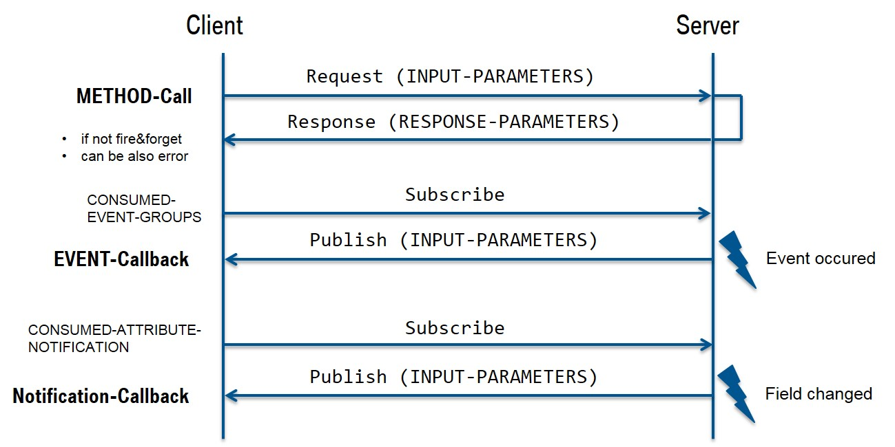
In addition to the standard REQUEST/RESPONSE mechanism for remote procedure calls there is also the PUBLISH/SUBSCRIBE pattern for events. Note that events in the SOME/IP protocol are always grouped in an event group; therefore, it is only possible to subscribe to event groups and not to the event itself. The SOME/IP specification also knows "fields"; in this case the setter/getter methods are following the REQUEST/RESPONSE pattern and notification messages of changes are events. The subscription itself is done via the SOME/IP service discovery.
Service Discovery and Description:
SOME/IP uses service discovery and description mechanisms to make services and their parameters known to other ECUs on the network. This allows clients to discover available services and interact with them. Service discovery can be achieved using a central directory or through multicast announcements.
The SOME/IP Service Discovery is used to locate service instances and to detect if service instances are running as well as implementing the Publish/Subscribe handling. This is mainly done via so-called offer messages; that means that each device broadcasts (multicasts) messages which contain all the services which are offered by this device. SOME/IP SD messages are sent via UDP. If services are required by client applications but at the moment not offered, then also "find messages" can be sent. Other SOME/IP SD messages can be used for publishing or subscribing an event group.
The following picture shows the general structure of a SOME/IP SD message.
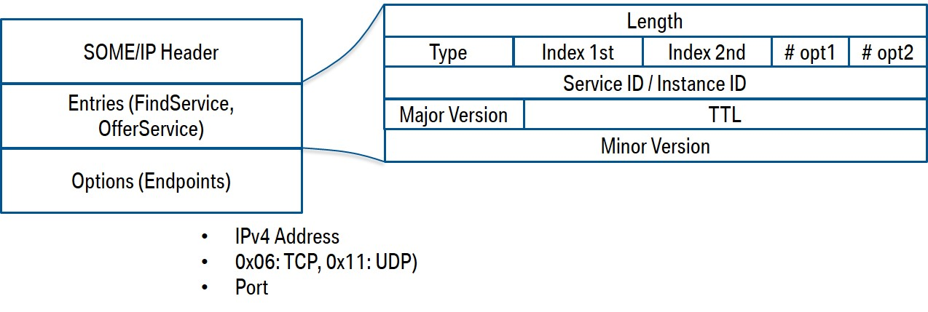
Remote Procedure Call (RPC):
This is a method for remote invocation of functions as requested by the Client ECU. It is a data exchange method employed by the client ECU when it requires some data from a server. An RPC may or may not have a return value, i.e., the client can ask for data as a response or simply call a function to perform some task at the server-end.

Understanding how Communication through Ethernet and SOME/IP Works
Before we start with our exploration, we must understand some terms associated with SOME/IP
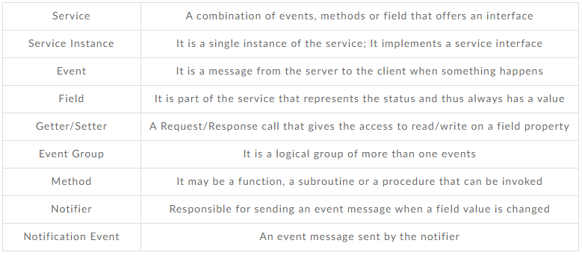
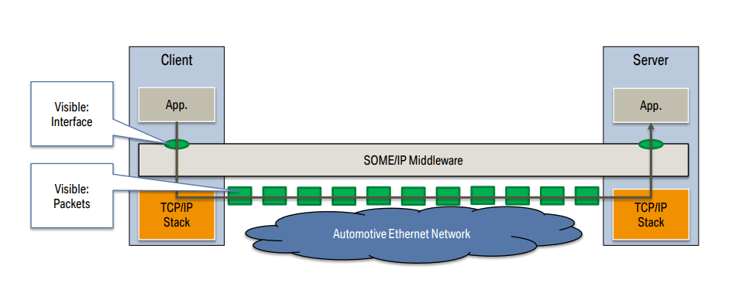
The Server ECU provides a service instance which implements a service interface. The client ECU can use this service instance using SOME/IP to request the required data from the server. The Service Discovery protocol has two mechanisms in place by which a client knows about the available services.
The first mechanism is the ‘Offer Service’ using which the server is able to provide the available services to the network. The other one is ‘Find Service’, which enables the clients to request for the available services.
However, in order for the client to use the service, it has to subscribe to the content on server first.
Using the SOME/IP Service Discovery protocol, a client can send a Subscribe Event group to the server. If the subscription request is valid, the server will respond with a positive acknowledgement and vice-versa.
As the applications inside the ECUs are not tightly coupled in a Service-oriented architecture, multiple clients can subscribe to a service on the server simultaneously. The data can be made available either over UDP or TCP. In case of UDP, data is sent to all the clients who are active subscribers. The data transfer is usually sent via unicast, multicast or broadcast. However, with TCP, the requesting client must establish a connection with the server for data transfer.
While the underlying principle of SOME/IP is based on the client-server architecture where a request by a client is followed by a response from the server, there are several methods/communication patterns for the communication. Let’s have a look at them.
- Request/Response Method
A request is a message sent from the client to the server for calling a function.
Response is the message sent from the server to the client depicting the result of the function invoked by the client
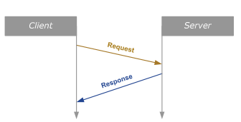
- Fire and Forget Method
A message is sent to the server from the client to call a function
No response is returned from the server
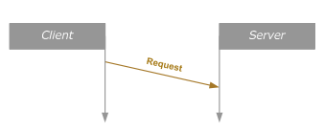
- Services: Event
An event is a callback sent from the server to the client either cyclically or when a change in the server attributes occur
The server notifies about the change only to those clients who have previously subscribed
A notification of event is sent to the client every time the event occurs
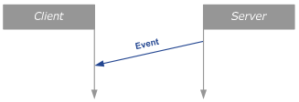
- Services: Field
Field is a property of service that can be remotely accessed using Getters/setters.
Getter is the method to read field value
Setter is the method to set the field value
When a field’s value changes, a notification event is sent out by the notifier.
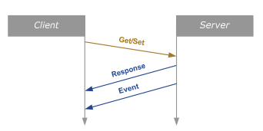

Signal-Based Communication vs Service-Oriented Architecture
🔁 Signal-Based Communication (Used in CAN, LIN, etc.)
- Static Communication: Fixed at design time; assumes software won't change later.
- Broadcasting Data: Sends data whenever it's updated, even if no one needs it.
- Tightly Coupled: Software and hardware are closely linked.
- Common in Traditional ECUs: Ideal for simple, fixed systems.
🌐 Service-Oriented Architecture (SOA) (Used in ADAS, Connected Cars)
- Dynamic Communication: Sends data only when requested by a receiver.
- Flexible & Scalable: New software/services can be added easily.
- Used in Modern Vehicles: Like autonomous or connected cars.
- Uses Ethernet + TCP/UDP + SOME/IP: For fast and structured communication.
- Middleware Needed: Handles remote calls, data formatting, etc.

SOME/IP Workflow in Adaptive AUTOSAR
SOME/IP (Scalable service-Oriented MiddlewarE over IP) is a middleware protocol used in Adaptive AUTOSAR to enable service-oriented communication between applications. It supports dynamic service discovery, communication, and data exchange across the network.
Service Advertisement:
- Service Provider (e.g., navigation system) makes itself available by advertising its services (e.g., GetRoute).
- This is done through a Service Discovery (SD) protocol, where the service sends out an advertisement that it can provide a specific service (e.g., navigation route).
- The advertisement includes information such as the service name, service ID, and available functions or methods that can be called by other applications.
Service Discovery:
- Service Consumers (e.g., infotainment system) discover available services in real time by querying the network for advertisements.
- The consumer identifies the available service, like the navigation service, and establishes communication with the service provider.
- The Service Discovery protocol enables dynamic and on-the-fly discovery of services in the vehicle network, so new ECUs can join the system and find services automatically.
Service Request and Response:
- Once the consumer discovers the service, it can send a request to the service provider.
- For example, the infotainment system sends a request to the navigation service asking for route data.
- The service provider (navigation system) processes the request and sends back a response containing the requested data (e.g., current route).
- Communication can happen using either unicast (one-to-one) or multicast (one-to-many) messaging depending on the use case.
Data Serialization and Deserialization:
- Data exchanged between the service provider and consumer is serialized into a binary format to ensure efficient transmission over the network.
- The data is deserialized at the receiving end to be understood and processed by the application.
Communication Methods:
- SOME/IP supports both unicast (communication between one consumer and one provider) and multicast (communication between one sender and multiple receivers) methods for data transmission.
Key Points:
- Service Advertisement: Services announce their availability to the network.
- Service Discovery: Consumers search for and find available services.
- Service Binding: Consumers establish communication links with the service.
- Request/Response: Consumers request services, and providers send back responses.
- Service Withdrawal: Providers can withdraw their services if unavailable.
In SOME/IP, both TCP and UDP are used, depending on the need for reliability or speed.
- UDP (User Datagram Protocol):
  - Used for Service Discovery (finding services on the network).
  - Faster and more efficient for sending short messages.
  - No guarantee of delivery (some packets may be lost).
  - Used when speed is more important than reliability, like in multicast service advertisements.
- TCP (Transmission Control Protocol):
  - Used for communication between service consumers and providers (e.g., exchanging data).
  - Slower than UDP but ensures that all messages are delivered correctly and in order.
  - Reliable and makes sure no data is lost.
  - Used when reliability is important, such as for large data exchanges or critical services. like in unicast service advertisements.
SOME/IP in Adaptive AUTOSAR Terminology For Communication 🚗📡
Scalable service-Oriented Middleware over IP (SOME/IP) is the key communication protocol in Adaptive AUTOSAR, enabling ECUs (Electronic Control Units) to exchange data dynamically over Ethernet.
Unlike Classic AUTOSAR, which relies on static signal-based communication (CAN, LIN, FlexRay), Adaptive AUTOSAR leverages SOME/IP for dynamic service discovery, remote method invocation, and event-based communication.
🔹 Key Features of SOME/IP in Adaptive AUTOSAR
✔ Service-Oriented Architecture (SOA) → ECUs communicate as services & clients.
✔ Dynamic Service Discovery (SD) → Supports runtime detection of services.
✔ Remote Procedure Call (RPC) → Clients invoke functions on remote ECUs.
✔ Event-Based Communication → ECUs subscribe & receive updates asynchronously.
✔ Uses Ethernet & TCP/IP → Enables high-speed, low-latency data exchange.

SOME/IP Communication Model
SOME/IP follows the Service-Oriented Architecture (SOA), where ECUs are either Service Providers or Service Consumers.
Component Function
Service Provider Offers a service (e.g., "Vehicle Speed Data").
Service Consumer Requests & uses the service (e.g., "Display Unit").
Service Discovery (SD) Dynamically detects available services.
🚗 Example: Vehicle Speed Data Sharing
ECU A (VehicleDataLogger) provides real-time speed data via SOME/IP.
ECU B (Infotainment Unit) subscribes to receive speed updates.
Dynamic Service Discovery (SD) allows the infotainment unit to detect and connect to the VehicleDataLogger at runtime.
Dynamic Service Discovery (SD) in SOME/IP
Unlike Classic AUTOSAR, where communication is pre-defined in ARXML files, Adaptive AUTOSAR supports dynamic service discovery.
🔹 How it Works:
- The Service Provider registers its availability with the Service Discovery (SD) module.
- The Service Consumer queries for available services.
- If the service is found, the consumer subscribes to it dynamically.
Example: SOME/IP Service Discovery Message
[SOME/IP-SD] Service Offered: "SpeedDataService" (ECU A)
[SOME/IP-SD] Service Requested: "SpeedDataService" (ECU B)
[SOME/IP-SD] Connection Established!
✔ This enables flexible, scalable communication in modern automotive systems.
SOME/IP Transport Protocols
SOME/IP supports multiple underlying transport mechanisms:
Protocol Usage
- TCP/IP Reliable, used for critical services.
- UDP/IP Low-latency, used for high-speed sensor data.
- Ethernet Backbone for in-vehicle networking.
SOME/IP vs. Classic AUTOSAR CAN Communication
- Feature SOME/IP (Adaptive AUTOSAR) CAN (Classic AUTOSAR)
- Architecture Service-Oriented Signal-Based
- Communication Ethernet (TCP/UDP) CAN, FlexRay, LIN
- Flexibility Dynamic Service Discovery Predefined Signals
- Data Rate High-Speed (1 Gbps+) Low-Speed (500 Kbps)
- Use Cases Autonomous Driving, OTA Updates Engine Control, ABS

Examples

Request / Response
service-example.cpp with offer and message handler
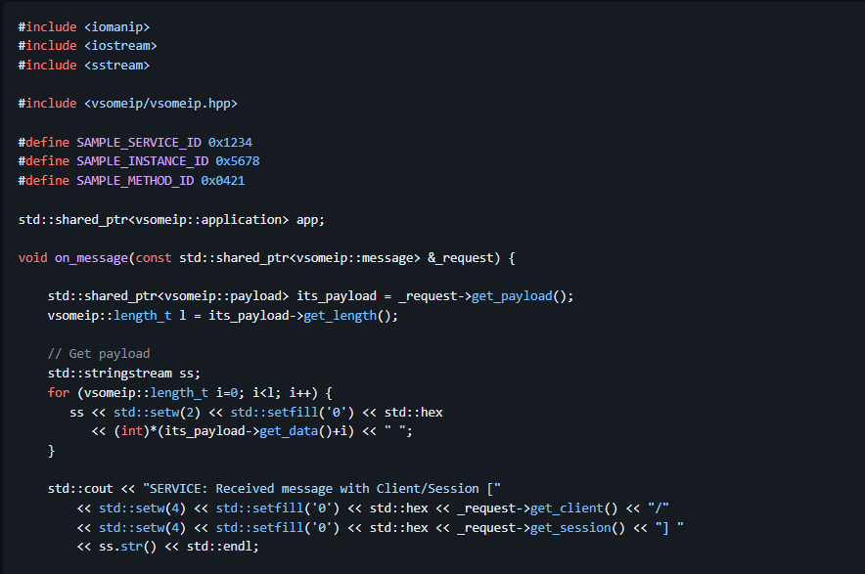
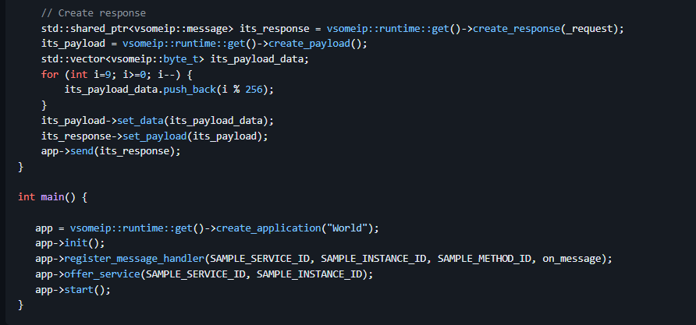

client-example. the message handler and send function
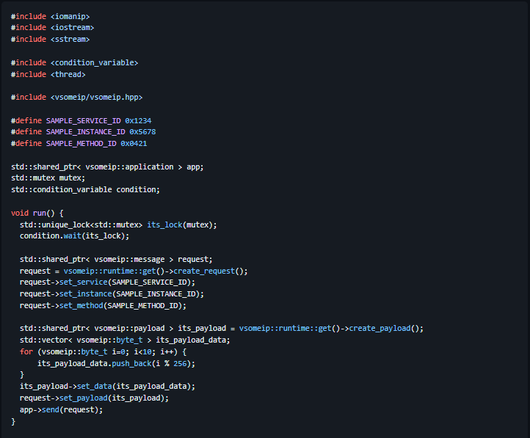
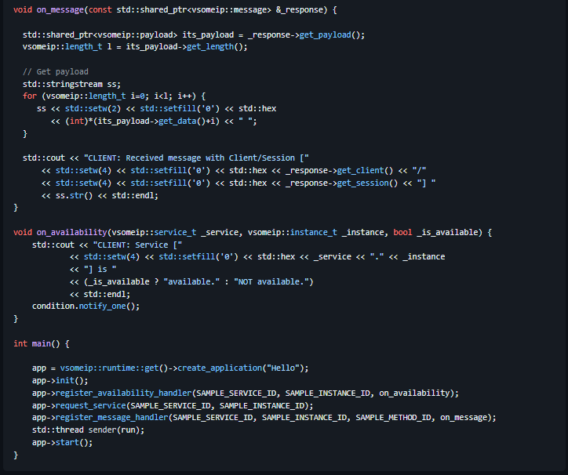

CMakeLists:
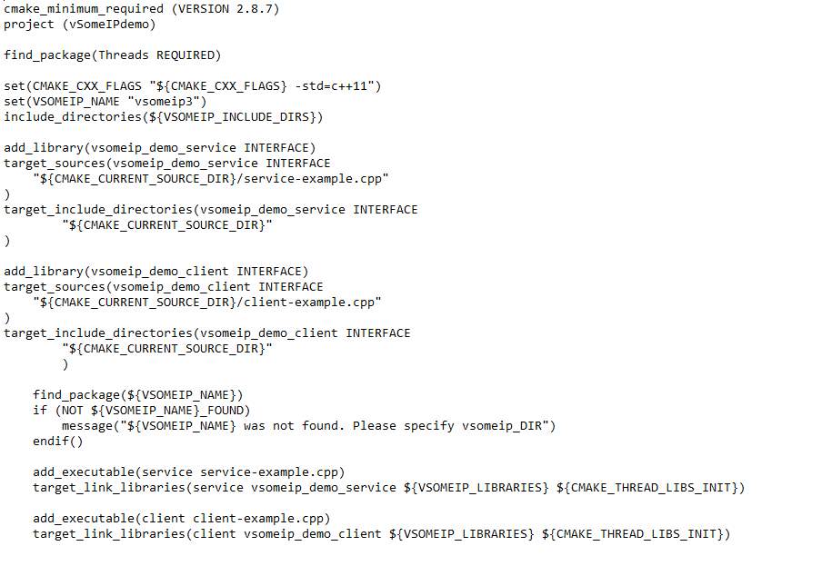
Result:
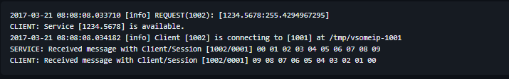
Explanation:
Like on service side we need to register a message handler for receiving the response of our call. In principle it is very easy to create the send message (request). Just get the request object by calling create_request(), set service ID, instance ID and method ID and at the end write the payload with your serialized data. In the example here we write the values from 0 to 9 in the payload (std::vector< vsomeip::byte_t >).
When we try to send our request from the client to the service then we run into a little problem. The application has to be started (app->start()) before we can send the message, because we need a running event-loop in order to process the message. But the method app->start() does not return because it has the running event-loop inside. Therefore we start a thread (run) and wait in this thread for the return of the availability callback before we call app->send(request).
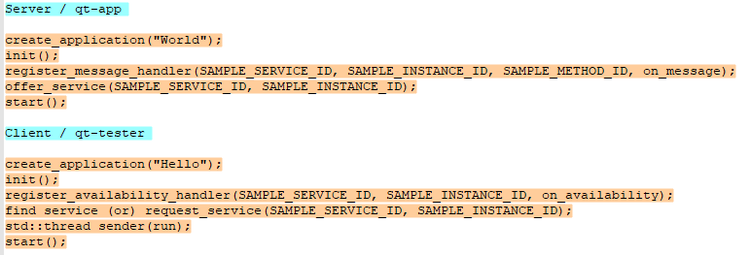

Subscribe / Notify
So far, we have created a service that implements a method and a client that calls this method. But that is not all that is possible. The SOME/IP specification also describes an event handling. That means that application can send events to which subscribers can subscribe if they are interested. Together with the definition of setter and getter methods it is possible to implement services which provide attributes.
Subscribe
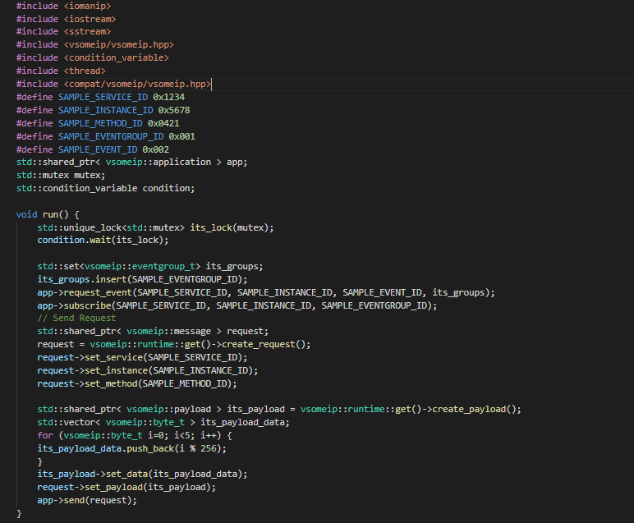
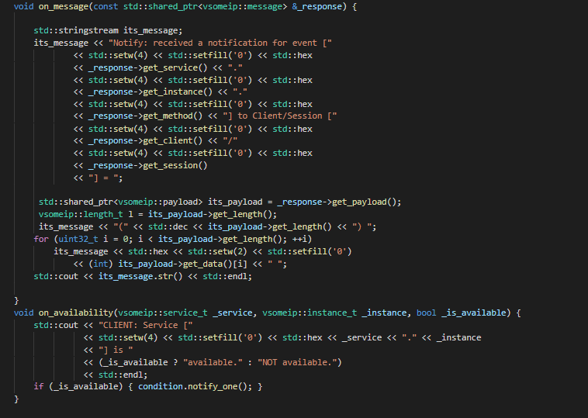
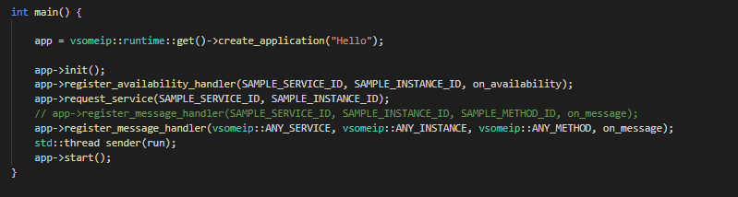

Notify
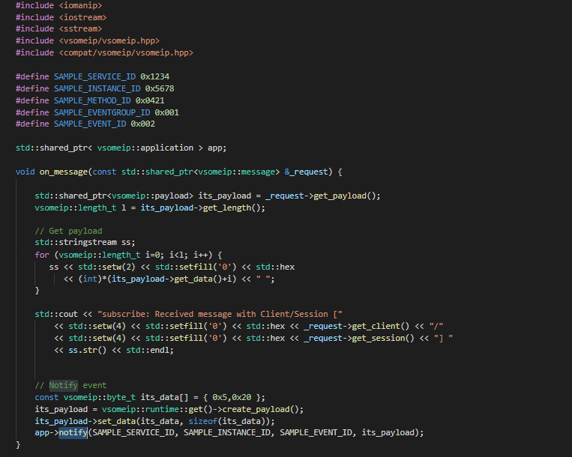
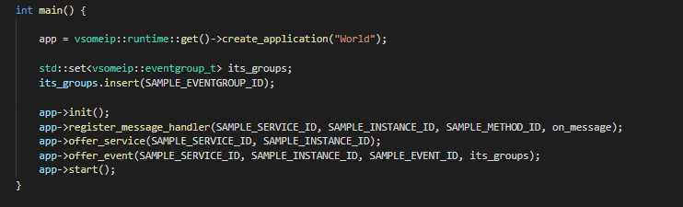

CMakeLists:
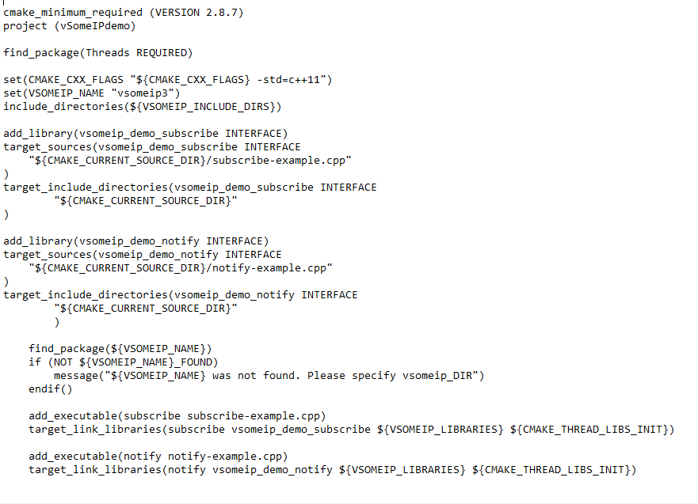

SomeIp_Method
Server:
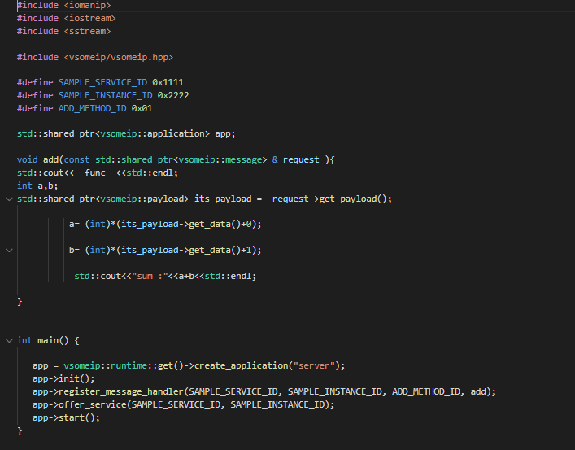
Client:
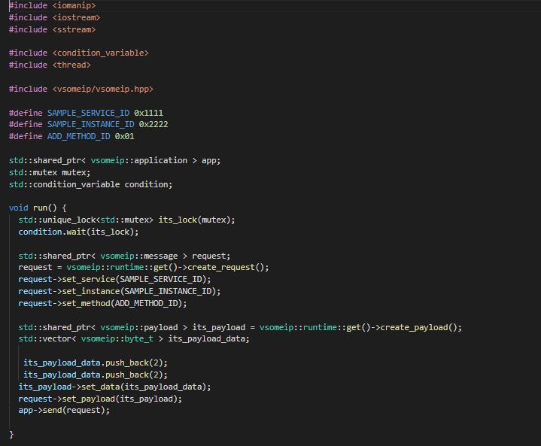
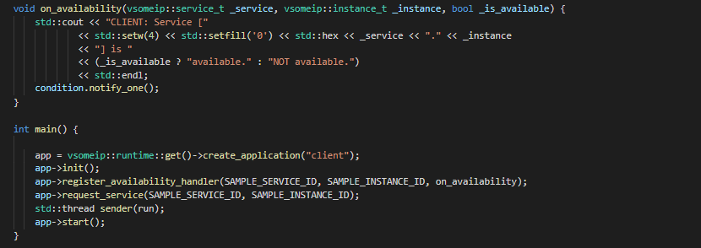

CMakeLists:
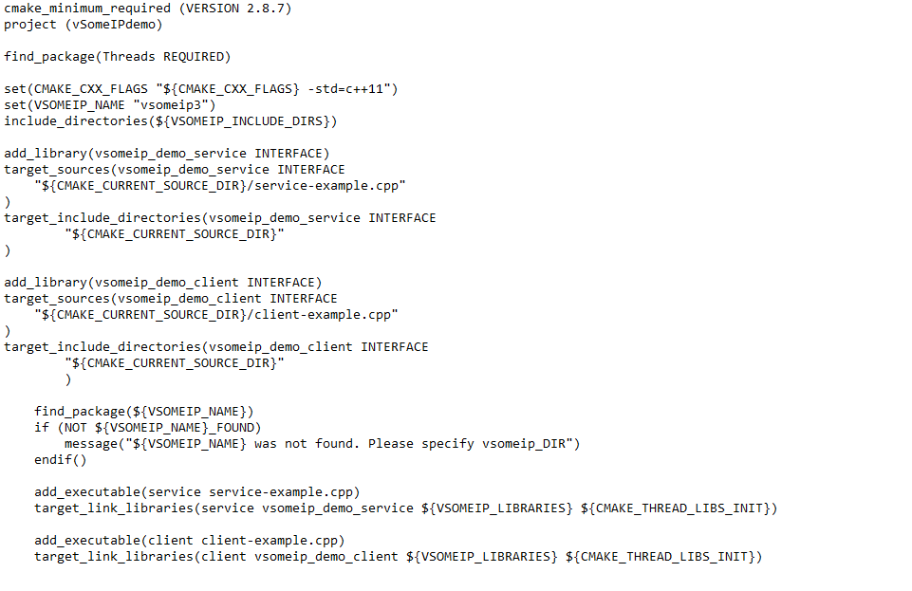

Advantages of SOME/IP
✅ Error Handling – Manages issues like timeouts, unavailable services, and bad requests using error codes.
🔐 Security – Can use secure protocols like TLS or IPsec to protect communication.
📈 Scalability – New services or ECUs can be added without big system changes.
🛠️ Diagnostics & Maintenance – Allows remote health checks, updates, and troubleshooting of ECUs.
📏 Standardization – Defined by AUTOSAR, ensuring all ECUs work well together.
🧩 Service-Oriented Architecture (SOA) – ECUs provide discoverable services, making the system modular.
⚡ Efficiency – Uses lightweight messages and supports unicast/multicast for fast communication.
🌐 Flexibility – Works over Ethernet, TCP, or UDP, adapting to various networks.
⏱️ Real-Time Communication – Supports message priority and timing for time-sensitive data.
💰 Cost-Effective – Reduces hardware/wiring cost by using standard IP networks instead of custom ones like CAN.

Reference Links:
https://github.com/COVESA/vsomeip/wiki/vsomeip-in-10-minutes
https://www.embitel.com/blog/embedded-blog/how-some-ip-enables-service-oriented-architecture-in-ecu-network

TCP/IP

TCP (Transmission Control Protocol)
TCP is a connection-oriented, reliable, and byte-stream protocol used for transport-layer communication in the TCP/IP protocol suite.
It is responsible for delivering data from one application to another across the network in the right order and without data loss.
TCP/IP, short for Transmission Control Protocol / Internet Protocol, is the foundation of all modern networking — from your home Wi-Fi to massive data centres to the Internet itself.
🧠 Think of it like this:
TCP/IP is a communication system — a set of rules (protocols) — that allows two or more devices (like your phone and a server, or two computers) to talk to each other over a network.
It's not just one protocol, but a whole suite of protocols, working together in layers — kind of like how a postal system works:
- You write a letter (application)
- Put it in an envelope (TCP)
- Write an address (IP)
- Hand it to the mail service (Ethernet, Wi-Fi)

Does TCP/IP Support Multicast?
✳️ TCP:
- 🚫 TCP does not support multicast.
- Reason: TCP is connection-oriented and designed for point-to-point communication (1:1).
- It establishes a reliable connection between exactly one sender and one receiver using a handshake mechanism.
- Multicast (1 sender → many receivers) conflicts with TCP’s design model.

Where is TCP/IP Present in the OSI Model?
TCP/IP doesn’t exactly match the OSI model, but it aligns closely:
OSI Layer | TCP/IP Equivalent | Examples
7 - Application | Application Layer | HTTP, FTP, SMTP, DNS
6 - Presentation | (Part of Application Layer)
5 - Session | (Part of Application Layer)
4 - Transport | Transport Layer | TCP, UDP
3 - Network | Internet Layer | IP, ICMP
2 - Data Link | Link Layer | Ethernet, ARP, WiFi
1 - Physical | Hardware Level (also Link Layer) | Cables, Network Cards, etc.
📦 TCP/IP Is Made of Layers
TCP/IP is layered, and each layer has its own job:
Layer | Role 🧩 | Examples 🧪
Application | Software that sends/receives data | HTTP (web), FTP, DNS
Transport | Reliable delivery, error checking | TCP, UDP
Internet | Handles addressing & routing | IP, ICMP, ARP
Link/Network | Sends data physically (cable, Wi-Fi) | Ethernet, Wi-Fi

What Happens When You Send a Message?
Imagine you're visiting a website:
- Your browser uses HTTP to request the page (Application layer).
- The request is handed to TCP, which breaks it into smaller chunks and ensures delivery (Transport layer).
- TCP hands each chunk to IP, which puts your and the server's address on it (Internet layer).
- IP gives it to the network (like Wi-Fi or Ethernet) to physically send it (Network layer).
- On the server side, the same stack works in reverse to reassemble the message.

Why Do We Need TCP/IP?
- ✅ Standardized: Universally accepted protocol suite.
- ✅ Interoperable: Works across different hardware and operating systems.
- ✅ Scalable: Powers everything from small home networks to the global internet.
- ✅ Reliable (TCP): Ensures data arrives in order and without duplication.

Where is TCP/IP Used?
- 🌐 Internet browsing
- 📧 Email communication
- 📡 IoT devices
- 🧠 Client-server architecture (web, DB)
- 🎮 Multiplayer gaming
- 📱 Mobile communications

How Much Data Can TCP/IP Support?
- TCP Segment Size (MSS): Typically around 1460 bytes (depending on MTU - Max Transmission Unit).
- Theoretically: TCP can handle gigabytes of data. It breaks it down into manageable segments and reassembles them.
- Port Range: 65,535 ports per IP address.

Limitations of TCP/IP
Limitation | Description
❌ Complex configuration | Manual IP assignment or subnetting can be hard
❌ Doesn’t guarantee security | Needs additional layers like SSL/TLS
❌ TCP is slower than UDP | Because of reliability overhead
❌ Not designed for real-time | High latency for time-critical apps

Advantages of TCP/IP
Advantage | Description
✅ Reliable | TCP guarantees delivery and order
✅ Scalable | Can be used in small and huge networks
✅ Platform-independent | Works across OS and hardware
✅ Fault-tolerant | Packets can be rerouted in case of failure
✅ Supports multiple routing protocols | Makes internet routing dynamic

How Client-Server Communication Works Over TCP/IP
🧩 Roles:
- Server: Waits for clients to connect. Offers a service (like a webpage, a message, a file).
- Client: Initiates the connection to the server and sends/receives data.
🔄 TCP Communication Steps:
- Server Side:
  - Create a socket
  - Bind it to an IP and port
  - Listen for incoming connections
  - Accept a connection
  - Communicate (send/recv)
  - Close the connection
- Client Side:
  - Create a socket
  - Connect to the server’s IP and port
  - Communicate (send/recv)
  - Close the connection
Server Workflow (tcp_server.cpp)
Step-by-step Flow:
[1] Create socket
[2] Bind to port 8080
[3] Listen for connection
[4] Accept client
[5] Read client's message
[6] Send response
🔁 Visual Summary:
+-------------------+
| TCP Server |
|-------------------|
| [socket()] | ← create socket
| [bind()] | ← bind to IP:Port
| [listen()] | ← wait for clients
| [accept()] | ← accept client
| [read()] | ← get message
| [send()] | ← reply
+-------------------+
Sample Output:
Server waiting for client...
Client says: Hello from client!

Client Workflow (tcp_client.cpp)
Step-by-step Flow:
[1] Create socket
[2] Set IP and Port
[3] Connect to server
[4] Send message
[5] Receive reply
🔁Visual Summary:
+-------------------+
| TCP Client |
|-------------------|
| [socket()] | ← create socket
| [connect()] | ← connect to server
| [send()] | ← say hello
| [read()] | ← get response
+-------------------+
Sample Output:
Server says: Hello from server!

Do Both IP Address and Port Need to Be the Same for Server and Client?
- IP Address: The client’s IP address does not need to match the server's IP address. The server has its own IP (either public or local), and the client connects to the server via this IP. The client can be located on the same local network or across the internet (using public IPs).
  - For Local Communication: If both client and server are on the same machine, they can use localhost or 127.0.0.1 as the IP address.
  - For Remote Communication: If they are on different machines, the client must use the server's public or private IP address.
- Port Number: The port number must be the same on both the server and the client to establish communication. If the server is listening on port 8080, the client must connect to the server on port 8080.
Example:
- Server (IP: 192.168.1.10, Port: 8080)
  - The server listens on IP 192.168.1.10 and port 8080.
- Client (Server IP: 192.168.1.10, Port: 8080)
  - The client must specify the same IP (192.168.1.10) and same port (8080) to connect to the server.

What is the Three-Way Handshake?
The Three-Way Handshake is a process used by the TCP protocol to establish a reliable connection between a client and a server before any actual data is transmitted.
This process ensures that both parties are ready to communicate and that the connection parameters (like sequence numbers) are agreed upon.
🔁 Why is the Three-Way Handshake Needed?
- To synchronize sequence numbers for both client and server
- To establish reliability and track each segment
- To make sure both client and server are online and ready
🧭 Step-by-Step Explanation:
🧑‍💻 1. Client Sends SYN (synchronize)
Client → Server
SYN → // "Hey, I want to start a connection!"
- Client sends a TCP packet with the SYN flag set.
- It includes an initial sequence number (say, Seq=1000).
- This tells the server: "I want to connect and start sending data, starting with sequence 1000."
🖥️ 2. Server Replies with SYN-ACK
← SYN+ACK // "Sure! Let's sync and I’m ready too!"
- Server responds with a SYN + ACK packet.
- It acknowledges the client’s sequence number (ACK=1001, i.e., client_seq + 1).
- And it also sends its own sequence number (say, Seq=3000) to initiate a return connection.
🙋‍♂️ 3. Client Sends ACK
Client → Server
ACK → // "Great, I got your message. Let's start!"
- Client sends a final ACK:
  - Acknowledges server's sequence number: ACK=3001 (i.e., server_seq + 1)
- Now both client and server have:
  - Exchanged sequence numbers ✅
  - Confirmed readiness ✅
🎉 Connection is now established!
📊 Example with Numbers
Client → SYN (Seq=1000)
Server ← SYN+ACK (Seq=3000, ACK=1001)
Client → ACK (ACK=3001)

TCP/IP Client & Server Code in C++
✅ TCP Server (C++)
// tcp_server.cpp
#include <iostream>
#include <sys/socket.h>
#include <netinet/in.h>
#include <unistd.h>
#include <cstring>

int main() {
int server_fd, new_socket;
struct sockaddr_in address;
int port = 8080;
char buffer[1024] = {0};

server_fd = socket(AF_INET, SOCK_STREAM, 0);
address.sin_family = AF_INET;
address.sin_addr.s_addr = INADDR_ANY;
address.sin_port = htons(port);

bind(server_fd, (struct sockaddr*)&address, sizeof(address));
listen(server_fd, 3);

std::cout << "Server listening on port " << port << "...\n";
socklen_t addrlen = sizeof(address);
new_socket = accept(server_fd, (struct sockaddr*)&address, &addrlen);

read(new_socket, buffer, 1024);
std::cout << "Client: " << buffer << "\n";
send(new_socket, "Hello from server", strlen("Hello from server"), 0);

close(new_socket);
close(server_fd);
return 0;
}

✅ TCP Client (C++)
// tcp_client.cpp
#include <iostream>
#include <sys/socket.h>
#include <arpa/inet.h>
#include <unistd.h>
#include <cstring>

int main() {
int sock = socket(AF_INET, SOCK_STREAM, 0);
struct sockaddr_in serv_addr;
char buffer[1024] = {0};

serv_addr.sin_family = AF_INET;
serv_addr.sin_port = htons(8080);
inet_pton(AF_INET, "127.0.0.1", &serv_addr.sin_addr);

connect(sock, (struct sockaddr*)&serv_addr, sizeof(serv_addr));
send(sock, "Hello from client", strlen("Hello from client"), 0);
read(sock, buffer, 1024);
std::cout << "Server: " << buffer << "\n";

close(sock);
return 0;
}
How to Compile and Run:
g++ tcp_server.cpp -o server
g++ tcp_client.cpp -o client
Then:
- Run the server: ./server
- In another terminal, run the client: ./client

UDP

UDP (User Datagram Protocol)
UDP is a connectionless, lightweight transport layer protocol. Unlike TCP, UDP does not establish a connection before sending data, and does not guarantee delivery, ordering, or error checking — making it much faster and more efficient in certain scenarios.
🔹 Think of it Like This:
📦 Imagine you're sending letters using a regular mailbox (UDP), versus using a courier with tracking and confirmation (TCP).
- With UDP, you drop the message in the mailbox and hope it gets delivered.
- No one confirms it arrived.
- No one checks if it got lost or mixed up.

Does UDP Support Multicast?
✅ UDP:
- ✅ UDP supports multicast.
- Reason: UDP is connectionless, doesn’t maintain a session, and is more flexible.
- You can send a UDP datagram to a multicast IP address (e.g., 224.0.0.1 to 239.255.255.255) and it will be received by multiple subscribed receivers.

Where is TCP/IP Present in the OSI Model?
TCP/IP doesn’t exactly match the OSI model, but it aligns closely:
OSI Layer | TCP/IP Equivalent | Examples
7 - Application | Application Layer | HTTP, FTP, SMTP, DNS
6 - Presentation | (Part of Application Layer)
5 - Session | (Part of Application Layer)
4 - Transport | Transport Layer | TCP, UDP
3 - Network | Internet Layer | IP, ICMP
2 - Data Link | Link Layer | Ethernet, ARP, WiFi
1 - Physical | Hardware Level (also Link Layer) | Cables, Network Cards, etc.

📦 TCP/IP Is Made of Layers
- TCP/IP is layered, and each layer has its own job:
Layer | Role 🧩 | Examples 🧪
Application | Software that sends/receives data | HTTP (web), FTP, DNS
Transport | Reliable delivery, error checking | TCP, UDP
Internet | Handles addressing & routing | IP, ICMP, ARP
Link/Network | Sends data physically (cable, Wi-Fi) | Ethernet, Wi-Fi

What Happens When You Send a UDP Message?
- Application prepares data (e.g., "Hello").
- UDP adds a header (source & destination port, length, checksum).
- IP wraps it with IP addresses.
- It’s sent over the network (Ethernet, WiFi, etc.).
- Receiver extracts layers and passes data to the app.

Why Do We Need UDP?
UDP is perfect when:
- Speed is more important than reliability
- No need to re-transmit or guarantee delivery
- Examples: Streaming, VoIP, Online Gaming, DNS

Where is UDP Used?
UDP is perfect when speed is more important than accuracy:
- 🎮 Online multiplayer games (fast, low-latency)
- 📹 Video streaming (like YouTube, Netflix live)
- 🗣️ Voice over IP (VoIP, Skype, Zoom)
- 📡 DNS queries (Domain name lookups)
- 📻 Broadcast and multicast communications

How Much Data Can UDP Support?
- UDP payload (data part): Up to 65,507 bytes
  - (Max UDP datagram: 65,535 bytes - 8 byte UDP header - 20 byte IP header)

Limitations of UDP
Limitation | Description
❌ No Reliability | No acknowledgment, retransmission
❌ No Ordering | Packets may arrive out of order
❌ No Congestion Control | Can flood the network
❌ No Handshake | No setup means more risk for data loss

dvantages of UDP
Advantage | Description
⚡ Faster | No connection overhead
🧠 Simple | Smaller header, simple protocol
🔁 Broadcast | Easily sends to multiple clients
📉 Low Overhead | Ideal for real-time applications

How Client-Server Communication Works Over UDP
Unlike TCP, UDP doesn't establish a connection — both client and server just send datagrams.
🔄 UDP Communication Steps:
1. Server Side:
- Create a UDP socket
- Bind it to an IP and port
- Wait for incoming datagrams using recvfrom()
- Respond using sendto()
2. Client Side:
- Create a UDP socket
- Send message using sendto()
- Wait for response using recvfrom()

Visual Summary:
Client (UDP) Server (UDP)
| |
| ---- "Hello Server" ------------>|
| |
| <------- "Hello Client" ---------|
| |
No handshake, no connection. Just fire-and-forget messages.

UDP Handshake?
There is NO handshake in UDP!
UDP is connectionless, meaning it just sends packets without establishing a reliable session.

UDP Client & Server Code in C++
UDP Server Code (C++)
#include <iostream>
#include <unistd.h> // For close()
#include <cstring> // For memset(), strlen()
#include <arpa/inet.h> // For socket functions and sockaddr_in

int main() {
int sockfd;
char buffer[1024];
sockaddr_in servaddr{}, cliaddr{};
socklen_t len;

// 1. Create a UDP socket
// AF_INET = IPv4, SOCK_DGRAM = UDP, 0 = default protocol
sockfd = socket(AF_INET, SOCK_DGRAM, 0);

// 2. Set up server address
servaddr.sin_family = AF_INET; // IPv4
servaddr.sin_addr.s_addr = INADDR_ANY; // Listen on all interfaces
servaddr.sin_port = htons(8080); // Port number (host to network short)

// 3. Bind the socket to the server address
bind(sockfd, (const struct sockaddr *)&servaddr, sizeof(servaddr));

std::cout << "UDP Server is listening...\n";

// 4. Receive data from client
len = sizeof(cliaddr); // Must set this before receiving
int n = recvfrom(
sockfd, buffer, sizeof(buffer), 0,
(struct sockaddr *)&cliaddr, &len
);

buffer[n] = '\0'; // Null-terminate the received message

std::cout << "Client says: " << buffer << "\n";

// 5. Send a response back to the client
const char *response = "Hello from UDP server!";
sendto(
sockfd, response, strlen(response), 0,
(const struct sockaddr *)&cliaddr, len
);

// 6. Close the socket
close(sockfd);
return 0;
}

UDP Client Code (C++)

#include <iostream>
#include <unistd.h> // For close()
#include <cstring> // For memset(), strlen()
#include <arpa/inet.h> // For socket functions and sockaddr_in

int main() {
int sockfd;
char buffer[1024];
sockaddr_in servaddr{};
socklen_t len;

// 1. Create a UDP socket
sockfd = socket(AF_INET, SOCK_DGRAM, 0);

// 2. Set up server address to send data to
servaddr.sin_family = AF_INET; // IPv4
servaddr.sin_port = htons(8080); // Port number (must match server)
inet_pton(AF_INET, "127.0.0.1", &servaddr.sin_addr); // Convert IP to binary form

// 3. Send a message to the server
const char *msg = "Hello from UDP client!";
sendto(
sockfd, msg, strlen(msg), 0,
(const struct sockaddr *)&servaddr, sizeof(servaddr)
);

// 4. Receive response from server
int n = recvfrom(
sockfd, buffer, sizeof(buffer), 0,
(struct sockaddr *)&servaddr, &len
);
buffer[n] = '\0'; // Null-terminate the message

std::cout << "Server says: " << buffer << "\n";

// 5. Close the socket
close(sockfd);
return 0;
}

⚙️ How to Compile and Run:
g++ udp_server.cpp -o udp_server
g++ udp_client.cpp -o udp_client
# Terminal 1
./udp_server
# Terminal 2
./udp_client

Full Comparison: TCP vs UDP vs SOME/IP
Feature / Aspect | TCP (Transmission Control Protocol) | UDP (User Datagram Protocol) | SOME/IP (Scalable service-Oriented Middleware over IP)
Type | Connection-oriented | Connectionless | Service-oriented middleware built on TCP/UDP
Protocol Layer | Transport Layer (OSI Layer 4) | Transport Layer (OSI Layer 4) | Application Layer (AUTOSAR Layered Architecture)
Connection Establishment | Yes (3-way handshake) | No | Optional (based on TCP/UDP transport)
Reliability | Reliable – ensures delivery | Unreliable – best-effort | Optional – depends on TCP (reliable) or UDP (unreliable)
Ordering of Packets | Guaranteed | Not guaranteed | Handled via underlying protocol (TCP/UDP)
Error Checking | Checksum + ACK + retransmit | Checksum only | Custom error checks based on configuration
Flow Control | Yes (sliding window, ACKs) | No | Depends on transport layer (TCP = yes, UDP = no)
Congestion Control | Yes | No | If TCP used → Yes; if UDP → No
Header Size | Large (20–60 bytes) | Small (8 bytes) | Larger (more metadata: service ID, method ID, etc.)
Speed / Latency | Slower due to overhead | Faster – minimal overhead | Moderate – overhead due to service/message structure
Streaming / Real-time | Not ideal | Ideal | Yes (via SOME/IP-TP or raw SOME/IP over UDP)
Use Cases | Web, email, FTP | DNS, VoIP, video, games | Automotive communication (ECU to ECU, Adaptive AUTOSAR)
Data Transmission | Stream-based | Datagram-based | Message-based (structured service method/events)
Acknowledgments | Yes | No | Optional (based on TCP/UDP use)
Retransmission on Loss | Yes | No | Optional (TCP-based = yes)
Packet Duplication Handling | Yes | No | TCP-based = Yes; UDP = No
Bandwidth Usage | Higher due to extra features | Low | Higher than UDP; depends on message size
Security Features | Can be used with TLS/SSL | Rare, must be added manually | TLS can be used (e.g., via Secure TCP stack)
Transmission Mechanism | Needs connection | Send and forget | Service request/response or event-based communication
Connection State | Maintains connection state | Stateless | Stateful (maintains service sessions, event subscriptions)
Broadcasting Support | Not supported | Supported | Not typically used; relies on Multicast for SD
Multicasting Support | Not supported | Supported | ✅ Used in Service Discovery (SOME/IP-SD over UDP)
Suitability for File Transfer | ✅ Best fit | ❌ Not recommended | ❌ Not used for file transfer
Suitability for Voice/Video | ❌ Too slow | ✅ Best fit | ✅ Event-based messaging can suit real-time needs
Protocol Number (IP Layer) | 6 | 17 | Built on 6 (TCP) or 17 (UDP)
Service Discovery | ❌ Manual configuration | ❌ Manual configuration | ✅ Yes (via SOME/IP-SD)
Data Format | Raw Bytes | Raw Bytes | Structured with headers: Service ID, Method ID, Payload
Automotive Usage | Rare | Sometimes (e.g., diagnostics) | ✅ Standard in Adaptive AUTOSAR stack

OSI Model – Full Overview
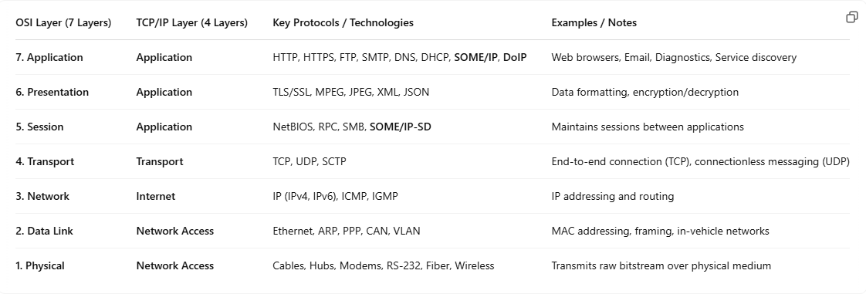

Parent and Child Processes in Linux
In Linux, when a process creates a new process, it becomes the parent process, and the new process is called the child process. This relationship is established using system calls like fork(), where the parent creates a child process by duplicating its own memory and execution context.
Here’s a breakdown of parent-child process concepts in Linux:
What is a Parent Process?
- The process that creates another process is called the parent.
- It uses fork() to create a new process, which is called the child.
- The parent is responsible for the overall control of its child process.
What is a Child Process?
- A child process is created by the parent process using fork().
- The child gets an identical copy of the parent’s data, but with a different PID (Process ID).
- The child may execute different code from the parent after the fork using exec().
How to Create Parent and Child Processes?
Fork System Call
- The fork() system call is used by the parent process to create a child process.
- It returns two values:
  - 0 in the child process (the newly created process).
  - The PID of the child process in the parent.
Parent-Child Relationship
The parent process continues running after fork(), and the child process starts its own execution.
Example Code in C++ for Parent-Child Relationship
#include <iostream>
#include <unistd.h> // for fork()
#include <sys/types.h> // for pid_t

int main() {
pid_t pid = fork(); // Create child process

if (pid == 0) {
// This block is executed by the child process
std::cout << "I am the child process. My PID is " << getpid() << " and my parent PID is " << getppid() << std::endl;
} else if (pid > 0) {
// This block is executed by the parent process
std::cout << "I am the parent process. My PID is " << getpid() << " and I created a child with PID " << pid << std::endl;
} else {
std::cerr << "Fork failed!" << std::endl;
return 1;
}

return 0;
}
Output:
I am the parent process. My PID is 5578 and I created a child with PID 5582
I am the child process. My PID is 5582 and my parent PID is 5578

Inter-Process Communication (IPC)

Defination
Inter-Process Communication (IPC) refers to the set of mechanisms that allow processes to communicate and coordinate with each other. In a multitasking operating system, processes are often isolated and run independently, so IPC enables them to share data and synchronize their activities.

Why IPC is Needed
- To exchange data between processes.
- To synchronize execution (e.g., one process waits for another to finish).
- To avoid race conditions and ensure data consistency.
- To allow modular software design (e.g., client-server model).

Common IPC Mechanisms
IPC Mechanism | Description
Pipes (Anonymous and Named) | Unidirectional or bidirectional data stream between processes.
Message Queues | Processes send and receive structured messages via a queue.
Shared Memory | Fastest IPC method; memory region is shared between processes.
Semaphores | Synchronization tool for managing shared resource access.
Sockets | Used for communication over a network or between unrelated processes.
Signals | Notify a process that a specific event has occurred.
Files and Memory-Mapped Files | Indirect communication using the file system.

​Inter-Process Communication (IPC) encompasses various mechanisms that allow processes to communicate and synchronize their actions.
Below is an overview of common IPC mechanisms, along with simple C++ examples for each:​

Pipes (Anonymous)

Defination:
An anonymous pipe is a unidirectional (one-way) communication channel used for interprocess communication (IPC) between a parent process and its child process. It allows one process to write data to the pipe, and the other to read it.
- Anonymous means it exists only while the processes are running—no file is created.
- Unidirectional means data flows in only one direction: either from parent to child or child to parent, not both (unless you create two pipes).
- It is created using the pipe() system call.

Why Use Pipes?
- To share data between parent and child processes without using external files.
- Lightweight and fast compared to sockets or shared memory for simple data exchange.
- Ideal for producer-consumer type scenarios.

System Calls & Functions Used
- pipe(int fd[2]): Creates a pipe with two file descriptors:
  - fd[0]: read end
  - fd[1]: write end
- fork(): Creates a child process.
- read(): Reads data from file descriptor.
- write(): Writes data to file descriptor.

Example of pipe:
#include <iostream> // For standard I/O like std::cout
#include <unistd.h> // For pipe(), fork(), read(), write()
#include <cstring> // For strlen()

int main() {
int fd[2]; // File descriptors: fd[0] = read end, fd[1] = write end

pipe(fd); // Create the pipe. After this, fd[0] and fd[1] are connected

pid_t pid = fork(); // Create child process. Both parent and child continue from here

if (pid == 0) { // This block runs in the child process
close(fd[1]); // Child doesn't write, so close write end
char buffer[100]; // Buffer to store received message

read(fd[0], buffer, sizeof(buffer)); // Read from pipe
std::cout << "Child received: " << buffer << std::endl;

close(fd[0]); // Close read end after use
} else { // This block runs in the parent process
close(fd[0]); // Parent doesn't read, so close read end

const char* msg = "Hello from parent"; // Message to send
write(fd[1], msg, strlen(msg) + 1); // +1 to send null terminator
close(fd[1]); // Close write end after sending
}
return 0;
}
Output:
Child received: Hello from parent

Where Are Pipes Used?
- Command pipelines in shell (ls | grep .cpp)
- IPC between parent and child processes in OS-level programs
- Producer-consumer problems in concurrent applications
- Process synchronization and data transfer

Advantages of Pipes
- Simple: Easy to implement and understand
- Fast: Lightweight IPC mechanism
- No files needed: Uses memory, not disk
- Secure: Only related processes can access it

Limitations of Pipes
- Unidirectional: For two-way communication, need two pipes
- Parent-child only: Typically used between related processes
- No persistence: Data lost once processes exit
- Fixed buffer size: OS defines maximum pipe buffer size

Named Pipes (FIFOs)

Defination:
A Named Pipe (or FIFO – First In, First Out) is a special type of file that exists in the file system and allows unrelated processes (not just parent-child) to communicate by reading from and writing to this file.
Unlike anonymous pipes (pipe(fd)), named pipes have a name in the filesystem (/tmp/myfifo) and can be used by any process that knows the path.

Why Use FIFO:
- Communicates Between Unrelated Processes
→ Unlike pipe(), FIFO works between any two separate programs.
- Uses a File Path (e.g., /tmp/myfifo)
→ Easy to access, debug, and share.
- Works Across Terminals
→ One terminal can write, another can read.
- Cross-Language Support
→ One process in C++, the other in Python, Bash, etc.
- Simple to Create and Use
→ Just mkfifo() and open() — no complex setup.
- Useful for Background Services (Daemons)
→ A service can keep reading data from a FIFO.
- No Need for Parent-Child Relationship
→ Processes don’t have to be related (unlike anonymous pipe).

System Calls & Functions Used
Function | Purpose
mkfifo(path, mode) | Creates a named pipe (FIFO) file at the given path
open(path, flags) | Opens the FIFO file (read or write mode)
read(fd, buf, size) | Reads data from FIFO
write(fd, buf, size) | Writes data into FIFO
close(fd) | Closes the file descriptor

Example of FIFO:
Writer Program (writer.cpp)
#include <iostream> // For std::cout
#include <fcntl.h> // For open() flags
#include <sys/stat.h> // For mkfifo()
#include <unistd.h> // For read(), write(), close(), fork()
#include <cstring> // For strlen()

int main() {
const char* fifoPath = "/tmp/myfifo";

// 1. Create a named pipe (FIFO)
// mkfifo() creates a FIFO special file with given permissions
// 0666 = rw-rw-rw- (read/write permission to everyone)
mkfifo(fifoPath, 0666);

// Open FIFO for writing
int fd = open(fifoPath, O_WRONLY); // blocks until reader opens

if (fd < 0) {
perror("Writer: Failed to open FIFO");
return 1;
}

const char* msg = "Hello from writer";
write(fd, msg, strlen(msg) + 1); // +1 to send null-terminator
std::cout << "Writer sent: " << msg << std::endl;

close(fd);
return 0;
}

Reader Program (reader.cpp)
#include <iostream> // For std::cout
#include <fcntl.h> // For open() flags
#include <sys/stat.h> // For mkfifo()
#include <unistd.h> // For read(), write(), close(), fork()
#include <cstring> // For strlen()

int main() {
const char* fifoPath = "/tmp/myfifo";

// Open FIFO for reading
int fd = open(fifoPath, O_RDONLY); // blocks until writer opens

if (fd < 0) {
perror("Reader: Failed to open FIFO");
return 1;
}

char buffer[100];
read(fd, buffer, sizeof(buffer));

std::cout << "Reader received: " << buffer << std::endl;

close(fd);
return 0;
}

How to Compile & Run
g++ writer.cpp -o writer
g++ reader.cpp -o reader

In 2 separate terminals:
# Terminal 1
./reader

# Terminal 2
./writer

Make sure /tmp/myfifo exists. If not, create it using:
mkfifo /tmp/myfifo

Cleanup
Once done, you can delete the FIFO:
rm /tmp/myfifo

Where Are FIFOs Used?
- Inter-Process Communication (IPC) → Used to pass data between unrelated processes.
- Log Handling Systems → One process writes logs, another reads and processes them.
- Cross-Language Communication → Different programming languages (C++, Python, etc.) can communicate.
- Background Daemons → Services running in the background can read from FIFOs.
- Real-time Data Streams → For example, streaming data between applications (video/audio).

Advantages of FIFO
- Easy to Implement → Simple commands (mkfifo() and open()).
- No Parent-Child Relationship Required → Works between completely unrelated processes.
- Cross-Language Compatibility → Works with different languages (C++, Python, Bash, etc.).
- File System Integration → FIFO is a special file, so it’s easy to debug and access.
- Persistent Until Deleted → FIFO remains in the filesystem until manually deleted.

Limitations of FIFO
- Unidirectional → Data flows in one direction only (read/write ends).
- Blocking Behavior → If the reader isn’t ready, the writer may block (wait).
- No Data Integrity → No built-in way to ensure message order or prevent data loss.
- No Size Limit → Data could get lost if the pipe buffer is full.
- Requires Manual Cleanup → You must delete the FIFO manually when no longer needed.

message queue

Definition:
A message queue is a method of inter-process communication (IPC) that allows processes to send and receive messages in a structured and sequential manner.

Why Use Message Queues?
- Asynchronous Communication: Processes can send messages without waiting for the receiver to be ready.
- Message Persistence: The queue holds messages until they are retrieved by the receiver.
- Synchronization: Multiple processes can communicate using message types and queues, without interfering with each other.

System Calls & Functions Used
Message Structure (msg_buffer):
- msg_type: A long integer that helps to distinguish between different types of messages in the queue.
- msg_text: A character array to store the actual message data.

Generate Unique Key (ftok()):
The ftok() function generates a unique key based on a file path and a project identifier. The key_t returned is used to access the message queue.
key_t key = ftok("progfile", 65);

Create Message Queue (msgget()):
- The msgget() function either creates a new message queue or retrieves access to an existing one using the key.
- 0666 sets the permission for the queue (read/write access).
- IPC_CREAT tells the system to create the queue if it doesn’t already exist.
int msgid = msgget(key, 0666 | IPC_CREAT);

Prepare the Message (msg_buffer):
The message is prepared by setting the message type (msg_type) and the content (msg_text).
message.msg_type = 1; // Assign a message type
strcpy(message.msg_text, "Hello via message queue");

Send the Message (msgsnd()):
msgsnd() sends the message to the queue. The message type (msg_type) helps identify the message type while receiving.
msgsnd(msgid, &message, sizeof(message.msg_text), 0);

Receive the Message (msgrcv()):
msgrcv() retrieves a message from the queue. It waits for a message of type 1 (the same type used while sending).
msgrcv(msgid, &message, sizeof(message.msg_text), 1, 0);

Delete the Message Queue (msgctl()):
After using the message queue, it is good practice to clean it up using msgctl().
The IPC_RMID command deletes the message queue.
msgctl(msgid, IPC_RMID, nullptr);

Example of Message queue:
Sender Example (Multiple Types)
#include <iostream>
#include <sys/ipc.h>
#include <sys/msg.h>
#include <cstring>

struct msg_buffer {
long msg_type;
char msg_text[100];
};

int main() {
key_t key = ftok("progfile", 65);
int msgid = msgget(key, 0666 | IPC_CREAT);

msg_buffer message;

// Type 1
message.msg_type = 1;
strcpy(message.msg_text, "This is an INFO message");
msgsnd(msgid, &message, sizeof(message.msg_text), 0);

// Type 2
message.msg_type = 2;
strcpy(message.msg_text, "This is a WARNING message");
msgsnd(msgid, &message, sizeof(message.msg_text), 0);

// Type 3
message.msg_type = 3;
strcpy(message.msg_text, "This is an ERROR message");
msgsnd(msgid, &message, sizeof(message.msg_text), 0);

std::cout << "All messages sent\n";
return 0;
}

Receiver Example (Read Specific Types)
#include <iostream>
#include <sys/ipc.h>
#include <sys/msg.h>
#include <cstring>

struct msg_buffer {
long msg_type;
char msg_text[100];
};

int main() {
key_t key = ftok("progfile", 65);
int msgid = msgget(key, 0666 | IPC_CREAT);

msg_buffer message;

// Read message of type 2 (WARNING)
msgrcv(msgid, &message, sizeof(message.msg_text), 2, 0);
std::cout << "Received WARNING: " << message.msg_text << std::endl;

// Read message of type 1 (INFO)
msgrcv(msgid, &message, sizeof(message.msg_text), 1, 0);
std::cout << "Received INFO: " << message.msg_text << std::endl;

// Read message of type 3 (ERROR)
msgrcv(msgid, &message, sizeof(message.msg_text), 3, 0);
std::cout << "Received ERROR: " << message.msg_text << std::endl;

// Clean up
msgctl(msgid, IPC_RMID, nullptr);
return 0;
}

How to Compile and Run:
Make sure a dummy file progfile exists:
touch progfile

Compile both files:
g++ sender.cpp -o sender
g++ receiver.cpp -o receiver

Open two terminals:
In Terminal 1, run:
./receiver
In Terminal 2, run:
./sender

Where Are Message Queues Used?
- Real-time Systems: To communicate critical information between processes.
- Distributed Systems: For communication between processes on different machines.
- Producer-Consumer Models: One process produces data, and another process consumes it.
- Service-based Applications: Services that need to process tasks asynchronously.
- Logging Systems: Where one process logs data and another process processes it later.

Advantages of Message Queues:
- Support for Multiple Producers and Consumers.
- FIFO Ordering: Messages are processed in the order they are sent.
- Decoupled Processes: Sender and receiver don’t need to be synchronized.

Limitations of Message Queues:
- Blocking: If the queue is full, the sender may block until space is available.
- Size Limit: Queues have a limit to the amount of data they can hold.
- No Direct Acknowledgment: No guarantee that messages are read, except that they will be stored in the queue.

Shared Memory
Shared memory is a method of Inter-Process Communication (IPC) where multiple processes can access the same memory segment. This allows fast and efficient data exchange without using intermediate files or pipes.

Why Use Shared Memory?
- Fastest IPC mechanism (no kernel copying between processes)
- Multiple readers/writers can share large data easily
- Used in real-time systems, multithreading, database caching, producer-consumer models, etc.

System Calls & Functions Used
Generate Unique Key
key_t key = ftok("shmfile", 65);
- ftok("shmfile", 65) generates a unique key using a file and an identifier.
- This key is required to create/access a shared memory segment.
- "shmfile" must be an existing file (can be empty).
- 65 is an arbitrary project ID (must be same across processes).
Create Shared Memory Segment
int shmid = shmget(key, 1024, 0666 | IPC_CREAT);
- shmget() allocates a shared memory segment.
- key: The unique key generated above.
- 1024: Size of shared memory in bytes (1 KB here).
- 0666: Permission bits (read/write for all users).
- IPC_CREAT: Creates the memory if it doesn’t exist.
Attach to Shared Memory
char* str = (char*) shmat(shmid, nullptr, 0);
- shmat() attaches the shared memory segment to the address space of the process.
- Returns a pointer to the start of the shared memory.
- nullptr: OS decides where to attach it.
- 0: Read/Write mode.
Write to Shared Memory
strcpy(str, "Hello via shared memory");
- This copies a string into the shared memory segment.
- Now other processes that attach to the same segment can read this data.
Print What Was Written
std::cout << "Data written to shared memory: " << str << std::endl;
Prints the string stored in shared memory.
Detach from Shared Memory
shmdt(str);
- shmdt() detaches the memory segment from the process.
- This is important to free up resources.

Destroy the Shared Memory (Optional)
shmctl(shmid, IPC_RMID, nullptr);
- shmctl() is used to control the shared memory.
- IPC_RMID removes the segment from the system.
- Do this only when you’re sure no other process is using it.

Example of Shared Memory:
Writer Program (writer.cpp)
#include <iostream>
#include <sys/ipc.h>
#include <sys/shm.h>
#include <cstring>
#include <unistd.h>

int main() {
// Generate unique key
key_t key = ftok("shmfile", 65);

// Create shared memory of size 1024 bytes
int shmid = shmget(key, 1024, 0666 | IPC_CREAT);

// Attach shared memory to this process
char* str = (char*) shmat(shmid, nullptr, 0);

// Write data into shared memory
strcpy(str, "Message from Writer Process");

std::cout << "[Writer] Data written to shared memory: " << str << std::endl;

// Keep process alive for a while to let reader access
sleep(10); // Wait for 10 seconds before cleanup

// Detach shared memory
shmdt(str);

return 0;
}

Reader Program (reader.cpp)
#include <iostream>
#include <sys/ipc.h>
#include <sys/shm.h>
#include <unistd.h>

int main() {
// Generate the same key
key_t key = ftok("shmfile", 65);

// Locate shared memory created by writer
int shmid = shmget(key, 1024, 0666);

// Attach to the same shared memory segment
char* str = (char*) shmat(shmid, nullptr, 0);

// Read and print data from shared memory
std::cout << "[Reader] Data read from shared memory: " << str << std::endl;

// Detach shared memory
shmdt(str);

// Cleanup: Remove shared memory (optional)
shmctl(shmid, IPC_RMID, nullptr);

return 0;
}

How to Compile and Run
# Compile both programs
g++ writer.cpp -o writer
g++ reader.cpp -o reader

# Run writer in one terminal
./writer

# Run reader in another terminal within 10 seconds
./reader

Where Shared Memory Is Used
- Used for Inter-Process Communication (IPC).
- Ideal for real-time systems where speed is critical.
- Common in databases for caching and fast data exchange.
- Applied in multimedia apps (video/audio buffer sharing).
- Utilized in client-server architectures for large data transfer.
- Suitable for parallel processing in scientific/engineering applications.

Advantages of Shared Memory
- Fast communication – direct memory access without kernel overhead.
- Memory-efficient – no need to duplicate data between processes.
- Low latency – great for time-sensitive applications.
- Scalable – multiple processes can access the same memory block.
- Supports large data – ideal for images, logs, and datasets.

Limitations of Shared Memory
- No built-in synchronization – must use semaphores/mutexes.
- Security risks – improper handling can lead to data leaks or corruption.
- Manual cleanup – must detach and remove memory segments explicitly.
- Complex to implement – more setup code and error handling needed.
- Prone to bugs – requires careful memory management and coordination.

Semaphores

Definition
A semaphore is a synchronization tool used to control access to a shared resource in a multi-threaded or multi-process environment. It works like a counter that regulates how many threads can access a particular section of code (usually called a critical section) at the same time.
There are two main types:
- Binary Semaphore (0 or 1) → Like a mutex
- Counting Semaphore (integer > 1) → Allows multiple entries

Why Use Semaphores?
- To prevent race conditions
- To synchronize threads or processes
- To enforce mutual exclusion (mutex)
- Useful in shared memory, multithreading, and producer-consumer scenarios

Examples of Semaphores:
1. Multi-Threaded Environment Example (Using pthread and sem_t)
This example shows how threads synchronize access to a shared resource using POSIX semaphores:
#include <iostream> // For standard input/output operations
#include <pthread.h> // For POSIX threads (pthread)
#include <semaphore.h> // For semaphore APIs
#include <unistd.h> // For sleep function

// Declare a global semaphore variable
sem_t sem;

// Function to be executed by each thread
void* threadFunction(void* arg) {
// sem_wait() decrements the semaphore. If it's 0, the thread will wait.
sem_wait(&sem); // Lock semaphore (enter critical section)

// Print message indicating the thread has entered the critical section
std::cout << "Thread " << *(int*)arg << " entered critical section\n";

// Simulate some work with sleep
sleep(2);

// Print message indicating the thread is exiting the critical section
std::cout << "Thread " << *(int*)arg << " exiting critical section\n";

// sem_post() increments the semaphore, allowing other threads to proceed
sem_post(&sem); // Unlock semaphore (exit critical section)

return nullptr; // Return from thread function
}

int main() {
pthread_t t1, t2; // Declare two thread identifiers
int id1 = 1, id2 = 2; // IDs for the threads (for identification in output)

// Initialize the semaphore
// Arguments:
// &sem => address of the semaphore
// 0 => pshared = 0 (semaphore is shared between threads in same process)
// 1 => initial value of the semaphore (binary semaphore)
sem_init(&sem, 0, 1);

// Create thread t1 and pass &id1 as its argument
pthread_create(&t1, nullptr, threadFunction, &id1);

// Create thread t2 and pass &id2 as its argument
pthread_create(&t2, nullptr, threadFunction, &id2);

// Wait for both threads to complete execution
pthread_join(t1, nullptr);
pthread_join(t2, nullptr);

// Destroy the semaphore and free associated resources
sem_destroy(&sem);

return 0; // Exit main function
}

Output:
Thread 1 entered critical section
Thread 1 exiting critical section
Thread 2 entered critical section
Thread 2 exiting critical section

2. Multi-Process Environment Example (Using fork() and sem_open())
This example shows inter-process synchronization using named semaphores:
#include <iostream> // For standard I/O (std::cout)
#include <fcntl.h> // For O_CREAT flag used in sem_open
#include <semaphore.h> // For POSIX semaphore functions
#include <unistd.h> // For fork(), sleep()
#include <sys/wait.h> // For wait()

int main() {
// Create or open a named semaphore
// Arguments:
// "/mysemaphore" => Unique name for the semaphore
// O_CREAT => Create the semaphore if it doesn't exist
// 0644 => Permission bits (owner: read/write, group/others: read)
// 1 => Initial value of the semaphore (binary semaphore)
sem_t* sem = sem_open("/mysemaphore", O_CREAT, 0644, 1);

// Create a child process using fork()
pid_t pid = fork();

if (pid == 0) {
// ---- Child process ----

// Wait (lock) the semaphore before entering the critical section
sem_wait(sem);

std::cout << "Child: Entered critical section\n";
sleep(2); // Simulate some operation (e.g., writing to shared resource)
std::cout << "Child: Exiting critical section\n";

// Post (unlock) the semaphore after leaving the critical section
sem_post(sem);
} else {
// ---- Parent process ----

// Wait (lock) the semaphore before entering the critical section
sem_wait(sem);

std::cout << "Parent: Entered critical section\n";
sleep(2); // Simulate some operation
std::cout << "Parent: Exiting critical section\n";

// Post (unlock) the semaphore after leaving the critical section
sem_post(sem);

// Wait for the child process to finish
wait(nullptr);

// Close the semaphore in the current process
sem_close(sem);

// Unlink (remove) the named semaphore from the system
sem_unlink("/mysemaphore");
}

return 0; // Exit successfully
}
Output:
Parent: Entered critical section
Parent: Exiting critical section
Child: Entered critical section
Child: Exiting critical section

Where Are Semaphores Used?
- Shared memory access (e.g., in inter-process communication)
- Multithreaded applications (synchronizing access to common data)
- Operating system kernels (scheduling, I/O buffering)
- Producer-consumer problems
- Real-time embedded systems

Advantages of Semaphores
- Allows multiple threads or processes to synchronize effectively
- Enforces mutual exclusion to prevent data corruption
- Can handle both binary and counting logic
- Useful in both single-CPU and multi-core systems

Limitations of Semaphores
- Hard to debug – bugs like deadlocks or priority inversion can be difficult to trace
- Blocking issues – a thread might block indefinitely if semaphore logic is wrong
- No ownership – unlike mutexes, any thread can release a semaphore (can lead to bugs)
- Overhead – requires careful design and cleanup

Signals

Defination:
Signals are used to notify a process that a particular event has occurred.​

Example:
#include <iostream>
#include <csignal>
#include <unistd.h>

void signalHandler(int signum) {
std::cout << "Interrupt signal (" << signum << ") received.\n";
exit(signum);
}

int main() {
signal(SIGINT, signalHandler);
while (true) {
std::cout << "Running...\n";
sleep(1);
}
return 0;
}
Output:
Running...
Running...
Running...
^CInterrupt signal (2) received.

Where Are Signals Used?
- Process Control: To stop, pause, or resume processes (e.g., SIGTERM to terminate, SIGSTOP to pause).
- Error Handling: To notify processes about errors (e.g., SIGSEGV for segmentation faults).
- User Interrupts: To handle events like Ctrl+C (SIGINT) to interrupt a process.
- Inter-process Communication: To notify other processes about specific events (e.g., signaling completion).

Advantages of Signals
- Asynchronous: They allow processes to be notified of events while running.
- Lightweight: No complex setup is needed for signals to work.
- Simple: Easy to use for handling simple notifications and errors.

Limitations of Signals
- Limited Data: Signals can only convey signal numbers, not complex data.
- Unreliable: Signals may not be delivered if the process is busy or blocked.
- No Guarantee of Delivery Order: Signals might be handled out of order.
- Complicated Handling: Signal handlers need to be fast and simple; complex operations can cause problems.

