# WanderTales: AI-Powered Travel Stories & Recommendations

We have enhanced our travel plan recommendation system by incorporating the purpose of the visit, allowing us to tailor responses more specifically to user needs. Additionally, we integrated DALL·E into the workflow to generate realistic images that align with the destination and user preferences. So far, we have successfully created relatable video outputs that appear somewhat realistic, accompanied by background audio.

However, we observed that the audio is slightly out of sync with the video, and we aim to refine this aspect to achieve a seamless experience. Furthermore, we plan to improve our image generation approach to align visuals with the user's purpose of visit, ensuring a more immersive travel storytelling experience. By leveraging Stable Diffusion, we have achieved satisfactory results, but we are making slight modifications to optimize the final output. We are also working on modifying API functions to better integrate visit-specific details, further personalizing travel plans for users.

From a technical perspective, we addressed challenges with our GAN model, where the generator was initially producing images with incorrect shapes ((28,28) instead of (28,28,1)). Additionally, training was hindered due to untrainable layers in the compiled GAN model, which we resolved by ensuring proper compilation before disabling discriminator training.

Our work involved experimenting with three AI techniques: Generative AI for data augmentation (which did not yield the expected results), Visual and Textual Generation (where we improved our stable diffusion-based video generation using DALL·E), and Multi-Modal Generative AI (where we successfully generated travel stories, images, and videos with synchronized audio).

Given our progress, we are now exploring knowledge graphs as a potential addition to enrich our travel storytelling system. While we initially used the GPT-4 (paid) model, we have exhausted our credits and are considering switching to a free model or purchasing additional credits to complete the project. Our ultimate goal is to enhance synchronization between video and audio while continuing to refine our personalized, AI-driven travel experience.

**Using DALLE to generate Travel story:**

**Generating Synthetic Image using GAN:**

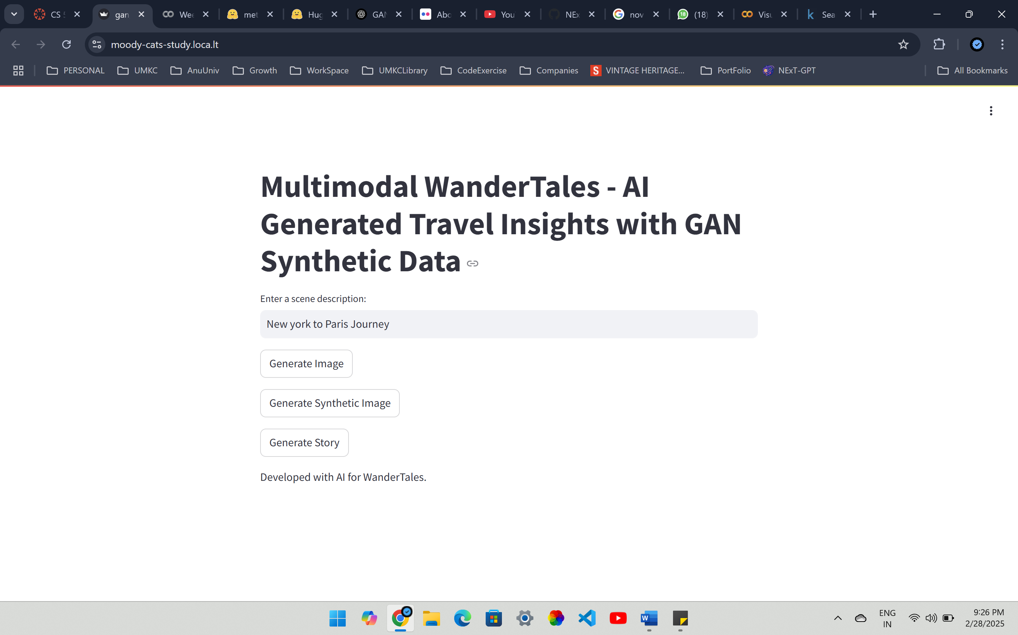  
  
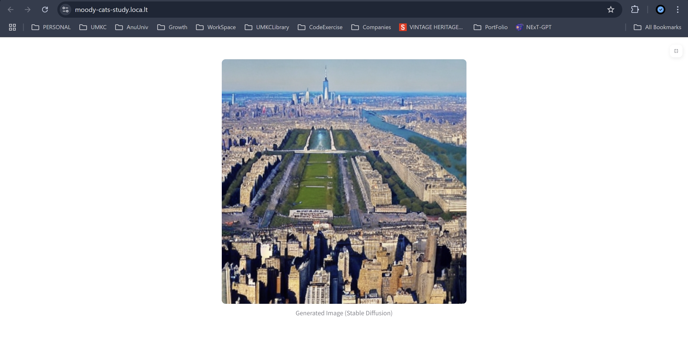  
  
**Multi modal generative AI enhanced Interaction:**<https://drive.google.com/file/d/1z1J4XfrFMWMMhEM1HW20VzIC-81QQcLo/view?usp=sharing>