Recommended documentation structure
- Setup
- Usage
- Design Decisions
- MACH Principles
- API Reference
- Testing

1) Setup

Prerequisites
- Node.js (LTS) — e.g. v18+ recommended
- npm or yarn
- (Optional) Docker if you want to run dependent services like a database in containers

Clone & install
# clone the repo
git clone https://github.com/pavan90-one/pavankumar.git
Mkdir healthgoals
cd healthgoals
# install dependencies (npm)
npm install express nodemon jest mongoose cors jwt dotenv

Environment
Create a .env file in the project root (example values):
PORT=3000
NODE_ENV=development
DATABASE_URL=mongodb://localhost:27017/healthGoals
JWT_SECRET=changeme
LOG_LEVEL=info
The app loads configuration from environment variables. Add any additional variables your service needs.

Run locally
# start in development mode (with auto-reload if you use nodemon)
npm run dev
# or run normally
npm start
Typical package.json scripts used in this project:
scripts": {
"test": "cross-env NODE_ENV=test jest --runInBand",
"test:watch": "jest --watch",
"start": "nodemon app.js"
},
"dependencies": {
"body-parser": "^2.2.0",
"cors": "^2.8.5",
"cross-env": "^10.1.0",
"dotenv": "^17.2.3",
"express": "^5.1.0",
"helmet": "^8.1.0",
"joi": "^18.0.1",
"mongoose": "^8.19.3",
"nodemon": "^3.1.10"
},
"jest": {
"testEnvironment": "node",
"coverageDirectory": "coverage",
"collectCoverageFrom": [
"Controllers/**/*.js",
"Routes/**/*.js",
"Models/**/*.js"
]
},
"devDependencies": {
"jest": "^30.2.0",
"supertest": "^7.1.4"
}

2) Usage
Once the server is running, the API will be available at http://localhost:${PORT || 3000}.
Example using curl:
# fetch all users(patints)
http://localhost:6000/patient/All

3) Design Decisions
This section captures the main architecture and assumptions behind the codebase.

High-level architecture
- Layered structure: routes → controllers → Models→ Schema/models.
  - Routes only map HTTP paths to controller functions.
  - Controllers handle request input/output and basic HTTP status mapping.
  - Models / Repositories encapsulate DB access (e.g. Mongoose models, Prisma client).

Advantages: - Clear separation of concerns (easy to unit-test controllers by mocking services). - Easier to evolve persistence implementation without affecting controllers.
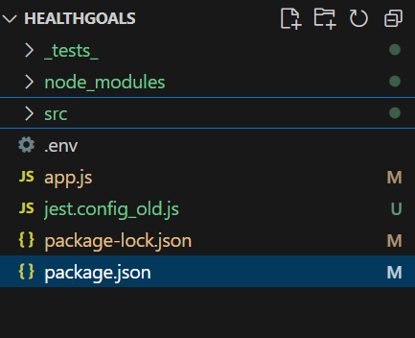
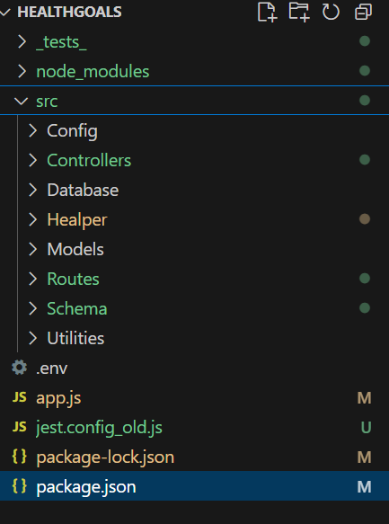
S.no | Folder Name | Folder Descriptions
1 | Config | config folder, or configuration folder, stores settings and parameters that control an application or project's behavior, allowing customization without altering source code
2 | Controller | a crucial role focused on monitoring, analyzing, and reporting on the project's financial performance and schedule adherence to ensure it stays within budget and on time
3 | Database | database folder is a digital location for storing and organizing all project-related information, acting as a centralized hub for documents, tasks, and other data
4 | Healper | "helper" folder (sometimes named "Utils" or "Supporting Materials") is used to store supplementary or reusable files that support the main project deliverables but are not client-facing outputs themselves.
5 | Models | the models folder is primarily a convention-based directory used to store files that define the application's data structure and business logic.
6 | Routes | - The folder contains files that map specific URL patterns (e.g., /users, /products/:productId, /api/status) to the corresponding handler functions or pages within the application code.
7 | Schema | a schema folder is used to store and organize the definitions and blueprints for the project's data structures

Error handling
- Centralized error handler (app.use((err, req, res, next) => {})) that logs and returns standardized error responses.
- Services should throw typed errors (e.g. NotFoundError, ValidationError) so controllers or the error middleware can map them to proper HTTP codes.

Validation
- Request validation should be done using middleware (e.g., Joi,) before controller logic executes.
- This keeps controllers focused on happy-path execution and delegates input verification.

Assumptions
- The service is stateless and expects an external DB for persistence.
- Auth/authorization is out of scope for the basic CRUD endpoints (but hooks are provided — e.g., authMiddleware).
- The service will be deployed in a cloud environment (containerized) with environment variables provided by the platform.

4) How this service adheres to MACH principles
MACH: Microservices, API-first, Cloud-native, Headless.

Microservices
- The codebase represents a single business capability (e.g., users service) and is structured to be independently deployable.
- Small surface area and focused domain boundaries encourage running this as part of a larger collection of services.

API-first
- Endpoints are designed and documented (see API Reference below). Request/response shapes are explicit.
- API-first allows clients to be developed independently (frontend, mobile) and encourages contract-driven development.

Cloud-native
- Configuration is injected through environment variables.
- The app is stateless and can run in multiple replicas behind a load balancer.
- Logging and health endpoints are present to integrate with cloud monitoring and orchestrators.

Headless
- The service exposes JSON APIs only and is UI-agnostic — any client can consume it (web apps, mobile apps, IoT).
Notes: If your environment uses an API gateway, service mesh, or central auth, the service is designed to plug into those without heavy coupling.

5) API Reference
Base URL: http://{host}:{port}
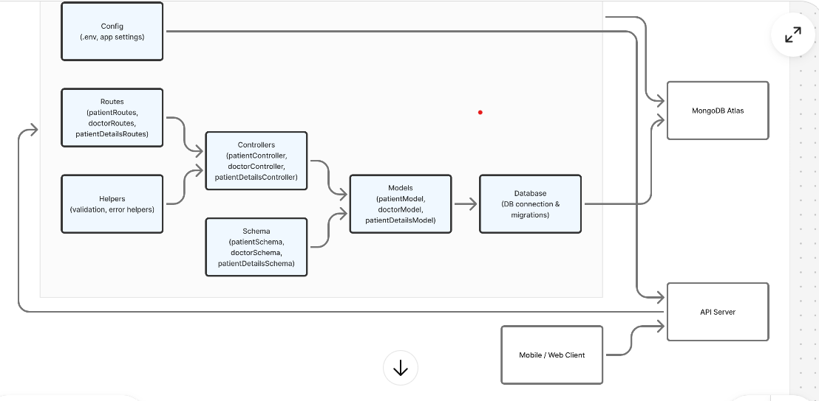

GET /users
- Description: Retrieve a list of patients.
- Response: 200 OK — array of user objects
Example response:
{
"message": "patients details",
"status": "success",
"patients": [
{
"_id": "690cc404e125259c02615133",
"patientName": "pawanreddy",
"patientEmail": "apavan@gmail.com",
"patientPhone": 8884664703,
"patientAge": 35,
"patientAddress": "Bengalore",
"patientStatus": false,
"createdAt": "2025-11-06T15:51:32.092Z",
"__v": 0,
"updatedAt": "2025-11-06T17:19:19.774Z"
}
]
}

GET /patient /:id
- Description: Get a single user by id
- Responses:
  - 200 OK — user object
  - 404 Not Found — when missing

POST /users
- Description: Create a new user
- Request body (application/json):
- {
- "patientName":"admin3",
- "patientEmail":"admin3@gmail.com",
- "patientPhone":"9488867243",
- "patientAge":33,
- "patientAddress":"Nellore"

- }

- Responses:
  - 201 Created — created resource
  - 404 Bad Request — validation error

PUT /users/:id
- Description: Update all fields of the user (or partial if you prefer PATCH semantics)
- Responses:
  - 200 OK — updated object
  - 400 Not Found

DELETE /users/:id
- Description: Delete a user
- Responses:
  - 204 No Content — success
  - 404 Not Found
Tip: When returning created resources, include the Location header with the URL of the new resource.
URL Details:
Sno | URL | Descriptions
1 | http://localhost:6000/patient/All
2 | http://localhost:6000/patient/Add
3 | http://localhost:6000/patient/690cc404e125259c02615133
4 | http://localhost:6000/patient/690cc404e125259c02615133
5 | http://localhost:6000/patient/updateImage
6 | http://localhost:6000/doctor/690d7e7a8d5a6993913d8e64
7 | http://localhost:6000/patientDetails/All

6) Testing
This project uses Jest and Supertest for unit and integration tests.

Run tests
# run all tests
npm test

Testing strategy
- Unit Tests (fast): test controllers and services in isolation. Mock external dependencies (DB clients, other services). Keep these fast — no network or DB.
- Integration Tests (medium): test routes using supertest but mock the service layer so the HTTP stack is exercised.
- End-to-end Tests (optional, slow): test the full stack against an in-memory DB (e.g., mongodb-memory-server) or a dockerized database.

Example test folders
/_tests_
patinet.routes.test.js

Coverage
Run tests with coverage:
npx jest --coverage
Aim for high coverage on controller/service logic; repository/ORM glue can have lighter coverage depending on the chosen integration testing strategy.

Contribution & Maintenance notes
- Follow the repo CONTRIBUTING.md (if present) for PR and branching flow.
- Keep controller functions thin and unit-testable.
- When changing API shapes, update the API Reference and notify consumers.

Appendix — Useful snippets

Example Error class (pattern)
class NotFoundError extends Error {
constructor(message = 'Not found') {
super(message);
this.name = 'NotFoundError';
this.status = 404;
}
}
module.exports = NotFoundError;

Example centralized error handler
function errorHandler(err, req, res, next) {
const status = err.status || 500;
const body = { error: err.message || 'Internal Server Error' };
// optionally attach error code, details, etc.
res.status(status).json(body);
}
module.exports = errorHandler;

If you’d like, I can also: - generate a README.md file tailored to your real code (paste your app.js, a controller, or package.json), - or produce OpenAPI (Swagger) JSON/YAML for the API reference.

system architecture diagram and flow diagram for my project, my project is health goals
I used the following the folders
  - Config : it used to configure the variable those variable will help the total project
  - Controller : it is used to fetch data from the models and routes, like it will act like meddler for request . like controller to model or controller routes
Controllers: patientController, doctorController and patinetDetailsController
  - Database : this is used to configure the database connect and migrations also
  - Helpers : it is used to help the common functions like validation or error message.
  - Models : it ise used to do the database operations like curd and it will send the data to controller. Model to controller
Models : patientModel, doctorModel and patinetDetailsModels
  - Routes : it is used to mantiained the url, it will communicate to controller
Routes : patientRoutes, doctorRoutes and patinetDetailsRoutes
  - Schema : here we will design the schema of database table. It is mostly communicate models, if we want add new filed, the first medication file is Schema
Schema : patientSchema, doctorSchema and patinetDetailsSchema

