ROTATE
LEFT OPERATION

EXP NO: 18

AIM:
To compute rotation of given data in left
without carry using 8085 processor.

ALGORITHM:

1) Load the base address of the array in HL register pair.

2) Move the data from memory location into accumulator.

3) Shift left the accumulator content for four times.

4) Store the result in the specified location.

PROGRAM:

MVI
A,02

RLC

RLC

RLC

RLC

STA
2000

HLT

INPUT:

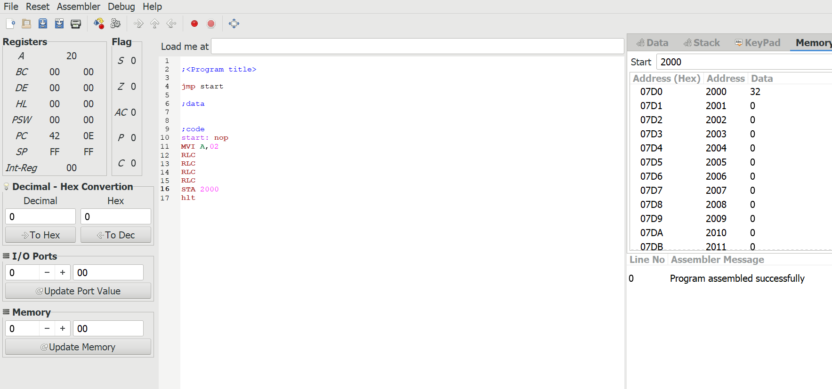

OUTPUT:

