**Class and Quiz Snapshots:**

**Programming in C**

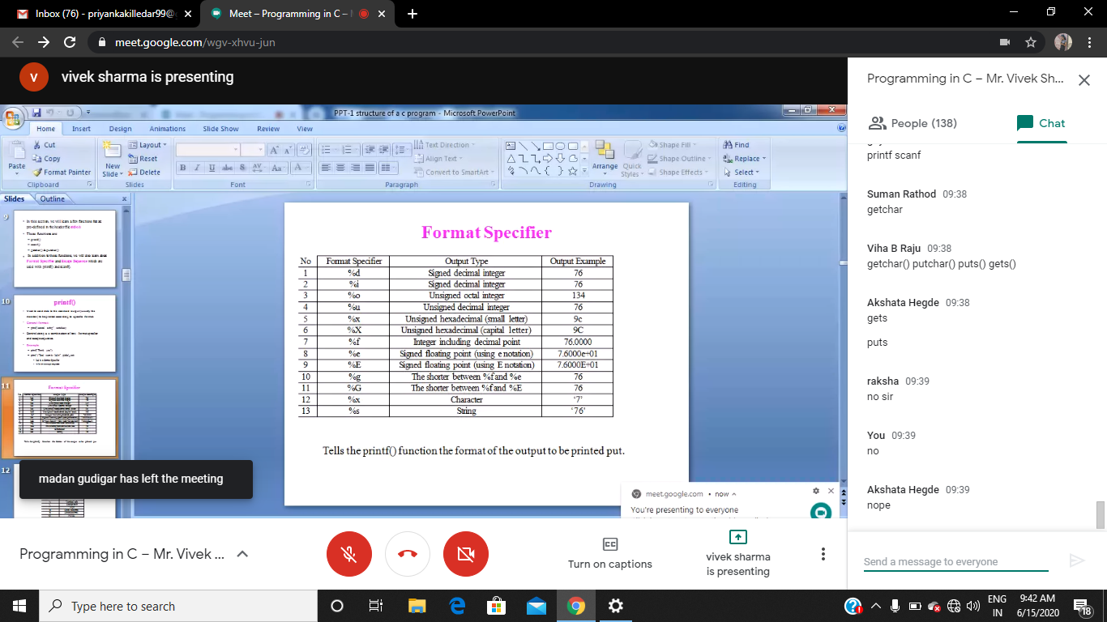

**Python workshop :**

