**DAILY ONLINE ACTIVITIES SUMMARY**

|  |  |  |  |  |  |  |  |  |
| --- | --- | --- | --- | --- | --- | --- | --- | --- |
| **Date:** | **19/05/2020** | | | | | **Name:** | **Pavana P** | |
| **Sem & Sec** | **V1 ‘A’** | | | | | **USN:** | **4AL17CS057** | |
| **Online Test Summary** | | | | | | | | |
| **Subject** | | **CGV** | | | | | | |
| **Max. Marks** | | **60** | | **Score** | | | **50** | |
| **Certification Course Summary** | | | | | | | | |
| **Course** | **Introduction to Information Security** | | | | | | | |
| **Certificate Provider** | | | **Great Learning Academy** | | **Duration** | | | **6 hrs** |
| **Coding Challenges** | | | | | | | | |
| **Problem Statement:** **.A user will input two strings, and we find if one of the strings is a sub sequence of the other. Program prints “yes” if either the first string is a sub sequence of the second string or the second string is a sub sequence of the first string.**  **Assume that, the length of the first string is smaller than or equal to the length of the second string.**  **We have a Letter or a word then we need add some letters to it and need to find out shortest palindrome**  **For example we take "S": S will be the shortest palindrome string.**  **.** | | | | | | | | |
| **Status: Completed** | | | | | | | | |
| **Uploaded the report in Github** | | | | | **Yes** | | | |
| **If yes Repository name** | | | | | **DAILY STATUS** | | | |
| **Uploaded the report in slack** | | | | | **Yes** | | | |

Online Test Details:

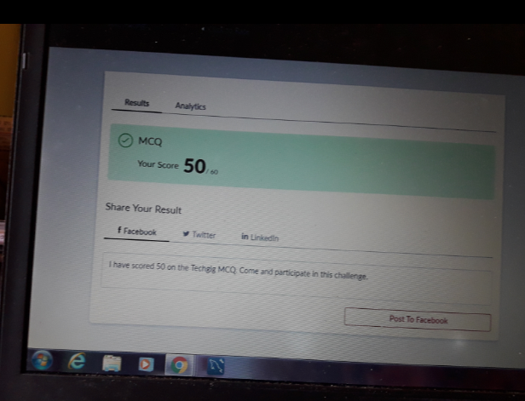

Certification course:

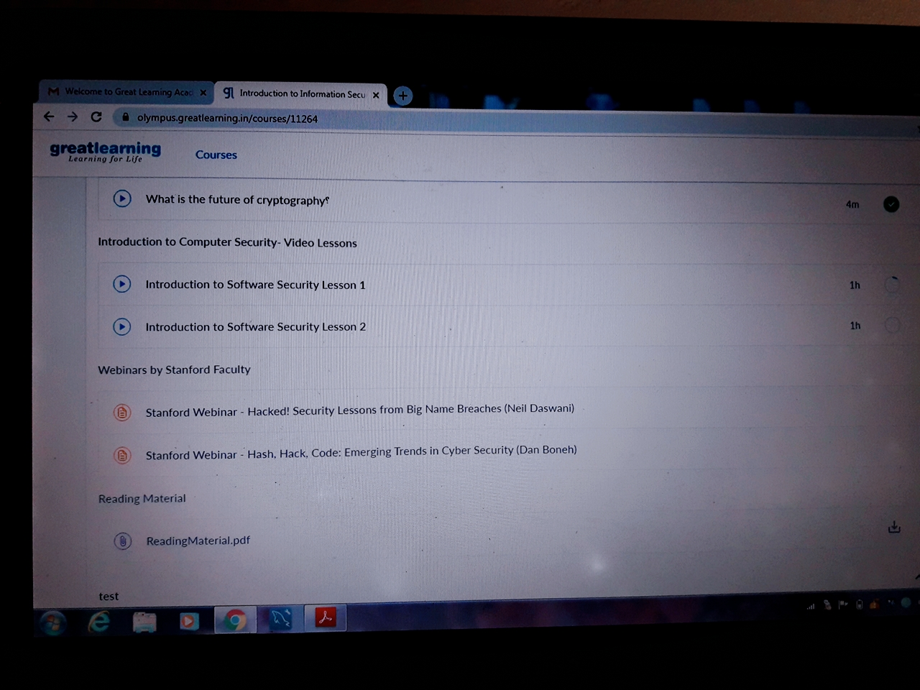

Coding challenge Details:

**https: //github.com/pavana-p-kulal/DAILY STATUS**