**DAILY ONLINE ACTIVITIES SUMMARY**

|  |  |  |  |  |  |  |  |  |
| --- | --- | --- | --- | --- | --- | --- | --- | --- |
| **Date:** | **20/05/2020** | | | | | **Name:** | **Pavana P** | |
| **Sem & Sec** | **V1 ‘A’** | | | | | **USN:** | **4AL17CS057** | |
| **Online Test Summary** | | | | | | | | |
| **Subject** | | **SSCD** | | | | | | |
| **Max. Marks** | | **30** | | **Score** | | | **23** | |
| **Certification Course Summary** | | | | | | | | |
| **Course** | **Introduction to Information Security** | | | | | | | |
| **Certificate Provider** | | | **Great Learning Academy** | | **Duration** | | | **6 hrs** |
| **Coding Challenges** | | | | | | | | |
| **Problem Statement:** **.**  **1.Write Python Program to Reverse a Given Number.**  **2. Python Program to Exchange the Values of Two Numbers using ^ (exclusive or operator)** | | | | | | | | |
| **Status: Completed** | | | | | | | | |
| **Uploaded the report in Github** | | | | | **Yes** | | | |
| **If yes Repository name** | | | | | **DAILY STATUS** | | | |
| **Uploaded the report in slack** | | | | | **Yes** | | | |

Online Test Details:

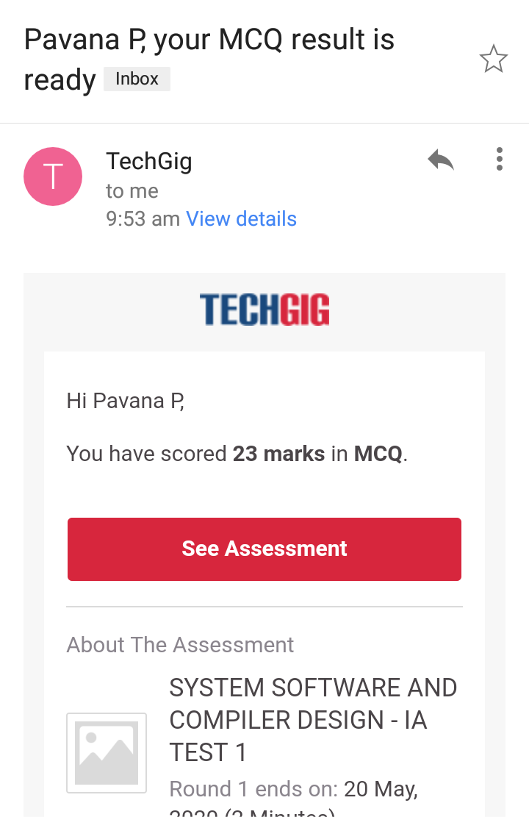

Certification course:

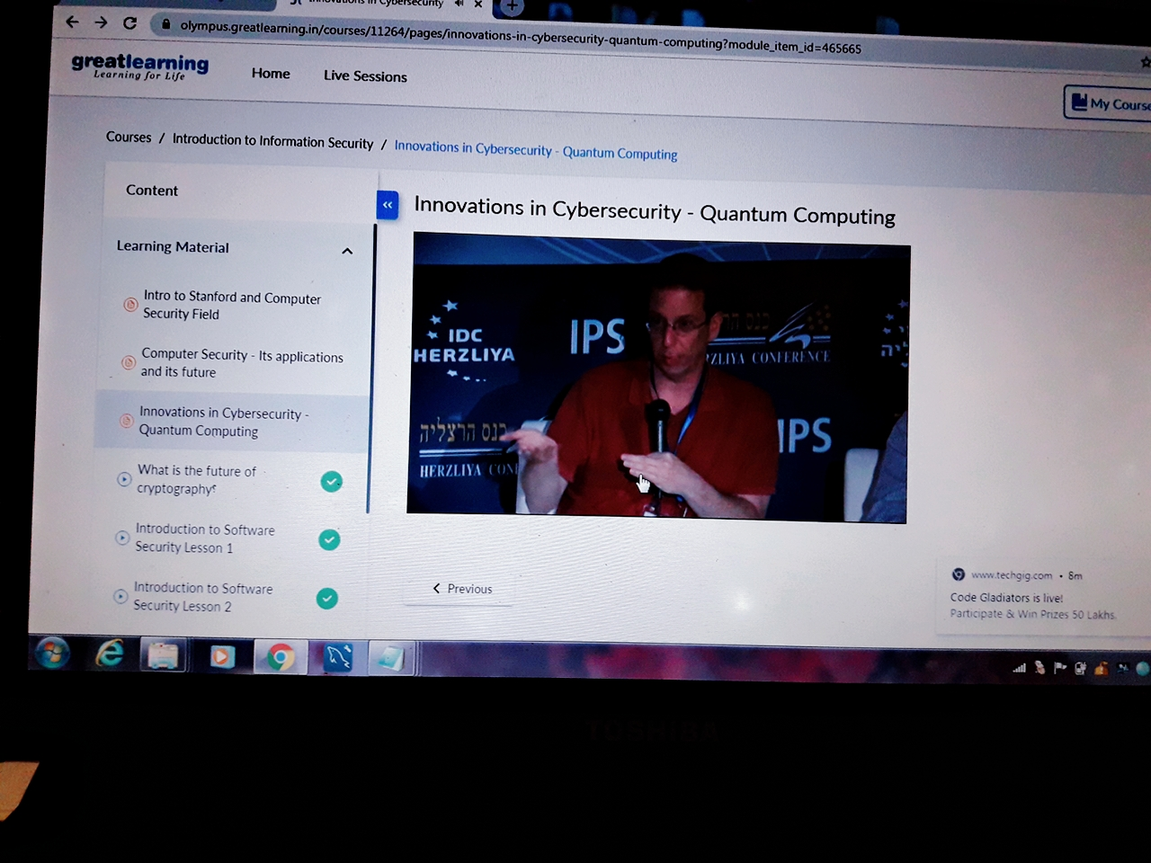

Coding challenge Details:

**https: //github.com/pavana-p-kulal/DAILY STATUS**