4.Write a Java Program to check whether the given number is Armstrong number or not.

public class Main {  
  
    public static void main(String[] args) {  
  
        int num = 370, number, temp, total = 0;  
  
        number = num;  
        while (number != 0)  
        {  
            temp = number % 10;  
            total = total + temp*temp*temp;  
            number /= 10;  
        }  
        if(total == num)  
            System.out.println(num + " is an Armstrong number");  
        else  
            System.out.println(num + " is not an Armstrong number");  
    }  
}

**Output:**

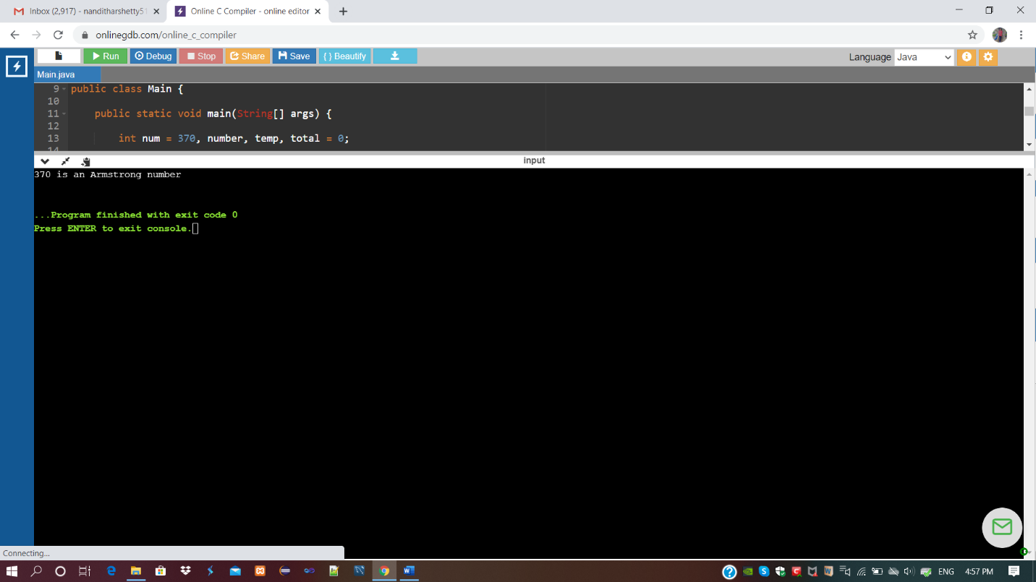

**For:** num=375

