1.Go to prompts.js and add new prompt templates for Playwright TypeScript
Take selenium Java as reference

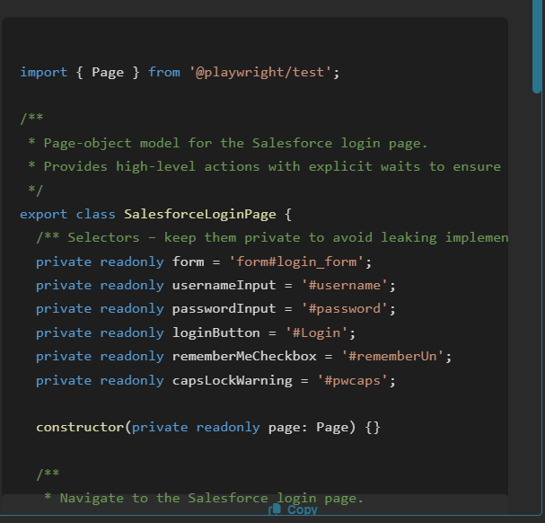

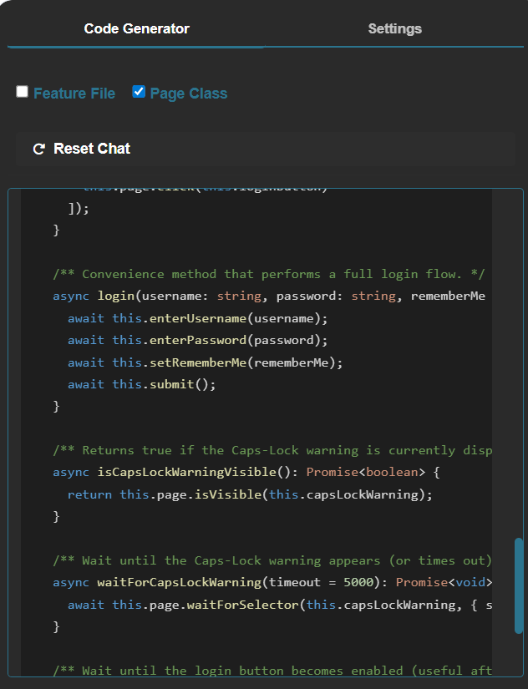

2. Go to chat.js
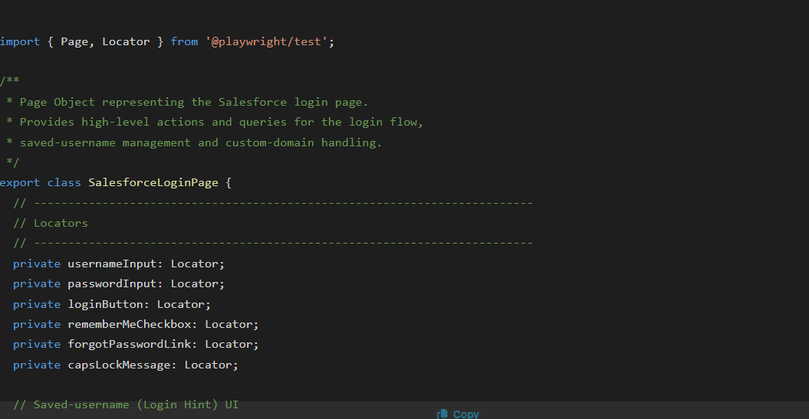
import { Page, Locator } from '@playwright/test';

/**
* Page Object representing the Salesforce login page.
* Provides high‑level actions and queries for the login flow,
* saved‑username management and custom‑domain handling.
*/
export class SalesforceLoginPage {
// -------------------------------------------------------------------------
// Locators
// -------------------------------------------------------------------------
private usernameInput: Locator;
private passwordInput: Locator;
private loginButton: Locator;
private rememberMeCheckbox: Locator;
private forgotPasswordLink: Locator;
private capsLockMessage: Locator;

// Saved‑username (Login Hint) UI
private chooserContainer: Locator;
private chooserError: Locator;
private savedUsernamesLabel: Locator;
private editListLink: Locator;
private managerContainer: Locator;
private managerSaveButton: Locator;
private managerCancelButton: Locator;
private clearIdentityLink: Locator;

// Custom‑domain UI
private customDomainLink: Locator;
private customDomainContainer: Locator;
private customDomainInput: Locator;
private domainPreview: Locator;
private domainContinueButton: Locator;
private domainBackButton: Locator;

constructor(private page: Page) {
// -----------------------------------------------------------------------
// Core login form
// -----------------------------------------------------------------------
this.usernameInput = page.locator('#username');
this.passwordInput = page.locator('#password');
this.loginButton = page.locator('#Login');
this.rememberMeCheckbox = page.locator('#rememberUn');
this.forgotPasswordLink = page.locator('#forgot_password_link');
this.capsLockMessage = page.locator('#pwcaps');

// -----------------------------------------------------------------------
// Saved‑username (Login Hint) section
// -----------------------------------------------------------------------
this.chooserContainer = page.locator('#chooser');
this.chooserError = page.locator('#chooser_error');
this.savedUsernamesLabel = page.locator('#chooser_label');
this.editListLink = page.locator('#edit');
this.managerContainer = page.locator('#manager');
this.managerSaveButton = page.locator('#hint_save_edit');
this.managerCancelButton = page.locator('#hint_back_edit');
this.clearIdentityLink = page.locator('#clear_link');

// -----------------------------------------------------------------------
// Custom‑domain section
// -----------------------------------------------------------------------
this.customDomainLink = page.locator('#mydomainLink');
this.customDomainContainer = page.locator('#mydomainContainer');
this.customDomainInput = page.locator('#mydomain');
this.domainPreview = page.locator('#mydomain_preview');
this.domainContinueButton = page.locator('#mydomainContinue');
this.domainBackButton = page.locator('#hint_back_domain');
}

// -------------------------------------------------------------------------
// Navigation
// -------------------------------------------------------------------------
async goto(url: string = 'https://login.salesforce.com/'): Promise<void> {
await this.page.goto(url);
await this.page.waitForLoadState('domcontentloaded');
}

// -------------------------------------------------------------------------
// Core login actions
// -------------------------------------------------------------------------
async enterUsername(username: string): Promise<void> {
await this.usernameInput.waitFor({ state: 'visible' });
await this.usernameInput.fill(username);
}

async enterPassword(password: string): Promise<void> {
await this.passwordInput.waitFor({ state: 'visible' });
await this.passwordInput.fill(password);
}

async clickLogin(): Promise<void> {
await this.loginButton.waitFor({ state: 'attached' });
await this.loginButton.click();
}

async setRememberMe(remember: boolean): Promise<void> {
await this.rememberMeCheckbox.waitFor({ state: 'visible' });
const isChecked = await this.rememberMeCheckbox.isChecked();
if (isChecked !== remember) {
await this.rememberMeCheckbox.click();
}
}

async clickForgotPassword(): Promise<void> {
await this.forgotPasswordLink.waitFor({ state: 'visible' });
await this.forgotPasswordLink.click();
}

async waitForCapsLockMessage(): Promise<void> {
await this.capsLockMessage.waitFor({ state: 'visible' });
}

async isCapsLockMessageVisible(): Promise<boolean> {
return await this.capsLockMessage.isVisible();
}

// -------------------------------------------------------------------------
// Saved‑username (Login Hint) handling
// -------------------------------------------------------------------------
/** Opens the “Edit List” UI for saved usernames. */
async openSavedUsernamesEditor(): Promise<void> {
await this.editListLink.waitFor({ state: 'visible' });
await this.editListLink.click();
await this.managerContainer.waitFor({ state: 'visible' });
}

/** Returns the text like “0 Saved Usernames”. */
async getSavedUsernamesLabel(): Promise<string> {
await this.savedUsernamesLabel.waitFor({ state: 'visible' });
return await this.savedUsernamesLabel.textContent() ?? '';
}

/** Saves changes made in the editor. */
async saveEditedUsernames(): Promise<void> {
await this.managerSaveButton.waitFor({ state: 'visible' });
await this.managerSaveButton.click();
await this.managerContainer.waitFor({ state: 'hidden' });
}

/** Cancels changes made in the editor. */
async cancelEditedUsernames(): Promise<void> {
await this.managerCancelButton.waitFor({ state: 'visible' });
await this.managerCancelButton.click();
await this.managerContainer.waitFor({ state: 'hidden' });
}

/** Returns true if the chooser error message is displayed. */
async isChooserErrorVisible(): Promise<boolean> {
return await this.chooserError.isVisible();
}

/** Clears the currently displayed identity (the “Log In with a Different Username” link). */
async clearExistingIdentity(): Promise<void> {
await this.clearIdentityLink.waitFor({ state: 'visible' });
await this.clearIdentityLink.click();
// The UI switches back to the username input; wait for it.
await this.usernameInput.waitFor({ state: 'visible' });
}

// -------------------------------------------------------------------------
// Custom‑domain handling
// -------------------------------------------------------------------------
/** Opens the custom‑domain entry panel. */
async openCustomDomainPanel(): Promise<void> {
await this.customDomainLink.waitFor({ state: 'visible' });
await this.customDomainLink.click();
await this.customDomainContainer.waitFor({ state: 'visible' });
}

/** Types a domain name into the custom‑domain field. */
async setCustomDomain(domain: string): Promise<void> {
await this.customDomainInput.waitFor({ state: 'visible' });
await this.customDomainInput.fill(domain);
}

/** Clicks the “Continue” button after entering a custom domain. */
async continueCustomDomain(): Promise<void> {
await this.domainContinueButton.waitFor({ state: 'visible' });
await this.domainContinueButton.click();
// The panel typically disappears after a successful continue.
await this.customDomainContainer.waitFor({ state: 'hidden' });
}

/** Clicks the “Back” button to return to the normal login view. */
async backFromCustomDomain(): Promise<void>
await this.domainBackButton.waitFor({ state: 'visible' });
await this.domainBackButton.click();
await this.customDomainContainer.waitFor({ state: 'hidden' });
}

/** Retrieves the live preview URL for the entered custom domain. */
async getDomainPreview(): Promise<string> {
await this.domainPreview.waitFor({ state: 'visible' });
return (await this.domainPreview.textContent())?.trim() ?? '';
}
}

3. Go to panel.html

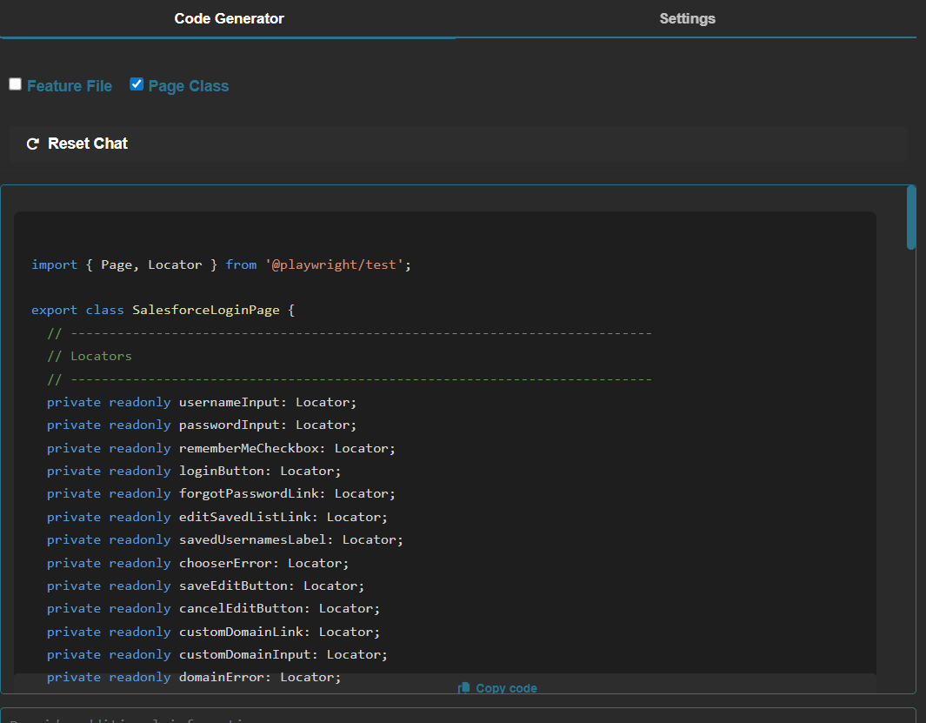

import { Page, Locator } from '@playwright/test';

export class SalesforceLoginPage {
// ---------------------------------------------------------------------------
// Locators
// ---------------------------------------------------------------------------
private readonly usernameInput: Locator;
private readonly passwordInput: Locator;
private readonly rememberMeCheckbox: Locator;
private readonly loginButton: Locator;
private readonly forgotPasswordLink: Locator;
private readonly editSavedListLink: Locator;
private readonly savedUsernamesLabel: Locator;
private readonly chooserError: Locator;
private readonly saveEditButton: Locator;
private readonly cancelEditButton: Locator;
private readonly customDomainLink: Locator;
private readonly customDomainInput: Locator;
private readonly domainError: Locator;
private readonly domainContinueButton: Locator;
private readonly domainBackButton: Locator;
private readonly loginFormContainer: Locator;

constructor(private readonly page: Page) {
// Primary login form
this.usernameInput = page.locator('#username');
this.passwordInput = page.locator('#password');
this.rememberMeCheckbox = page.locator('#rememberUn');
this.loginButton = page.locator('#Login');
this.forgotPasswordLink = page.locator('#forgot_password_link');
this.loginFormContainer = page.locator('#theloginform');

// Saved usernames (chooser / manager)
this.editSavedListLink = page.locator('#edit');
this.savedUsernamesLabel = page.locator('#chooser_label');
this.chooserError = page.locator('#chooser_error');
this.saveEditButton = page.locator('#hint_save_edit');
this.cancelEditButton = page.locator('#hint_back_edit');

// Custom domain UI
this.customDomainLink = page.locator('#mydomainLink');
this.customDomainInput = page.locator('#mydomain');
this.domainError = page.locator('#domain_error');
this.domainContinueButton = page.locator('#mydomainContinue');
this.domainBackButton = page.locator('#hint_back_domain');
}

// ---------------------------------------------------------------------------
// Navigation
// ---------------------------------------------------------------------------
async goto(url: string): Promise<void> {
await this.page.goto(url);
await this.waitForLoginFormVisible();
}

// ---------------------------------------------------------------------------
// Login actions
// ---------------------------------------------------------------------------
async enterUsername(username: string): Promise<void> {
await this.usernameInput.waitFor({ state: 'visible' });
await this.usernameInput.fill(username);
}

async enterPassword(password: string): Promise<void> {
await this.passwordInput.waitFor({ state: 'visible' });
await this.passwordInput.fill(password);
}

async setRememberMe(checked: boolean): Promise<void> {
await this.rememberMeCheckbox.waitFor({ state: 'attached' });
const isChecked = await this.rememberMeCheckbox.isChecked();
if (isChecked !== checked) {
await this.rememberMeCheckbox.click();
}
}

async clickLogin(): Promise<void> {
await this.loginButton.waitFor({ state: 'visible' });
await Promise.all([
this.page.waitForNavigation({ waitUntil: 'load' }),
this.loginButton.click(),
]);
}

async clickForgotPassword(): Promise<void> {
await this.forgotPasswordLink.waitFor({ state: 'visible' });
await this.forgotPasswordLink.click();
}

// ---------------------------------------------------------------------------
// Saved usernames (chooser / manager) handling
// ---------------------------------------------------------------------------
async openSavedUsernamesEditor(): Promise<void> {
await this.editSavedListLink.waitFor({ state: 'visible' });
await this.editSavedListLink.click();
await this.saveEditButton.waitFor({ state: 'visible' });
}

async getSavedUsernamesCount(): Promise<number> {
await this.savedUsernamesLabel.waitFor({ state: 'visible' });
const text = await this.savedUsernamesLabel.textContent();
const match = text?.match(/(\d+)\s+Saved/);
return match ? parseInt(match[1], 10) : 0;
}

async saveEditedUsernames(): Promise<void> {
await this.saveEditButton.waitFor({ state: 'visible' });
await this.saveEditButton.click();
// After saving the chooser returns to visible state
await this.editSavedListLink.waitFor({ state: 'visible' });
}

async cancelEditedUsernames(): Promise<void> {
await this.cancelEditButton.waitFor({ state: 'visible' });
await this.cancelEditButton.click();
await this.editSavedListLink.waitFor({ state: 'visible' });
}

async getChooserErrorMessage(): Promise<string | null> {
if (await this.chooserError.isVisible()) {
return await this.chooserError.textContent();
}
return null;
}

// ---------------------------------------------------------------------------
// Custom domain handling
// ---------------------------------------------------------------------------
async openCustomDomainDialog(): Promise<void> {
await this.customDomainLink.waitFor({ state: 'visible' });
await this.customDomainLink.click();
await this.customDomainInput.waitFor({ state: 'visible' });
}

async setCustomDomain(domain: string): Promise<void> {
await this.customDomainInput.waitFor({ state: 'editable' });
await this.customDomainInput.fill(domain);
}

async clickContinueCustomDomain(): Promise<void> {
await this.domainContinueButton.waitFor({ state: 'visible' });
await this.domainContinueButton.click();
}

async clickBackFromCustomDomain(): Promise<void> {
await this.domainBackButton.waitFor({ state: 'visible' });
await this.domainBackButton.click();
}

async getCustomDomainError(): Promise<string | null> {
if (await this.domainError.isVisible()) {
return await this.domainError.textContent();
}
return null;
}

// ---------------------------------------------------------------------------
// Utility waits
// ---------------------------------------------------------------------------
async waitForLoginFormVisible(): Promise<void> {
await this.loginFormContainer.waitFor({ state: 'visible' });
}

async waitForChooserVisible(): Promise<void> {
await this.page.locator('#chooser').waitFor({ state: 'visible' });
}

async waitForManagerVisible(): Promise<void> {
await this.page.locator('#manager').waitFor({ state: 'visible' });
}
}

