DAY8
SESSION ASSIGNMENTS

1.When to use (Rapid Application Development) RAD modelWhen not to use (Rapid ApplicationDevelopment) RAD model.

RAD should be used
- When the projects can be completed in small period of time.
- when there is a need to create a project that can be modularized in 2-3 months of time.
- It should be used if there’s are high level of designers and can afford the good resources.
- RAD used if resources have high knowledge and wants to produce the system in a short span
- When customer wants output.
When not to use RAD
- When customer wants outcome
- When their is no high available knowledgable designer.
- When the projects dont have to be deliverable in short time span.When they can not offer high quality resources.

2.Define an ER diagram of a software Organization with all the relationship model that was discussed inthe classroom
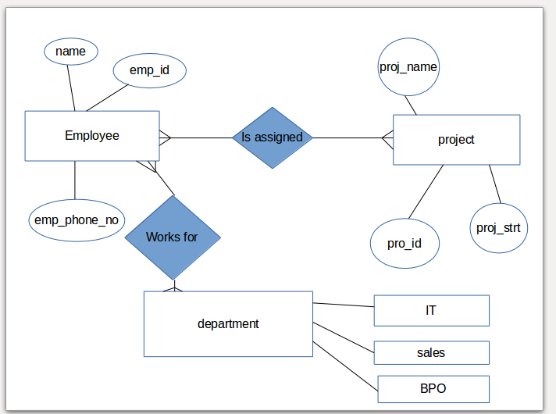

3.Describe the Entity Relationships for the following diagram

Entity Attribute
- Login details contains like-user_name,user_id.
- Staff details contains staff_id,Staff name,user_nam contact.
- Leave details To date,From date,Apply date
,status,type, leave_id,staff_id.
- Admin

Relation each admin has the login details -many to many relation.
- One or more Staff has the login details,Each staff has their login details.
- One or more Admin can add many new staff details to the account with attributes.
- One or more staff members can apply for leave by providing staff_id.
- One or more Admin acess leave details about staff by staff_id .

