NOTES :---
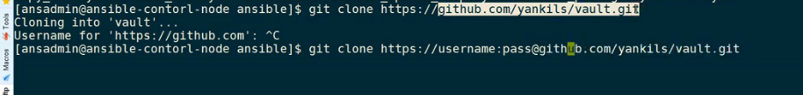
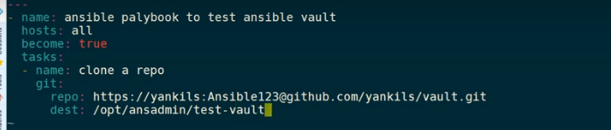
Git :
GIT(CLI) –> command line utility to talk to your repository (GIT HUB [central or remote repo]) GITHUB->VCS- (maintain version and restore them any time)
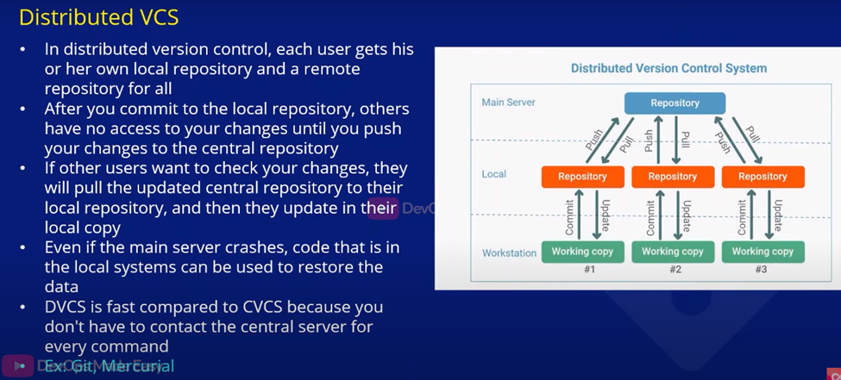
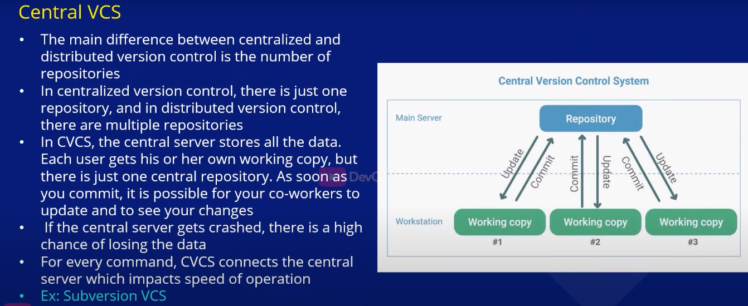
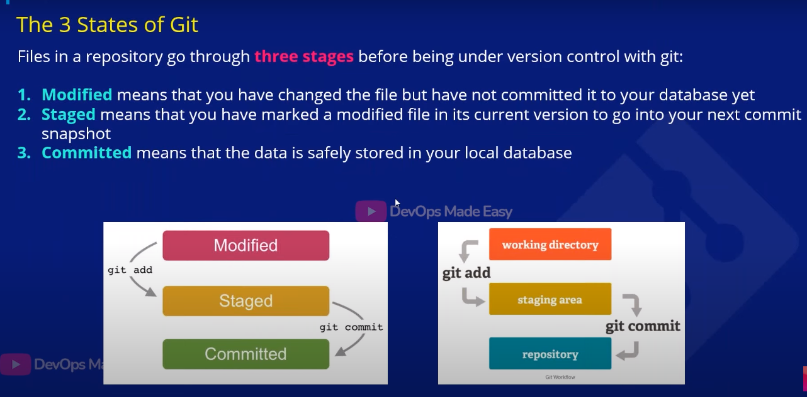
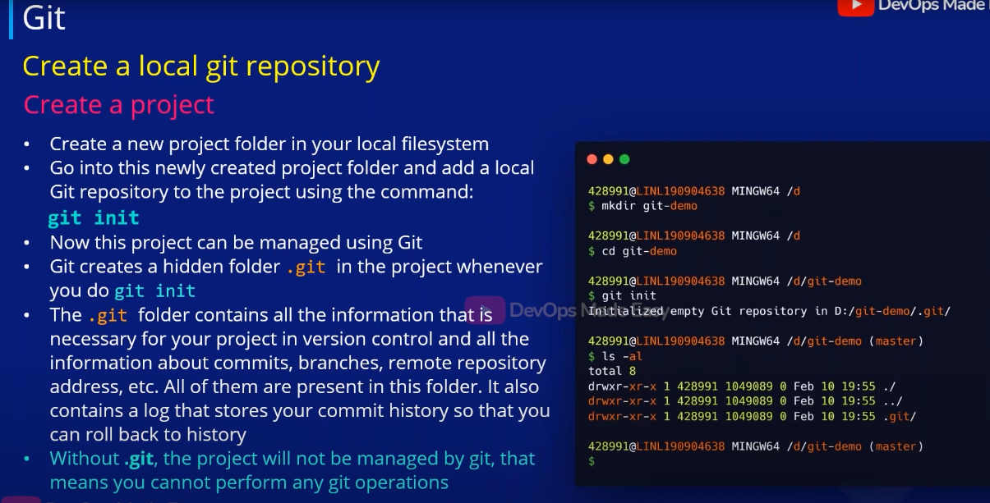

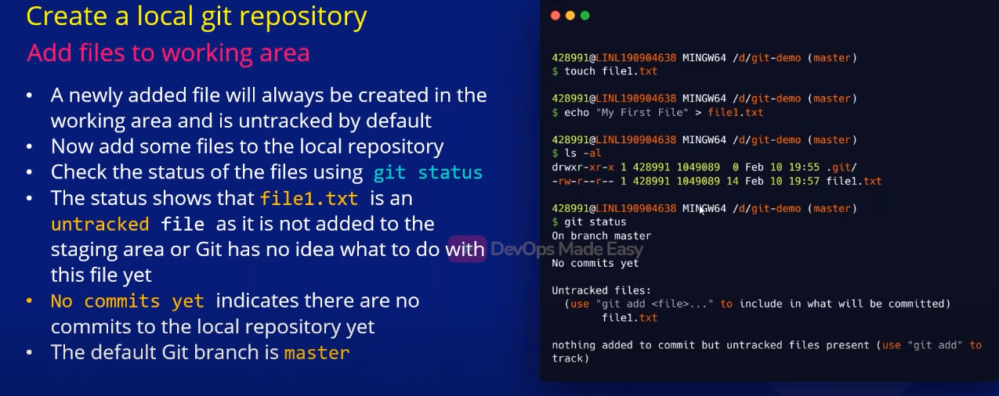
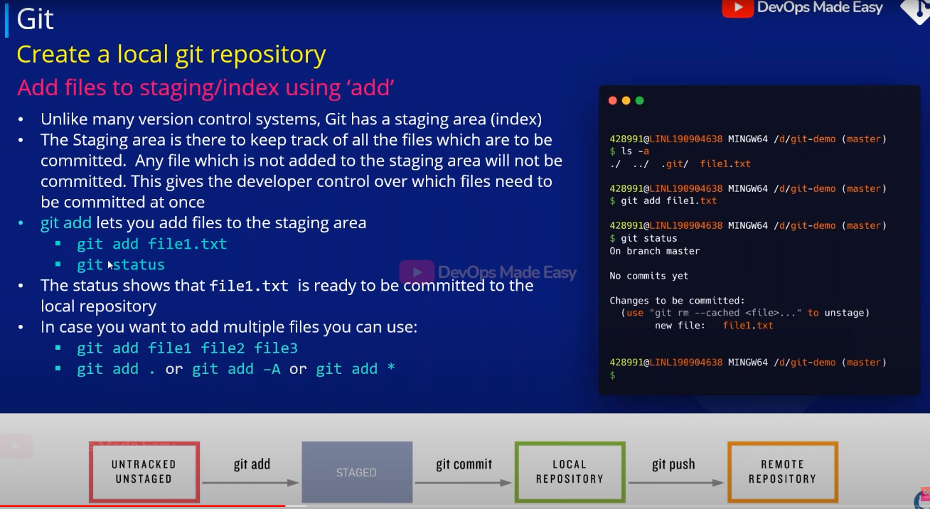

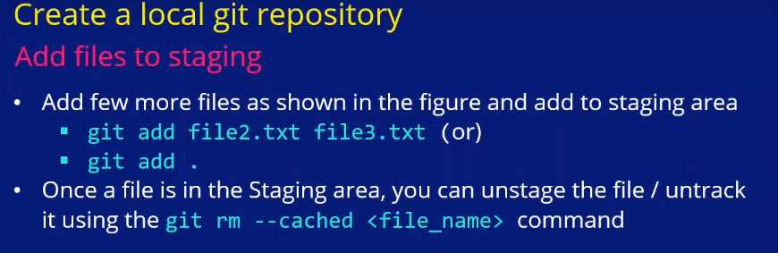

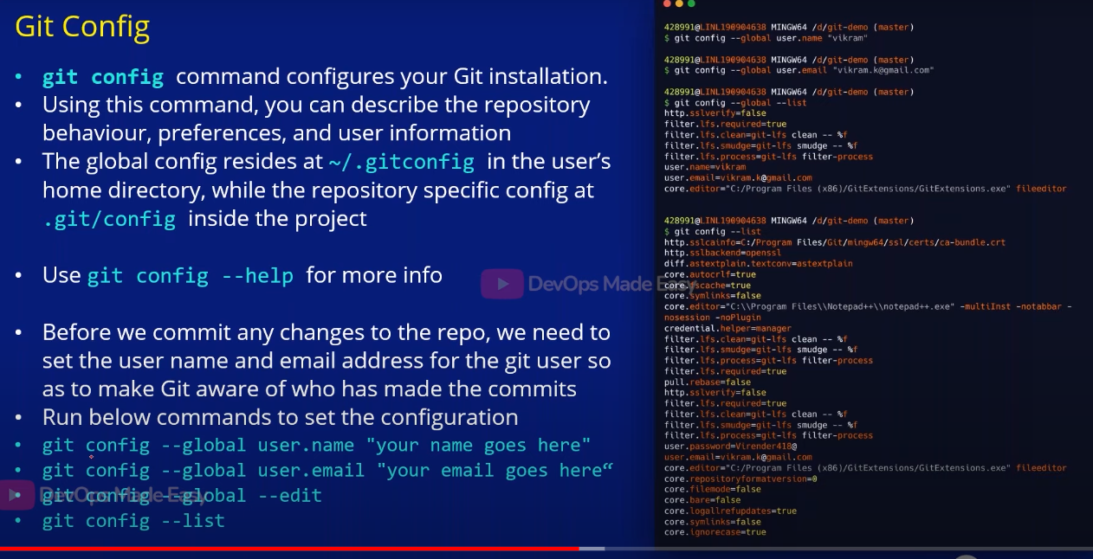
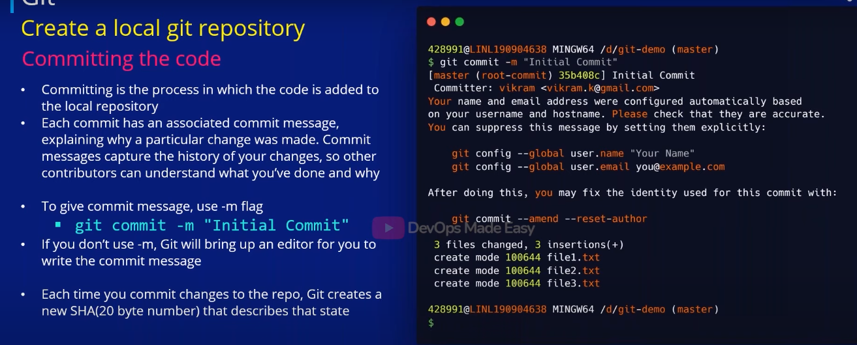
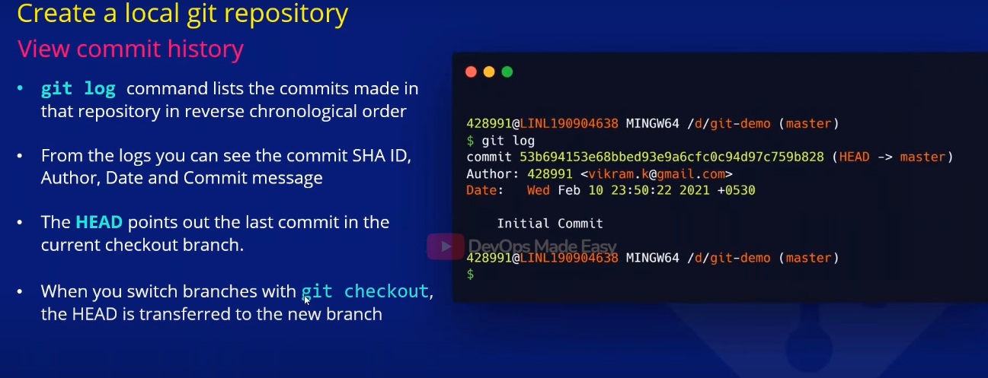
# Head is important (pointer to the latest commit in particular branch) & git log –oneline
# To show recent commit id (git show or git show HEAD) and (git log v/s git show)
# if you want specific id information git show id
# if you want to see last second commit git show HEAD~1
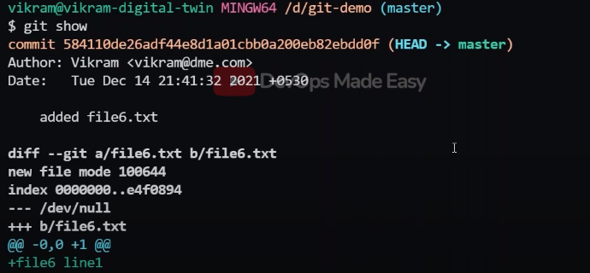
# git log –graph –decorate ( through branch wise displaying all commit id information try it )
# git log –follow file1.txt (show the commits that changed a particular file)

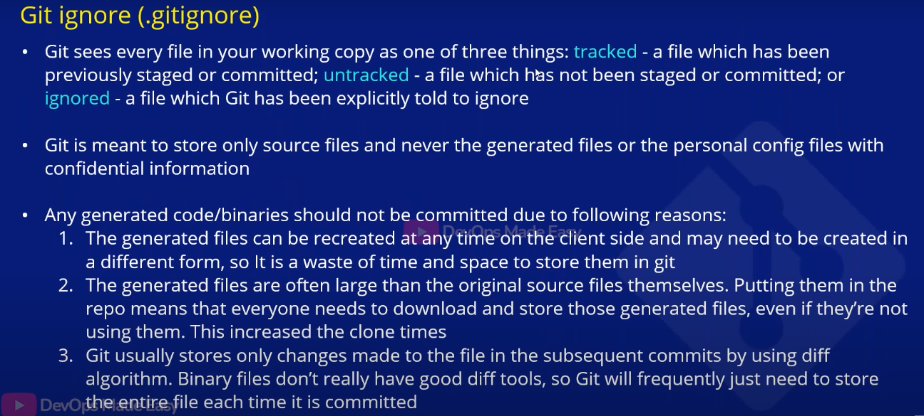
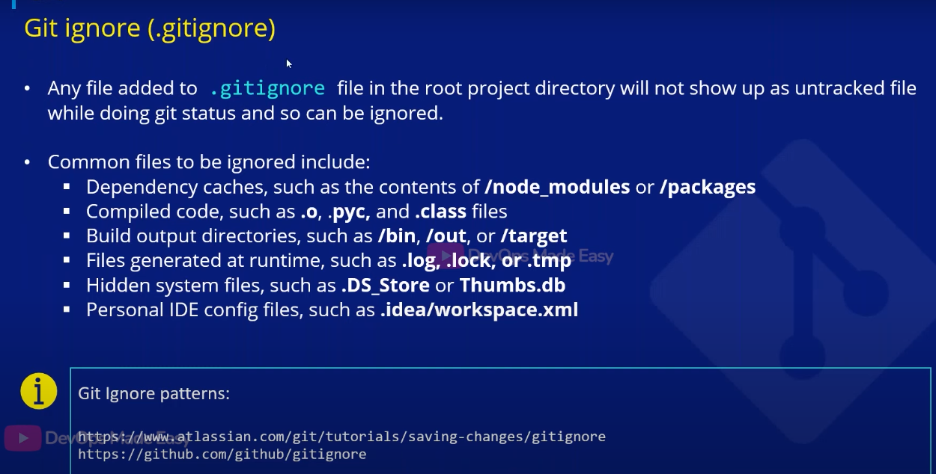
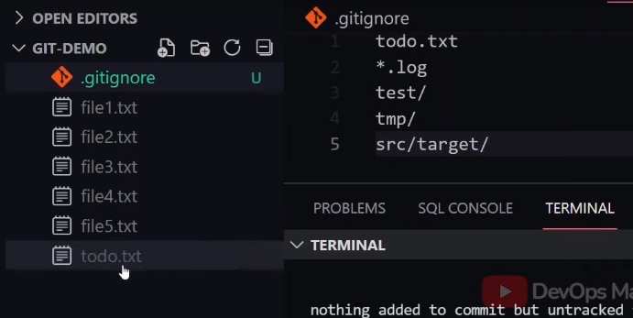
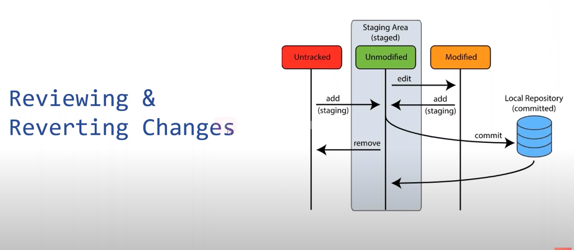
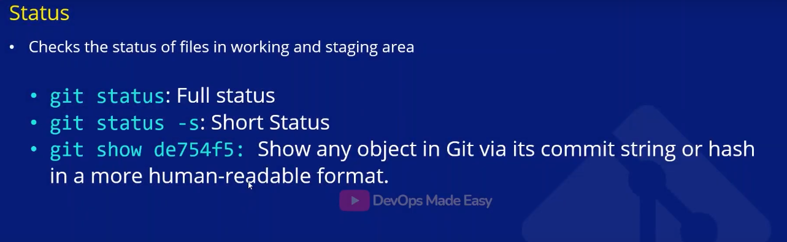
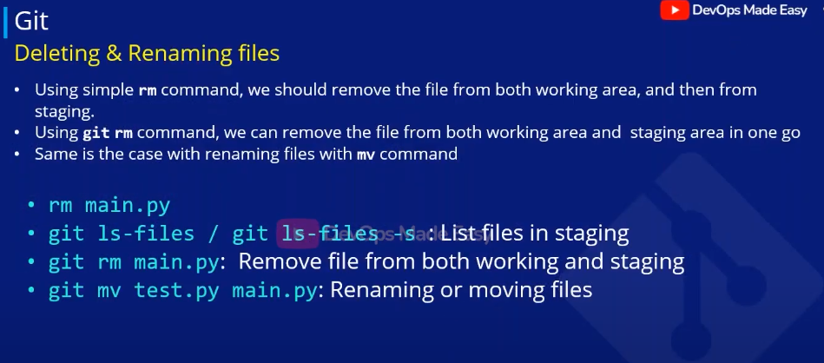
# rm file1 but it will just effect to working area then you need to git add file1 to apply in staging area remove file from both (git rm file1) similarly for git mv file1 file1.1
Reverse order –>
# git checkout <filename>/. (Revert changes in working directory before moving to staging area)
# git reset HEAD <filename>/. (unstage from staging area)
git rm –cached <filename>
Remove a commit from local repository:-
Git reset ---- 3 typs (soft , hard & mixed reset)
Git reset → completely takes out commits from the history
Note : - . if the commits are not pushed to remote then we can use git reset
. And using git reset we can remove recent one commit or 2 commit or 3 commit but there is no
Option to remove a specific commit
# git reset HEAD~1 → meaning remove recent commit and point to previous commit all files added part of this commit they kept in working area (by default mixed reset)
Git reset HEAD~3 [git reset –mixed HEAD~3] → remove recent 3 commit
# git reset –soft HEAD~1 → it keeps all the changes in staging area and remove commits
# git reset –hard HEAD~1 → it remove commits as well it discard those changes from working tree as well (dangerous)

git revert : -
after push the commit to remote, for some reason I want to undo this commit but if you do that from reset the commit id is gone in local but still there in remote (we get conflict issues remote commit not present locally)
git revert it wont actually remove that commit instead it create a new commit asking message for it
and it don’t remove the history

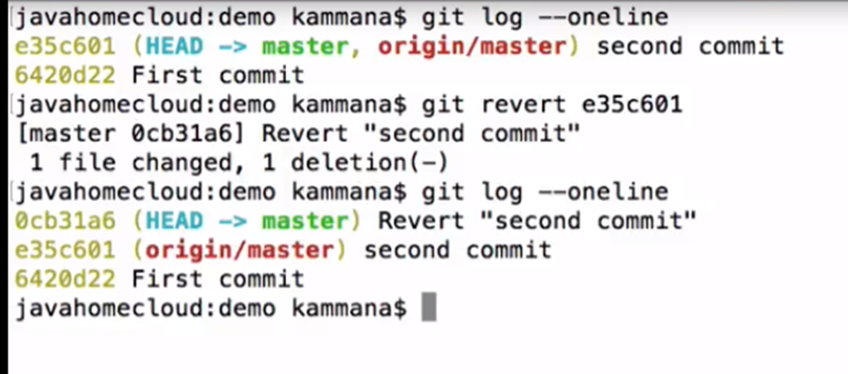

Git diff:-
Diferance in working area
git diff –color-words for all the files and for specific file git diff –color-words <filename>
git diff –color-words –staged for all the files specific file git diff –color-words –staged <filename>
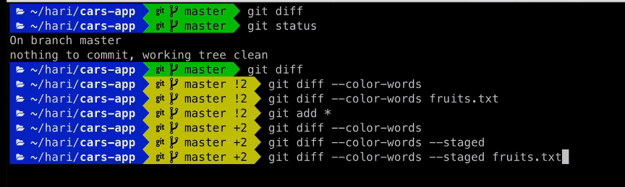
After commit
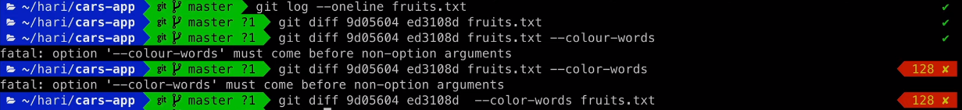
Comparing the branches
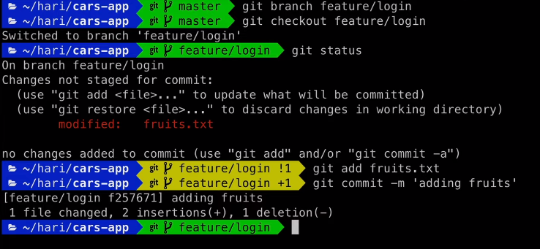
( to run it precise mode we use –color-words)
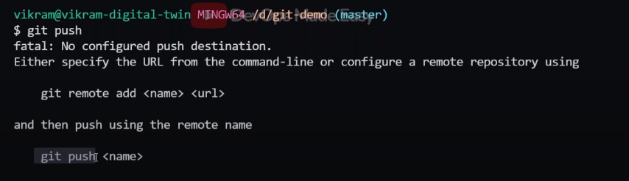
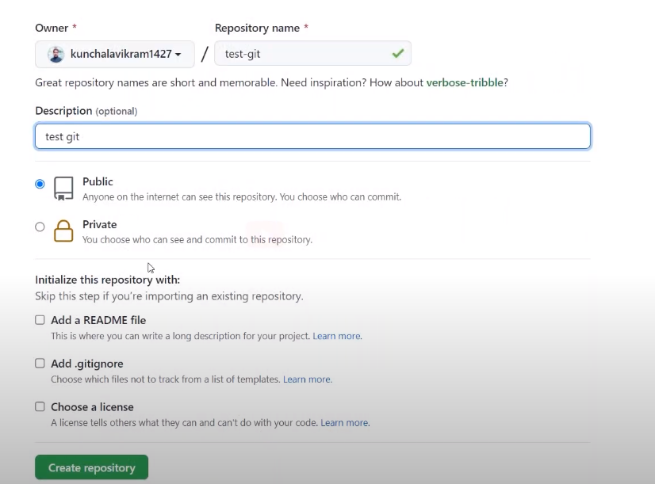
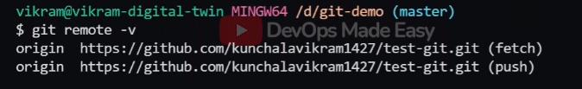

* git remote set-url origin new.git.url/here (to change the url)
- git pull origin master --allow-unrelated-histories

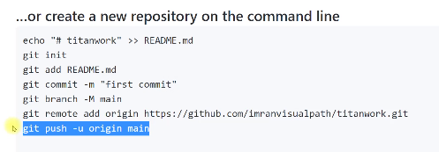
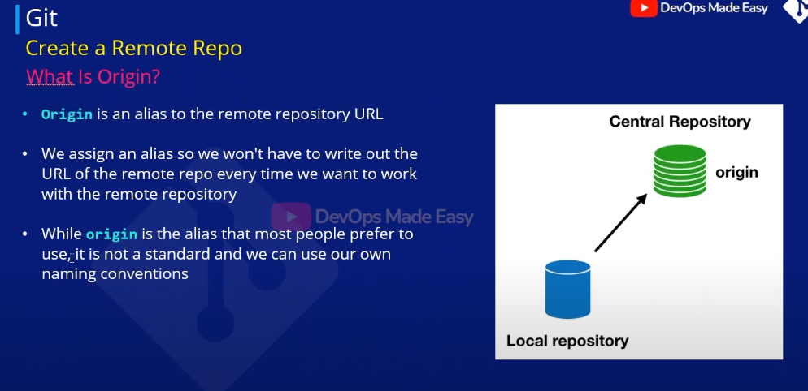
# Check out git config –global –list and git config –list (51 min)
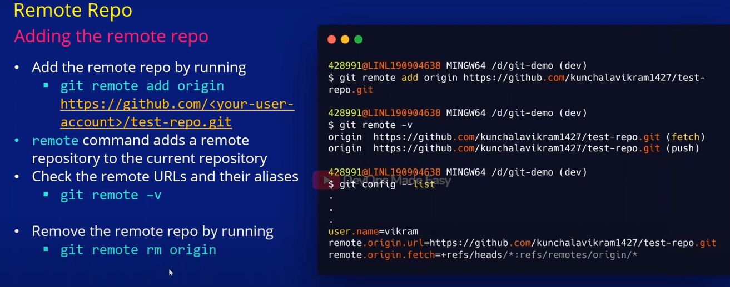
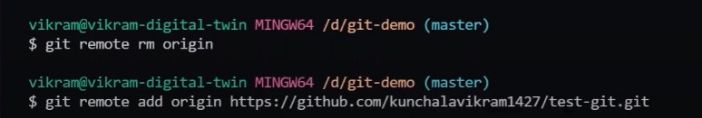
------------------------------------------------------------------------------------------------------------------------------------------

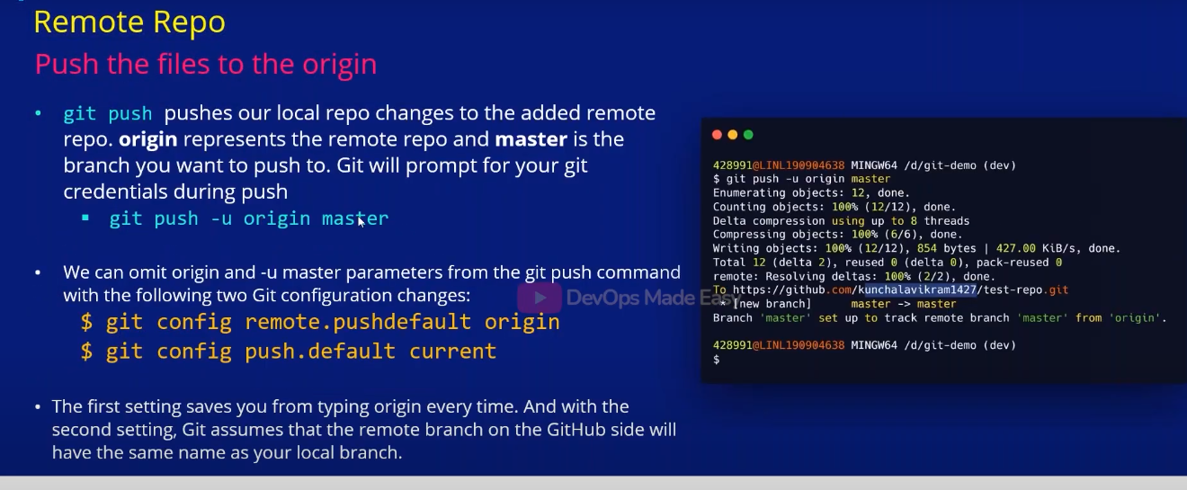
# Then you just type git push
# You can’t take a single file and move into another branch you will take everything like a snapshot and referenced to another branch

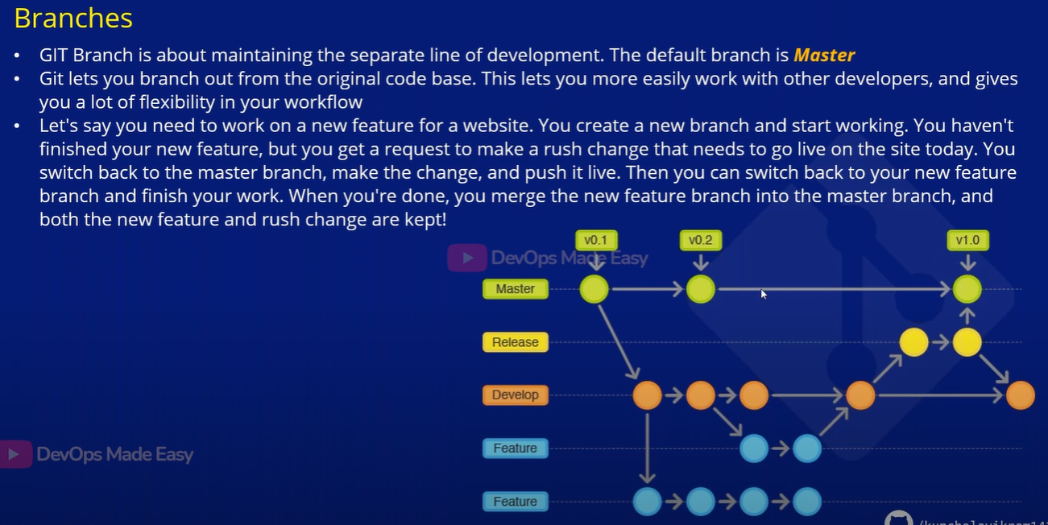
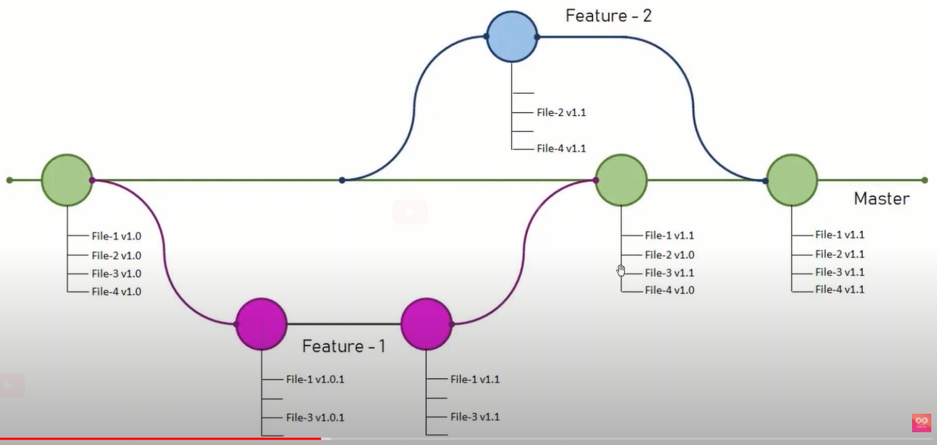
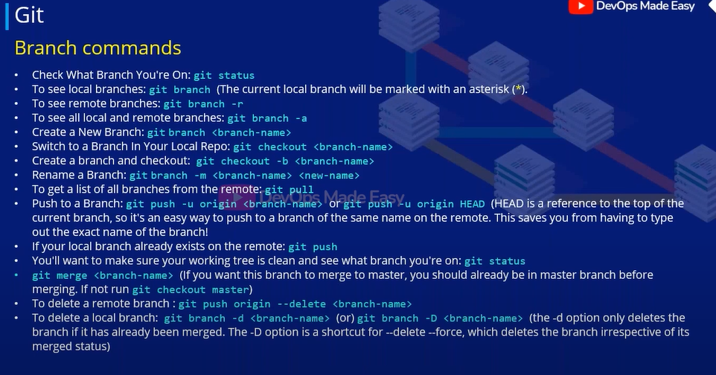
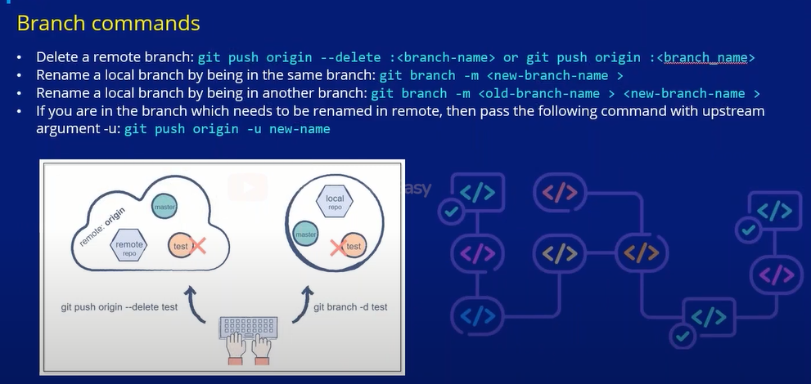
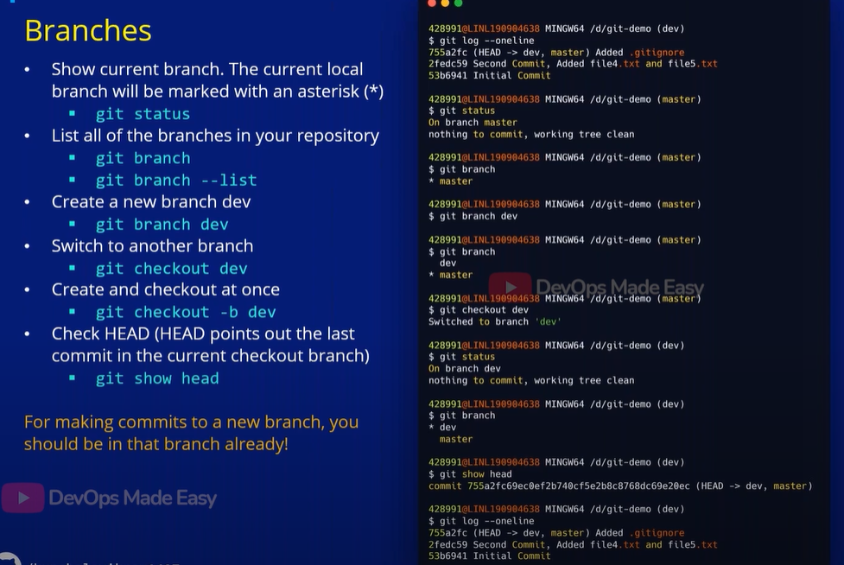
Note :-- before push just pull it then push ( to solve merge conflict)
# in dev 5 file created then create new branch feature by using command git checkout –b feature currently your in feature branch create file6 add and commit it and you want to merge it to dev then
First checkout to master git checkout dev ( basically file6 is not there) and git merge feature ( then you can able to see file6) merge is completed and check git log –oneline the feature and master branch pointing to same head because they are merged then you can delete feature branch git branch –d feature, check in remote still feature branch is there you have delete in remote also
git push origin :feature. (fast forword merge)

currently working on feature branch you added some functionality you didn’t committed yet then a manager is going to ask you there is a argent fix in dev branch then if you switch from feature branch to dev branch so all your changes has been last then what you will do is STASH them (temporarily storing your changes somewhere like stack) then you will switch to dev branch and make some commit and then go back to your feature branch then restore the changes by using git stash pop then all the changes comeback here
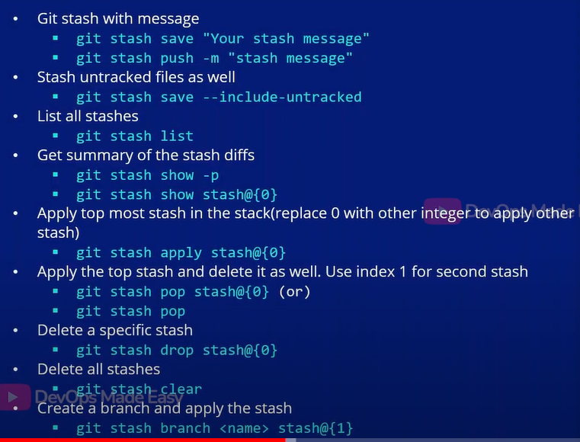

# git stash show –patch stash@{0} -> what all the changes show
------------------------------------------------------------------------------------------------------------------------------------------

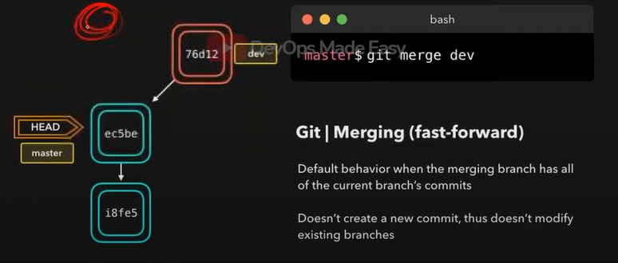
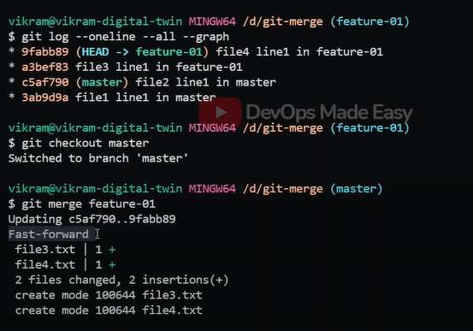
To get branches that are merged -> git branch –merged
To get branches that are not merged -> git branch –no-merged

# 3 way merge : --
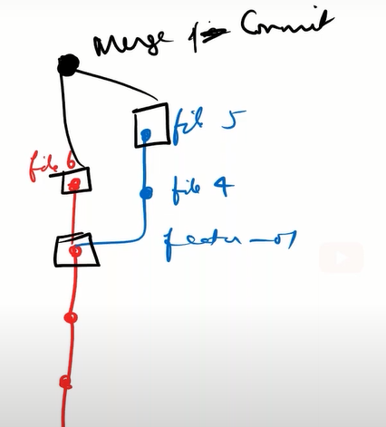
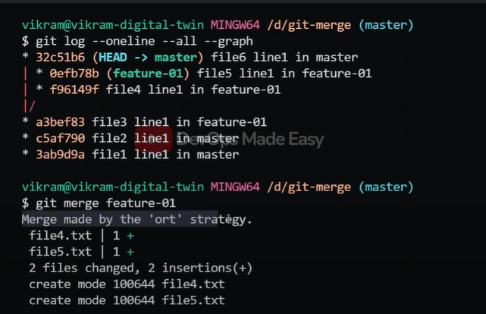

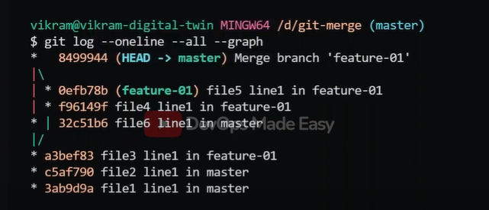

To revert back of commit id -→ git reset –hard commitidgit
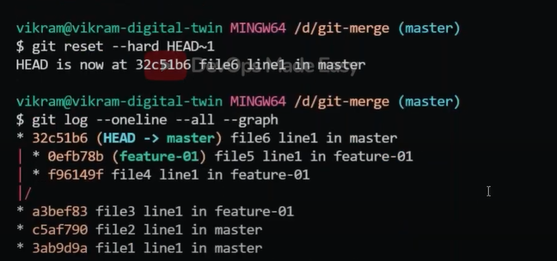

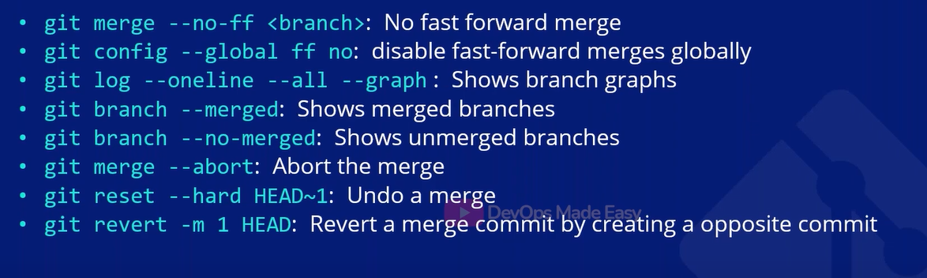
# let say dev1 and dev2 both are working an index.html file which is get from dev branch and they want to commit it to dev branch at that time merge conflict will accord

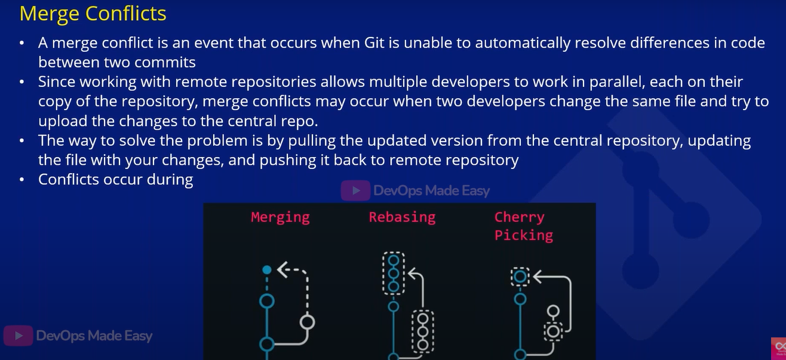

# we have file1 which is common both in dev and master (content is file1 line1)
-> in master I am adding content then add & commit it
-> git checkout dev (in that file1 content is file1 lin1) I am adding content like 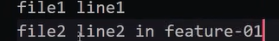 then add & commit it
-> now I want to merge git checkout master & git merge dev
( git merge –squash dev )

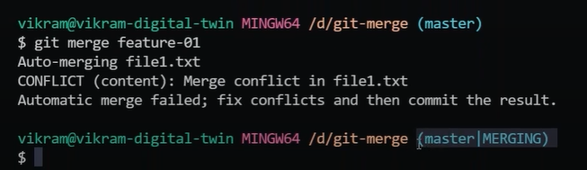
# Whichever is important you keep it In file1 (by discussing with that person) 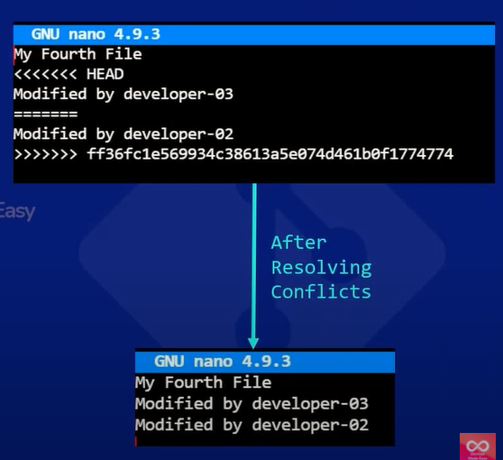
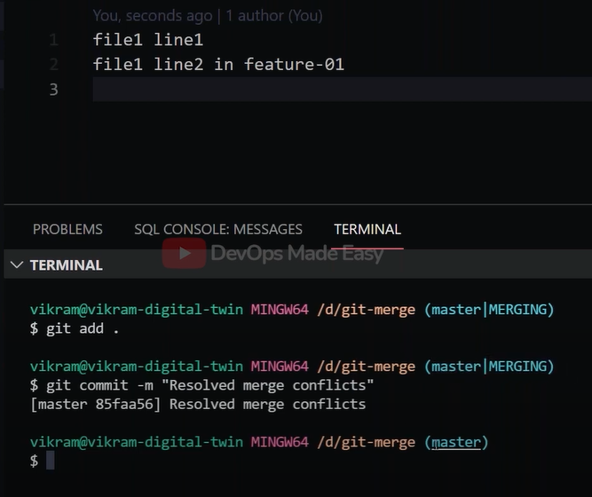
After resolving we have commit the changes
------------------------------------------------------------------------------------------------------------------------------------------

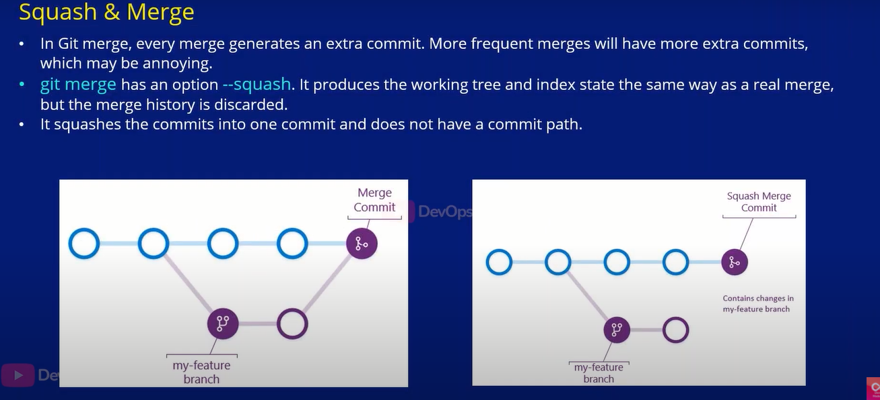

git merge –squash it won’t merge the branch but merge the changes ( generally we don’t use it)
*** git rebase –i HEAD^10
-----------------------------------------------------------------------------------------------------------------------------------------

git rebase → ( generally we don’t use it )
# if you want to merge feature branch to master git create new commit and integrate the changes in master ( a new commit is called merge commit)
# In rebase currently feature branch has base commit c1 after that master progress with couple of new commit now if I do rebase of feature branch then the base commit is updated to c1 to c3 according to this c2 and c3 got integrated with c5 ( you have to take care of that conflict)
• git branches linear
***** git rebase dev (in feature branch)
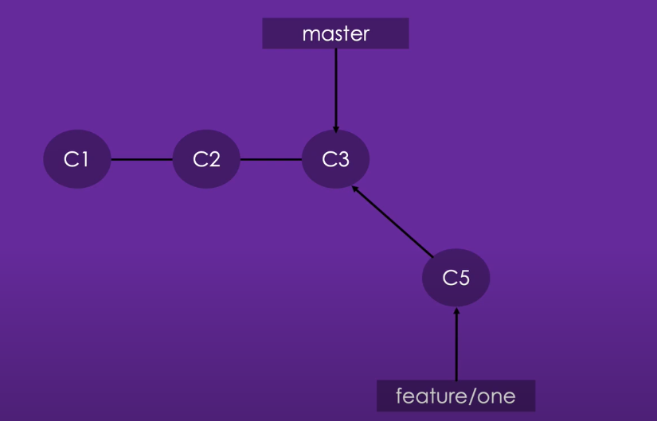

------------------------------------------------------------------------------------------------------------------------------------------

------------------------------------------------------------------------------------------------------------------------------------------
• Pull request in remote ( merge through remote) [56min]
Push changes to remote (dev branches)
Remote –> master → compare & pull request → create pull request → you can see pull request tag (click on it) -> merge pull request (click on confirm) -> your pull request got closed

Now over file has changed in remote to apply in local git pull origin master

Git cherry-pick

Let say you created one branch feature/one from master branch which have one.sh file
Feature/one branch you added some file three.sh and committed it and four.sh and committed it
Now I don’t want to commit both three.sh and four.sh just I want to commit three.sh to the master branch then
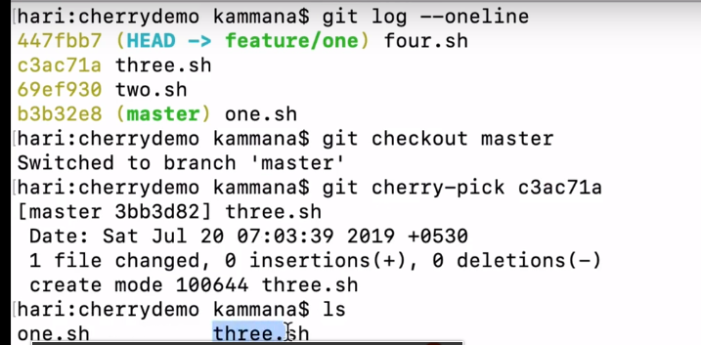

How to revert to previous version of a file :-
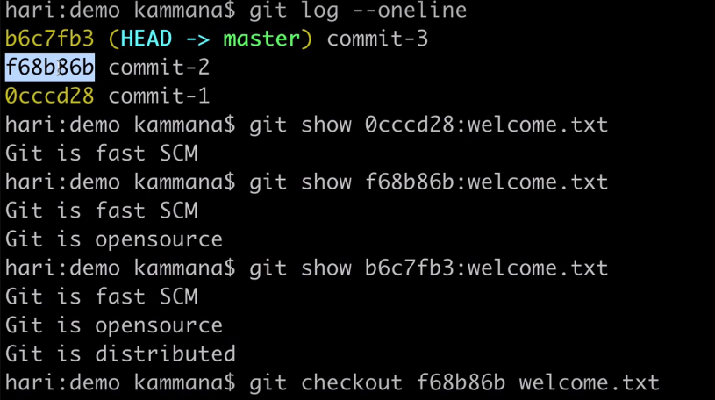
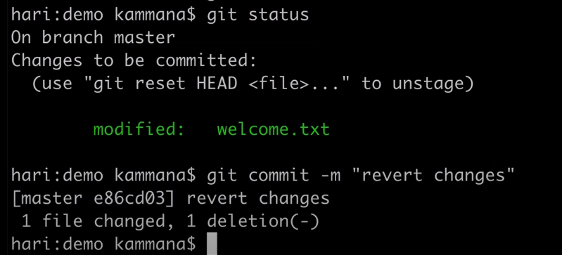
---- 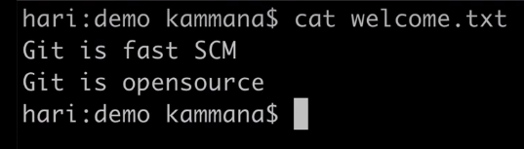-----------------------------------------------------------------------------------------------------------------------------------------------------------------------------------------------------------

Tagging in git : --- (tags are nothing but release point)
Let say this commit should be a stable release we will going provide tag for that commit id (it is easy to remember the tag name)
# once you make a tag you can’t override in the history because you lose the ability update in the history of the commits and allow you to identify specific release point

2 types –> Annotated tag and light weighted tag
* Light weighted tags --- it stores hash of the specific commit it will not carry any other information apert from that (we can’t give author )
* Annotated tag (meaning full tag) ---
Contain the tagging name, email, and date & having tagging message also
=> git tag –a “v1.0” –m “my release version 1.0”

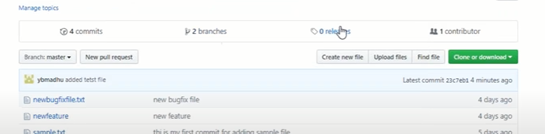

Once you create a tag when you push to remote repo you have to see that in release
-> git tag –a “v1.0” –m “my release version 1.0”
-> git tag
-> git show v1.o
-> git push origin master ( it will not pushed to remote repo)
-> git push origin v1.0 (you will see the tag in remote repo)

In case if you want to give tag at 3rd commit in (5 commits)
-> git tag v0.1 <commit_id>

git tag tagname --> to create a tag name (lightweight tag)
git checkout tagname --> switch to tag
git tag --> to list all tags
git tag -a tag_name -m "message" : create tag (Annotated tag)

git tag -d tagname --> to delete the tag (local)
git tag -d $(git tag -l) --> to delete all the tag
git push origin :refs/tags/v1.0 --> to delete the tag in remote
git push origin --delete $(git tag -l)

git push origin <tagname1> -> push the tag to remote
git push origin --tags -> push all the tags to remote

------------------------------------------------------------------------------------------------------------------------------------------



