­­­­­ A PROJECT REPORT

on

**MetaFortess**

*Submitted by*

**Mr. Pavan Arun Bagwe**

in partial fulfillment for the award of the degree

of

**BACHELOR OF SCIENCE**

in

**COMPUTER SCIENCE**

*under the guidance of*

**MR. SHIVKUMAR R. CHANDEY**

**Department of Computer Science**



**Nirmala Memorial Foundation College of Commerce and Science**

**Sem V**

**(2023 – 2024)**

**NIRMALA MEMORIAL FOUNDATION COLLEGE OF COMMERCE AND SCIENCE**

**Kandivali (East), Mumbai-400101**

*(Affiliated to University of Mumbai)*

**DEPARTMENT OF COMPUTER SCIENCE**



**CERTIFICATE**

This is to certify that the project entitled, **“Merafortess”,** is bonafied work of **Pavan Arun Bagwe** of **T.Y.B.Sc. CS** bearing Div./Roll No:____________ submitted in partial fulfilment of the requirements for the award of degree of BACHELOR OF SCIENCE in COMPUTER SCIENCE form University of Mumbai.

**Date of Submission: Head/Incharge,**

**Project Guide:**

**Department Computer Science**

**College Seal Signature of Examiner**

**ABSTRACT**

Metafortess is a comprehensive multimedia management platform, seamlessly integrating mobile applications, web interfaces, and a robust backend infrastructure. Developed with React Native for Android and iOS apps, React.js for the frontend, and powered by Node.js with Express.js and SQLite for the backend, Metafortess empowers users to effortlessly upload, organize, and access images, videos, and diverse media types from any location within their local network.

The system's core functionalities include advanced media search capabilities, enabling users to discover content based on embedded text within images. Notably, Metafortess facilitates efficient content deletion by allowing users to search and filter media with specific textual content, enhancing the management of their multimedia library.

**ACKNOWLEDGEMENT**

This is a sincere effort from me to express my heartfelt gratitude in creating the “**MetaFortess**” which is a desktop application.

I would like to thank **Prof. Shivkumar Chandey** for her help, motivation towards the project. Her guidance has helped me at the time of research and writing of thesis, continuous support, enthusiasm and immense knowledge has given a boost for the successful fulfilment of this project. I would also like to thank Co-ordinator of Bsc.IT/CS Department **Ms. Vaishali Mishra** and Principal

**Ms. Swiddle D’cunha**.

I take this opportunity to express my profound gratitude to management of **Nirmala Memorial**

**Foundation College of Commerce & Science** and the entire **Computer Science Department.**

I would like to thank all the teaching and non - teaching staff who have directly or indirectly helped in the successful creation of this project. I would like to thank my friends and family for helping me, encouraging me which led to the accomplishment of the project within the time frame.

This project has helped me gain a lot of practical experience which will be

beneficial to me in the future.

**DECLARATION**

I Pavan Arun Bagwe hereby declare that the project entitled Metafortess submitted in the partial fulfillment for the award of **Bachelor of Science** in **Computer Science** during the academic year **2023 - 2024** is my original work and the project has not formed the basis for the award of any degree, associateship, fellowship or any other similar titles.

.

**Signature of Student:**

**Place:**

**Date:**

**TABLE OF CONTENTS**

#1 Original copy of approved project proposal

#2 **Plagiarism report**

Chapter 1 1

1.1. Background 1

1.2. Objective 1

1.3. Purpose 2

1.4. Scope 2

1.5. Advantage 3

1.6. Front End 4

1.7. Back End 4

Chapter 2 5

2.1. Survey Of Technologies 5

2.1.1 Existing System 5

2.1.2 Limitations of Existing systems 6

2.1.3 Advantages over previous system: 6

2.2. Feasibility Study 7

2.2.1. Technical Feasibility 8

2.2.2. Operational Feasibility 9

2.2.3. Economic Feasibility 9

2.3. Table 1:Comparative Study 11

2.4. Selected Technologies 13

Chapter 3 13

3.1. Problem Definition 14

3.2. Software and Hardware Requirements: 11

3.3. Fig 1 Conceptual Models/SDLC Lifecycle 16

3.3.1. Planning phase 17

3.3.2. Requirement analysis stage 17

3.3.3. Software design and architectural phase 18

3.3.4. Coding / Development phase 19

3.3.5. Testing phase 20

3.3.6 Implementation / Deployment phase 20

3.3.7 Maintenance phase 20

3.4. Basic SDLC Methodologies 21

3.4.1. Waterfall Model 22

3.4.2. Iterative Model 22

3.4.3. Spiral Model 23

3.4.4. Agile Model 24

Chapter 4 25

4.1. UML 25

4.2. Use Case Diagram 26

4.2.1. Fig 2 Use-Case Diagram 27

4.3. Activity Diagram 28

4.3.1. Fig 3 Activity Diagram 29

4.4. Sequence Diagram 29

4.4.1 Fig 4 Sequence Diagram 30

4.5. State Machine Diagram 31

4.5.1. Fig 5 State Machine Diagram 31

Chapter 5 32

5.1. Implementation Approach 32

5.1.1. Fig 6 Phases of Prototyping 33

5.2. Coding 34

5.2.1. Fig 7 Transaction Code 36

5.2.2. Fig 8 SMART Contract 37

5.2.3. Fig 9 UI Code 38

5.3. Testing 39

5.3.1. Unit Testing 39

5.3.2. Integration Testing 40

5.4. Tools Requirement 41

5.5. Table 2: Test Cases 42

Chapter 6 43

6.1. Test Reports 43

6.2. Table 3 : Test Reports 43

6.3. User Documentation 44

6.3.1. Fig 10 UI Web 44

6.3.2. Fig 11 Upload Images 44

6.3.3. Fig 12 Upload from Android 45

Chapter 7 47

7.1. Conclusion 47

7.2. Limitations of the System 48

7.3. Future Scope 49

7.4. Refrence 50

7.5. Glossary 51

7.6. Appendices 53

**#1 Project Proposal**

**Title:** Metafortress

**Introducing Metafortress:** Your Personal Media Guardian

In the ever-evolving digital landscape, your media files are more than just data; they're your memories, your creativity, and your moments captured in time. But with the exponential growth of digital content, managing and safeguarding these treasures can be a daunting task. That's where Metafortress steps in.

**What is Metafortress?**

Metafortress is your digital stronghold, a robust and intelligent application meticulously designed to safeguard, organize, and streamline your media files. Whether you're at home or in the office, Metafortress serves as your personal media guardian, providing a secure and efficient way to manage your digital life.

**Cutting-Edge Technology**

At its core, Metafortress combines the power of React Native for mobile and React JS for the web, delivering a seamless and intuitive user experience. It operates within your local network, ensuring your media files remain under your complete control.

**AI-Driven Image Management**

Metafortress is not just a storage solution; it's a smart assistant. With built-in AI capabilities, it intelligently processes and categorizes your images, making it easier than ever to find that special moment or cherished memory. Say goodbye to endless scrolling and searching – let Metafortress do the heavy lifting.

**Multi-User Support**

Sharing your media fortress with loved ones or colleagues has never been simpler. Metafortress offers robust multi-user support, allowing you to grant access to select individuals while maintaining the utmost privacy and control over your files.

**Secure and Private**

We understand the value of your privacy, which is why Metafortress operates exclusively on your local network. Your data never leaves the comfort and security of your home or office. Rest easy, knowing your media files are protected from prying eyes.

Metafortress is not just an application; it's a promise to safeguard your digital legacy. Whether you're an enthusiast, a creative professional, or a family archivist, Metafortress is your fortress of protection, organization, and convenience. Welcome to a new era of media management – welcome to Metafortress.

**Objectives:**

**Media Management**: To provide users with a reliable and efficient platform for organizing, backing up, and synchronizing their media files, including photos, videos, and documents.

**User-Friendly Interface**: To create an intuitive and user-friendly interface accessible through both React Native mobile and React JS web applications, ensuring a seamless experience for users.

**AI Image Processing**: To implement AI-powered image recognition and categorization, enabling users to easily sort and search for media files based on content and metadata.

**Multi-User Support**: To develop a multi-user system with robust access controls, allowing users to share their media fortress with trusted individuals while maintaining data privacy.

**Local Network Operation**: To ensure Metafortress operates exclusively within the user's local network, guaranteeing data security and privacy.

**Scope:**

Metafortress will encompass the following key features:

**Media Upload and Backup**: Users can upload and back up media files from their devices to Metafortress.

**Media Synchronization**: Media files across multiple devices within the local network will be synchronized automatically.

**AI Image Recognition**: The AI component will process and categorize images based on content, location, date, and other metadata.

**User Management**: Admin controls to manage user access and permissions, enabling shared access to the media library.

**Web** **and** **Mobile** **Accessibility**: Metafortress will be accessible via both web and mobile applications, catering to a wide range of users

**Methodology:**

**Requirements Gathering**: Gather user requirements through surveys and feedback to define the application's features and functionality.

**Design and Wireframing**: Create wireframes and design mockups for both the mobile and web interfaces, ensuring a user-friendly and visually appealing design.

**Development**: Implement the front-end and back-end components using React Native for mobile and React JS for web.

**AI Integration**: Integrate AI-powered image recognition libraries and algorithms for image processing and categorization.

**User Authentication**: Implement user authentication and authorization mechanisms to manage user access.

**Testing**: Perform rigorous testing, including functionality, performance, and security testing, to ensure the application's stability.

**Deployment**: Deploy Metafortress within the user's local network, ensuring data remains secure and private.

**Documentation**: Create user guides and documentation for easy onboarding and troubleshooting.

**Tools and Technologies:**

**Front-end Development:**

* React Native for mobile app development
* React JS for web application development
* JavaScript and TypeScript for coding

**Back-end Development:**

Node.js for server-side development

Express.js for building RESTful APIs

**Database**:

SQLite for local user data storage

**AI Integration:**

TensorFlow and Opencv for AI image recognition

Python for AI model development

Version Control:

Git for version control and collaboration

Development Tools:

Visual Studio Code gnu Nano

Postman for API testing

Jest and Enzyme for testing

**Timeline:**

**June-July: Project Setup and Development**

* Hold initial project kickoff meetings.
* Define project scope, objectives, and requirements.
* Create a basic project plan.
* Set up version control tools (e.g., Git).
* Start gathering user requirements.
* Begin design phase and create wireframes.
* Develop front-end components using React Native and React JS.
* Initiate user authentication and authorization.
* Begin AI image recognition component development.

**August-September: Testing and Refinement**

* Continue front-end and back-end development.
* Integrate AI image recognition and synchronize media files.
* Conduct basic testing for functionality and performance.
* Gather initial user feedback for improvements.
* Refine user interface based on early feedback.
* Prepare simple user documentation.

**October-November: Finalization and Submission**

* Address any identified issues and bugs.
* Conduct final testing and quality assurance.
* Implement minor enhancements based on feedback.
* Prepare and submit the project.
* Conclude the project by November.

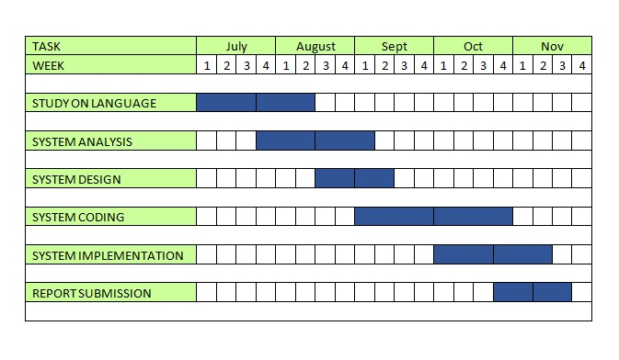

**Resources:**

**Hardware and Infrastructure:**

Development and Testing Servers

Local Network Hardware (for deployment)

**Software and Tools:**

Development IDEs (Visual Studio Code)

Version Control (Git/GitHub)

Collaboration Tools (Github)

Testing Tools (Postman)

AI/ML Libraries and Frameworks

Docker for Containerization

**Data:**

Media files for testing and development

AI training datasets

**Expected Outcomes:**

Fully Functional Application: The primary outcome is to deliver a fully functional Metafortress application that allows users to efficiently manage and secure their media files within their local network.

User-Friendly Interface: An intuitive and user-friendly interface for both mobile and web platforms that ensures a seamless user experience.

AI-Driven Image Processing: Implementation of AI image recognition and categorization, improving media file organization and accessibility.

Multi-User Support: A robust multi-user system with access controls to enable secure sharing of media libraries among trusted individuals.

Local Network Operation: Successful deployment of Metafortress within the local network, ensuring data privacy and security.

**References:**

During the development of Metafortress, you may refer to various resources and documentation to aid in the project. Some potential references include:

[1] React Native Documentation: https://reactnative.dev/docs/getting-started

React JS Documentation: https://reactjs.org/docs/getting-started.html

[2] Node.js Documentation: https://nodejs.org/en/docs/

.

**#2 SELF - ATTESTED PLAGARISM REPORT**

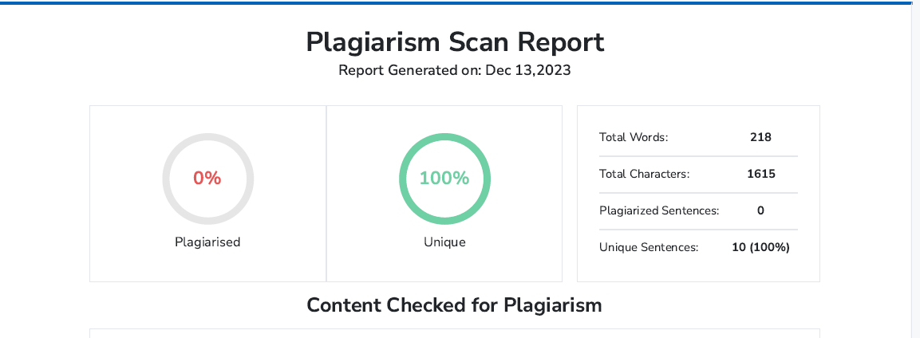

Chapter 1

**INTRODUCTION**

* 1. Background

In the contemporary landscape of multimedia management, Metafortess emerges as a pivotal solution designed to address the diverse needs of users in handling images, videos, and other media content. Traditional approaches to digital asset management have often faced challenges, prompting the development of innovative platforms like Metafortess..

* 1. Objective
* Provide users with a centralized and versatile platform for managing various media types.
* .Enable seamless uploading, efficient organization, and easy retrieval of media assets.
* Allow users to categorize and discover content based on embedded text within images.
  1. Purpose

**Streamlined Multimedia Management:** Metafortess is purpose-built to streamline multimedia management for users across diverse domains. By offering a centralized platform, it aims to simplify the process of uploading, organizing, and accessing various media types, including images, videos, and more. The goal is to empower users with an efficient and user-friendly solution for managing their digital assets seamlessly.

**Enhanced User Control and Security:** The core purpose of Metafortess extends to providing users with heightened control and security over their media assets. Through robust authentication mechanisms and adherence to industry-best security practices, Metafortess ensures that users can confidently manage and protect their multimedia content within their local network. This emphasis on security is fundamental to fostering trust and safeguarding valuable digital assets.

**Intuitive and Responsive User Experience:** Metafortess is designed with the purpose of delivering an intuitive and responsive user experience. Whether accessed through mobile applications or the web interface, the platform is crafted to facilitate effortless navigation and usage. The purpose is to offer users a seamless and enjoyable interaction with Metafortess, ensuring that multimedia management is not only efficient but also a user-friendly experience.

* 1. Scope
* Multimedia Hub:

Centralized platform for efficient management of diverse multimedia assets, enabling seamless uploading, organization, and access.

* Advanced Search Experience:

Implementation of advanced search functionalities for optimized content discovery based on embedded text within images, enhancing user interaction.

* Security and User Empowerment:

Robust security measures and user control mechanisms ensure data protection and a secure, personalized environment within the local network.

* 1. Advantage

Metafortess offers a myriad of advantages, foremost among them being its capability to efficiently organize multimedia assets through a centralized platform, simplifying the process of content categorization and management. Users benefit from advanced search functionalities, allowing precise content discovery based on embedded text within images. The platform stands out for its commitment to robust security measures, implementing strong authentication mechanisms to protect user data and ensuring a secure environment for managing and accessing multimedia assets. Additionally, Metafortess provides an intuitive and responsive user interface across platforms, delivering a seamless and user-friendly experience for both mobile and web users, further enhancing its overall usability and accessibility.

* 1. Front End

React

|  |  |
| --- | --- |
| React is a framework that employs Webpack to automatically compile React, JSX, and ES6 code while handling CSS file prefixes. React is a JavaScript-based UI development library.  React offers various extensions for entire application architectural support, such as Flux and React Native, beyond mere UI. |  |

|  |  |
| --- | --- |
| React Native is a JavaScript framework for building cross-platform mobile apps, letting developers use a single codebase for iOS and Android. With a declarative syntax and hot-reloading, it's efficient and supports native code integration. Its modular design and community support make it widely used for mobile development. |  |

* 1. Back End

|  |  |
| --- | --- |
|  | Node.js, a JavaScript runtime, and Express.js, a minimal web application framework for Node, form a powerful backend combination. Node.js allows server-side JavaScript execution, while Express.js simplifies building robust web applications with its minimalist design. Together, they offer a scalable, efficient, and flexible backend solution, ideal for creating APIs and handling server-side logic in web applications. |

Chapter 2

**System Analysis**

* 1. **Survey Of Technologies**

2.1.1 **Existing System**

In the contemporary landscape of multimedia management, Metafortess emerges as a transformative project, introducing innovative solutions to streamline the organization and access of multimedia content. While existing cloud storage services like Google Photos and Google Drive offer convenient options for users to store and access media remotely, Metafortess differentiates itself by providing a local server deployment within the home network. This facilitates quick and direct access to media files from anywhere within the home, eliminating dependencies on external cloud services and offering enhanced privacy.

In comparison to manual image management on local computers, Metafortess stands out with its intuitive mobile applications and web interface, providing a user-friendly platform for uploading, categorizing, and discovering media content. The embedded text search functionality adds a layer of sophistication, allowing users to find images based on specific content, a feature not commonly found in traditional manual management or cloud storage systems

2.1.2 Limitations of Existing systems

* **Paid Subscription Models:**
  + Existing cloud storage solutions, such as Google Photos and Google Drive, often rely on paid subscription models for expanded storage.
  + Users may face constraints with storage limits in free plans, leading to financial barriers for accessing additional space.
* **Data Privacy and Security Concerns:**
  + Reliance on external servers in cloud storage solutions raises concerns about data privacy and security.
  + Users may be apprehensive about potential data breaches or unauthorized access to their sensitive multimedia content.
* **Manual Organization Challenges:**
  + Traditional cloud storage solutions lack sophisticated embedded text search capabilities.
  + Users are required to perform manual organization and tagging for effective content retrieval, resulting in a less streamlined user experience.
    1. **Advantages over previous system**:
* . **Cost-Effective Accessibility:**
  + Metafortess offers a cost-effective solution without the reliance on paid subscription models, providing expanded multimedia storage within the local network without recurring costs.
* **Enhanced Data Privacy and Security:**
  + By deploying a local server within the home network, Metafortess mitigates concerns related to data privacy and security, ensuring that users have greater control over their sensitive multimedia content.
* **Effortless Content Retrieval:**
  + Metafortess outshines traditional cloud storage by introducing sophisticated embedded text search capabilities. Users can effortlessly retrieve images based on specific text within them, eliminating the need for manual organization and tagging.
* **User-Centric, Decentralized Management:**
  + Metafortess adopts a user-centric approach by prioritizing user control over multimedia assets. It eliminates the need for intermediaries and external servers, providing a decentralized management solution that aligns with evolving user expectations.
* **Streamlined User Experience:**
  + The intuitive mobile applications and web interface of Metafortess enhance the overall user experience, offering a convenient platform for uploading, organizing, and accessing multimedia content.

* 1. **Feasibility Study**

Feasibility study is one of stage among important four stages of Software Project Management Process. As name suggests feasibility study is the feasibility analysis or it is a measure of the software product in terms of how much beneficial product development will be for the organization in a practical point of view. Feasibility study is carried out based on many purposes to analyse whether software product will be right in terms of development, implantation, contribution of project to the organization etc.

With respect to this Project:

There are two components of this prototype. First the client-side software, then the server-side software. There are also authentication factors involved such as Hashing.

**Types of Feasibility Study:**

* Technical Feasibility
* Operational Feasibility
* Economic Feasibility
  + 1. Technical Feasibility

In Technical Feasibility current resources both hardware software along with required technology are analysed/assessed to develop project. This technical feasibility study gives report whether there exists correct required resources and technologies which will be used for project development.  Along with this, feasibility study also analyses technical skills and capabilities of technical team, existing technology can be used or not, maintenance and up-gradation is easy or not for chosen technology etc.

With respect to this project:

The technical feasibility of Metafortess is assured through the integration of React.js, React Native, Node.js, and Express.js, providing a responsive and user-friendly multimedia management platform. Utilizing a local server within the home network optimizes resource utilization, enhancing accessibility and ensuring data privacy and security. The modular architecture allows for seamless maintenance and upgradation, showcasing Metafortess's commitment to innovation and adaptability

* + 1. Operational Feasibility

In Operational Feasibility degree of providing service to requirements is analysed along with how much easy product will be to operate and maintenance after deployment. Along with these other operational scopes are determining usability of product, determining suggested solution by software development team is acceptable or not etc.

With respect to this project:

The operational feasibility of Metafortess is underpinned by its intuitive user interface, robust security measures, and commitment to regulatory compliance. The user-friendly design facilitates seamless multimedia management, ensuring accessibility and efficiency for a diverse user base. Comprehensive security protocols, including encryption and authentication mechanisms, safeguard user data and media assets, contributing to a secure operational environment. Metafortess aligns with regulatory standards, enhancing its credibility and ensuring that users can confidently engage in multimedia operations within the framework of legal requirements. Together, these operational facets ensure a smooth, secure, and compliant user experience, positioning Metafortess as a viable and user-centric multimedia management solution.

* + 1. Economic Feasibility

In Economic Feasibility study cost and benefit of the project is analysed. Means under this feasibility study a detail analysis is carried out what will be cost of the project for development which includes all required cost for final development like hardware and software resource required, design and development cost and operational cost and so on. After that it is analysed whether project will be beneficial in terms of finance for organization or not.

With respect to this project:

Metafortess demonstrates strong economic feasibility as an open-source and freely accessible multimedia management solution. The adoption of an open-source model eliminates licensing costs, making Metafortess a cost-effective choice for users seeking robust multimedia management capabilities. Users benefit from a platform that is not only free but also fosters collaboration and community-driven development. The open-source nature ensures continuous improvement, adaptability, and the potential for widespread adoption without financial barriers. This economic model positions Metafortess as a sustainable and accessible solution, aligning with the principles of affordability, inclusivity, and community engagement.

Table 1: Comparative Study

**Technology Features Advantages Disadvantages**

|  |
| --- |
|  |
| React | Declarative | Efficiency | Learning Curve |
|  | Component-Based | Maintainability | Tooling Complexity |
|  | Virtual DOM | Community | SEO Challenges |
|  | Reusable | JSX | Limited Documentation |
| React native | React Native enables cross-platform app development using JavaScript, | **Portability**  **Low Manoeuvre Language**  **Great Memory Management** | Some disadvantages of React Native include occasional performance issues due to JavaScript. |
| Sqlite Database | Scalability and Performance  Availability  Backup and Recovery  Security | **Performance**  **Editions**  **Failure Recovery**  **Clusters**  **Multiple Database** | **Relatively new Technology**  **Many features require licensing** |
| javascript | Versatile language for web development, supports both front-end and back-end | **Transparency**  **Efficiency**  **Automation**  **Decentralization** | **Security**  **Complexity**  **Lack Of Formal Verification**  **Learning Curve** |
| python | Independent | Simple | slow and has |
| Portable | Object- | a poor |
| Simple and | Oriented | performance |
| Familiar | Programming | no backup |
| interpreted | language | facility |

* 1. Selected Technologies

**List of Technologies:**

* React
* React Native
* Node.js Express.js
* Sqlite
* Python (image analysis)

**Selected Technologies and why?**

**React:**

React is chosen for the frontend development of Metafortess due to its efficiency in handling dynamic user interfaces. With JSX syntax and component-based architecture, React facilitates the creation of an intuitive and responsive user interface across platforms, including web and mobile applications. The modular design of React aligns well with the goal of building a user-friendly multimedia management platform.

**React Native:**

React Native extends the capabilities of React to mobile application development. Leveraging React Native allows for the creation of cross-platform mobile applications for both Android and iOS devices using a single codebase. This enables Metafortess to provide a consistent and seamless user experience across various mobile devices.

**Node.js with express.js:**

Node.js, coupled with Express.js, is employed for the backend development of Metafortess. This technology duo offers a lightweight and efficient runtime environment for server-side operations. The event-driven, non-blocking I/O model of Node.js ensures scalability, and Express.js simplifies the development of robust APIs, contributing to the overall responsiveness and performance of Metafortess**.**

**Python (for Image Analysis):**

Python is incorporated for image analysis within Metafortess. Its extensive libraries, such as OpenCV and Tesseract, make it well-suited for extracting text from images and implementing advanced search functionalities. Python's versatility and ease of integration complement Metafortess's goal of offering efficient content discovery based on embedded text within images.

Chapter 3

**Requirement & Analysis**

* 1. **Problem Definition**

In the contemporary digital landscape, individuals encounter challenges in effectively organizing, accessing, and managing their diverse multimedia assets across multiple devices within a home network. Existing solutions often present limitations, such as reliance on paid cloud storage, potential privacy concerns, and the absence of advanced search capabilities based on content within images. Metafortess addresses these challenges by offering a decentralized and user-controlled multimedia management platform. The platform aims to streamline the process of uploading, organizing, and retrieving images, videos, and various media types. By deploying a local server within the home network and integrating innovative technologies like image analysis for text search, Metafortess seeks to provide a cost-effective, secure, and user-friendly solution that enhances the overall multimedia management experience for users within the comfort of their homes.

* 1. **Software and Hardware Requirements**:

The minimum hardware and software requirement for the project will be as fellow:

**Hardware Requirements:**

1. Processor – i3 7th Gen Minimum
2. RAM – 16 GB Minimum
3. OS – Windows 10 Minimum

**Software Requirements:**

. **Frontend:**

1. **React:**
   * Version: Latest stable release
   * Description: React.js for building the user interface of Metafortess, providing a modular and efficient development framework.
2. **React Native:**
   * Version: Latest stable release
   * Description: React Native for mobile application development, enabling the creation of cross-platform applications for Android and iOS devices.

**Backend:**

1. **Node.js:**
   * Version: Latest LTS release
   * Description: Node.js as the runtime for server-side development, ensuring scalability and efficient handling of asynchronous operations.
2. **Express.js:**
   * Version: Latest stable release
   * Description: Express.js as the backend framework for building robust APIs and handling HTTP requests/responses.

**Database:**

1. **SQLite:**
   * Version: Latest stable release
   * Description: SQLite as the relational database management system for storing and retrieving multimedia assets within the local server.

**Image Analysis:**

1. **Python:**
   * Version: 3.x
   * Description: Python for implementing image analysis functionalities, leveraging libraries like OpenCV and Tesseract for extracting text from images.

**Containerization:**

1. **Docker:**
   * Version: Latest stable release
   * Description: Docker for containerization, ensuring consistency and portability of Metafortess across various environments.

**Development Tools:**

1. **Package Manager (npm):**
   * Version: Latest stable release
   * Description: A package manager for installing and managing dependencies in the development environment.
2. **Code Editor (Gnu nano, Visual Studio Code):**
   * Version: Latest stable release
   * Description: A code editor for frontend and backend development, providing features for code organization and debugging.

**Version Control:**

1. **Git:**
   * Version: Latest stable release
   * Description: Git for version control, enabling collaborative development and tracking changes to the Metafortess codebase.
   1. Fig 1 **Conceptual Models/SDLC Lifecycle**

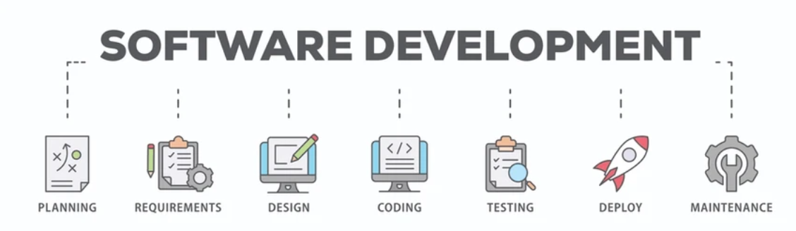

**SDLC or the Software Development Life Cycle** is a process that produces software

with the highest quality and lowest cost in the shortest time possible. SDLC provides a

well-structured flow of phases that help an organization to quickly produce high-quality

software which is well-tested and ready for production use.

**How the SDLC Works**

SDLC works by lowering the cost of software development while simultaneously

improving quality and shortening production time. SDLC achieves these apparently

divergent goals by following a plan that removes the typical pitfalls of software

development projects. That plan starts by evaluating existing systems for deficiencies.

Next, it defines the requirements of the new system. It then creates the software through

the stages of analysis, planning, design, development, testing, and deployment. By

anticipating costly mistakes like failing to ask the end-user or client for feedback, SLDC

can eliminate redundant rework and after-the-fact fixes.

It’s also important to know that there is a strong focus on the testing phase. As the SDLC

is a repetitive methodology, you have to ensure code quality at every cycle. Many

organizations tend to spend few efforts on testing while a stronger focus on testing can

save them a lot of rework, time, and money. Be smart and write the right types of tests.

**3.3.1.** Planning phase

|  |  |
| --- | --- |
| The planning stage (also called the feasibility stage) is exactly what it sounds like: the phase in which developers will plan for the upcoming project. |  |

It helps to define the problem and scope of any existing systems, as well as determine the objectives for their new systems. By developing an effective outline for the upcoming development cycle, they'll theoretically catch problems before they affect development.

And help to secure the funding and resources they need to make their plan happen.

Perhaps most importantly, the planning stage sets the project schedule, which can be of key importance if development is for a commercial product that must be sent to market by a certain time.

3.3.2. Requirement analysis stage

|  |  |
| --- | --- |
|  | The analysis stage includes gathering all the specific details required for a new system as well as determining the first ideas for prototypes. |

Developers may:

* Define any prototype system requirements
* Evaluate alternatives to existing prototypes
* Perform research and analysis to determine the needs of end-users

Furthermore, developers will often create a software requirement specification or SRS document.

This includes all the specifications for software, hardware, and network requirements for the system they plan to build. This will prevent them from overdrawing funding or resources when working at the same place as other development teams.

3.3.3. Software design and architectural phase

|  |  |
| --- | --- |
| The design stage is a necessary precursor to the main developer stage. |  |

Developers will first outline the details for the overall application, alongside specific aspects, such as its:

* User interfaces
* System interfaces
* Network and network requirements
* Databases

They’ll typically turn the SRS document they created into a more logical structure that can later be implemented in a programming language. Operation, training, and maintenance plans will all be drawn up so that developers know what they need to do throughout every stage of the cycle moving forward.

Once complete, development managers will prepare a design document to be referenced throughout the next phases of the SDLC.

3.3.4. Coding / Development phase

|  |  |
| --- | --- |
|  | The development stage is the part where developers actually write code and build the application according to the earlier design documents and outlined specifications.  This is where Static Application Security Testing or SAST tools come into play. |

Product program code is built per the design document specifications. In theory, all of the prior planning and outlined should make the actual development phase relatively straightforward. Developers will follow any coding guidelines as defined by the organization and utilize different tools such as compilers, debuggers, and interpreters.

Programming languages can include staples such as C++, PHP, and more. Developers will choose the right programming code to use based on the project specifications and requirements.

3.3.5. Testing phase

|  |  |
| --- | --- |
|  | Building software is not the end.  Now it must be tested to make sure that there aren’t any bugs and that the end-user experience will not negatively be affected at any point. |

During the testing stage, developers will go over their software with a fine-tooth comb, noting any bugs or defects that need to be tracked, fixed, and later retested.

it’s important that the software overall ends up meeting the quality standards that were previously defined in the SRS document.

3.3.6 Implementation / Deployment phase

|  |  |
| --- | --- |
| After testing, the overall design for the software will come together. Different modules or designs will be integrated into the primary source code through developer efforts, usually by leveraging training environments to detect further errors or defects. |  |

The information system will be integrated into its environment and eventually installed. After passing this stage, the software is theoretically ready for market and may be provided to any end-users.

3.3.7 Maintenance phase

|  |  |
| --- | --- |
|  | The SDLC doesn’t end when software reaches the market. Developers must now move into a maintenance mode and begin practicing any activities required to handle issues reported by end-users. |

Furthermore, developers are responsible for implementing any changes that the software might need after deployment.

This can include handling residual bugs that were not able to be patched before launch or resolving new issues that crop up due to user reports. Larger systems may require longer maintenance stages compared to smaller systems.

* 1. **Basic SDLC Methodologies**

Although the system development life cycle is a project management model in the broad sense, six more specific methodologies can be leveraged to achieve specific results or provide the greater SDLC with different attributes.

3.4.1. Waterfall Model

|  |  |
| --- | --- |
| The waterfall model is the oldest of all SDLC methodologies. It’s linear and straightforward and requires development teams to finish one phase of the project completely before moving on to the next. | waterfall icon |

Each stage has a separate project plan and takes information from the previous stage to avoid similar issues (if encountered). However, it is vulnerable to early delays and can lead to big problems arising for development teams later down the road.

3.4.2. Iterative Model

|  |  |
| --- | --- |
| Iteration - Free business and finance icons | The iterative model focuses on repetition and repeat testing. New versions of a software project are produced at the end of each phase to catch potential errors and allow developers to constantly improve the end product by the time it is ready for market. |

One of the upsides to this model is that developers can create a working version of the project relatively early in their development life cycle, so implement the changes are often less expensive.

3.4.3. Spiral Model

|  |  |
| --- | --- |
| Spiral models are flexible compared to other methodologies. Projects pass through four main phases again and again in a metaphorically spiral motion. | spiral model |

It’s advantageous for large projects since development teams can create very customized products and incorporate any received feedback relatively early in the life cycle.

3.4.4. Agile Model

|  |  |
| --- | --- |
| Top Agile Methodology Stock Vectors, Illustrations & Clip Art - iStock |  Agile, Scrum, Agile methodology icon | The agile model is relatively well-known, particularly in the software development industry. |

The agile methodology prioritizes fast and ongoing release cycles, utilizing small but incremental changes between releases. This results in more iterations and many more tests compared to other models.

Theoretically, this model helps teams to address small issues as they arise rather than missing them until later, more complex stages of a project.3.5. Selected SDLC Model

**List of Models:**

* Waterfall Model
* Iterative Model
* Spiral Model
* Agile Model

**Selected Methodology and Why?**

**Waterfall Model**

The waterfall model is the oldest of all SDLC methodologies. It’s linear and straightforward and requires development teams to finish one phase of the project completely before moving on to the next.

Each stage has a separate project plan and takes information from the previous stage to avoid similar issues (if encountered). However, it is vulnerable to early delays and can lead to big problems arising for development teams later down the road.

In case of this project:

Waterfall model provides the best environment which is easily understandable and easy to use and implement.

Chapter 4

**System Design**

* 1. **UML**

UML is an acronym that stands for Unified Modeling Language. Simply put, UML is a modern approach to modeling and documenting software. In fact, it’s one of the most popular business process modeling techniques.

It is based on diagrammatic representations of software components. As the old proverb says: “a picture is worth a thousand words”. By using visual representations, we are able to better understand possible flaws or errors in software or business processes.

UML was created as a result of the chaos revolving around software development and documentation. In the 1990s, there were several different ways to represent and document software systems. The need arose for a more unified way to visually represent those systems and as a result, in 1994-1996, the UML was developed by three software engineers working at Rational Software. It was later adopted as the standard in 1997 and has remained the standard ever since, receiving only a few updates.

* 1. **Use Case Diagram**

A **use case diagram** is a graphical depiction of a user's possible interactions with a system. A use case diagram shows various use cases and different types of users the system has and will often be accompanied by other types of diagrams as well. The use cases are represented by either circles or ellipses. The actors are often shown as stick figures.

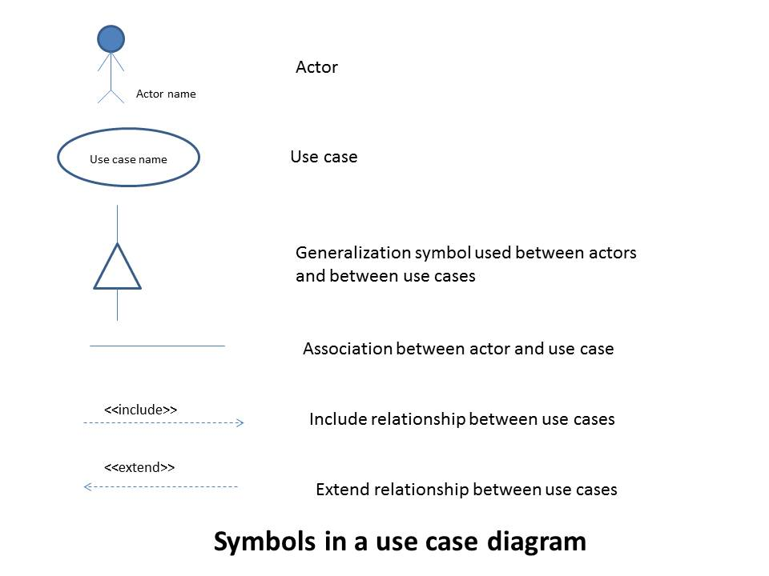

* + 1. Fig 2 Use-Case Diagram

* 1. **Activity Diagram**

**Activity diagrams** are graphical representations of [workflows](https://en.wikipedia.org/wiki/Workflow) of stepwise activities and actions with support for choice, iteration and concurrency. In the [Unified Modeling Language,](https://en.wikipedia.org/wiki/Unified_Modeling_Language) activity diagrams are intended to model both computational and organizational processes (i.e., workflows), as well as the data flows intersecting with the related activities. Although activity diagrams primarily show the overall flow of control, they can also include elements showing the flow of data between activities through one or one or more data stores

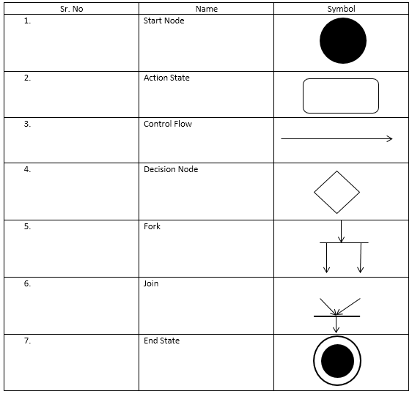

**4.3.1**.  Fig 3 Activity Diagram

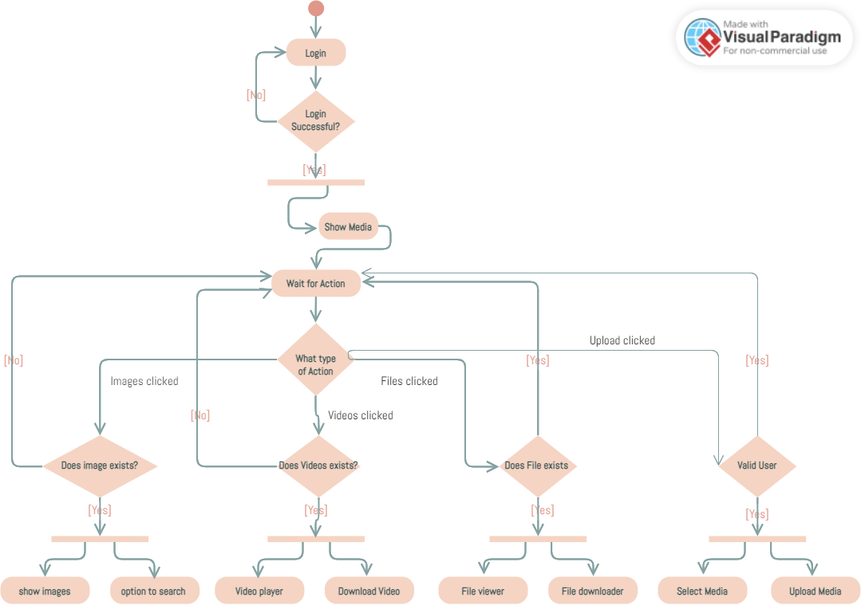

* 1. Sequence Diagram

A sequence, in a general context, refers to the order or arrangement of events, actions, or elements as they occur or follow one another in a specific progression. In the realm of software engineering and system design, a sequence diagram is a type of UML diagram that illustrates the dynamic interactions between various objects or components within a system over time. Sequence diagrams are valuable tools for understanding and designing the behavior of systems, helping developers visualize the runtime interactions and relationships between different entities in a software applications.

4.4.1 Fig 4 Sequence Diagram

* 1. State Machine Diagram

A state machine diagram is a visual representation in the Unified Modeling Language (UML) that depicts the different states an object or system can exist in, as well as the transitions between these states. It is particularly useful for modeling the behavior of an entity that undergoes distinct, well-defined states in response to events or conditions. The diagram typically consists of states, transitions, and events, with each state representing a specific condition or mode of the system. Transitions define the movement between states triggered by events, and the conditions under which these transitions occur. State machine diagrams are widely employed in software engineering to model the behavior of complex systems, such as the various states and transitions a software component may experience during its lifecycle.

* + 1. Fig 5 State Machine Diagram

Chapter 5

**IMPLEMENTATION & TESTING**

* 1. Implementation Approach

The prototype model requires that before carrying out the development of actual software, a working prototype of the system should be built. A prototype is a toy implementation of the system. A prototype usually turns out to be a very crude version of the actual system, possible exhibiting limited functional capabilities, low reliability, and inefficient performance as compared to actual software.

In many instances, the client only has a general view of what is expected from the

software product. In such a scenario where there is an absence of detailed information regarding the input to the system, the processing needs, and the output requirement, the prototyping model may be employed.

The prototype model requires that before carrying out the development of actual software, a working prototype of the system should be built. A prototype is a toy implementation of the system.

A prototype usually turns out to be a very crude version of the actual system, possible exhibiting limited functional capabilities, low reliability, and inefficient performance as compared to actual software. In many instances, the client only has a general view of what is expected from the software product.

In such a scenario where there is an absence of detailed information regarding the input to the system, the processing needs, and the output requirement, the prototyping model may be employed.

**The prototyping Model has following six phases as follows:**

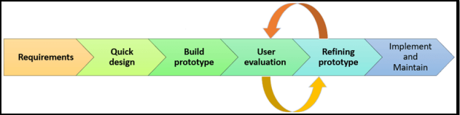

* + 1. Fig 6 Phases of Prototyping

**Step 1: Requirements gathering and analysis**

A prototyping model starts with requirement analysis. In this phase, the requirements of the system are defined in detail. During the process, the users of the system are interviewed to know what their expectation from the system is.

**Step 2: Quick design**

The second phase is a preliminary design or a quick design. In this stage, a simple design of the system is created. However, it is not a complete design. It gives a brief idea of the system to the user. The quick design helps in developing the prototype.

**Step 3: Build a Prototype**

In this phase, an actual prototype is designed based on the information gathered from quick design. It is a small working model of the required system.

**Step 4: Initial user evaluation**

In this stage, the proposed system is presented to the client for an initial evaluation. It helps to find out the strength and weakness of the working model. Comment and suggestion are collected from the customer and provided to the developer.

**Step 5: Refining prototype**

If the user is not happy with the current prototype, you need to refine the prototype according to the user’s feedback and suggestions.

This phase will not over until all the requirements specified by the user are met. Once the user is satisfied with the developed prototype, a final system is developed based on the approved final prototype

**Step 6: Implement Product and Maintenance**

Once the final system is developed based on the final prototype, it is thoroughly tested and

deployed to production. The system undergoes routine maintenance for minimizing downtime and prevent large-scale failures.

**Advantages**

* Users are actively involved in development. Therefore, errors can be detected in the initial stage of the software development process.
* Missing functionality can be identified, which helps to reduce the risk of failure as Prototyping is also considered as a risk reduction activity.
* Helps team member to communicate effectively
* Customer satisfaction exists because the customer can feel the product at a very early stage.
* There will be hardly any chance of software rejection.
* Quicker user feedback helps you to achieve better software development solutions.
* Allows the client to compare if the software code matches the software specification.
* It helps you to find out the missing functionality in the system.
* It also identifies the complex or difficult functions.
* Encourages innovation and flexible designing.

**Disadvantages**

* Prototyping is a slow and time taking process.
* The cost of developing a prototype is a total waste as the prototype is ultimately thrown away.
* Prototyping may encourage excessive change requests.
* Sometimes customers may not be willing to participate in the iteration cycle for the longer time duration.
* There may be far too many variations in software requirements when each time the prototype is evaluated by the customer.
* Poor documentation because the requirements of the customers are changing.
* It is very difficult for software developers to accommodate all the changes demanded by the clients.
* After seeing an early prototype model, the customers may think that the actual product will be delivered to him soon.
* The client may lose interest in the final product when he or she is not happy with the initial prototype.
* Developers who want to build prototypes quickly may end up building sub-standard development solutions.
  1. Coding
     1. Fig 7 Image Ocr code

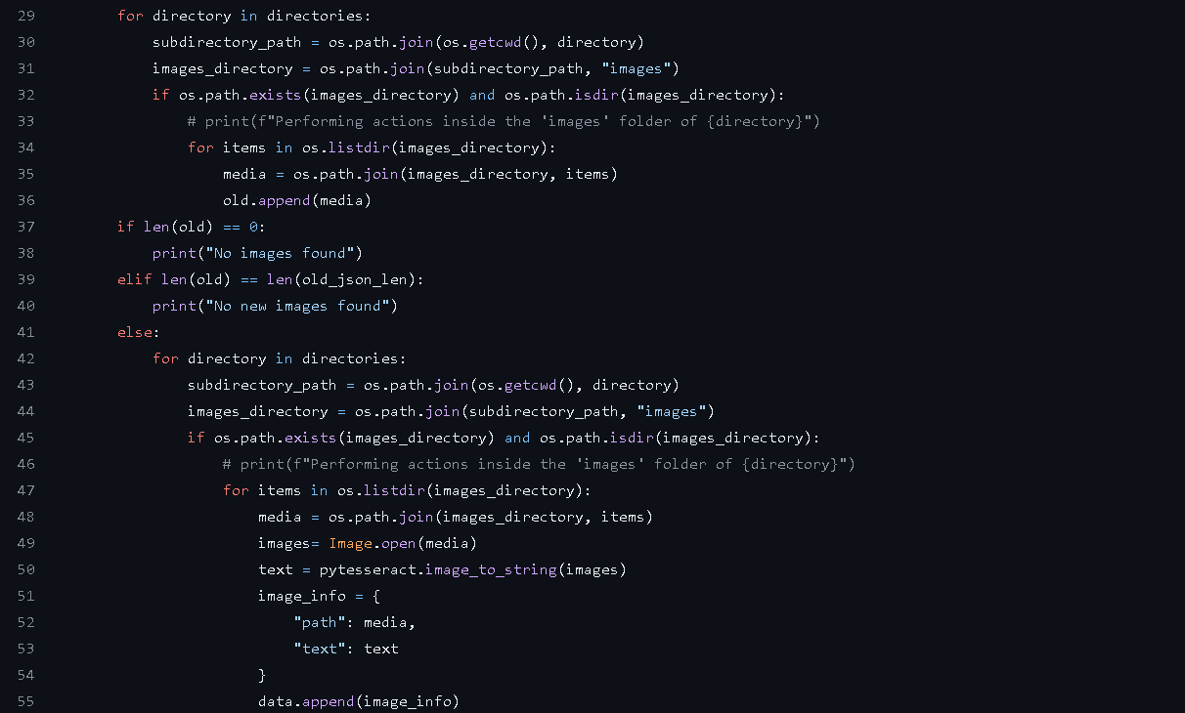

* + 1. HomeScreen Android

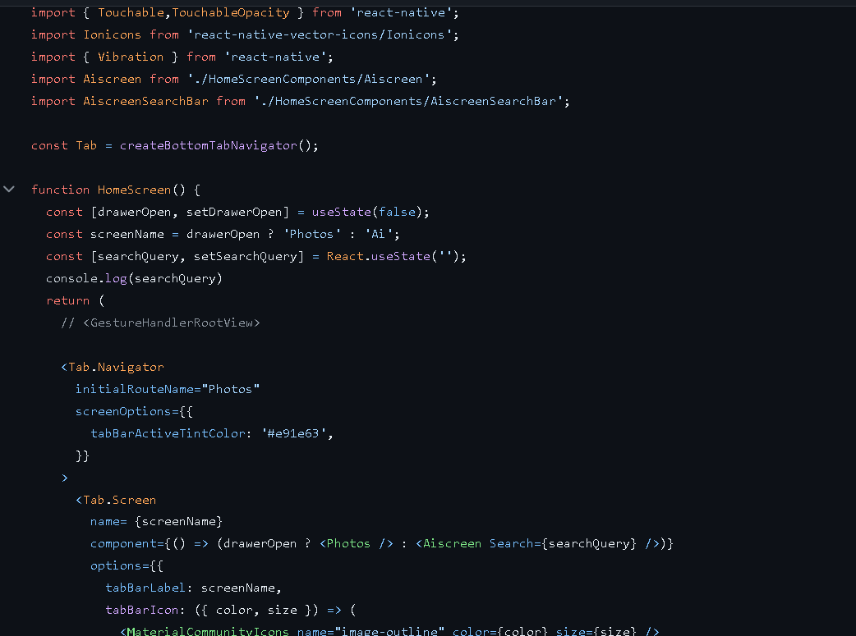

* + 1. Fig 9 UI Code



* 1. Testing

Software Testing is a method to check whether the actual software product matches expected requirements and to ensure that software product is Defect free. It involves execution of software/system components using manual or automated tools to evaluate one or more properties of interest. The purpose of software testing is to identify errors, gaps or missing requirements in contrast to actual requirements.

* + 1. Unit Testing

Unit Testing is a type of software testing where individual units or components of a software are tested. The purpose is to validate that each unit of the software code performs as expected. Unit Testing is done during the development (coding phase) of an application by the developers. Unit Tests isolate a section of code and verify its correctness. A unit may be an individual function, method, procedure, module, or object.

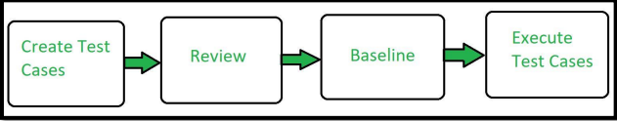

**Advantages**

* Unit Testing allows developers to learn what functionality is provided by a unit and how to use it to gain a basic understanding of the unit API.
* Unit testing allows the programmer to refine code and make sure the module works properly.
* Unit testing enables testing parts of the project without waiting for others to be completed.
* Early Detection of Issues: Unit testing allows developers to detect and fix issues early in the development process, before they become larger and more difficult to fix.
* Improved Code Quality: Unit testing helps to ensure that each unit of code works as intended and meets the requirements, improving the overall quality of the software.

**Disadvantages**

* The process is time-consuming for writing the unit test cases.
* Unit Testing will not cover all the errors in the module because there is a chance of having errors in the modules while doing integration testing.
* Unit testing is not efficient for checking the errors in the UI (User Interface) part of the module.
* It requires more time for maintenance when the source code is changed frequently.
* It cannot cover the non-functional testing parameters such as scalability, the performance of the system, etc.
  + 1. Integration Testing

|  |  |
| --- | --- |
| Integration testing is a software testing technique that focuses on verifying the interactions and data exchange between different components or modules of a software application. The goal of integration testing is to identify any problems or bugs that arise when different components are combined and interact with each other.  Integration testing is typically performed after unit testing and before system testing. It helps to identify and resolve integration issues early in the development cycle, reducing the risk of more severe and costly problems later on. |  |

**Advantages**

* It is convenient for small systems.
* Simple and straightforward approach.
* Can be completed quickly.
* Does not require a lot of planning or coordination.
* May be suitable for small systems or projects with a low degree of interdependence
* between components.

**Disadvantages**

* There will be quite a lot of delay because you would have to wait for all the modules to be
* integrated.
* High risk critical modules are not isolated and tested on priority since all modules are tested
* at once.
* Not Good for long Projects.
* High risk of integration problems that are difficult to identify and diagnose.
* Can result in long and complex debugging and troubleshooting efforts.
  1. Tools Requirement

|  |  |
| --- | --- |
| Postman is a widely used collaboration platform for API development. It simplifies the process of designing, testing, and documenting APIs by providing a user-friendly interface. With Postman, developers can create requests to various endpoints, test API functionality, and automate testing workflows. It supports various authentication methods, environments for different configurations, and collection sharing for collaboration. Postman is valuable for developers, testers, and teams involved in building and maintaining APIs. | [This Photo](https://www.marcus-povey.co.uk/2020/08/31/known-postman-collection/) by Unknown Author is licensed under [CC BY-SA-NC](https://creativecommons.org/licenses/by-nc-sa/3.0/) |

**Advantages:**

* User-Friendly Interface: Postman provides an intuitive and easy-to-use interface for designing, testing, and documenting APIs.
* Efficient API Testing: Developers can create and execute API requests, automate testing, and validate responses, ensuring the reliability of APIs.
* Collaboration Platform: Postman facilitates teamwork with features like shared collections, team workspaces, and version control for API development.
  1. Table 2: Test Cases

|  |  |  |  |  |
| --- | --- | --- | --- | --- |
| TEST CASE ID | TEST CASE OBJECTIVE | TEST CASE SPECIFICATION | EXPECTED RESULT | ACTUAL RESULT |
| 1 | Check whether the Application is loading | User attempts to open the Application | Application opens | Opened Successfully |
| 2 | Check whether the user can login to their account | User attempts the connect to the wallet | server is connected | Connected Successfully |
| 3 | Check whether the application can be used to upload and see the media | User attempts to upload media and browse the media | Able to upload | Uploaded and viewed Successfully |

Chapter 6

**Results And Discussions**

6.1. Test Reports

Test Report is a document which contains a summary of all test activities and final test results of a testing project. Test report is an assessment of how well the Testing is performed. Based on the test report, stakeholders can evaluate the quality of the tested product and make a decision on the software release.

6.2. Table 3 : Test Reports

|  |  |  |  |  |
| --- | --- | --- | --- | --- |
| TEST CASE ID | COMPONENT TEST | DESCRIPTION | EXPECTED RESULT | ACTUAL RESULT |
| 1 | Application | Check whether the Application is loading on most Operating Systems | Application opens | Opened Successfully |
| 2 | Account | Check whether the application can connect to the Account with registered Login ID | Account is connected | Connected Successfully |
| 3 | Media Upload | User attempts to Upload Media | Media is Uploaded | Upload Successfully |

6.3. User Documentation

6.3.1. Fig 10 UI Frontend Ui Web

6.3.2. Fig 11 Upload Images

6.3.3. Fig 12 User upload Android App

**Chapter 7**

CONCLUSION AND FUTURE SCOPE

7.1. Conclusion

In conclusion, Metafortess stands as a cutting-edge multimedia management solution that addresses the contemporary challenges users face in organizing, accessing, and securing their diverse media assets within a home network. Leveraging a powerful combination of technologies including React and React Native for an intuitive user interface, Node.js with Express.js for a robust backend, SQLite for efficient local storage, Python for advanced image analysis, and Docker for seamless deployment, Metafortess embodies a user-centric approach.

The platform's decentralized architecture, relying on a local server, not only optimizes resource utilization but also enhances user privacy and security. By introducing innovative image analysis capabilities for text search, Metafortess redefines how users interact with and manage their multimedia content.

The commitment to an open-source model ensures affordability and inclusivity, fostering collaboration and continuous improvement within the community. Metafortess represents more than a multimedia management app; it symbolizes a commitment to user empowerment, technological innovation, and a seamless user experience.

As technology evolves and user expectations grow, Metafortess positions itself not just as a solution for today but as a dynamic platform ready to adapt and scale with the ever-changing landscape of multimedia management. With a blend of versatility, security, and user-friendliness, Metafortess emerges as a promising tool, empowering users to take control of their multimedia assets effortlessly.

7.2. Limitations of the System

**Scalability Challenges:**

The system may encounter scalability limitations during periods of high transaction volumes, potentially leading to delays or increased processing times.

**Security Risks:**

Despite robust security measures, the inherent complexity of blockchain systems introduces the risk of vulnerabilities, necessitating ongoing monitoring and updates to address emerging threats.

**Regulatory Compliance Complexity:**

Adhering to diverse and evolving regulatory frameworks across jurisdictions may present challenges, requiring continuous efforts to ensure compliance and legal conformity.

**Learning Curve for Users:**

The platform's advanced features and integration with blockchain technology may pose a learning curve for users unfamiliar with cryptocurrency trading, potentially affecting user adoption rates.

**Market Volatility Impact**:

The system may be susceptible to the impact of market volatility, affecting the value of cryptocurrencies and influencing user behavior on the platform.

7.3. Future Scope

1. Integration of Cloud Services:
   * Metafortess could explore optional integrations with popular cloud services, offering users the flexibility to extend their storage beyond the local server. This would cater to users who prefer a hybrid approach, combining local and cloud storage for enhanced accessibility.
2. Enhanced Collaboration Features:
   * Future iterations of Metafortess could introduce collaborative features, allowing multiple users within the same home network to contribute and manage multimedia assets collectively. This would be particularly beneficial for families or shared living spaces.
3. Artificial Intelligence (AI) Integration:
   * Incorporating AI capabilities could elevate Metafortess by providing automated content tagging, facial recognition, and more. This would enhance the platform's ability to organize and categorize multimedia assets intelligently.
4. Extended Platform Support:
   * Metafortess could expand its reach by providing dedicated applications for additional platforms, such as smart TVs, smart home devices, and other emerging technologies, ensuring a seamless multimedia experience across various devices.

By embracing these future scopes, Metafortess aims to not only stay relevant in the dynamic landscape of multimedia management but also continue to lead in providing innovative, secure, and user-friendly solutions for users within their home networks.

**7.4. References**

[1] React Native Documentation: <https://reactnative.dev/docs/getting-started>

[2] Node.js Documentation: <https://nodejs.org/en/docs/>

[3] TensorFlow Documentation[: https://www.tensorflow.org/guide](:%20https:/www.tensorflow.org/guide)

[4] PyTorch Documentation: <https://pytorch.org/docs/stable/index.html>

[5] MongoDB Documentation: <https://docs.mongodb.com/>

[6] Docker Documentation: <https://docs.docker.com/>

[7] Git/GitHub Documentation: <https://docs.github.com/en>

**7.5. Glossary**

1. Multimedia Management:
   * *Definition:* Multimedia management within the context of Metafortess involves the systematic organization, storage, and retrieval of various media types, such as images, videos, and audio files, within a localized home network.
2. React Native:
   * *Definition:* React Native is a framework utilized in the development of Metafortess for creating cross-platform mobile applications, ensuring a consistent user experience on both Android and iOS devices through a single codebase.
3. Local Server Deployment:
   * *Definition:* Local server deployment refers to the hosting of Metafortess's server infrastructure within the user's home network, enabling efficient access and management of multimedia assets from various devices within the home.
4. Image Analysis:
   * *Definition:* Image analysis in Metafortess involves the utilization of Python and related libraries, such as OpenCV and Tesseract, to extract text and implement advanced search functionalities within images, enhancing content discovery.
5. Decentralized Architecture:
   * *Definition:* The decentralized architecture of Metafortess emphasizes user control and privacy by relying on a local server, minimizing dependencies on external servers and providing a secure environment for multimedia management.
6. Open-Source Model:
   * *Definition:* Metafortess adopts an open-source model, allowing free access to its source code. This encourages collaboration, community-driven development, and ensures affordability and inclusivity for users.
7. Docker Containerization:
   * *Definition:* Docker containerization in Metafortess involves encapsulating the application and its dependencies into containers, ensuring consistent deployment across different environments and simplifying maintenance and updates.
8. SQLite Database:
   * *Definition:* The SQLite database in Metafortess serves as a lightweight and efficient solution for storing and retrieving multimedia assets, supporting the platform's goal of providing seamless local storage within the home network.
9. User-Friendly Interface:
   * *Definition:* The user-friendly interface of Metafortess ensures an intuitive and responsive interaction for users, facilitating effortless uploading, organizing, and accessing of multimedia content.
10. Community-Driven Development:
    * *Definition:* Metafortess embraces community-driven development by allowing users to contribute extensions or plugins, fostering an organic evolution of the platform based on user needs and preferences.

**7.6. Appendices**

1. React Native:
   * *Description:* React Native is a framework utilized in Metafortess for cross-platform mobile application development. It enables the creation of responsive and consistent user interfaces on both Android and iOS devices using a single codebase.
2. Tesseract OCR:
   * *Description:* Tesseract OCR is an optical character recognition engine incorporated into Metafortess for advanced image analysis. It facilitates the extraction of text from images, contributing to the platform's embedded text search capabilities.
3. Material-UI:
   * *Description:* Material-UI is a React-based UI framework employed in Metafortess to implement a visually appealing and responsive user interface. It provides pre-designed React components and styles, streamlining the frontend development process.
4. Node.js and Express.js:
   * *Description:* Node.js, coupled with Express.js, forms the backend foundation of Metafortess. Node.js provides a runtime environment, while Express.js facilitates the development of robust APIs, ensuring efficient server-side operations.
5. SQLite Database:
   * *Description:* Metafortess utilizes SQLite as its database technology. SQLite is a lightweight and serverless relational database management system, well-suited for local server deployment within the home network.
6. Docker:
   * *Description:* Docker is employed for containerization in Metafortess, encapsulating the application and its dependencies. This ensures consistency in deployment across different environments and facilitates maintenance and updates.
7. Python with OpenCV:
   * *Description:* Python, along with OpenCV, is integrated into Metafortess for image analysis and processing. This combination enhances Metafortess's capabilities in extracting text from images and implementing advanced search functionalities.
8. GitHub:
   * *Description:* GitHub is utilized as the version control platform for Metafortess. It enables collaborative development, version tracking, and facilitates community contributions through the platform's open-source model.
9. Community Forums:
   * *Description:* Community forums serve as discussion platforms for Metafortess users and developers. These forums encourage collaboration, problem-solving, and the exchange of ideas, contributing to the community-driven development aspect of Metafortess.