Java Experiment – 4
Vectors

Name: Pavan Bhapkar

PRN: 24070126137
Main:
import java.util.Scanner;
public class VectorMain {
public static void main(String[] args) { Scanner sc = new Scanner(System.in);

try {
System.out.print("Enter dimension of Vector 1 (2 or 3): "); int dim1 = sc.nextInt();
double[] comp1 = new double[dim1];
System.out.println("Enter " + dim1 + " components of Vector 1:"); for (int i = 0; i < dim1; i++) {
System.out.print(" Component " + (i + 1) + ": "); comp1[i] = sc.nextDouble();
}
Vector A = new Vector(comp1);
System.out.print("Enter dimension of Vector 2(2 or 3): "); int dim2 = sc.nextInt();
double[] comp2 = new double[dim2];
System.out.println("Enter " + dim2 + " components of Vector 2:"); for (int i = 0; i < dim2; i++) {
System.out.print(" Component " + (i + 1) + ": "); comp2[i] = sc.nextDouble();
}
Vector B = new Vector(comp2);
boolean running = true; while (running) {
System.out.println("\n--- Vector Operations ---");
System.out.println("1. Add");
System.out.println("2. Subtract (A - B)");
System.out.println("3. Dot Product");
System.out.println("4. Display Vectors");
System.out.println("5. Exit");
System.out.print("Choose an option: "); int choice = sc.nextInt();
switch (choice) { case 1:
System.out.print("Vector 1 + Vector 2 = "); Vector sum = A.add(B); sum.display(); break; case 2:
System.out.print("Vector 1 - Vector 2 = "); Vector diff = A.subtract(B); diff.display(); break; case 3:
double dot = A.dotProduct(B);
System.out.println("Vector 1 . Vector 2 = " + dot); break; case 4:
System.out.print("Vector 1 = ");
A.display();
System.out.print("Vector 2 = "); B.display(); break; case 5:
running = false;
System.out.println("Exiting..."); break; default:
System.out.println("Invalid option. Try again.");
}
}

} catch (VectorException e) {
System.out.println("VectorException: " + e.getMessage());
}
}
}

Vector:
import java.util.Arrays;

public class Vector {
private double[] components; private int dimension;

public Vector(double... components) throws VectorException { if (components.length != 2 && components.length != 3) { throw new VectorException("Invalid dimension! Only 2D or 3D vectors are allowed."); }

this.components = components.clone(); this.dimension = components.length;
} public int getDimension() { return dimension;
} public double getComponent(int index) { return components[index];
} private void checkDimensionality(Vector v) throws VectorException { if (this.dimension != v.dimension) { throw new VectorException("Dimension of the vectors do not match! Cannot perform operations.");
}
} public Vector add(Vector v) throws VectorException { checkDimensionality(v); double[] result = new double[dimension]; for (int i = 0; i < dimension; i++) { result[i] = this.components[i] + v.components[i];
} return new Vector(result);
} public Vector subtract(Vector v) throws VectorException { checkDimensionality(v); double[] result = new double[dimension]; for (int i = 0; i < dimension; i++) { result[i] = this.components[i] - v.components[i];
} return new Vector(result);
} public double dotProduct(Vector v) throws VectorException { checkDimensionality(v); double result = 0; for (int i = 0; i < dimension; i++) {
result += this.components[i] * v.components[i];
}
return result;
}
public void display() {
System.out.println(this.dimension + "D Vector: " +
Arrays.toString(this.components)); }}
Exceptions:
class VectorException extends Exception { public VectorException(String message) { super(message);
}
}

Output:
Creating Vectors ( 2D or 3D):
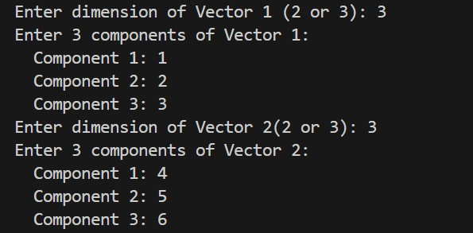
Addition:
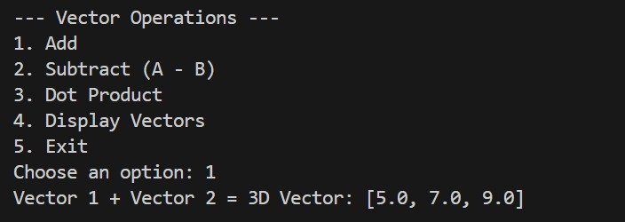
Subtraction:
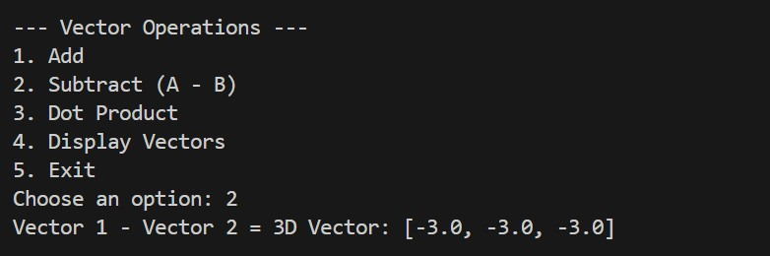
Dot Product:
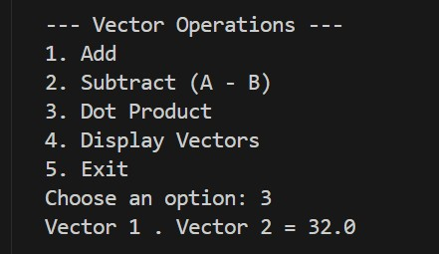
Display:
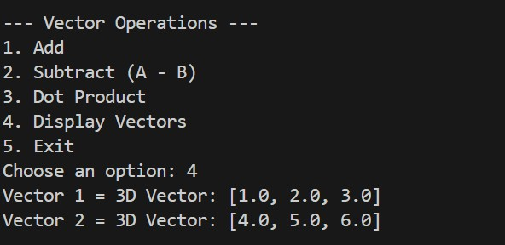

Exception Handling:
Dimensions of vectors do not match
