Introduction
In today’s digital era, spreadsheets play a vital role in storing, analysing, and organizing large volumes of data efficiently. Spreadsheet applications like Microsoft Excel provide powerful tools such as filters, sorting, conditional formatting, and pivot tables, which help users analyse data meaningfully and make informed decisions. In this assignment, a spreadsheet containing student information such as name, age, grade, school, telephone number, and sport participation is used as the base dataset. Analysing this data helps in identifying trends such as age distribution, sport popularity, and grouping students based on various criteria. These tools are widely used in educational institutions, business organizations, and research fields to summarize raw data into understandable information. This exercise enables first-semester students to gain hands-on experience with data analysis techniques using spreadsheet applications, improving their digital literacy and problem-solving skills.

Problem Statement
The student data created in the spreadsheet (as per Questions 4 and 5) contains multiple records that are difficult to interpret in raw form. Without proper organization and analysis tools, it becomes challenging to extract meaningful insights such as identifying students by sport, age group, or school, and determining sport-wise participation. Hence, there is a need to analyse and organize the spreadsheet data using built-in spreadsheet features like filters, sorting, conditional formatting, and pivot tables to make the data more structured, readable, and informative.

Objective
- To understand the importance of data analysis in spreadsheets
- To organize student data using sorting and filtering techniques
- To visually highlight important data using conditional formatting
- To summarize large datasets using pivot tables
- To gain practical knowledge of spreadsheet tools used for real-world data analysis
- To perform structured data handling for improving readability and interpretation.
To explore how spreadsheet automation reduces manual effort in data management.
- To introduce students to digital tools used for real-time data decision-making.
- To categorize student records based on multiple parameters such as age, sport, and school.
- To identify relationships and patterns within the dataset using analytical tools.
- To observe the impact of data visualization techniques in simplifying complex information.
- To enhance proficiency in data preprocessing for further statistical analysis.
- To develop accuracy and precision in handling and managing datasets.
- To introduce the concept of data summarization for academic and administrative use.
- To demonstrate how organized data can support institutional planning and evaluation.
- To bridge the gap between theoretical learning and practical spreadsheet applications.
- To encourage the use of spreadsheet software as a productivity and analytical tool.
- To understand the role of spreadsheet-based analytics in modern industries.
- To prepare students for future coursework involving data science and computational analysis.
- To utilize spreadsheet tools for meaningful interpretation rather than only storage of data.

Methodology
The spreadsheet created earlier with student details is used as input data. The following techniques are applied:
- Sorting is used to arrange student data based on age or grade.
- Filtering is applied to display students belonging to a specific sport or school.
- Conditional Formatting highlights specific values such as maximum age or repeated entries.
- Pivot Tables are created to summarize the number of students participating in each sport.
Each tool is applied step-by-step using Microsoft Excel to convert raw data into organized and meaningful information.

Result
Student data was successfully organized and analysed
Sorting helped in arranging data systematically
Filters allowed viewing specific student groups
Conditional formatting visually highlighted important values
Pivot table summarized sport-wise student participation clearly
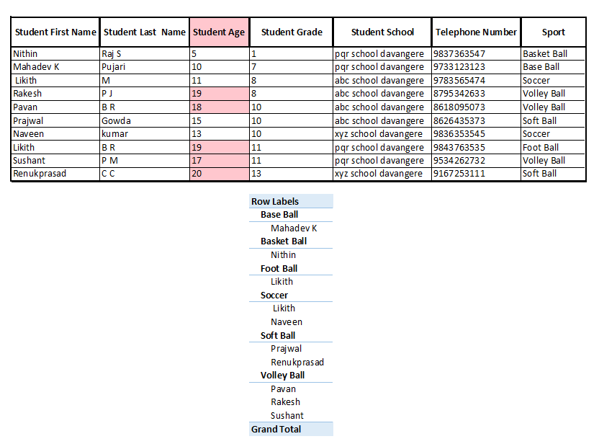

Conclusion

This experiment demonstrates the effective use of spreadsheet tools for analyzing and organizing data. Features like filters, sorting, conditional formatting, and pivot tables transform raw data into structured and meaningful information. Such skills are essential for students in academics and professional environments. The activity enhances analytical thinking and practical knowledge of spreadsheet applications.

References
• Microsoft Support – Excel Documentation and Tutorials
• Data Analysis Using Excel” – McGraw Hill Education
• Office Training – Excel (Microsoft Online Tutorials)
• Spreadsheet Analysis and Design” – Cambridge Publishing
• Journal Articles on Spreadsheet Applications in Data Analysis
• VTU Academic Resources and Laboratory Manuals
• Khan Academy – Data and Spreadsheet Basics (Online Tutorials)
• Coursera – Excel Skills for Business

